EXPERIMENT -11
Approval Process
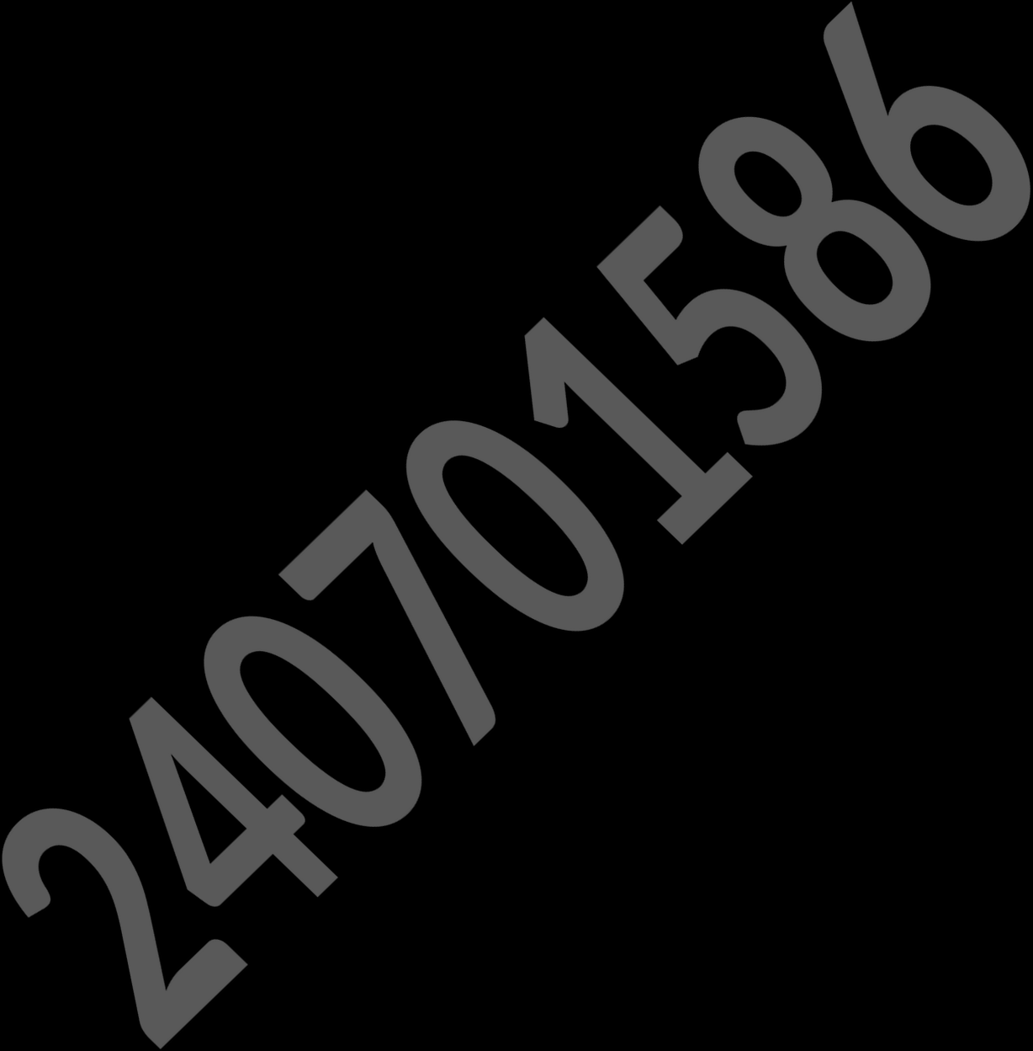
Application Name: Vehicle Service Management System

NAME: VIDHUN R
ROLL NO: 240701586

Aim
To design and configure an approval workflow process for high-cost service requests in the Vehicle Service Management System.

Procedure
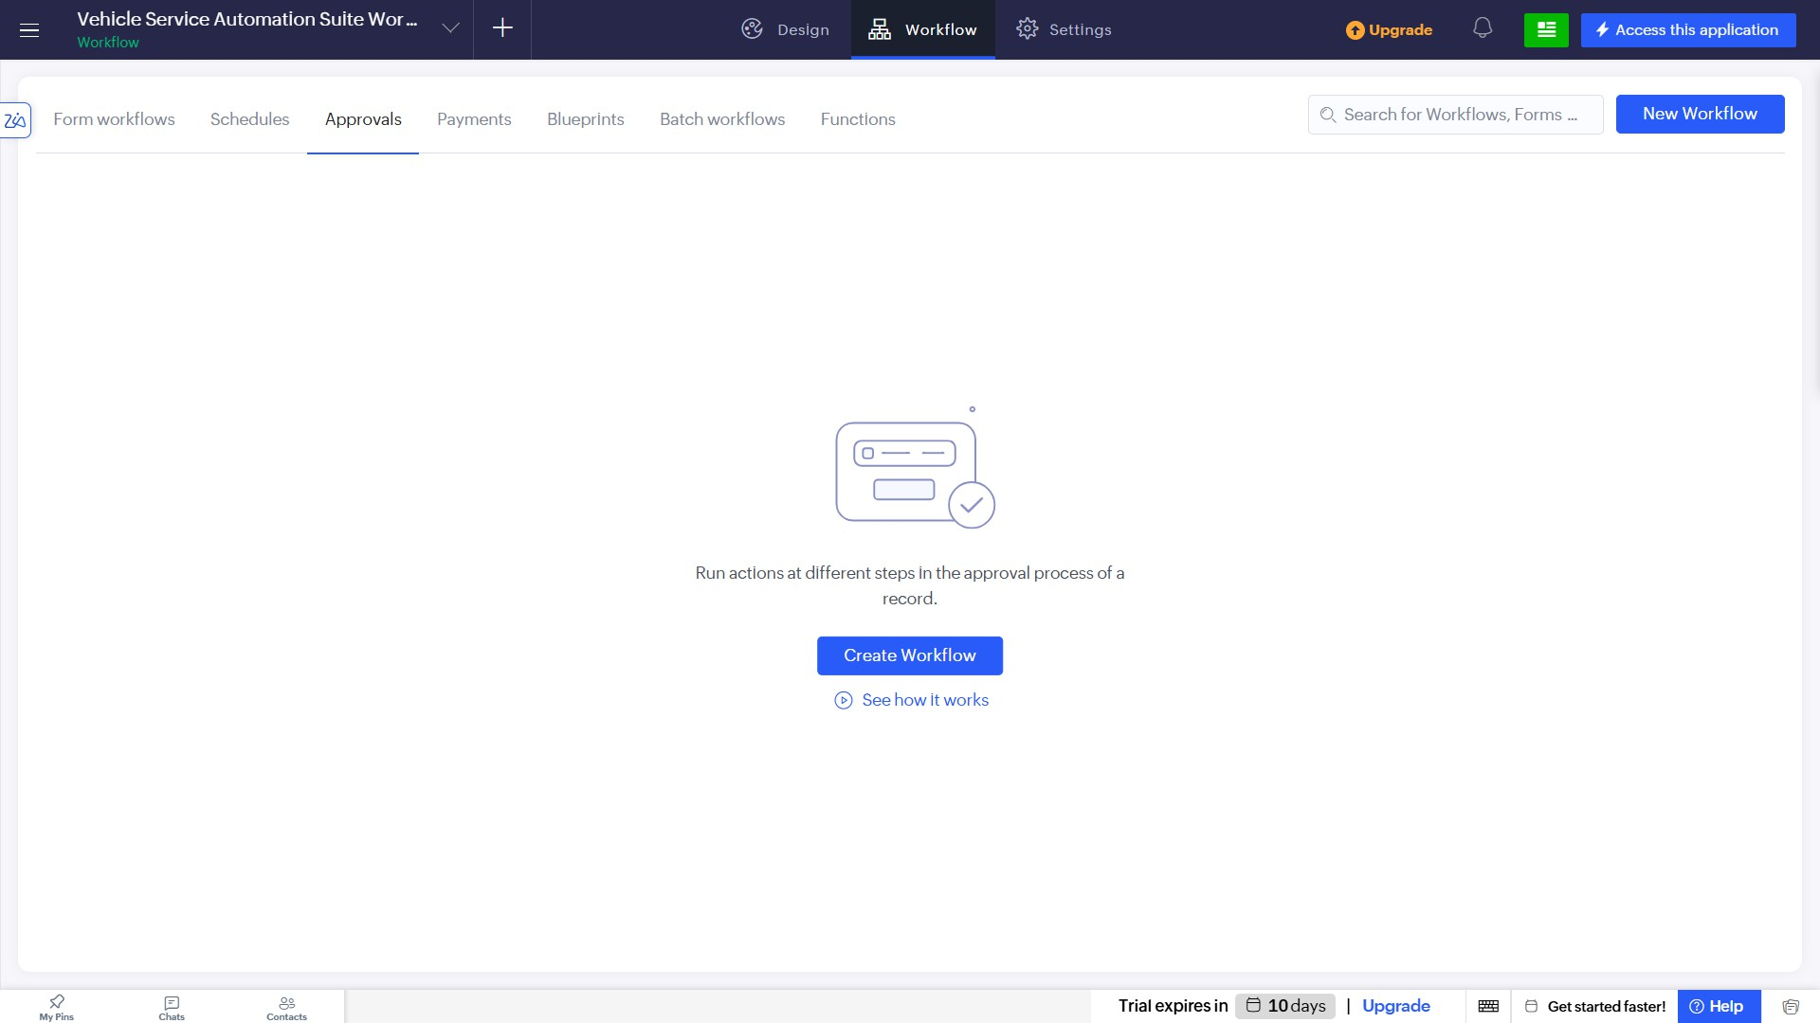
- Navigate to the Approvals tab under Workflow and click on "Create Workflow".
- Set up the approval process to run on record addition for the "Service Request" form and name it HighCost_Repair_Approval.

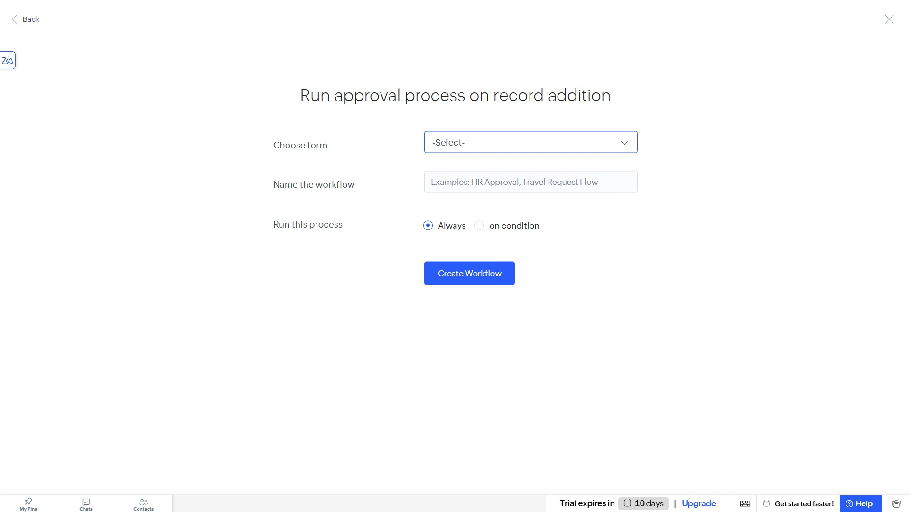

- Define the condition for the approval process to trigger only when the Estimated_Service_Cost is greater than 10000.
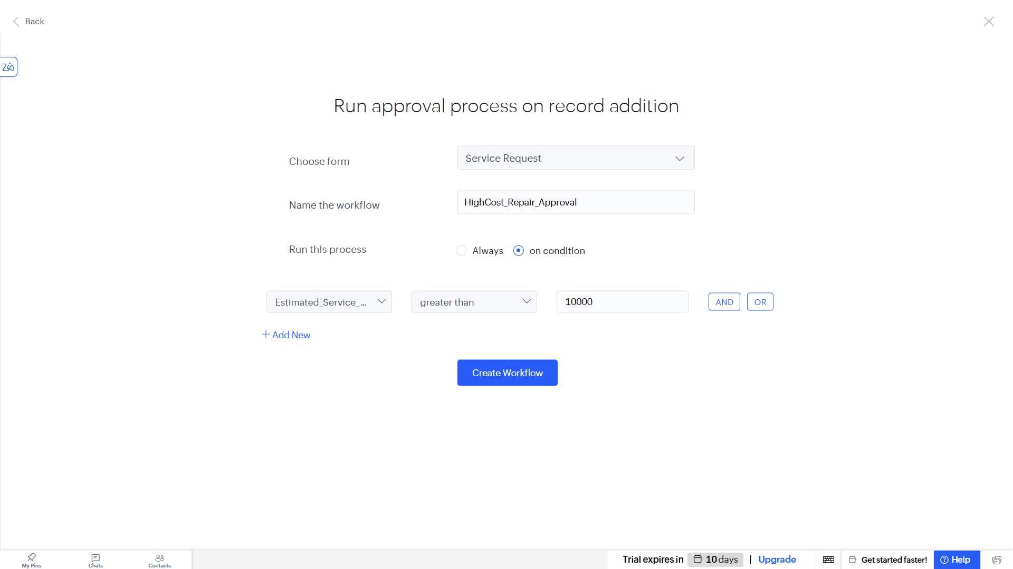

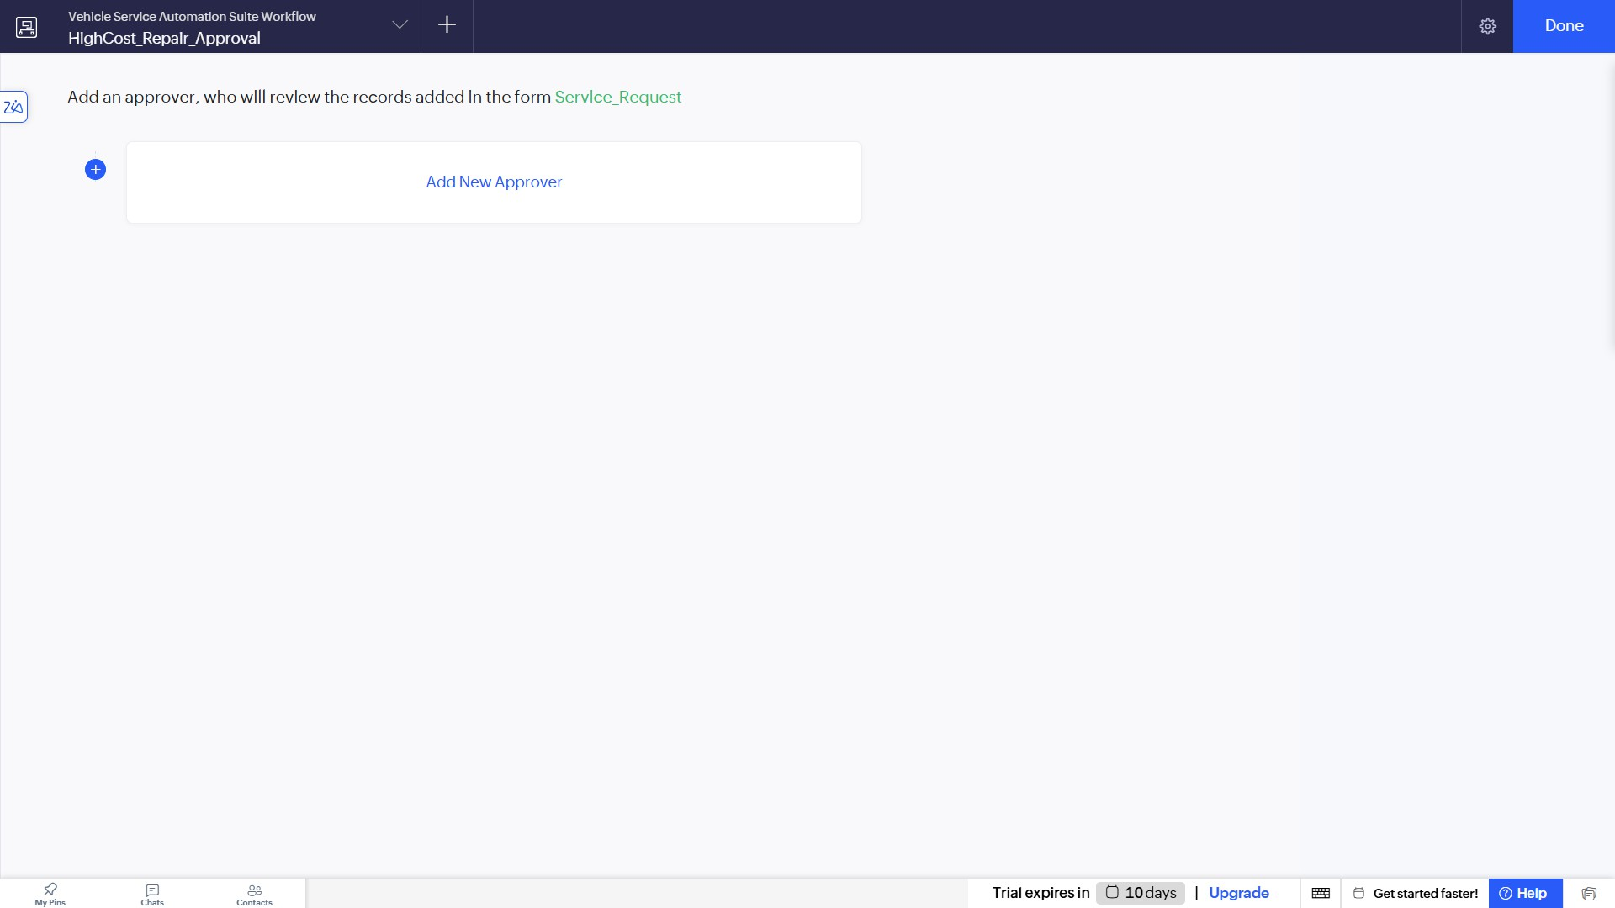

- Add a new approver by selecting a specific user and setting the Approval label to "Approved" and Denial label to "Rejected".
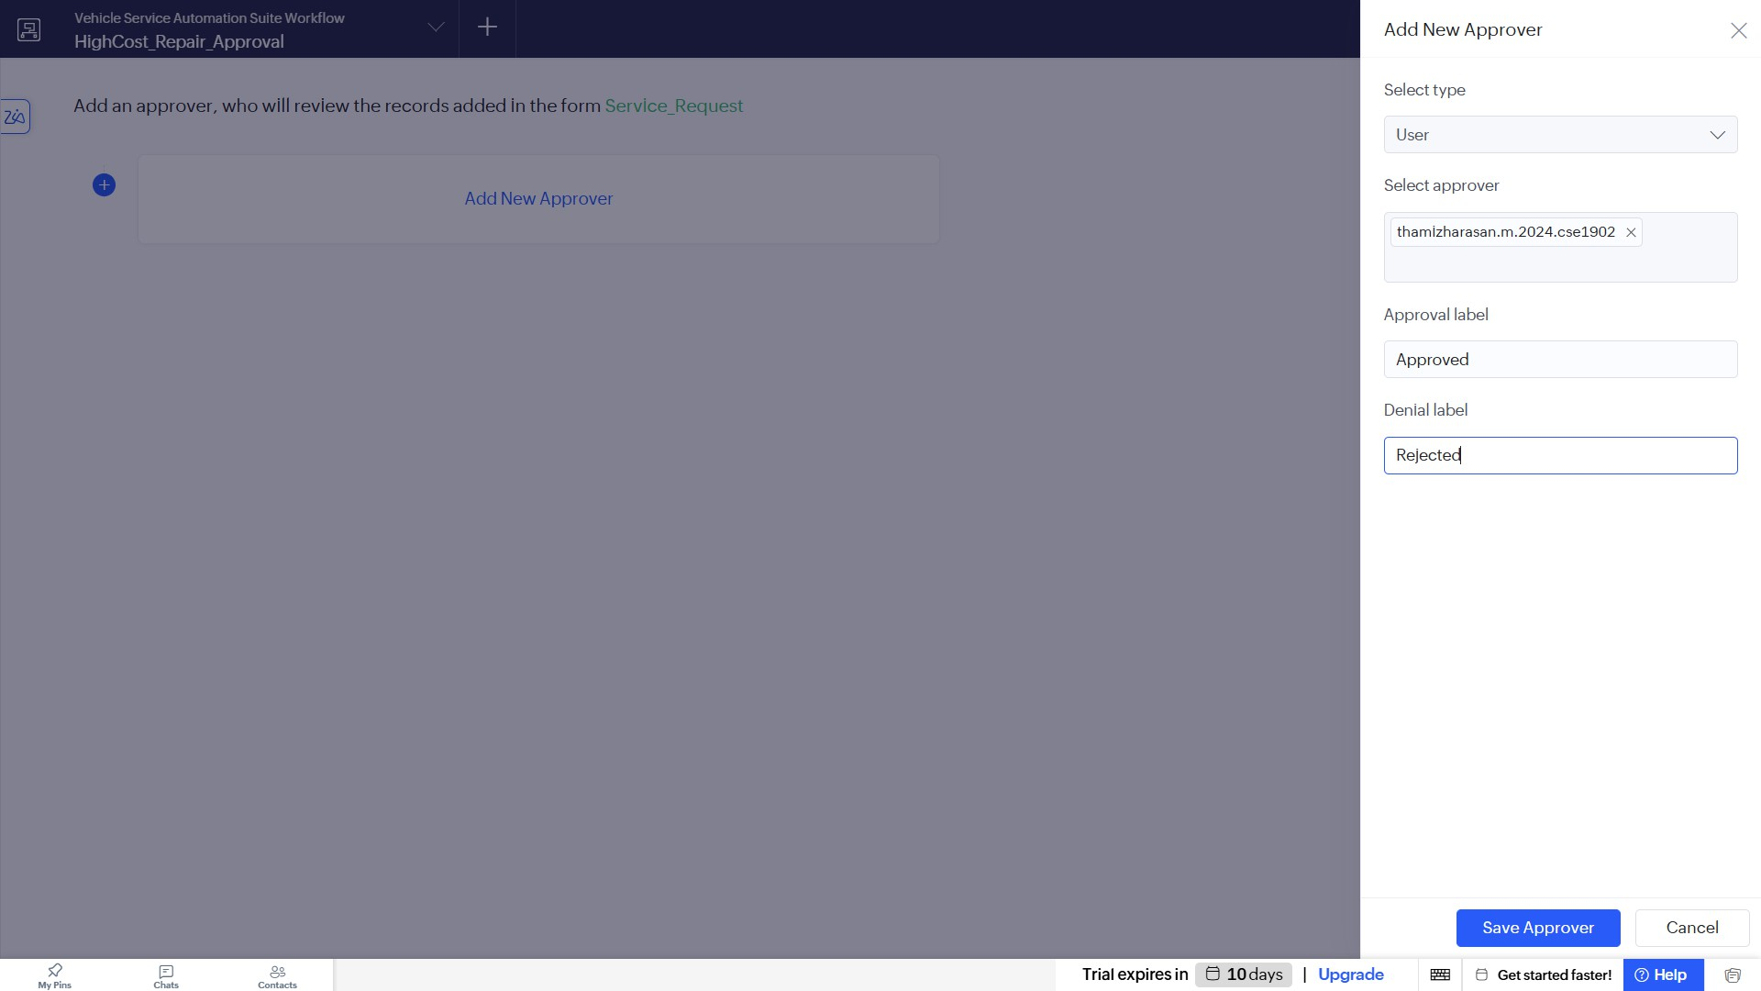

- Configure automated email notification actions to be sent to the submitter upon both "Approved" and "Rejected" outcomes.
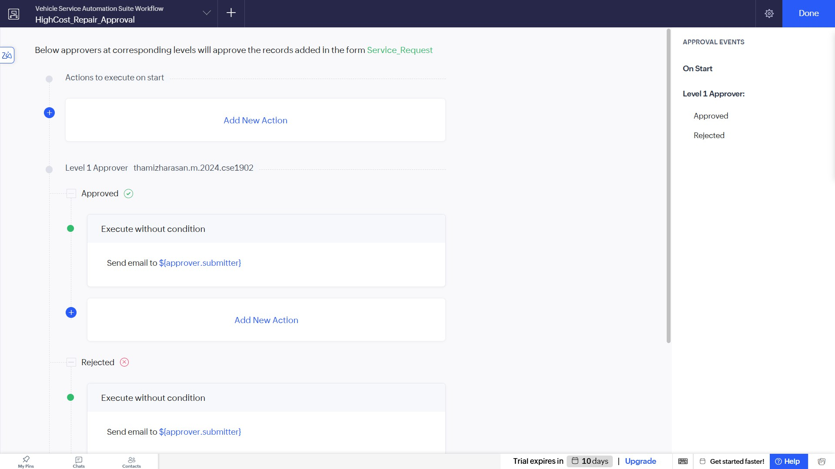

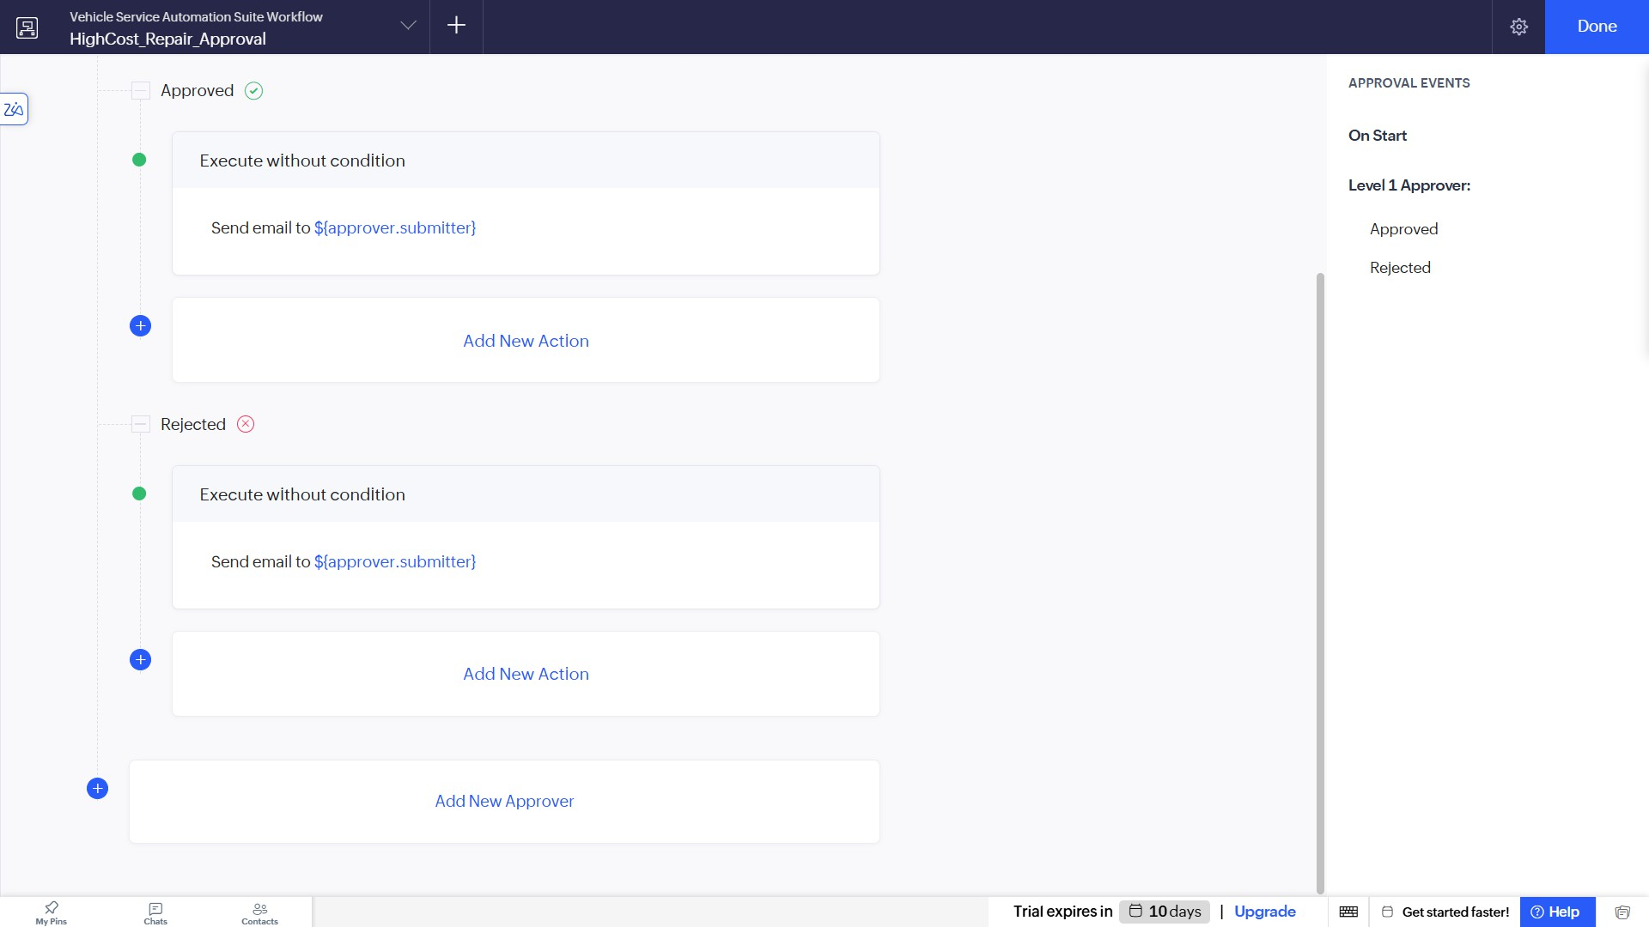

- Save the configuration and verify that the approval workflow is active and listed as "Enabled" in the Approvals dashboard.
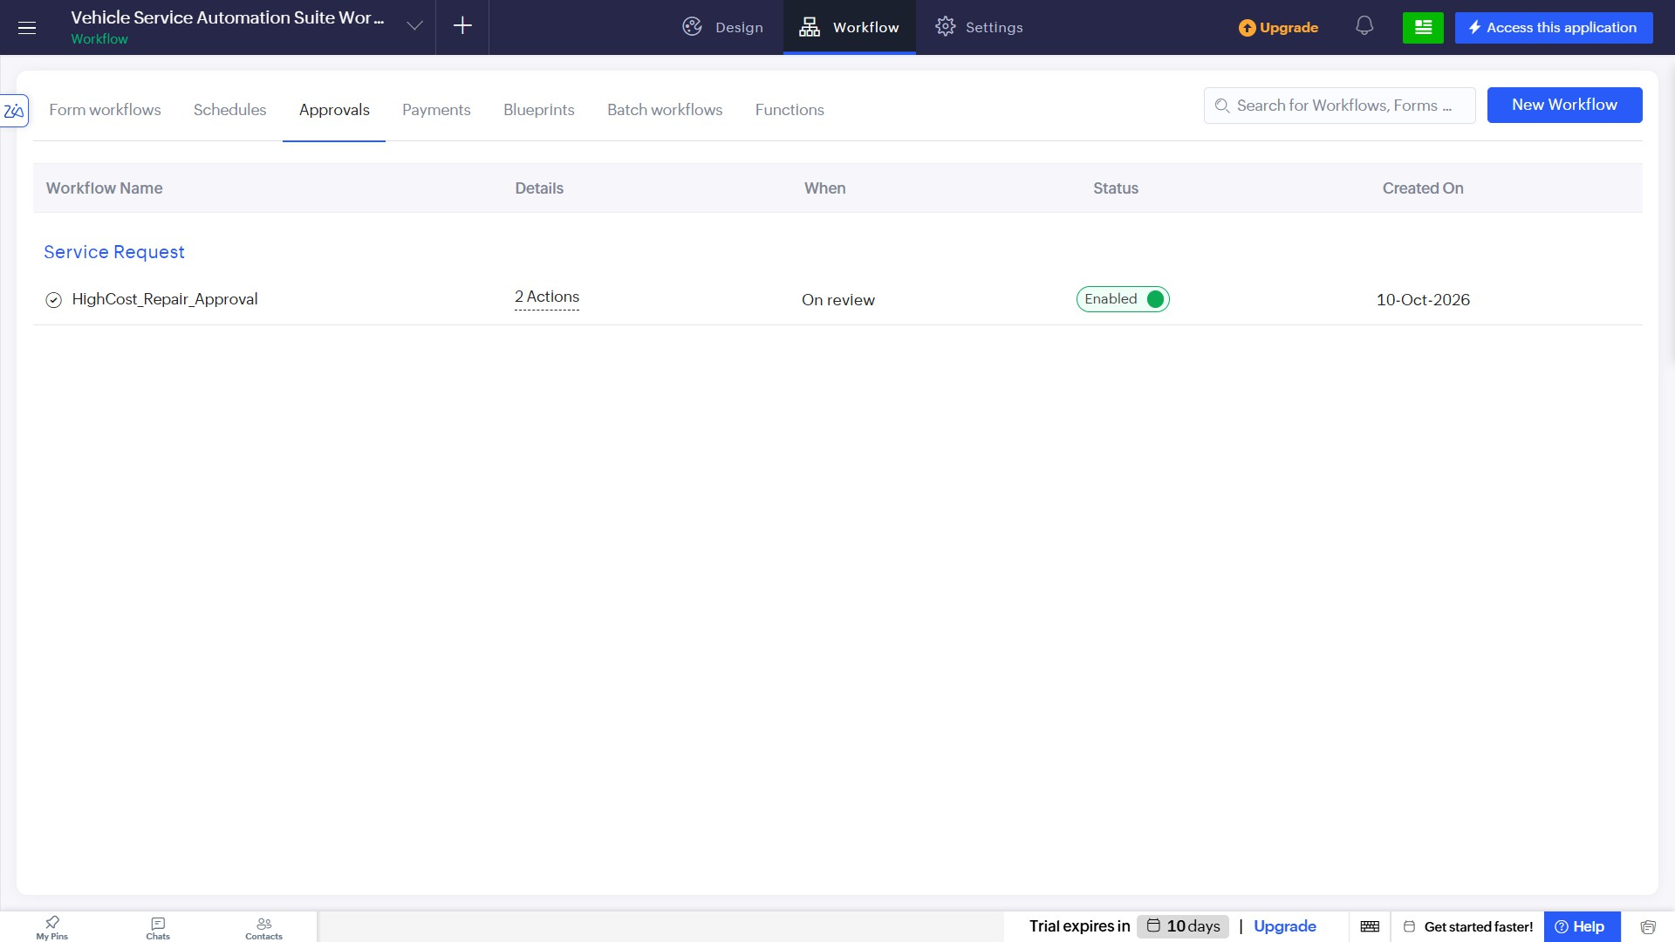

Result
The conditional approval workflow for high-cost repairs was successfully created, configured with designated approvers and email notifications, and enabled within the Vehicle Service Management System.

