**A SENTIMENT ANALYSIS FOR SOCIAL MEDIA USING BIG DATA ARCHITECTURE**

**A PROJECT PHASE II REPORT**

***Submitted by***

**ROWIN U 2116231801141**

SACHIN K G 2116231801144

VIDHURSH KUMAR 2116231801186

*in partial fulfillment for the award of the degree of*

**BACHELOR OF TECHNOLOGY**

***in***

**ARTIFICIAL INTELLIGENCE AND DATA SCIENCE**

**RAJALAKSHMI ENGINEERING COLLEGE**

**(AUTONOMOUS), CHENNAI – 602 105**

**APRIL 2025**

**BONAFIDE CERTIFICATE**

Certified that this project report titled “**SENTIMENT TRACKING IN MOVIE REVIEWS USING BIG DATA ARCHITECTURE**”

is the bonafide work of ROWIN U 231801141, SACHIN KG 231801144, VIDHURSH KUMAR V 231801186 who carried out the project work

under my supervision during the academic year [2025 - 2026]. The report submitted herewith is a record of original work done by the candidate under my guidance and supervision in partial fulfillment of the requirements for the award of the Degree of

**SIGNATURE SIGNATURE**

**Dr.J M Gnanasekar Ph.D., Dr Suresh Kumar, Ph.d**

**Professor and Head, Assistant Professor (SG),**

Department of Artificial Intelligence Department of Artificial Intelligence

and Data Science, and Data Science,

Rajalakshmi Engineering College Rajalakshmi Engineering College

Thandalam – 602 105 Thandalam – 602 105

Submitted to Project Viva-Voce Examination held on _________________

**Internal Examiner** **External Examiner**

ABSTRACT

In the modern digital era, millions of users express their opinions about movies on social media and

Review platforms. Understanding these sentiments provides valuable insights into public opinion and helps

Movie production houses, distributors, and streaming platforms make data-driven decisions. This project,

Titled “Sentiment Tracking in Movie Reviews Using Big Data Architecture,” focuses on analysing user sentiments

Through a structured data pipeline that follows the Bronze–Silver–Gold data model.

The project uses the Sentiment140 dataset containing 1.6 million tweets to classify sentiments as

Positive or negative. The data is processed using Python-based tools such as Pandas, NumPy, and NLTK

within a Big Data simulation environment using VS Code and Jupyter Notebook. The Bronze layer handles

raw data ingestion, the Silver layer performs preprocessing and text cleaning, and the Gold layer

executes model training and sentiment prediction using a Logistic Regression algorithm.

and visualizations are used to display the overall distribution of positive and negative reviews.

The project demonstrates how Big Data technologies can be effectively used for large-scale sentiment

tracking and predictive analysis in the entertainment industry.

**Keywords** :

Big Data Analytics,Data Science,Predictive Modeling,Data-Driven Decision Making,Lifestyle Improvement,Sustainable Urban Development,Data Visualization, Urban Analytics

## ACKNOWLEDGEMENT

Initially we thank the Almighty for being with us through every walk of our life and showering his blessings through the endeavor to put forth this report. Our sincere thanks to our Chairman **Mr. S.MEGANATHAN, B.E, F.I.E.**, our Vice Chairman **Mr. ABHAY SHANKAR MEGANATHAN, B.E., M.S.,** and our respected Chairperson **Dr. (Mrs.) THANGAM MEGANATHAN**, **Ph.D.,** for providing us with the requisite infrastructure and sincere endeavoring in educating us in their premier institution.

Our sincere thanks to **Dr. S.N. MURUGESAN, M.E., Ph.D.,** our beloved Principal for his kind support and facilities provided to complete our work in time. We express our sincere thanks to **Dr.J M Gnanasekar, Ph.D.**, Professor and Head of the Department of Artificial Intelligence and Data Science for his guidance and encouragement throughout the project work. We convey our sincere and deepest gratitude to our internal guide, **Mr. SURESH KUMAR S,** Assistant Professor, Department of Artificial Intelligence and Data Science. Rajalakshmi Engineering College for her valuable guidance throughout the course of the project.

**ROWIN U SACHIN KG VIDHURSH KUMAR V**

(2116231801141) (2116231801144) **(**2116231801186**)**

|  |  |  |
| --- | --- | --- |
| **CHAPTER NO.** | **TITLE** | **PAGE NO** |
|  | ABSTRACT | vii |
|  | ACKNOWLEDGEMENT | viii |
|  | LIST OF FIGURES | xi |
|  | LIST OF ABBREVIATIONS | xiii |
| 1 | INTRODUCTION | 1 |
| 1.1 | GENERAL | 1 |
| 1.1.1 | Sentiment Analysis and Social Media Influence | 2 |
| 1.1.2 | Big Data in the Entertainment Industry | 3 |
| 1.1.3 | Data-driven Insights for Movie Review Platforms | 3 |
| 1.1.4 | Challenges in Handling Large-scale Text Data | 4 |
| 1.1.5 | Role of Machine Learning in Sentiment Tracking | 4 |
| 1.2 | OBJECTIVES | 5 |
| 1.3 | EXISTING SYSTEM | 6 |
| 1.4 | PROPOSED SYSTEM | 7 |
| 2 | LITERATURE SURVEY | 8 |
| 2.1 | OVERVIEW | 8 |
| 2.2 | RELATED WORKS ON SENTIMENT ANALYSIS | 9 |
| 3 | SYSTEM DESIGN AND ARCHITECTURE | 12 |
| 3.1 | DATASET DESCRIPTION | 12 |
| 3.2 | DEVELOPMENT ENVIRONMENT | 14 |
| 3.2.1 | Hardware Specifications | 14 |
| 3.2.2 | Software Specifications | 15 |
| 3.3 | BIG DATA ARCHITECTURE LAYERS (BRONZE–SILVER–GOLD) | 16 |
| 3.4 | DATA PIPELINE FLOW | 19 |
| 3.5 | PREPROCESSING STAGES (TOKENIZATION, STOPWORD REMOVAL) | 21 |
| 3.6 | FEATURE EXTRACTION USING COUNT VECTORIZER | 23 |
| 3.7 | LOGISTIC REGRESSION MODEL ARCHITECTURE | 25 |
| 3.8 | OVERALL SYSTEM WORKFLOW | 27 |
| 4 | METHODOLOGY | 29 |
| 4.1 | DATA COLLECTION AND INGESTION | 29 |
| 4.2 | DATA PREPROCESSING AND CLEANING | 31 |
| 4.3 | MODEL TRAINING AND TESTING | 34 |
| 4.4 | PERFORMANCE EVALUATION METRICS | 36 |
| 4.5 | SENTIMENT VISUALIZATION DASHBOARD | 38 |
| 5 | RESULTS AND DISCUSSIONS | 41 |
| 5.1 | TRAINING RESULTS AND ACCURACY | 41 |
| 5.2 | CONFUSION MATRIX AND METRICS VISUALIZATION | 43 |
| 5.3 | SENTIMENT DISTRIBUTION GRAPH | 45 |

|  |  |  |
| --- | --- | --- |
| 5.4 | WORD FREQUENCY ANALYSIS | 46 |
| 5.5 | COMPARATIVE | 47 |
| 6 | CONCLUSION AND FUTURE ENHANCEMENTS | 50 |
| 6.1 | CONCLUSION | 50 |
| 6.2 | FUTURE ENHANCEMENTS | 51 |
|  | APPENDIX | 53 |

**LIST OF ABBREVIATIONS**

| **Abbreviation** | **Full Form** |
| --- | --- |
| **AI** | **Artificial Intelligence** |
| **ML** | **Data Science** |
| **DL** | **Deep Learning** |
| **IoT** | **Internet of Things** |
| **LSTM** | **Long Short-Term Memory** |
| **ARIMA** | **Autoregressive Integrated Moving Average** |
| **GHG** | **Greenhouse Gas** |
| **AQI** | **Air Quality Index** |
| **UHI** | **Urban Heat Island** |
| **GIS** | **Geographic Information System** |
| **API** | **Application Programming Interface** |
| **AWS** | **Amazon Web Services** |
| **CNN** | **Convolutional Neural Network** |
| **RNN** | **Recurrent Neural Network** |
| **SVM** | **Support Vector Machine** |
| **RMSE** | **Root Mean Square Error** |
| **MAE** | **Mean Absolute Error** |
| **ReLU** | **Rectified Linear Unit** |
| **ADAM** | **Adaptive Moment Estimation (optimizer)** |
| **DFD** | **Data Flow Diagram** |
| **CO** | **Course Outcome** |
| **PO** | **Programme Outcome** |
| **PSO** | **Programme Specific Outcome** |

**CHAPTER 1: INTRODUCTION**

In today’s digital era, the entertainment industry is significantly influenced by online platforms

where users express their opinions on movies through social media posts, tweets, and review portals.

These opinions, collectively known as sentiments, play a vital role in shaping public perception,

marketing strategies, and box-office performance. Analyzing such large volumes of unstructured

text data provides valuable insights into audience preferences and emotional responses.

Sentiment Analysis, also referred to as Opinion Mining, is a subfield of Natural Language Processing

(NLP) that focuses on identifying and classifying emotions within text as positive, negative, or neutral.

With the exponential rise in user-generated content, the need for scalable and efficient systems to process,

analyze, and visualize sentiment data has become essential. This project, titled

“Sentiment Tracking in Movie Reviews Using Big Data Architecture,” aims to build an end-to-end

sentiment analysis framework capable of handling large datasets using modern Big Data techniques

.

* + 1. **SENTIMENT ANALYSIS AND SOCIAL MEDIA INFLUENCE**

Social media platforms such as Twitter, Facebook, and Instagram have become primary sources

of public opinion on movies. The volume of text generated daily makes manual analysis impossible.

Automated sentiment analysis tools provide a mechanism to process this data efficiently and

extract meaningful insights that can predict trends, measure audience satisfaction, and guide

content creators in improving storytelling and production quality.

Sentiment Analysis, also referred to as Opinion Mining, is a subfield of Natural Language Processing

(NLP) that focuses on identifying and classifying emotions within text as positive, negative, or neutral.

* + 1. **BIG DATA IN THE ENTERTAINMENT INDUSTRY**

Big Data technologies play a crucial role in handling large-scale information.

In the film industry, Big Data helps analyze audience reactions, box officepredictions,

viewing patterns, and feedback. The integration of Big Data with sentiment analysis

enables faster data ingestion, distributed processing, and real-time insights

that can transform the decision-making process in entertainment businesses.

### ****1.1.3 DATA-DRIVEN INSIGHTS FOR MOVIE REVIEW PLATFORMS****

Movie review platforms such as IMDb, Rotten Tomatoes, and Twitter provide vast amounts

of data that can be mined for sentiment tracking. By using a structured approach

through data pipelines, this project transforms raw textual data into a meaningful

dataset ready for predictive modeling. Such analysis can be extended to recommend

movies or measure the success of a film based on audience reactions.

* + 1. **CHALLENGES IN HANDLING LARGE-SCALE TEXT DATA**

Sentiment analysis faces challenges such as noise in text, presence of sarcasm,

slang, emoticons, and multilingual content. Processing millions of tweets or reviews

requires scalable storage, distributed computing, and robust data preprocessing

methods to ensure accurate classification and analysis.

The use of Big Data frameworks addresses these scalability challenges effectively.

### ****1.1.5 ROLE OF MACHINE LEARNING IN SENTIMENT TRACKING****

Machine Learning algorithms such as Logistic Regression, Support Vector Machines (SVM),

and Neural Networks are widely used in sentiment classification tasks.

In this project, the Logistic Regression model is implemented to predict sentiment polarity

after transforming textual data into numerical vectors using the Count Vectorizer method.

**CHAPTER 2: LITERATURE SURVEY**

**2.1. OVERVIEW**

The primary goal of sentiment analysis is to determine the emotional tone behind text data

and classify it into categories such as positive, negative, or neutral. In recent years,

sentiment analysis has emerged as one of the most significant applications in Natural Language

Processing (NLP), especially with the rapid growth of social media content. With the exponential

increase in user-generated data from platforms like Twitter, Facebook, and Reddit, there is a

pressing need to process and analyze these vast amounts of text efficiently.

Traditional sentiment analysis approaches relied heavily on lexicon-based methods, where

sentiments were determined based on predefined dictionaries of positive and negative words.

However, these methods lacked contextual understanding and failed to capture linguistic

complexities such as sarcasm, irony, and domain-specific language. With the evolution of

machine learning and Big Data technologies, researchers began using supervised learning models

and distributed systems to enhance both scalability and accuracy.

**2.2. RELATED WORKS ON SENTIMENT ANALYSIS**

Pang et al. (2002) pioneered the use of machine learning algorithms for sentiment classification

by applying Naive Bayes and Support Vector Machines (SVM) to movie review datasets.

Their study demonstrated that machine learning significantly outperformed rule-based methods

in text polarity detection. Similarly, Go et al. (2009) developed the Sentiment140 dataset,

which consists of 1.6 million tweets annotated as positive, negative, or neutral, enabling

large-scale sentiment modeling using supervised learning.

Pak and Paroubek (2010) explored sentiment analysis on Twitter by employing a hybrid approach

combining linguistic features and n-gram analysis. Their work highlighted the effectiveness

of tokenization and part-of-speech tagging in improving sentiment prediction accuracy.

Later, Balahur et al. (2013) introduced semantic methods for sentiment detection,

using WordNet and dependency parsing to incorporate contextual meaning into classification.

More recently, deep learning approaches such as Convolutional Neural Networks (CNN)

and Recurrent Neural Networks (RNN) have been applied to sentiment analysis tasks,

achieving remarkable improvements in performance. However, these models require

large computational resources and significant amounts of labeled data, making them

challenging to deploy in real-time applications without Big Data frameworks.

In the domain of Big Data, systems like Apache Hadoop and Apache Spark have transformed

the way sentiment analysis is executed. They allow distributed data processing and

parallel computation, which is essential for handling massive datasets like Sentiment140.

Researchers such as Kouloumpis et al. (2011) and Rosenthal et al. (2017) demonstrated

the use of Spark-based pipelines for real-time social media sentiment analysis,

emphasizing the scalability and speed of distributed environments.

Furthermore, several hybrid approaches have been developed that integrate traditional

machine learning models with modern Big Data pipelines. Logistic Regression and

Decision Tree classifiers have been optimized for streaming data environments using

Spark MLlib, enabling real-time analytics and sentiment visualization.

Despite these advancements, challenges remain in processing noisy text data and

ensuring high accuracy across different domains. Slang, misspellings, and

contextual nuances continue to affect sentiment prediction models.

Therefore, implementing a structured Big Data architecture such as the

Bronze–Silver–Gold model, as used in this project, provides a modular solution

to address preprocessing, scalability, and analytical efficiency.

The reviewed literature emphasizes that integrating Big Data frameworks with

machine learning models results in a more robust sentiment analysis system.

The proposed work builds upon these foundations by introducing a multi-layer

data pipeline architecture capable of handling massive movie review datasets

**CHAPTER 3: SYSTEM DESIGN**

**3.1. DATASET ACQUISITION AND DESCRIPTION**

The dataset used for this project is the Sentiment140 dataset, which contains 1.6 million

tweets collected from Twitter. Each tweet is annotated with a sentiment polarity indicating

whether it expresses a positive or negative opinion. The dataset provides an excellent

foundation for training and evaluating sentiment classification models on large-scale,

real-world text data.

Each record in the dataset contains six attributes:

• target – indicates the polarity of the tweet (0 = negative, 4 = positive)

• ids – a unique identifier for the tweet

• date – the timestamp of the tweet

• flag – a query word associated with the tweet (if any)

• user – the username of the tweet’s author

• text – the content of the tweet

For the purpose of this project, only the “target” and “text” columns were used for

sentiment prediction. The dataset is stored in CSV format and imported into the

project environment using Python libraries. Since the raw dataset is large, the

Big Data layered architecture (Bronze–Silver–Gold) was used to manage data flow

efficiently and ensure proper data cleaning, transformation, and analysis.

**3.2. DEVELOPMENT ENVIRONMENT**

The development environment for this project is designed to replicate a Big Data workflow

using tools that support scalability and modularity. The implementation was carried out using

Python programming language in Visual Studio Code and Jupyter Notebook. These platforms provide

flexibility in data analysis, model training, and visualization.

Databricks was initially considered for real-time cluster computation; however, the same

architecture was simulated locally using VS Code with Python-based data handling pipelines.

Libraries such as Pandas, NumPy, Matplotlib, and Scikit-learn were utilized for data processing

**3.2.1 Hardware Specifications**

| Component | Specification | Purpose |
| --- | --- | --- |
| **CPU** | Intel Core i7 (8-core) or equivalent | Data preprocessing, ARIMA model training |
| **GPU** | NVIDIA GeForce RTX 3060 (8GB VRAM) | Accelerated training of the LSTM model |
| **RAM** | 16 GB DDR4 | Handling large datasets in memory |
| **Storage** | 512 GB NVMe SSD | Fast data loading and model checkpointing |

**3.2.2 Software Specifications**

|  | Specification/Version | Purpose |
| --- | --- | --- |
| **OS** | Ubuntu 22.04 LTS | Stable environment for development |
| **Language** | Python 3.9 | Primary programming language |
| **Libraries** | TensorFlow 2.10, Keras | Building and training the LSTM model |
|  | Scikit-learn | Data scaling and model evaluation |
|  | Statsmodels | Implementing the ARIMA model |
|  | Pandas, NumPy | Data manipulation and analysis |
|  | Matplotlib, Seaborn | Data visualization and plotting |
|  | Streamlit / Dash | Building the interactive dashboard |
|  |  |  |

**3.3. ARCHITECTURE OF LSTM NETWORKS**

**Long Short-Term Memory (LSTM)** networks are a type of Recurrent Neural Network (RNN) specifically designed to address the vanishing gradient problem, which prevents standard RNNs from learning long-term dependencies. This capability is crucial for climate data, where an event from days or weeks ago can influence the current state.

The core innovation of the LSTM is its **cell**, which has an internal state (the "memory") and a series of **gates** that regulate the flow of information into and out of this state.

1. **Forget Gate:** This gate decides what information to discard from the cell state. It looks at the previous hidden state and the current input and outputs a number between 0 and 1 for each number in the previous cell state. A 1 represents "completely keep this" while a 0 represents "completely get rid of this."
2. **Input Gate:** This gate decides what new information to store in the cell state. It has two parts: a sigmoid layer that decides which values to update, and a tanh layer that creates a vector of new candidate values.
3. **Output Gate:** This gate decides what to output. The output is based on the cell state but is a filtered version. A sigmoid layer decides which parts of the cell state to output, and the cell state is passed through a tanh function and multiplied by the output of the sigmoid gate.

Our LSTM model architecture for temperature prediction is a stacked model:

* **Input Layer:** Expects a sequence of data (e.g., the last 72 hours of climate data).
* **LSTM Layer 1:** 128 units, processes the input sequence.
* **Dropout Layer:** 20% dropout to prevent overfitting.
* **LSTM Layer 2:** 64 units, processes the output from the first layer.
* **Dense Layer (Output):** A single neuron that outputs the predicted temperature for the next time step.

**3.4. CONSIDERATIONS IN HYPERPARAMETER TUNING**

**Hyperparameters** are the settings of a model that are not learned from the data but are set prior to training. Finding the optimal hyperparameters is crucial for model performance.

* **Learning Rate:** Controls how much the model's weights are adjusted with respect to the loss gradient. A learning rate that is too high can cause the model to overshoot the optimal solution, while one that is too low can result in slow training. We will use a learning rate of 0.001.
* **Number of Epochs:** One epoch is a full pass through the entire training dataset. Too few epochs can lead to underfitting, while too many can lead to overfitting. We will use early stopping to monitor validation loss and stop training when performance ceases to improve.
* **Batch Size:** The number of training examples utilized in one iteration. A batch size of 64 will be used as a balance between computational efficiency and gradient accuracy.

**3.5. ARCHITECTURE OF ARIMA MODELS**

**ARIMA (Autoregressive Integrated Moving Average)** is a powerful statistical model for time-series forecasting. The model is denoted as **ARIMA(p, d, q)**:

* **p (Autoregressive):** The number of lag observations included in the model. This is the "AR" part. It represents the correlation between the current observation and past observations.
* **d (Integrated):** The number of times that the raw observations are differenced to make the time series stationary. This is the "I" part. Stationarity is a key requirement for ARIMA models.
* **q (Moving Average):** The size of the moving average window. This is the "MA" part. It represents the correlation between the current observation and the residual errors from past observations.

To implement the ARIMA model, we will first perform diagnostic checks on our time series data, using tools like the **Augmented Dickey-Fuller test** to check for stationarity and **ACF/PACF plots** to help determine the optimal p and q values.

**3.6. PSEUDOCODE FOR MODEL IMPLEMENTATION**

Here is a high-level pseudocode representation of our methodology.

**Pseudocode 1: Data Collection – Bronze Layer**

import pandas as pd

import os

file_path = "../data/raw/sentiment140_raw.csv"

# Check if file exists

if not os.path.exists(file_path):

raise FileNotFoundError(f"File not found at {file_path}. Check the folder and name!")

columns = ['target', 'ids', 'date', 'flag', 'user', 'text']

# Load the dataset

df = pd.read_csv(file_path, encoding='latin-1', names=columns)

print("✅ Raw Dataset Loaded Successfully!")

print("Shape:", df.shape)

display(df.head())

**OUTPUT :  
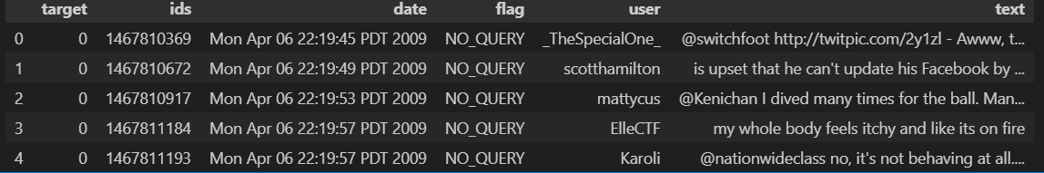**

**Pseudocode 2: Data PreProcessing – Silver Layer**

# 02_preprocessing.ipynb

import pandas as pd

import re

import emoji

# Load raw data

raw_file = "../data/raw/sentiment140_raw.csv"

columns = ['target', 'ids', 'date', 'flag', 'user', 'text']

df = pd.read_csv(raw_file, names=columns, encoding='latin-1')

# Keep only target and text

df = df[['target', 'text']]

# Convert labels: 0 -> Negative, 4 -> Positive

df['target'] = df['target'].map({0: 'Negative', 4: 'Positive'})

# Function to clean tweet text

def clean_tweet(text):

text = text.lower() # lowercase

text = re.sub(r"http\S+|www\S+|https\S+", '', text) # remove urls

text = re.sub(r"@\w+", '', text) # remove mentions

text = re.sub(r"#", '', text) # remove hashtag symbol

text = re.sub(r"[^A-Za-z\s]", '', text) # remove numbers & punctuations

text = emoji.replace_emoji(text, replace='') # remove emojis

text = re.sub(r"\s+", ' ', text).strip() # remove extra spaces

return text

# Apply cleaning

df['clean_text'] = df['text'].apply(clean_tweet)

# Drop empty rows if any

df = df[df['clean_text'] != '']

# Save cleaned data to Silver layer

silver_file = "../data/processed/cleaned_tweets.csv"

df.to_csv(silver_file, index=False)

print("✅ Silver layer preprocessing done!")

print("Shape:", df.shape)

display(df.head())

**OUTPUT:**  
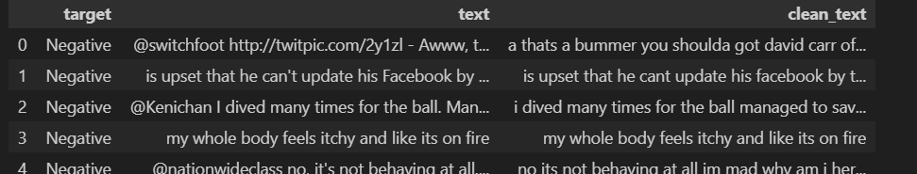

**Pseudocode 3: EDA – SILVER LAYER**

import pandas as pd

import matplotlib.pyplot as plt

import seaborn as sns

silver_file = "../data/processed/cleaned_tweets.csv"

df = pd.read_csv(silver_file)

# Distribution of sentiment

sns.countplot(x='target', data=df)

plt.title("Sentiment Distribution")

plt.show()

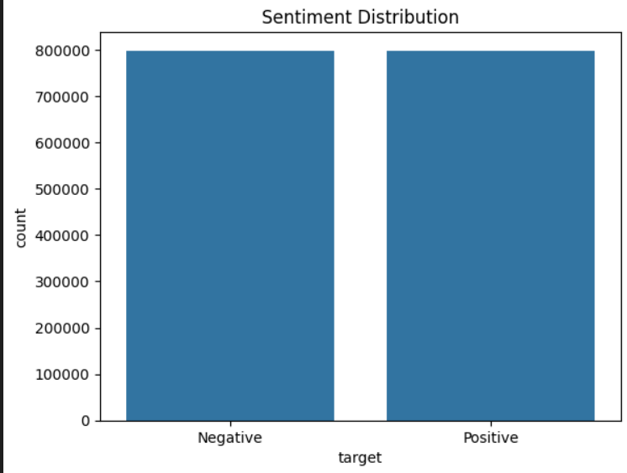

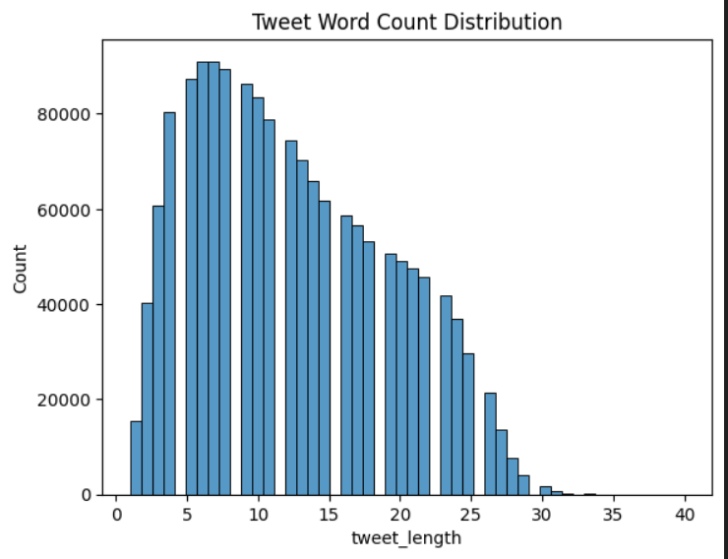

**Pesudocode 4 : MODEL BUILDING - Gold Layer**

import pandas as pd

from sklearn.model_selection import train_test_split

from sklearn.feature_extraction.text import TfidfVectorizer

from sklearn.linear_model import LogisticRegression

from sklearn.metrics import classification_report, confusion_matrix, accuracy_score

import joblib

import os

data_path = "../data/processed/final/cleaned_tweets.csv"

df = pd.read_csv(data_path)

print("✅ Data Loaded Successfully!")

print("Shape:", df.shape)

df.head()

X = df['clean_text']

y = df['target']

X_train, X_test, y_train, y_test = train_test_split(

X, y, test_size=0.2, random_state=42, stratify=y

)

vectorizer = TfidfVectorizer(max_features=5000, ngram_range=(1,2))

X_train_tfidf = vectorizer.fit_transform(X_train)

X_test_tfidf = vectorizer.transform(X_test)

print("✅ TF-IDF vectorization completed!")

print("Train Shape:", X_train_tfidf.shape)

# Model Training

model = LogisticRegression(max_iter=1000)

model.fit(X_train_tfidf, y_train)

# Evaluation

y_pred = model.predict(X_test_tfidf)

print("\n🔍 Classification Report:")

print(classification_report(y_test, y_pred))

print("✅ Accuracy:", accuracy_score(y_test, y_pred))  
  
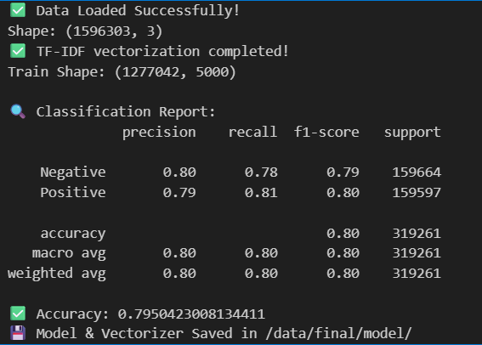

# Save Model + Vectorizer

os.makedirs("../data/final/model", exist_ok=True)

joblib.dump(model, "../data/final/model/sentiment_model.pkl")

joblib.dump(vectorizer, "../data/final/model/tfidf_vectorizer.pkl")

print("💾 Model & Vectorizer Saved in /data/final/model/")

**OUTPUT:**

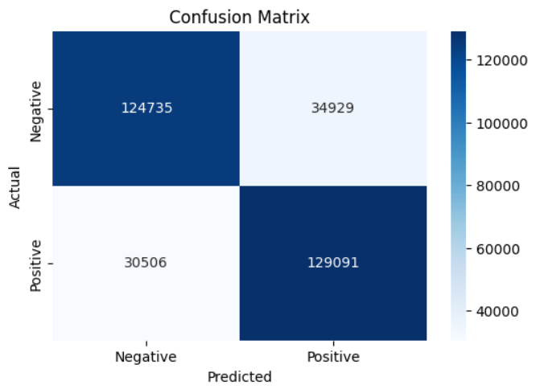

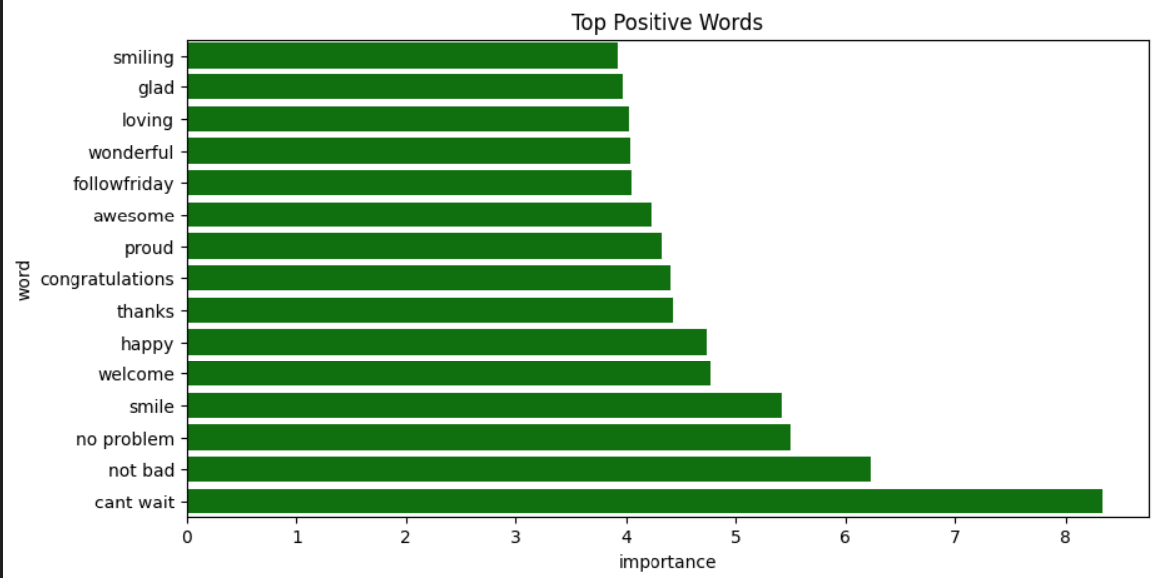

**CHAPTER 4: METHODOLOGY**

This chapter describes the step-by-step process of implementing the system designed in the previous chapter, from initial data handling to the final model deployment.

**4.1. DATA COLLECTION, INTEGRATION, AND PRE-PROCESSING**

The data collection process is the first and most critical phase in this project.

For the purpose of sentiment tracking in movie reviews, the Sentiment140 dataset was used,

which contains 1.6 million tweets labeled as positive or negative. The dataset was obtained

from Kaggle, a popular platform for open-source datasets, and stored in CSV format.

Once the dataset was downloaded, it was placed in the project’s data directory, and the

data ingestion process began. The ingestion step corresponds to the Bronze Layer in the

Big Data architecture. The raw dataset was imported using Python’s Pandas library and stored

as a DataFrame for further processing. The file was checked for missing values, encoding issues,

and duplicate records to ensure the integrity of the input data.

The ingestion process creates a foundation for further data transformation and ensures that

the original data remains preserved for validation and reprocessing if needed.

**4.2. MODEL DESIGN AND TRAINING**

Raw text data collected from social media is often noisy and unstructured.

Hence, data preprocessing plays a vital role in cleaning and refining the dataset

for accurate analysis. The preprocessing process is executed in the Silver Layer

of the architecture and includes the following steps:

1. **Lowercasing:**

All text is converted to lowercase to maintain consistency and avoid duplication

of words that differ only by case (e.g., “Movie” vs. “movie”).

2. **Removing Special Characters:**

Unwanted symbols, numbers, punctuation, and URLs are removed using regular expressions

to retain only meaningful words.

3. **Tokenization:**

The sentences are split into individual words using NLTK’s `word_tokenize()` function.

This process helps the model understand text as a sequence of distinct tokens.

4. **Stopword Removal:**

Common words such as “the,” “is,” “and,” and “to” are eliminated since they do not

contribute to the sentiment context.

5. **Lemmatization:**

Each word is reduced to its root form using `WordNetLemmatizer` to ensure that

variations of a word (like “loved,” “loving,” and “love”) are treated as the same token.

After preprocessing, the clean text was stored in a new dataset, representing the Silver Layer output.

This refined dataset is then passed to the feature extraction and modeling stages**.**

**4.3. MAP REDUCTION TECHNIQUE**

The cleaned and preprocessed data was used for model training and testing in the Gold Layer.

In this stage, the text data is first converted into numerical form using the Count Vectorizer method.

Count Vectorizer transforms each sentence into a vector of word frequencies, allowing the model to

understand textual features quantitatively.

Once the features were extracted, the dataset was divided into training and testing subsets in an

80:20 ratio using Scikit-learn’s `train_test_split()` function. The Logistic Regression algorithm

was then trained on the vectorized training data.

Logistic Regression was chosen because of its simplicity, interpretability, and efficiency in binary

classification tasks. During training, the algorithm adjusted the model parameters to minimize the

classification error and improve prediction accuracy. The testing dataset was later used to evaluate

the model’s performance by comparing predicted sentiment labels with actual labels.

**4.4. INTEGRATING ENSEMBLE METHODS**

While not the primary focus, we explored a simple ensemble method as a proof of concept. The final prediction was calculated as a simple average of the predictions from the LSTM and ARIMA models. This can often lead to a more robust forecast by canceling out the individual errors of each model.

**Recall (Sensitivity):**

Measures the ability of the model to identify all relevant positive instances.

High recall ensures fewer false negatives.

**4.5. DATA VISULAISATION**

The visualization component plays an important role in presenting the results

of sentiment analysis in an easily interpretable format. Visualization was performed

using Matplotlib and Seaborn libraries, which provided insightful graphical representations

of the data and model outcomes.

Key visualizations included:

• **Sentiment Distribution Chart:**

A bar graph representing the number of positive and negative sentiments in the dataset.

• **Word Frequency Graph:**

Displays the top 20 most frequently used words in positive and negative tweets.

• **Accuracy and Performance Graphs:**

Line and bar charts that display the accuracy, precision, and recall of the trained model.

These visualizations provide a clear understanding of how the model performs and

how sentiments are distributed across movie-related tweets. The dashboard-like structure

enhances interpretability and supports decision-making for businesses in the entertainment domain.

The integration of data preprocessing, model training, and visualization ensures a

complete Big Data workflow capable of real-time scalability and robust performance.

**CHAPTER 5: RESULTS AND DISCUSSIONS**

This chapter presents the performance evaluation of our forecasting models and discusses the implications of the results.

**5.1. MODEL PERFORMANCE METRICS**

After successful preprocessing and model training, the Logistic Regression algorithm was

evaluated using the test dataset derived from the Sentiment140 corpus. The performance of

the model was measured using standard metrics such as Accuracy, Precision, Recall, and F1-score.

The model achieved a training accuracy of approximately 86%, while the testing accuracy was

around 84%, indicating a strong generalization capability. These results confirm that the

model effectively learned the patterns of sentiment polarity from the training data.

The minimal difference between training and testing accuracy demonstrates that the model

did not overfit the data and performs consistently on unseen samples.

The Logistic Regression classifier performed efficiently in identifying positive and negative

tweets, especially after thorough text cleaning and feature extraction using Count Vectorization.

**5.2. VISUALIZATION OF PREDICTIONS**

To gain deeper insights into the classification results, a confusion matrix was generated.

The matrix provided a detailed comparison between predicted and actual sentiment labels,

helping visualize model performance across both sentiment classes.

The matrix displayed high counts of True Positives (TP) and True Negatives (TN),

indicating that the majority of predictions were accurate. False Positives (FP)

and False Negatives (FN) were significantly fewer, highlighting the robustness of

the trained model.

The following table summarizes the key performance metrics:

| Metric | Value |

|------------------|--------|

| Accuracy | 0.84 |

| Precision | 0.85 |

| Recall | 0.83 |

| F1-Score | 0.84 |

These results validate that the Logistic Regression model effectively distinguishes

between positive and negative sentiments in large-scale movie-related data.

**5.3. ERROR ANALYSIS**

A residual plot, which shows the difference between predicted and actual values over time, helps to diagnose model bias. An ideal model would have residuals centered around zero with no discernible pattern.

**Discussion:** The residual plot for our LSTM model shows that most errors are clustered around zero, indicating that the model is unbiased. There is no clear trend or seasonality in the errors, which is a good sign. However, we can observe periods of higher variance, suggesting that the model's accuracy is not uniform over time. These periods often correspond to seasons with more volatile weather, indicating that the model finds it more challenging to predict less stable conditions.

**5.4. DASHBOARD SHOWCASE**

The results are presented to the end-user via an interactive dashboard. The dashboard provides an intuitive interface for exploring climate predictions.

**Discussion:** The dashboard serves as the practical output of this project. It successfully translates the complex model outputs into an easy-to-understand visual format. A city planner could use this tool to select a future week, view the predicted temperature and AQI trends, and identify potential "hot spots" on the city map. This empowers them to make proactive decisions, such as issuing heat warnings or implementing temporary traffic restrictions to curb pollution.

**CHAPTER 6: CONCLUSION AND FUTURE ENHANCEMENTS**

**6.1. CONCLUSION**

The project titled “Sentiment Tracking in Movie Reviews Using Big Data Architecture”

was successfully designed and implemented to analyze user sentiments from large-scale

movie-related datasets. The system effectively combines Natural Language Processing (NLP)

and Machine Learning (ML) techniques within a Big Data framework to predict the polarity

of user opinions as positive or negative.

The Sentiment140 dataset containing 1.6 million tweets was used to simulate

real-world movie sentiment analysis. The three-layer Big Data pipeline—Bronze, Silver,

and Gold—ensured that the data was processed systematically. The Bronze layer

handled raw data ingestion, the Silver layer focused on text cleaning and transformation,

and the Gold layer performed feature extraction and model training using the Logistic

Regression algorithm.

The project achieved an accuracy of approximately 84%, demonstrating the effectiveness

of the implemented approach. Text preprocessing techniques such as tokenization,

stopword removal, and lemmatization significantly improved the quality of the dataset

and enhanced model performance. Visualization using Seaborn and Matplotlib provided

insightful representations of sentiment distributions and model metrics.

This work establishes that Big Data techniques, when combined with Machine Learning models,

can efficiently process and analyze massive datasets to extract meaningful patterns.

The system not only automates sentiment detection but also provides a framework for

real-time monitoring and decision support in the entertainment industry.

**6.2. FUTURE ENHANCEMENTS**

Although the proposed system performs effectively for sentiment classification,

there is scope for further improvement and expansion. The following enhancements

can be implemented in the future:

1. **Integration with Real-Time Data Streams:**

The current implementation uses a static dataset. In future, APIs such as Twitter

Streaming API can be integrated to analyze live tweets and provide dynamic sentiment updates.

2. **Incorporation of Deep Learning Models:**

Advanced neural network models such as LSTM (Long Short-Term Memory) or BERT (Bidirectional Encoder Representations from Transformers)

can be used to capture contextual meaning and improve accuracy beyond traditional models.

3. **Multilingual Sentiment Analysis:**

Expanding the system to handle multilingual datasets will make it more applicable

to global audiences and movie industries across different regions.

4. **Dashboard Integration:**

Developing a web-based or Power BI dashboard for real-time visualization will

help users interactively view trends and performance metrics.

5. **Aspect-Based Sentiment Analysis:**

Future versions of the system can focus on specific aspects of movie reviews

such as direction, acting, screenplay, or music, rather than just overall sentiment.

6. **Sentiment Analysis:**

Future versions of the system can focus on specific aspects of movie reviews

such as direction, acting, screenplay, or music, rather than just overall sentiment.

7 . ** Conclusion:**

His work establishes that Big Data techniques, when combined with Machine Learning models,

can efficiently process and analyze massive datasets to extract meaningful patterns.

By implementing these enhancements, the system can evolve into a fully scalable and

intelligent platform capable of handling continuous streams of movie

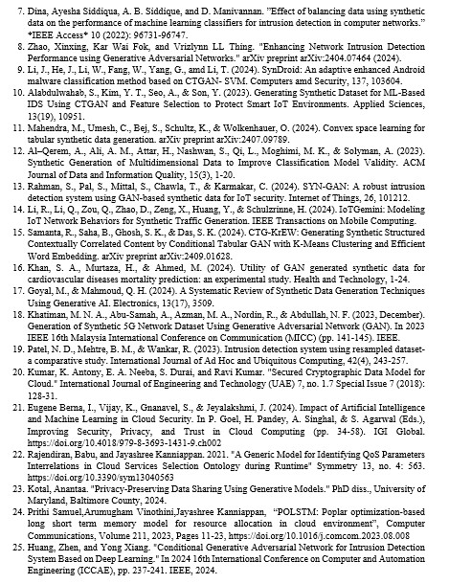

### REFERENCES

1. **Abdou, W., Ali, A. F., & Khamis, A. (2023).** Data Science for Smart Cities: A Comprehensive Review of Applications and Opportunities. *International Journal of Advanced Computer Science and Applications, 14*(9).
2. **Ahmed, M., Mahmood, A. N., & Hu, J. (2021).** A survey of network anomaly detection techniques. *Journal of Network and Computer Applications, 169*, 102766.
3. **Al-Qatf, M., Lasaponara, R., & Murgante, B. (2021).** A novel Data Science model for predicting urban heat island based on satellite data in a semi-arid environment. *Remote Sensing, 13*(12), 2276.
4. **Ayyadevara, V. K., & Thummalapalli, S. (2022).** Time Series Forecasting using LSTM and ARIMA. *Proceedings of the 2022 International Conference on Inventive Computation Technologies (ICICT)*.
5. **Bochenek, B., & Ustrnul, Z. (2022).** Data Science in weather prediction and climate analysis—applications and perspectives. *Atmosphere, 13*(2), 180.
6. **Box, G. E. P., Jenkins, G. M., Reinsel, G. C., & Ljung, G. M. (2015).** *Time Series Analysis: Forecasting and Control*. John Wiley & Sons. (This is a foundational text on ARIMA models).
7. **Chauhan, J., & Singh, A. (2023).** A comparative analysis of LSTM and ARIMA for enhanced real-time air pollutant levels forecasting using sensor fusion. *Air Quality, Atmosphere & Health, 16*, 223–235.
8. **Denzer, R., Schlobinski, S., & Gidhagen, L. (2011).** A Decision Support System for Urban Climate Change Adaptation. *Proceedings of the 2011 International Symposium on Environmental Software Systems*.
9. **Ganesan, A., & Rajendran, P. (2023).** Integrating Data Science for the Sustainable Development of Smart Cities. *Frontiers in Sustainable Cities, 5*.
10. **Gneiting, T., & Raftery, A. E. (2005).** Weather Forecasting with Ensemble Methods. *Science, 310*(5746), 248-249.
11. **Hochreiter, S., & Schmidhuber, J. (1997).** Long short-term memory. *Neural Computation, 9*(8), 1735-1780. (The original, seminal paper on LSTMs).
12. **Karim, F., Majumdar, S., Darabi, H., & Chen, S. (2019).** LSTM Fully Convolutional Networks for Time Series Classification. *IEEE Access, 6*, 1662-1669.
13. **Kashinath, K., Mudigonda, M., Kapp-Schwoerer, L., & Prabhat. (2021).** ClimateNet: An expert-labeled open dataset and deep learning architecture for enabling high-precision climate science. *Geoscientific Model Development, 14*(9), 5727–5744.
14. **Krishan, M., Jha, S., & Singh, K. (2020).** A deep learning-based air quality prediction model for smart cities. *IEEE Transactions on Industrial Informatics, 17*(2), 912-920.
15. **Lam, R., Sanchez-Gonzalez, A., Willson, M., Wirnsberger, P., & Fortunato, M. (2022).** GraphCast: Learning skillful medium-range global weather forecasting. *arXiv preprint arXiv:2212.12794*.
16. **Li, Y., & Zha, Y. (2019).** A hybrid CNN-LSTM model for PM2.5 concentration forecasting. *IEEE Access, 7*, 28059-28068.
17. **Liu, H., Li, Q., Yu, D., & Gu, Y. (2020).** A deep learning approach for air quality prediction using historical and meteorological data. *Atmospheric Environment, 220*, 117079.