
RECORD OF EXPERIMENTS
Register Number: 231801093
Academic Year 2025 – 2026
List of Experiments
- Private Cloud using OpenStack
- PaaS in Public Cloud Using Render
- Setting Up Hybrid Cloud Connectivity Using Cisco Packet Tracer
- Virtual Private Server (VPS) Provisioning and Configuration
- Cloud Backup and Migration using Google Drive
- CDN Service Selection and Configuration

Ex: 2 | PaaS in Public Cloud Using Render
Date:08/07/2026

Aim
To build and deploy a web application on Render, a Platform-as-a-Service (PaaS) provider, and to understand how cloud providers host applications without manual server administration.

What is PaaS?
Platform-as-a-Service (PaaS) is a cloud computing model that provides a ready-made platform for developing, running, and managing applications. The developer only needs to write the application; the cloud provider manages the server, operating system, runtime, networking, and maintenance. Render is a cloud hosting platform that automates this process — creating servers, installing dependencies, running the application, and providing a public URL.

Requirements
- A computer with an internet connection
- Python 3.10 or later
- A GitHub account
- A Render account (linked to GitHub)

Procedure
- Sign in to GitHub, which will host the application's source code.

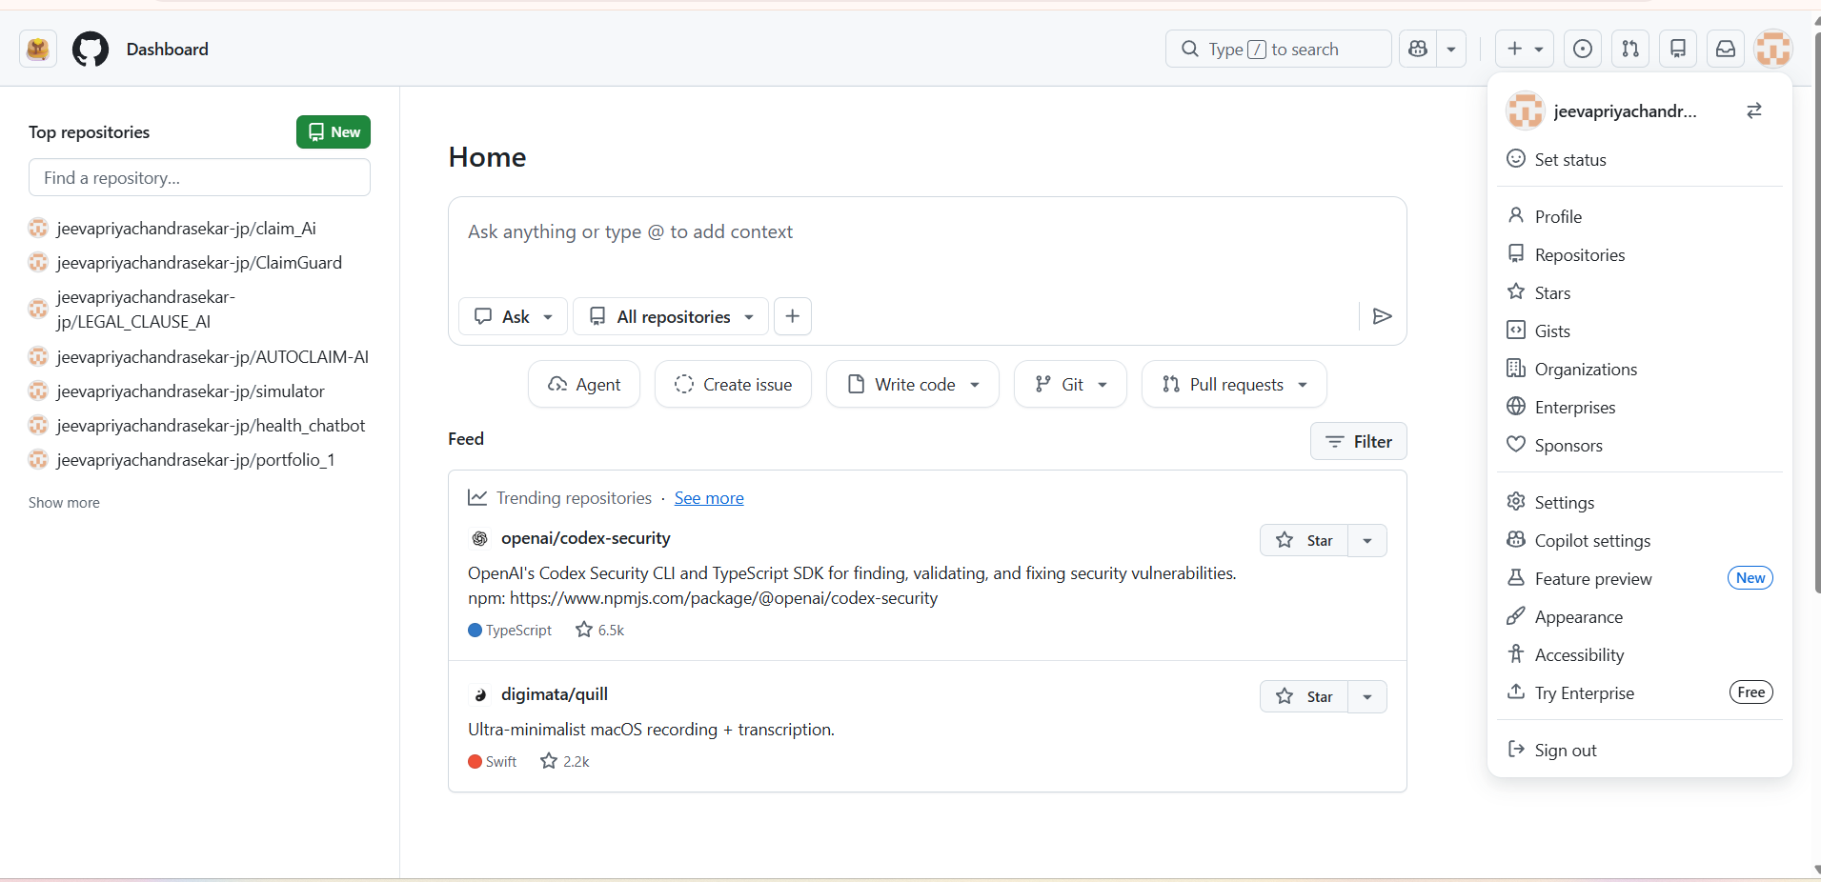
Figure 2.1: GitHub sign-in page.

- Create a local project folder named RenderHelloApp containing two files: app.py (the Flask application code) and requirements.txt (listing Flask and gunicorn).

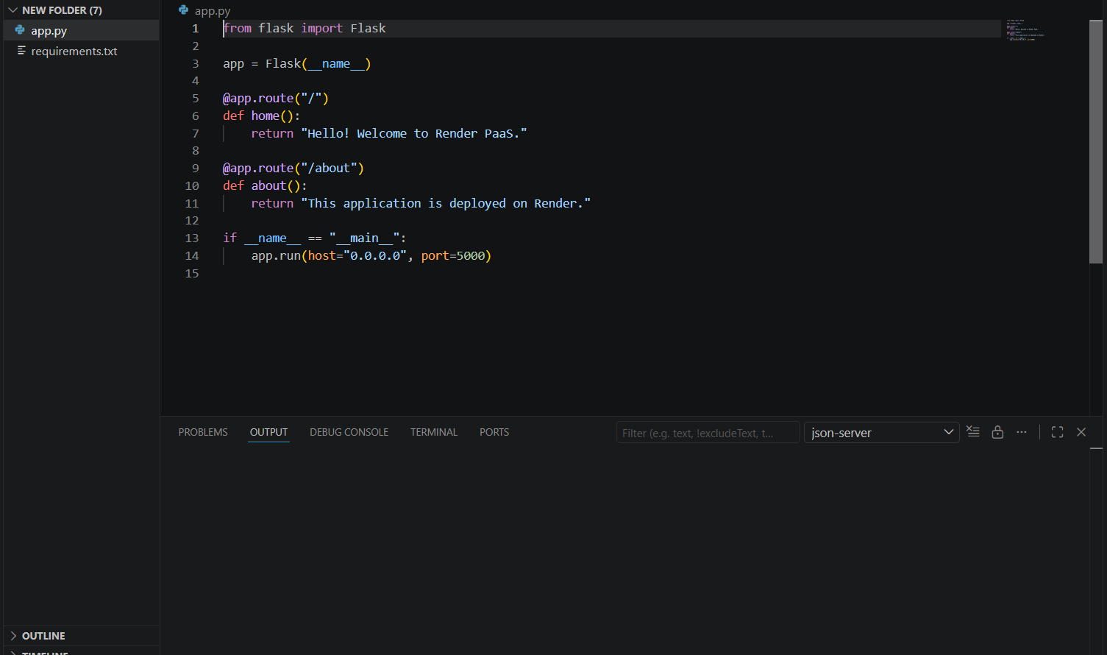
Figure 2.2: Contents of app.py.
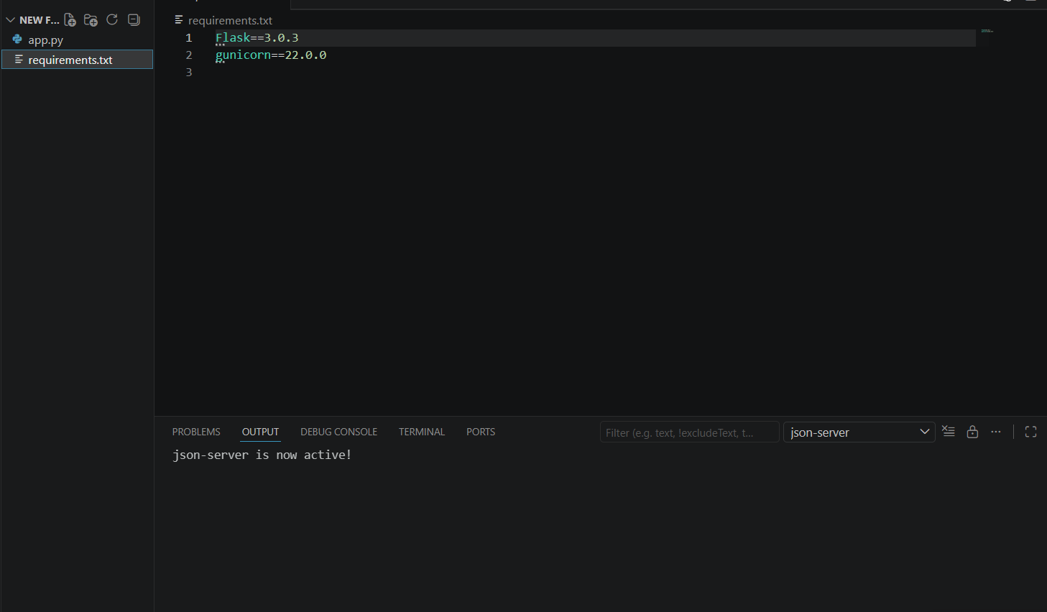
Figure 2.3: Contents of requirements.txt.
- Create a new public GitHub repository named renderHello, then upload app.py and requirements.txt and commit the changes.

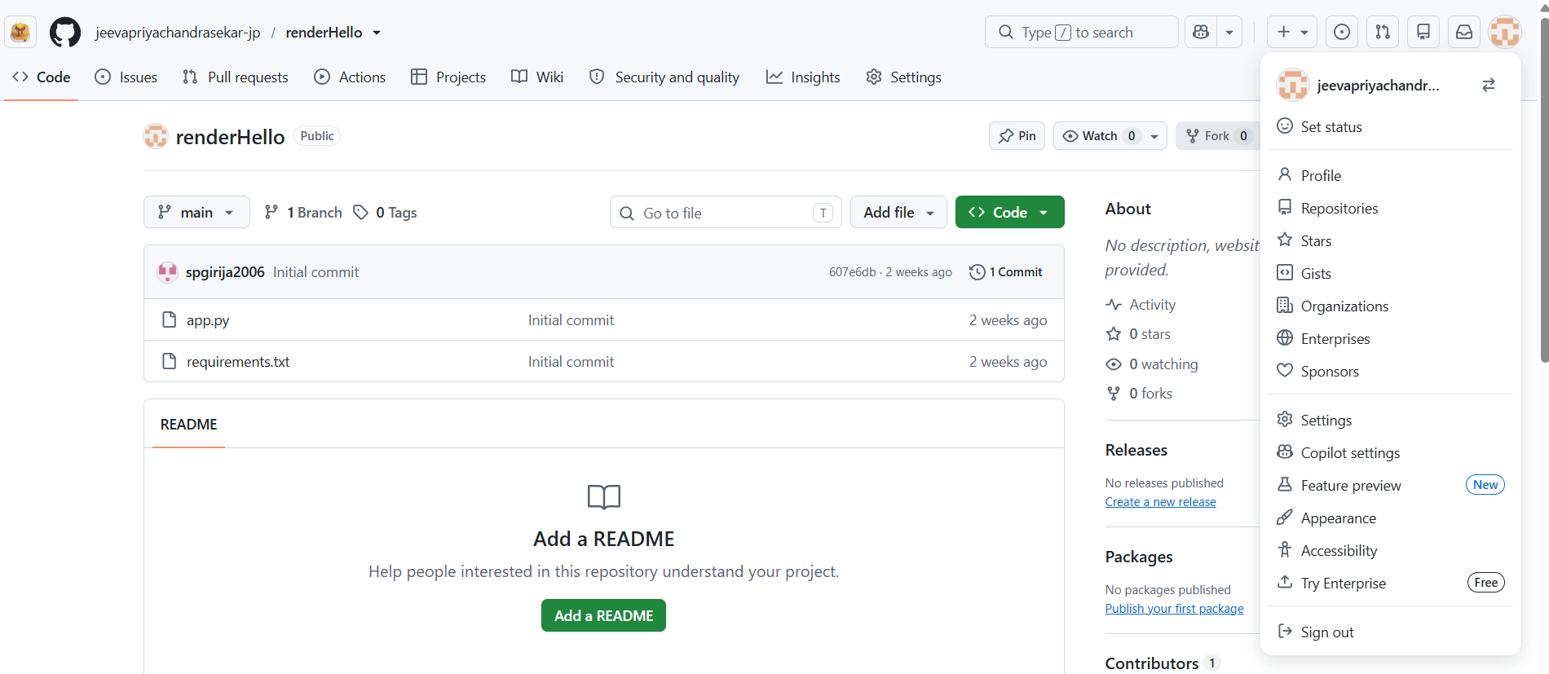
Figure 2.4: Creating the new GitHub repository.
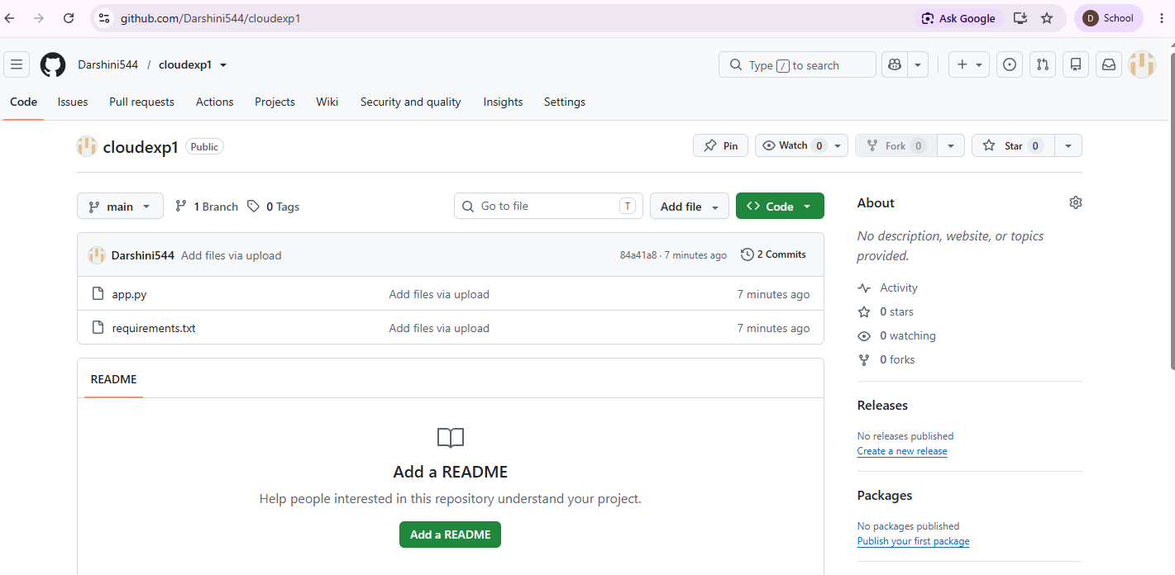
Figure 2.5: Committing the uploaded project files.
- Create a Render account and sign in, then choose to create a new Web Service.

- Connect the GitHub account and select the renderHello repository.

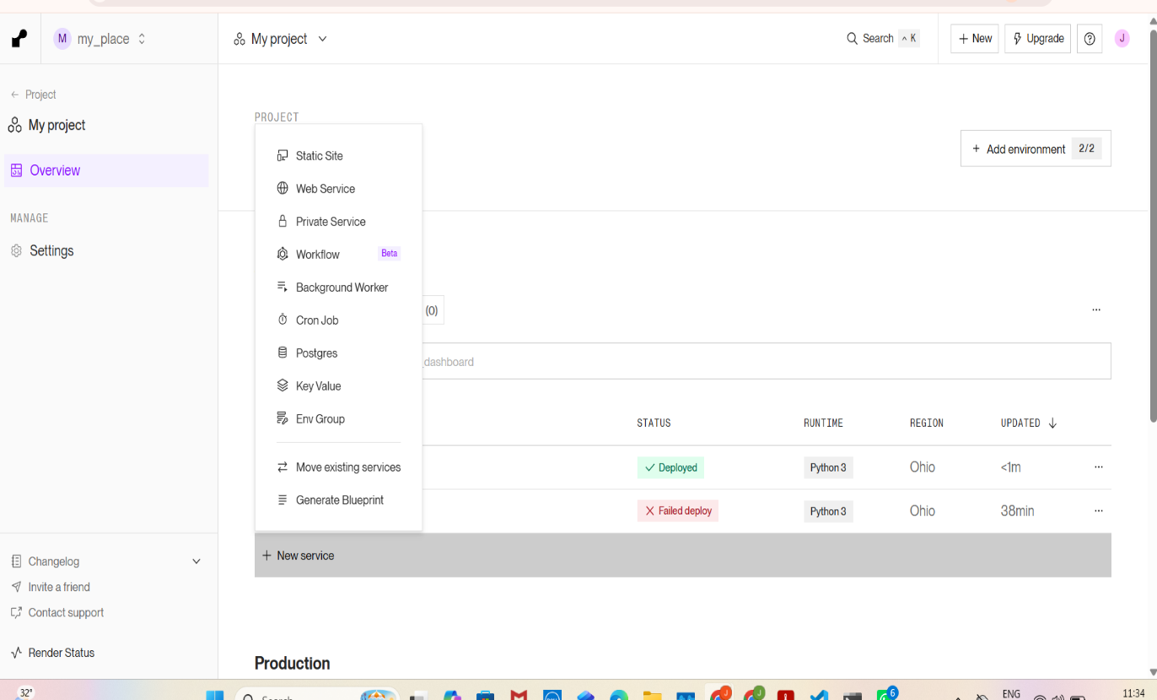
Figure 2.6: Selecting the GitHub repository on Render.
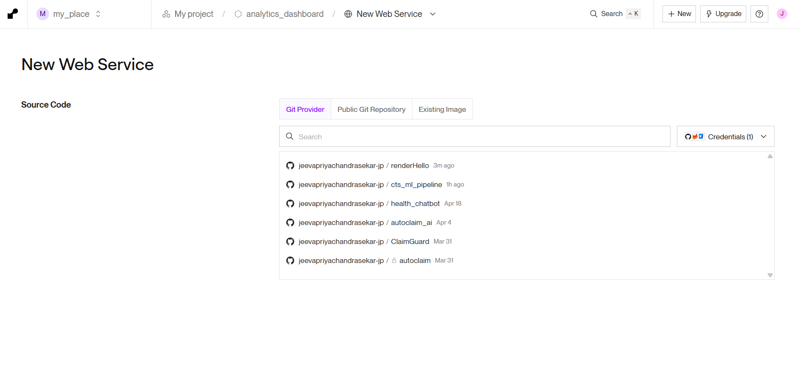
Figure 2.7: Repository connected to the new Web Service.
- Configure the deployment: Language – Python, Branch – main, Root Directory – blank, Build Command – pip install -r requirements.txt, Start Command – gunicorn app:app, Instance Type – Free.

- Click Deploy Web Service and wait for the build and deployment to complete.

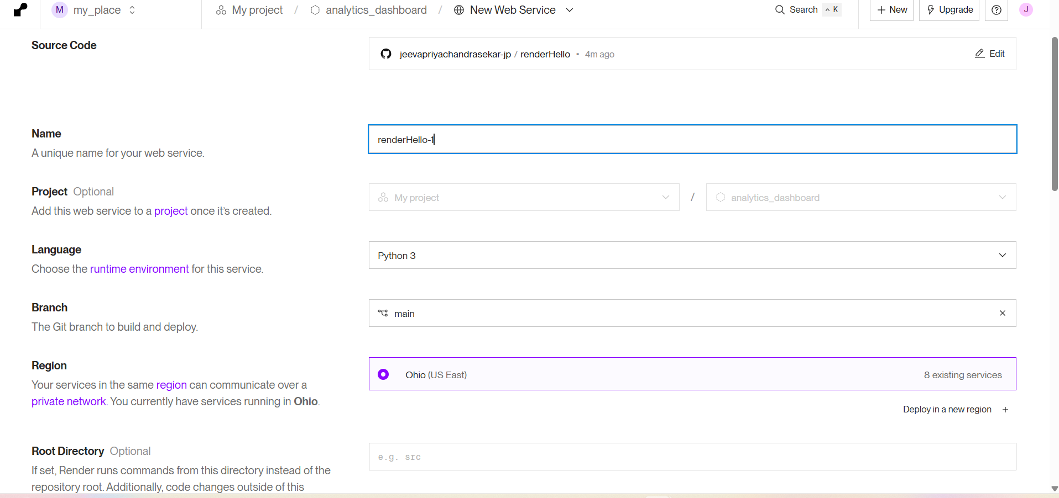
Figure 2.8: Deployment configuration and deploy action.
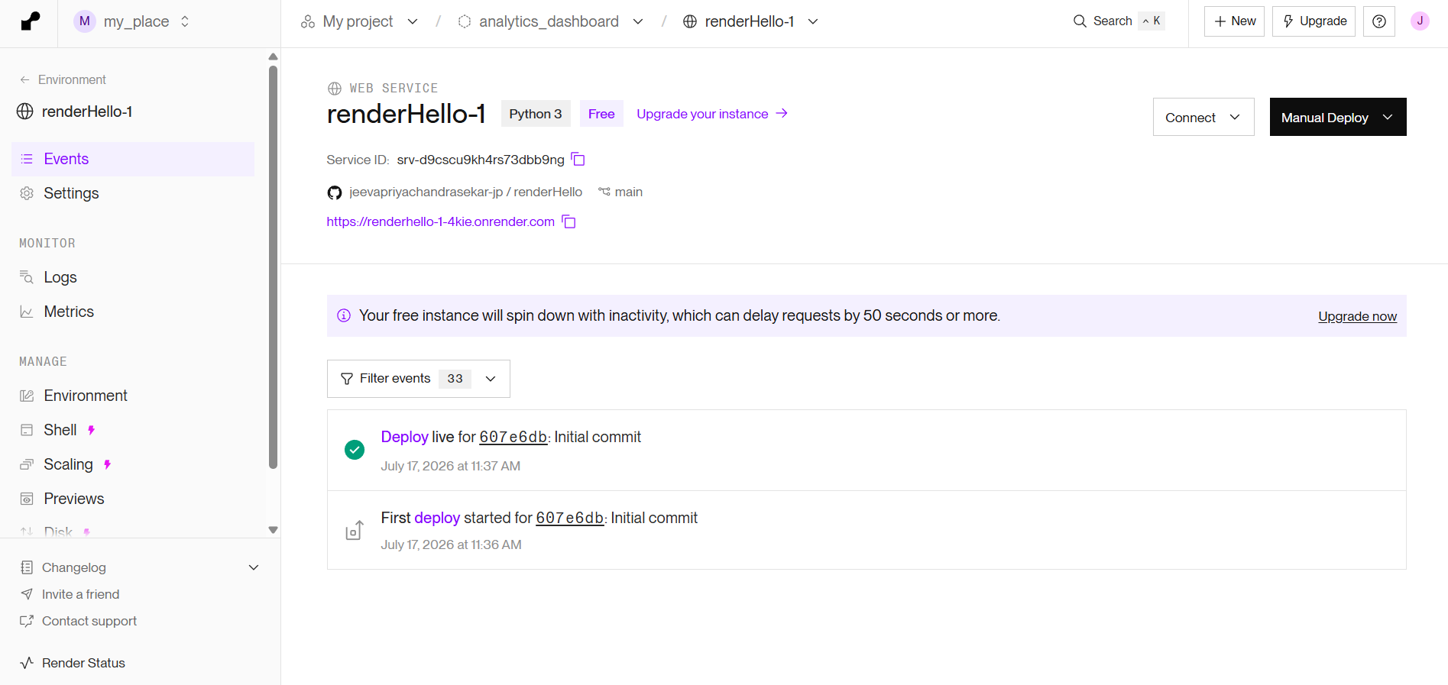
Figure 2.9: Deployment completing successfully on Render.
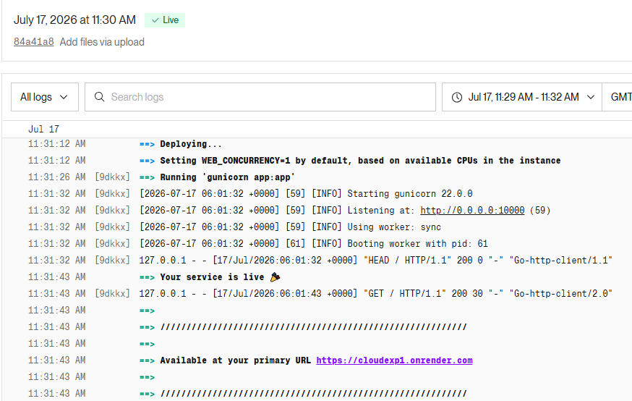
Figure 2.10: Render dashboard confirming the service is live.

- Open the generated Render URL to verify that the home page renders correctly.
Output:

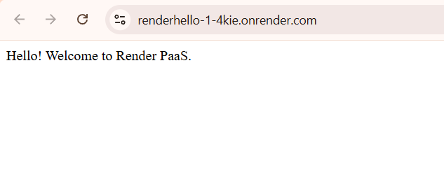
Figure 2.11: Home page output — "Hello! Welcome to Render PaaS."
- Append /about to the application URL to validate the second route.
Output:

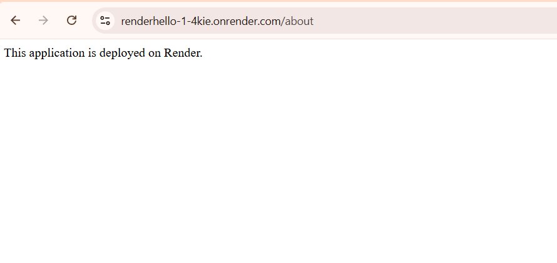
Figure 2.12: About page output confirming the application is deployed on Render.

Conclusion
The web application was successfully built and deployed on Render, a PaaS platform. Both the home page and the /about route responded correctly, demonstrating the ease of hosting cloud applications without manual server administration.

