
RECORD OF EXPERIMENTS
Register Number: 231801093
Academic Year 2025 – 2026
List of Experiments
- Private Cloud using OpenStack
- PaaS in Public Cloud Using Render
- Setting Up Hybrid Cloud Connectivity Using Cisco Packet Tracer
- Virtual Private Server (VPS) Provisioning and Configuration
- Cloud Backup and Migration using Google Drive
- CDN Service Selection and Configuration

Ex: 3 | Setting Up Hybrid Cloud Connectivity Using Cisco Packet Tracer
Date:22/07/2026

Aim
To simulate a secure hybrid cloud connection between an on-premises data centre and a cloud network using routers, switches, subnets, and static routing in Cisco Packet Tracer.

What is Hybrid Cloud?
A hybrid cloud architecture combines private, on-premises infrastructure with public cloud services, allowing seamless data and application portability so that organisations can use the benefits of both environments.

Procedure

Part A – Setting up the Simulator
- Create a NetAcad account (or sign in with a Google account) at netacad.com, then enrol in the free "Getting Started with Cisco Packet Tracer" course.
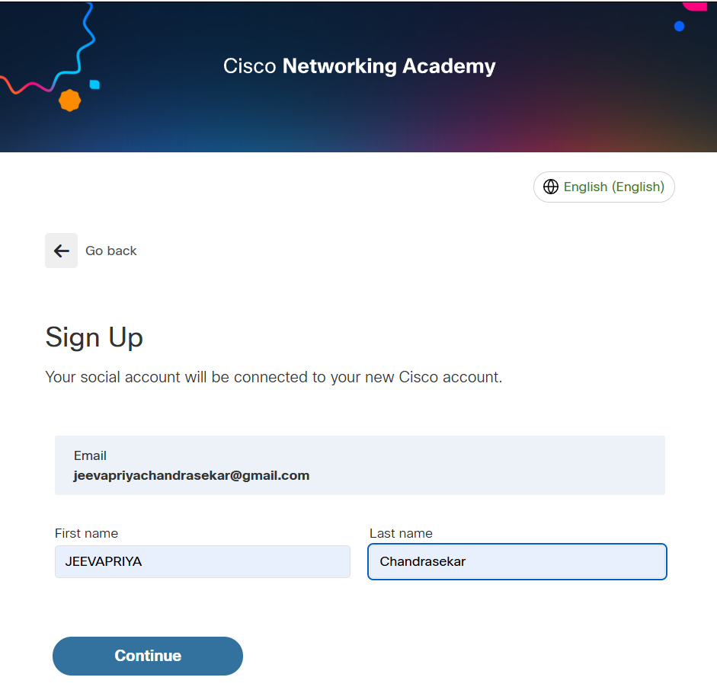
Figure 3.1: Signing in to Cisco Networking Academy.
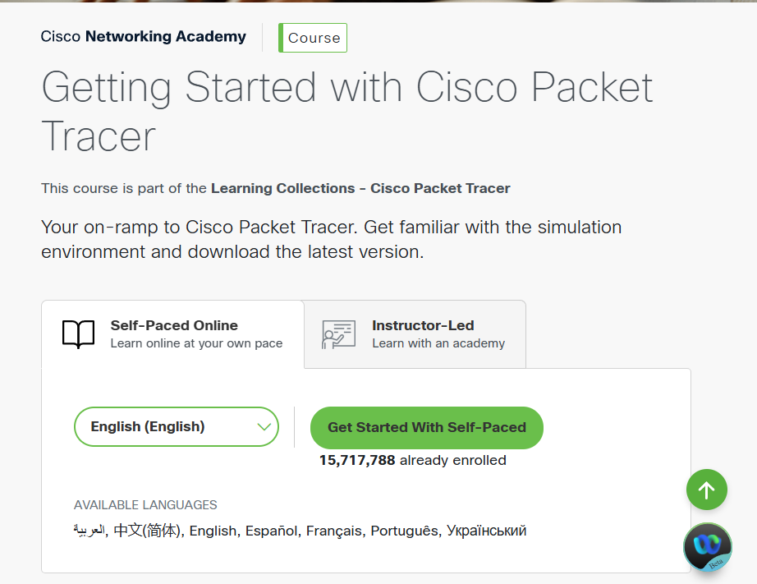
Figure 3.2: Enrolling in the Packet Tracer course.
- Download and install Cisco Packet Tracer for the appropriate operating system from the course resources.

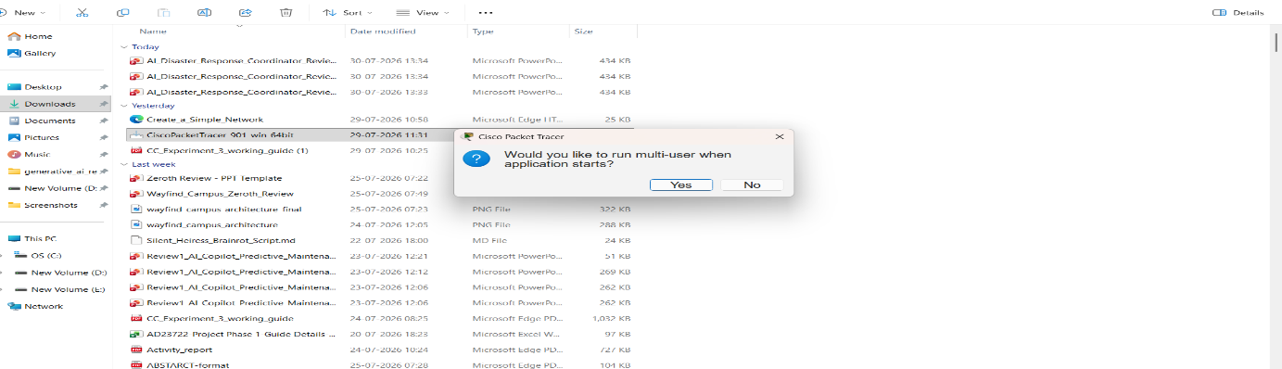
Figure 3.3: Downloading Packet Tracer.
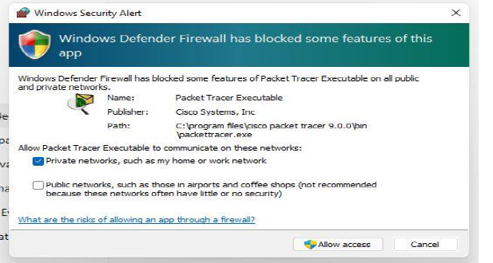
Figure 3.4: Installing Packet Tracer.
- Launch Packet Tracer and sign in using the NetAcad/Google account.

Part B – Building the Network Topology
- Place two routers (2911), two switches (2960), one PC, and one server on the workspace.

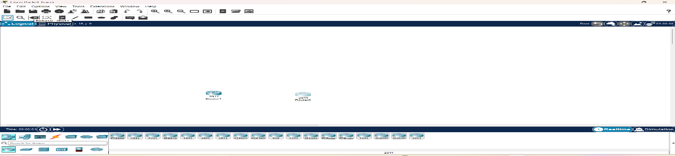
Figure 3.5: Placing the two routers.
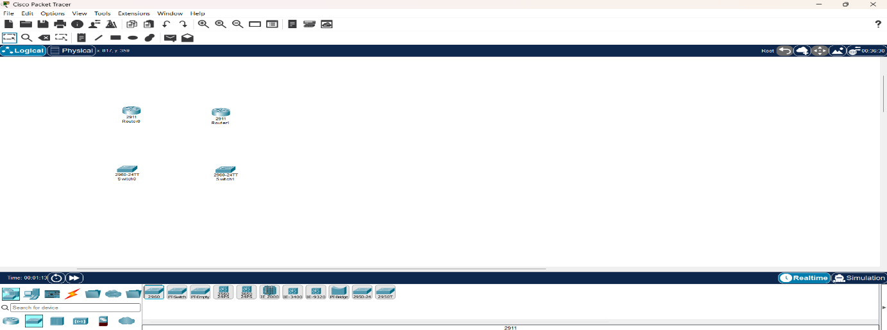
Figure 3.6: Placing the two switches below each router.
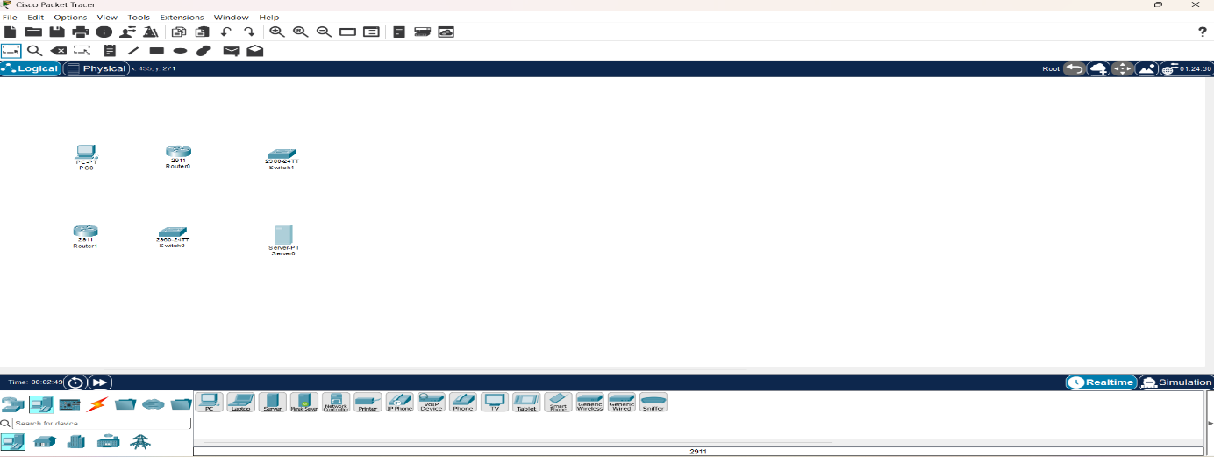
Figure 3.7: Placing the PC (on-premises) and Server (cloud side).
- Connect all devices using Copper Straight-Through cables: PC–Switch0, Switch0–Router0, Server–Switch1, and Switch1–Router1. Connect Router0 to Router1 using a Copper Cross-Over cable.
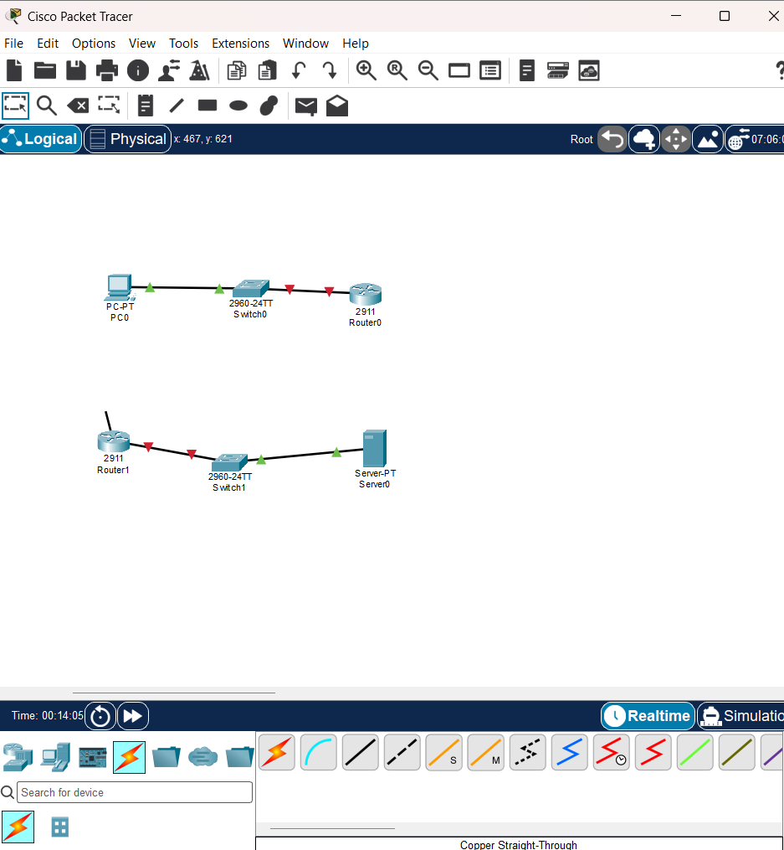
Figure 3.8: Devices connected to form the complete topology.
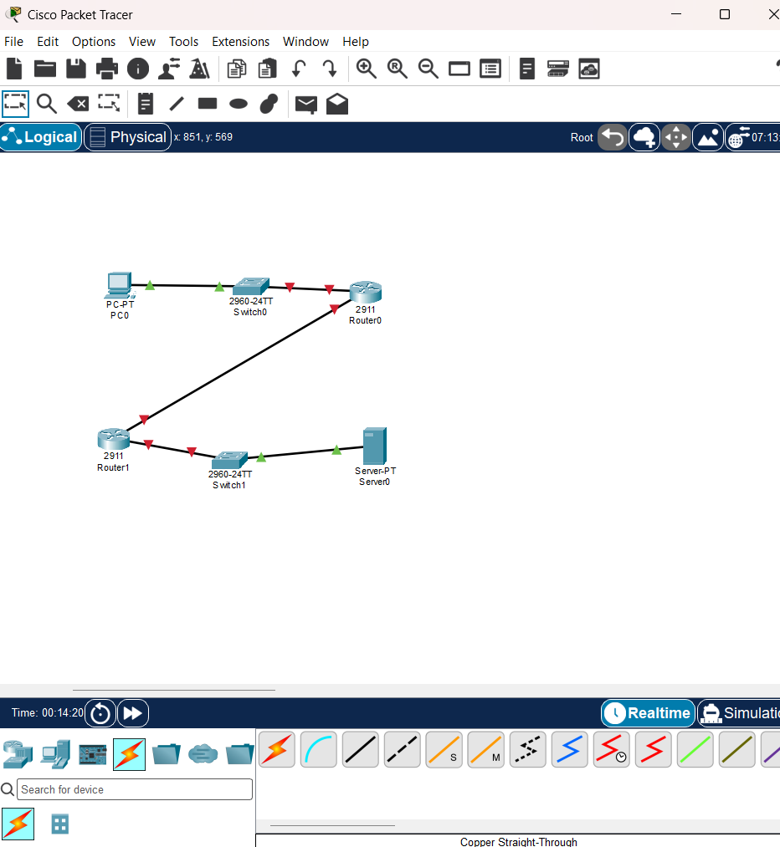
Figure 3.9: Final network topology before configuration.

Part C – Configuring Router0 (On-Premises Side)
- Open Router0's CLI and configure the LAN interface: interface gigabitEthernet0/0, ip address 192.168.1.1 255.255.255.0, no shutdown.

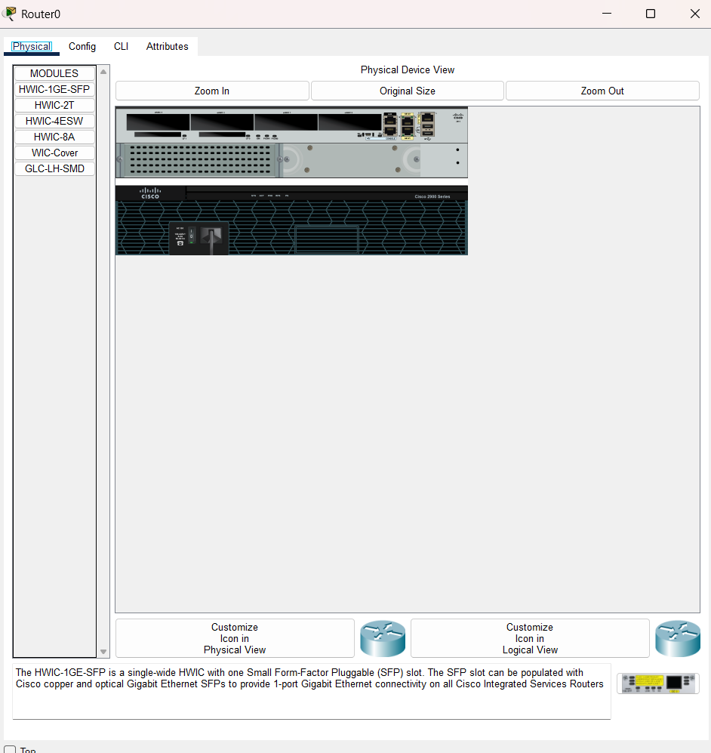
Figure 3.10: Accessing Router0's CLI.
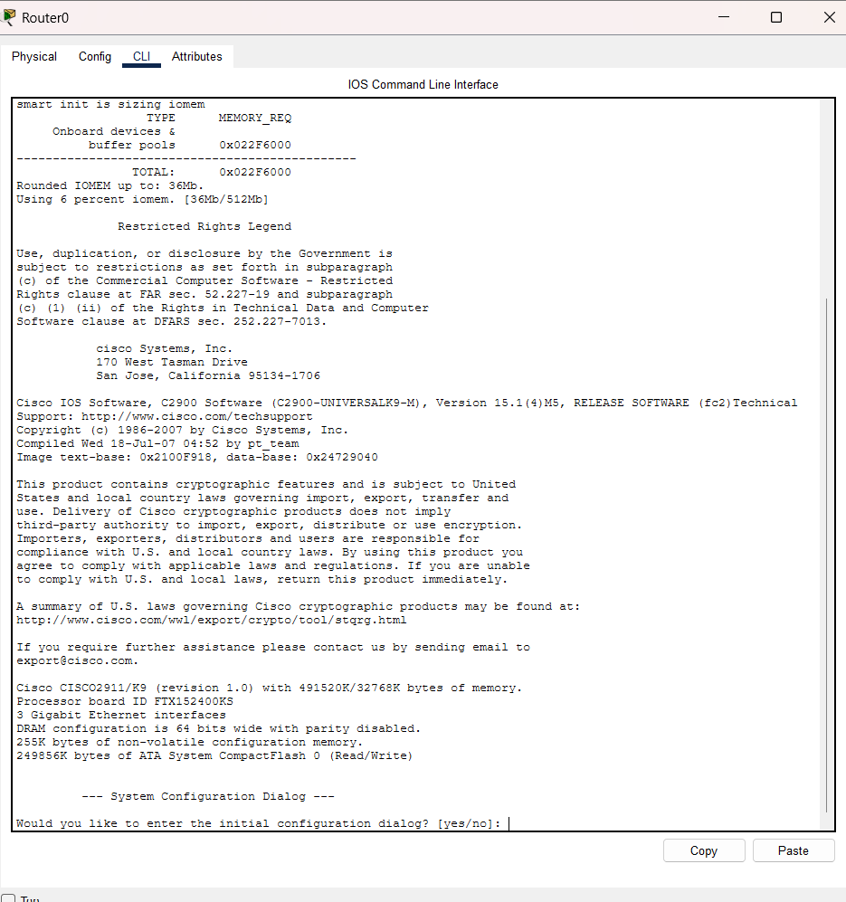
Figure 3.11: Configuration dialog and initial CLI prompt.
- Configure the router-to-router interface: interface gigabitEthernet0/1, ip address 10.10.10.1 255.255.255.252, no shutdown.

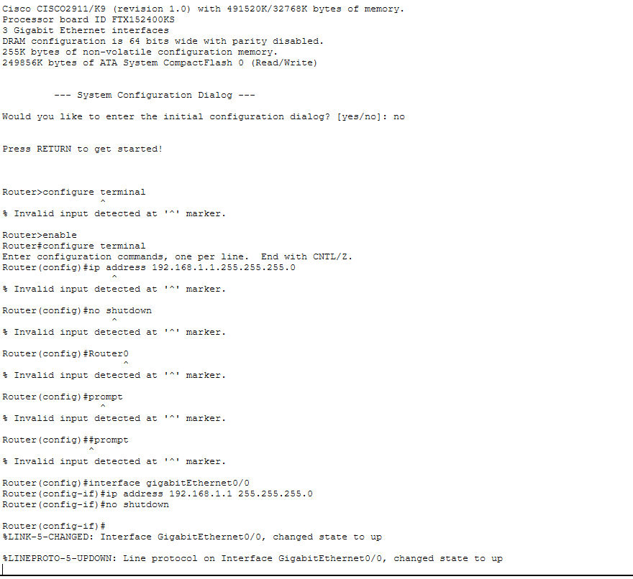
Figure 3.12: Configuring the GigabitEthernet0/0 interface on Router0.
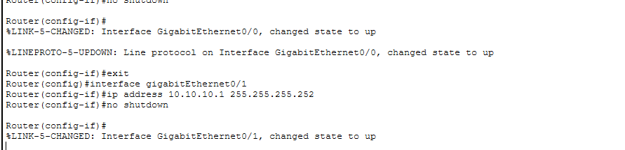
Figure 3.13: Configuring the GigabitEthernet0/1 interface on Router0.
- Verify both interfaces are up using: do show ip interface brief.

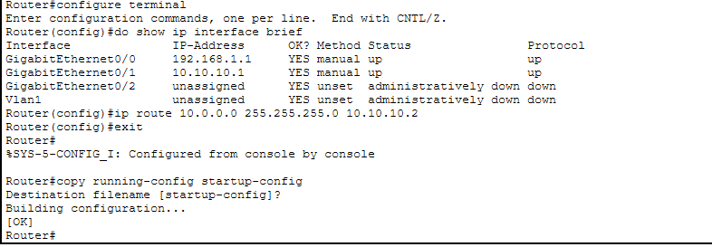
Figure 3.14: Verifying interface status on Router0.

Part D – Configuring Router1 (Cloud Side) and Endpoints
- On Router1, configure interface gigabitEthernet0/0 with IP 10.0.0.1 255.255.255.0, and interface gigabitEthernet0/1 with IP 10.10.10.2 255.255.255.252, enabling both with no shutdown.

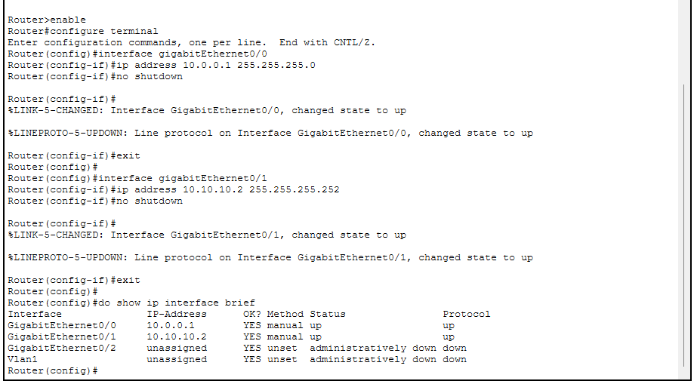
Figure 3.15: Configuring Router1's interfaces.

- Configure the PC's IP settings: address 192.168.1.10, subnet mask 255.255.255.0, gateway 192.168.1.1.

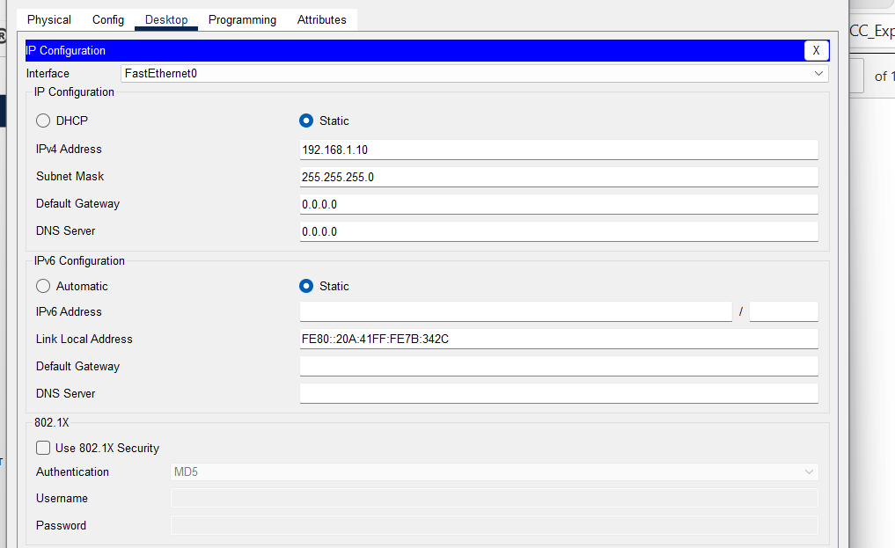
Figure 3.16: Configuring the PC's IP settings.
- Configure the Server's IP settings: address 10.0.0.10, subnet mask 255.255.255.0, gateway 10.0.0.1.

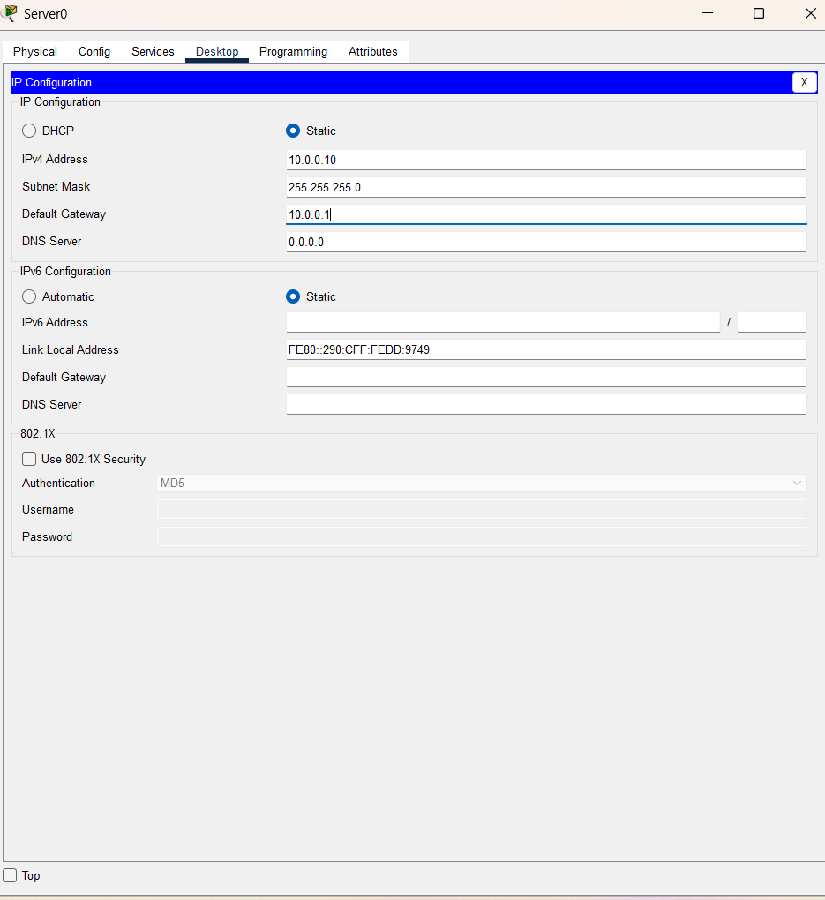
Figure 3.17: Configuring the Server's IP settings.

Part E – Static Routing and Verification
- On Router0, add a static route to the cloud network: ip route 10.0.0.0 255.255.255.0 10.10.10.2. On Router1, add a static route to the on-premises network: ip route 192.168.1.0 255.255.255.0 10.10.10.1. Save both configurations with copy running-config startup-config.

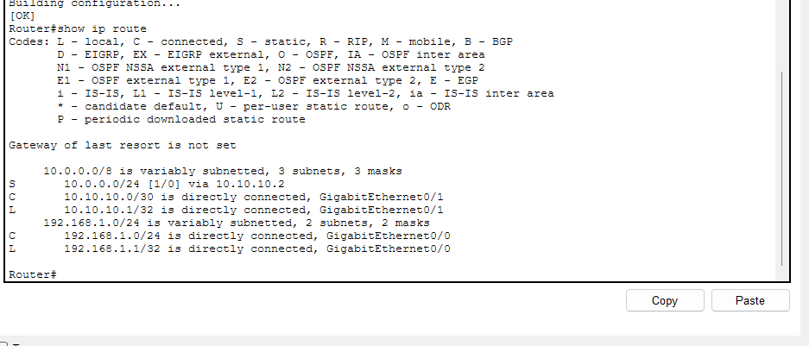
Figure 3.18: Adding the static route.
- Verify the routing table on each router using show ip route, confirming the static (S) routes are present.

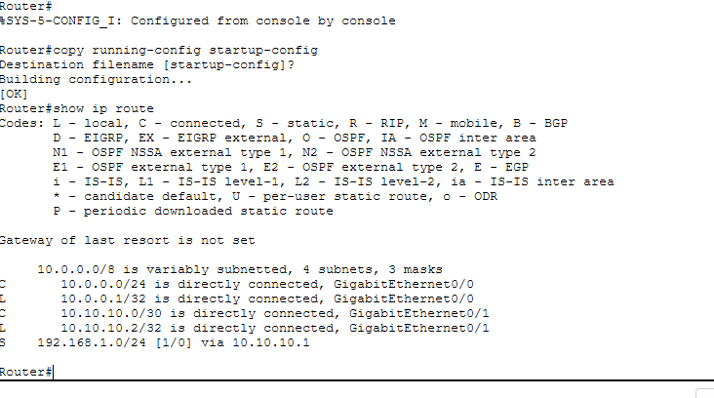
Figure 3.19: Verifying the static route on Router1.

- From the PC's command prompt, ping the cloud server (10.0.0.10) to test end-to-end connectivity.

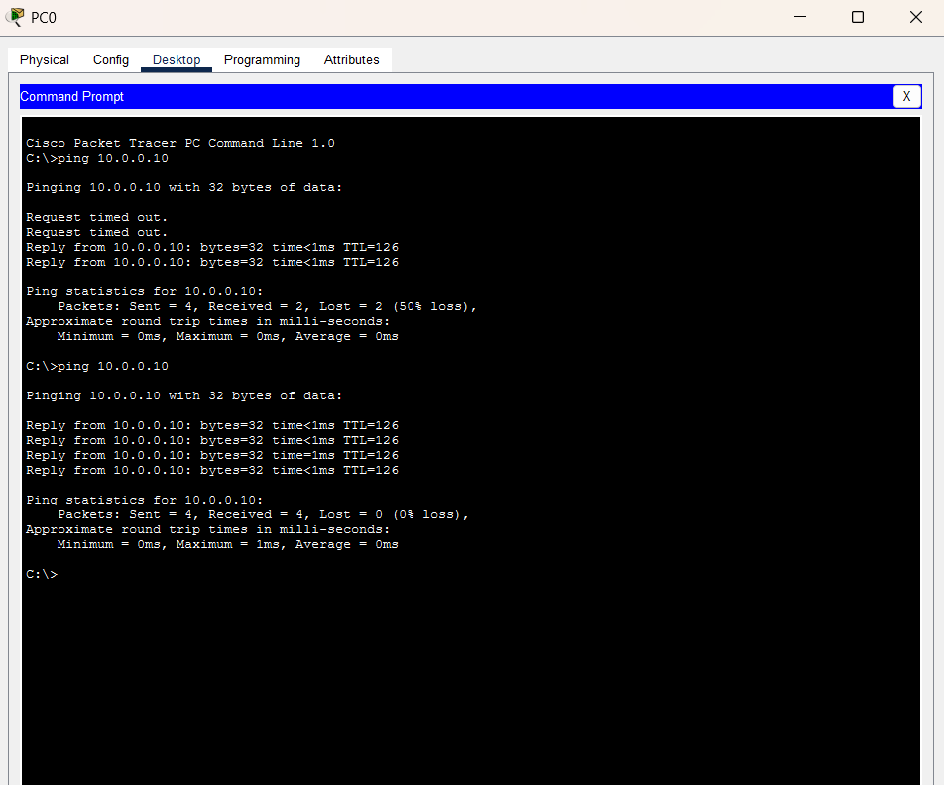
Figure 3.20: Successful ping from the PC to the cloud Server, confirming connectivity.

Conclusion
A hybrid cloud network was successfully simulated using Cisco Packet Tracer. The on-premises network and the cloud network were interconnected through routers configured with static routing, and end-to-end connectivity between the PC and the cloud server was verified using the ping command.

