Home.html

<!DOCTYPE html>

<html lang="en">

<head>

    <meta charset="UTF-8">

    <meta name="viewport" content="width=device-width, initial-scale=1.0">

    <title>VIDHUSHAN VISWARAJAH - Portfolio</title>

    <link rel="stylesheet" href="styles.css">

</head>

<body>

    <div class="container">

        <header>

            <h1>Vidhushan Viswarajah</h1>

            <img src="profile-picture.jpg" alt="vidhushan" class="profile-pic">

        </header>

        <section class="about">

            <h2>About Me</h2>

            <p>I am Vidhushan, and I am currently pursuing a degree in Electronics and Computer Science at the University of Kelaniya. With a strong interest in full stack development and artificial intelligence, I am passionate about creating innovative solutions that bridge technology and user experience. My academic background, combined with hands-on projects, has equipped me with the skills to tackle complex challenges in the tech industry. I am eager to explore opportunities that allow me to further develop my expertise and contribute to impactful projects..</p>

        </section>

        <section class="skills">

            <h2>Skills & Strengths</h2>

            <ul>

                <li>Skill 1: photography</li>

                <li>Skill 2: Time management</li>

                <li>Skill 3: Team work</li>

                <li>Skill 4: communication </li>

                <li>Skill 5: Problem solving </li>

            </ul>

        </section>

        <section class="contact">

            <h2>Contact Information</h2>

            <p>Email: vidhushan1017@gmail.com</p>

            <p>Phone: 0779309298</p>

            <p>LinkedIn: <a href="https://www.linkedin.com/in/vidhushan-viswarajah-a63375273?utm_source=share&utm_campaign=share_via&utm_content=profile&utm_medium=ios_app">LinkedIn </a></p>

            <p>facebook: <a href="https://www.facebook.com/vidhuvidhushan.vidhushan?mibextid=LQQJ4d">Face book</a></p>

        </section>

        <a href="page2.html" class="next-page-link ">Go to projects & Achivements</a>

    </div>

</body>

</html>

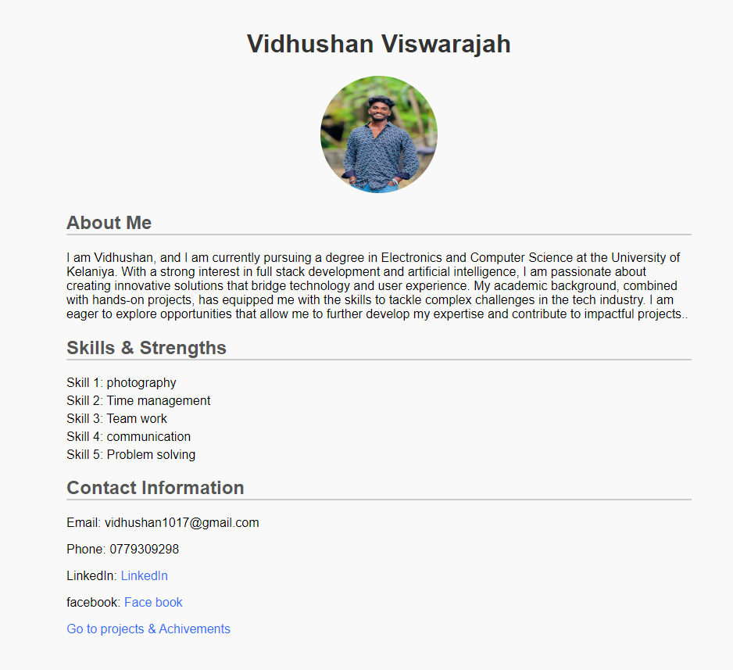

Page2.html

<!DOCTYPE html>

<!DOCTYPE html>

<html lang="en">

<head>

    <meta charset="UTF-8">

    <meta name="viewport" content="width=device-width, initial-scale=1.0">

    <title>John Doe - Portfolio</title>

    <link rel="stylesheet" href="styles.css">

</head>

<body>

    <div class="container">

        <header>

            <h1>Vidhushan Viswarajah</h1>

        </header>

        <section class="experience">

            <h2>Professional Experience</h2>

            <h3>Software Engineer, Tech Solutions Inc. (June 2021 UTF-8 Present)</h3>

            <p>Developing web applications using JavaScript and React. Collaborated with cross-functional teams to enhance user experience and reduce load times by 30%.</p>

            <h3>Junior Developer, Creative Agency (January 2020 - May 2021)</h3>

            <p>Assisted in the development of client websites and applications. Responsible for debugging and optimizing code, contributing to an increase in project efficiency.</p>

            <h3>Intern, Nonprofit Organization (Summer 2019)</h3>

            <p>Helped create a data management system for tracking donations, improving reporting accuracy and reducing manual entry time by 40%.</p>

        </section>

        <section class="projects">

            <h2>Projects</h2>

            <h3>Personal Portfolio Website</h3>

            <p>Designed and developed a responsive personal portfolio site to showcase my projects and skills using HTML, CSS, and JavaScript.</p>

            <h3>Task Management App</h3>

            <p>Created a task management application using React and Node.js, allowing users to create, edit, and delete tasks, and manage deadlines.</p>

            <img src="project.png"alt="task management" class="project">

            <h3>Blog Platform</h3>

            <p>Developed a full-stack blog platform with user authentication and content management features, using Django and PostgreSQL.</p>

        </section>

        <section class="testimonials">

            <h2>Testimonials</h2>

            <blockquote>

                "vidhu consistently delivers high-quality work and has been a great asset to our team." – Sarah Smith, Team Lead at Tech Solutions Inc.

            </blockquote>

        </section>

        <a href="home.html" class="Previous-page-link ">back to interduction overview </a>

    </div>

    </div>

</body>

</html>

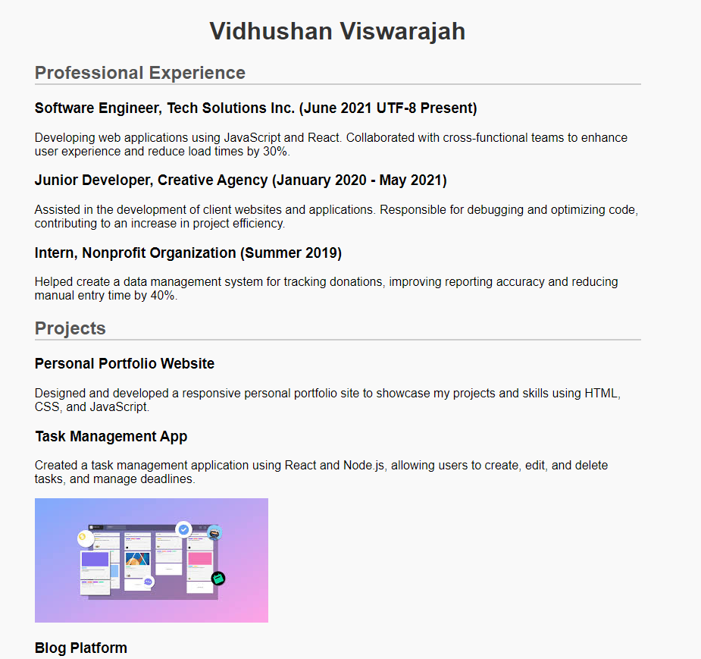

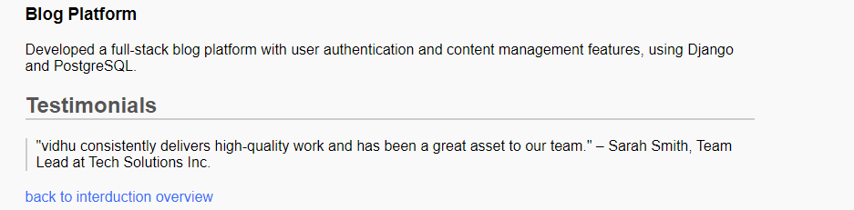

Styles.css

body {

    font-family: Arial, sans-serif;

    margin: 0;

    padding: 0;

    background-color: #f9f9f9;

}

.container {

    max-width: 800px;

    margin: auto;

    padding: 20px;

}

header {

    text-align: center;

}

.profile-pic {

    width: 150px;

    height: 150px;

    border-radius: 50%;

}

h1 {

    color: #333;

}

h2 {

    color: #555;

    border-bottom: 2px solid #ccc;

}

ul {

    list-style-type: none;

    padding: 0;

}

ul li {

    margin: 5px 0;

}

a {

    color: #007BFF;

    text-decoration: none;

}

a:hover {

    text-decoration: underline;

}

blockquote {

    border-left: 2px solid #ccc;

    padding-left: 10px;

    margin: 20px 0;

}