**PROJECT**

**TOPIC:Road Safety in Digital Cities**

**Submitted By,**

**Vidhya Vijayan**

**MCA S5 Regular**

**Abstract**

Nowadays cities invest more in their public services, and particularly digital ones, to improve their resident’s quality of life and attract more people.Thus, new road safety in digital cities services appear and they are based on contributions made by users equipped with website.. For example, the respect of the trafﬁc code is essential to ensure citizens’ security and welfare in their city.This service has been implemented and experiments and demonstrations have been performed in the urban environment.This service allows users appropriatingtheir urban environment with an active participation regarding the collectivity.Road safety education plays an important role in shaping the attitudes and behavior of children and young people ensuring they become responsible drivers,passengers,pedestrians and cyclists. In this paper, we present a new service for improving road safety in cities. This project allows users to report trafﬁc offence they witness in real time and to map them on a city plan. This service also represents a tool for city administrators to help for decisions and improve their urbanization policy, or to check the impact of their policy in the city environment. In this project help users to report road safety issues they experiment in their ur- ban environment (excessive speed, vehicles illegally parked, signs and signals, roads quality and trafﬁc levels, etc.) and share this information with their community.This service has inform citizen about their urban environment, showing them what can be a dangerous driving area or a safety zone. In addition, this piece of information may allow city administrators modifying road signs or infrastructure to improve welfare in the city.

**DATABASE DESIGN**

tbl_login

|  |  |  |  |
| --- | --- | --- | --- |
| Fieldname | Data type | Description | Constraints |
| lid | int | Login id | pk |
| username | Varchar(50) | username | Not null |
| password | Varchar(50) | password | Not null |
| status | int | status | int |
| role | int | role | int |

tbl_User Registration

|  |  |  |  |
| --- | --- | --- | --- |
| Fieldname | Datatype | Description | Constraints |
| uid | int | User id | pk |
| fname | Varchar(50) | First name | Not null |
| lname | Varchar(50) | Last name | Not null |
| hname | Varchar(50) | House name | Not null |
| place | Varchar(50) | place | Not null |
| pin | Varchar(50) | pin | Not null |
| age | Varchar(50) | age | Not null |
| gender | Varchar(50) | gender | Not null |
| email | Varchar(50) | email | Not null |
| mobile | Varchar(50) | mobile | Not null |

tbl_Safety officer registration

|  |  |  |  |
| --- | --- | --- | --- |
| Fieldname | Datatype | Description | Constraints |
| officerid | int | Office rid | pk |
| officername | Varchar(50) | Officer name | Not null |
| designation | Varchar(50) | designation | Not null |
| hname | Varchar(50) | House name | Not null |
| place | Varchar(50) | place | Not null |
| pin | Varchar(50) | pin | Not null |
| age | Varchar(50) | age | Not null |
| gender | Varchar(50) | gender | Not null |
| email | Varchar(50) | email | Not null |
| mobile | Varchar(50) | mobile | Not null |
|  |  |  |  |

tbl_location

|  |  |  |  |
| --- | --- | --- | --- |
| locationid | int | Location id | pk |
| locationname | Varchar(50) | Location name | Not null |

tbl_hospital registration

|  |  |  |  |
| --- | --- | --- | --- |
| Fieldname | Datatype | Description | Constraints |
| hid | int | Hospital id | pk |
| hname | Varchar(50) | Hospital name | Not null |
| did | Varchar(50) | District id | Not null |
| state | Varchar(50) | state | Not null |
| country | Varchar(50) | country | Not null |
| email | Varchar(50) | email | Not null |
| mobile | Varchar(50) | mobile | Not null |
| ambulanceno | Varchar(50) | Ambulance no | Not null |
| contactno | Varchar(50) | Contact no | Not null |

tbl_district

|  |  |  |  |
| --- | --- | --- | --- |
| Fieldname | Datatype | Description | Constraints |
| did | int | District id | pk |
| dnmae | Varchar(50) | District name | Not null |

tbl_rule

|  |  |  |  |
| --- | --- | --- | --- |
| Fieldname | Datatype | Description | Constraints |
| ruleid | int | Rule id | pk |
| typeofrule | Varchar(50) | Type of rule | Not null |
| ruledescription | Varchar(50) | Rule description | Not null |

tbl_insurance agent registration

|  |  |  |  |
| --- | --- | --- | --- |
| Fieldname | Datatype | Description | Constraints |
| agentid | int | Agent id | pk |
| agentname | Varchar(50) | Agent name | Not null |
| designation | Varchar(50) | designation | Not null |
| hname | Varchar(50) | House name | Not null |
| place | Varchar(50) | place | Not null |
| pin | Varchar(50) | pin | Not null |
| age | Varchar(50) | age | Not null |
| gender | Varchar(50) | gender | Not null |
| mobile | Varchar(50) | mobile | Not null |

Tbl_rule

|  |  |  |  |
| --- | --- | --- | --- |
| Fieldname | Data type | Description | Constraints |
| ruleid | int | Rule id | pk |
| typeofrule | Varchar(50) | Type of rule | Not null |
| ruledescription | Varchar(50) | Rule description | Not null |

tbl_vehicle registration

|  |  |  |  |
| --- | --- | --- | --- |
| Fieldname | Data type | Description | Constraints |
| vechiclenumber | int | Vehicle number | pk |
| companyname | Varchar(50) | Company name | Not null |
| modelname | Varchar(50) | Model name | Not null |
| modelnumber | Varchar(50) | Model number | Not null |
| image | Varchar(50) | image | Not null |

tbl_insurance

|  |  |  |  |
| --- | --- | --- | --- |
| Fieldname | Data type | Description | Constraints |
| insuranceid | int | Insurance id | pk |
| userid | int | User id | fk |
| date | Varchar(50) | date | Not null |
| typeofinsurance | Varchar(50) | Type of insurance | Not null |
| typeofpayement | Varchar(50) | Type of payement | Not null |

tbl_feedback

|  |  |  |  |
| --- | --- | --- | --- |
| Fieldname | Data type | Description | Constraints |
| feedbackid | int | Feedback id | pk |
| usertype | Varchar(50) | User type | Not null |
| registrationid | int | Registration id | fk |
| message | Varchar(50) | message | Not null |

**USECASE DIAGRAM**

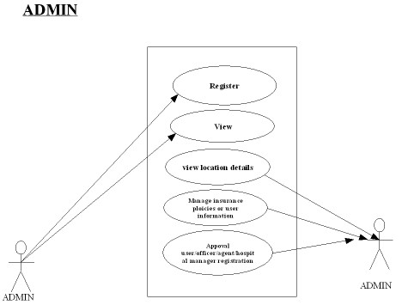

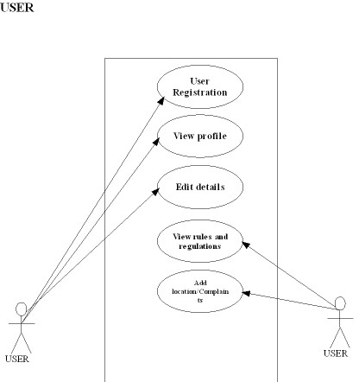

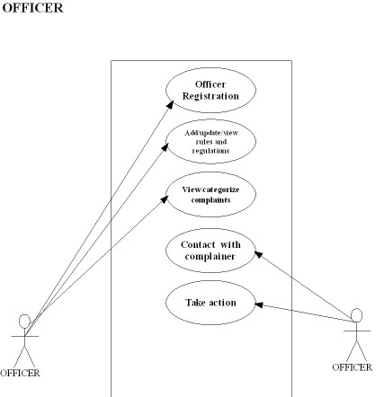

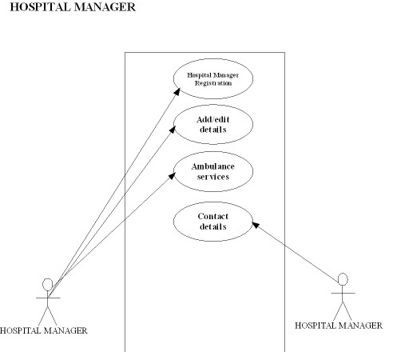

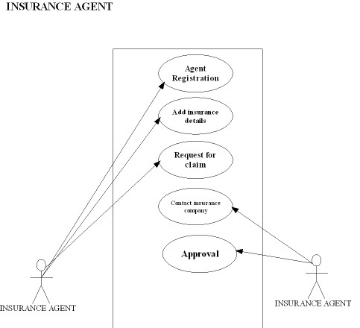

**DATA FLOW DIAGRAM**

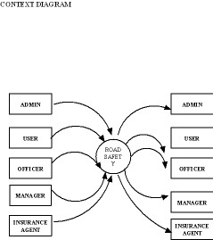

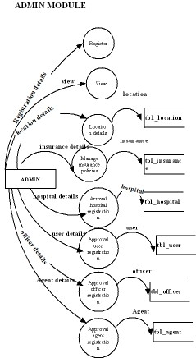

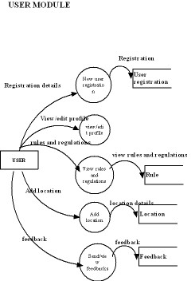

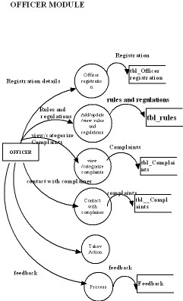

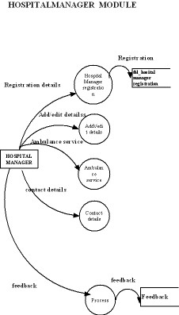

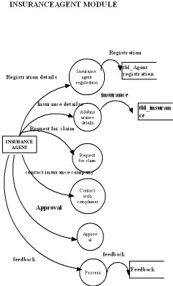

**Forms**

