Data Visualizations of World Population

Vidhyasagar Janga  
vidhyasagarjanga@lewisu.edu  
DATA-53000, Summer 2023

Data Visualization Lewis University

# Introduction

The world population dataset contains various demographic indicators for different countries. It includes the population of each country in the year 2020, along with the yearly change in population and net change in population. The dataset also provides information on population density (measured in people per square kilometer), land area in square kilometers, net migration rate, fertility rate, median age, urban population percentage, and the country's share of the world population. These indicators offer insights into the size, growth, distribution, and demographic characteristics of the populations in the countries or regions mentioned in the dataset.

# Data Description

The dataset contains demographic indicators for 201 countries. It includes population data for the year 2020, along with yearly changes and net changes in population. The dataset statistics reveal that the average population in 2020 was approximately 38.8 million people, with a yearly change of 1.2 and a net change of approximately 404,623 individuals. The population density averaged around 361.7 people per square kilometer, with a wide variation indicated by the standard deviation of 1710.3. The land area ranged from 30 square kilometers to 16,376,870 square kilometers. The dataset also provides information on the urban population percentage, with an average value of 59.6%, indicating that approximately 59.6% of the population resides in urban areas. The world share column represents the percentage of the global population represented by each country, ranging from 0.00% to 18.47%.

Reference: <https://www.kaggle.com/datasets/anandhuh/countries-in-the-world-by-population-2022>

1. Data Attributes

| **Attribute** | **Type** | **Example Value** | **Description** |
| --- | --- | --- | --- |
| Country/Other | Text | United States | Name of countries and dependent territories |
| Population (2020) | Numeric | 328,200,000 | Population in the year 2020 |
| Yearly Change | Numeric | 0.7% | Percentage Yearly Change in Population |
| Net Change | Numeric | 2,225,000 | Net Change in Population |
| Density (P/Km²) | Numeric | 36 | Population density (population per square km) |
| Land Area (Km²) | Numeric | 9,147,420 | Land area of countries / dependent territories |
| Migrants (net) | Numeric | 900,000 | Total number of migrants |
| Fert. Rate | Numeric | 1.8 | Fertility rate |
| Med. Age | Numeric | 38 | Median age of the population |
| Urban Pop % | Numeric | 82% | Percentage of urban population |
| World Share | Numeric | 4.2% | Population share |

# Methodology and results

The data was input into Tableau, and multiple visualizations were created to conduct exploratory visualizations on the data. The below population density map drawn between countries and their respective population density provides a visual representation of the concentration of population across different nations. This map displays varying shades or colors to depict the intensity of population density. The insights derived from this map are valuable for various stakeholders, including international organizations like the World Health Organization (WHO), world leaders and researchers. WHO can utilize the insights to assess healthcare needs and plan interventions in areas with high population density. World leaders can use the map to understand regional disparities, plan infrastructure development, and allocate resources effectively. Researchers can analyze the map to study demographic trends, migration patterns, and environmental impacts. Ultimately, these insights contribute to evidence based decision making and sustainable development strategies in the real world.

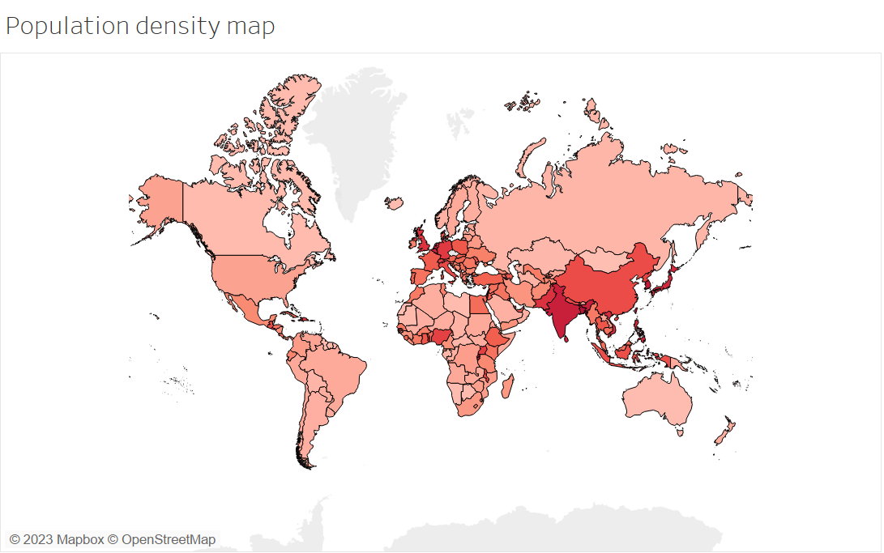

Fig. 1 Countries vs Population Density

In Fig. 2(a) Fig. 2(b) shows visualization comparison between Countries and Population net change. From the first look at the visualization, it can be identified that India has highest net population change, which indicates that despite China has highest population, India's significant net population change suggests the possibility of India becoming the most populated country in the future. Countries with high positive net population change indicate a youthful population with high birth rates and potential future population growth. On the other hand, countries with negative net population change may have aging populations or factors contributing to population decline.

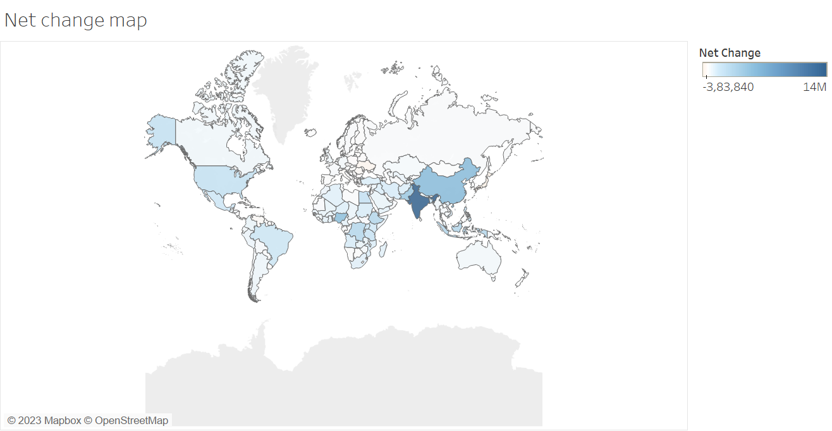

Fig. 2(a) Countries vs Population Net Change

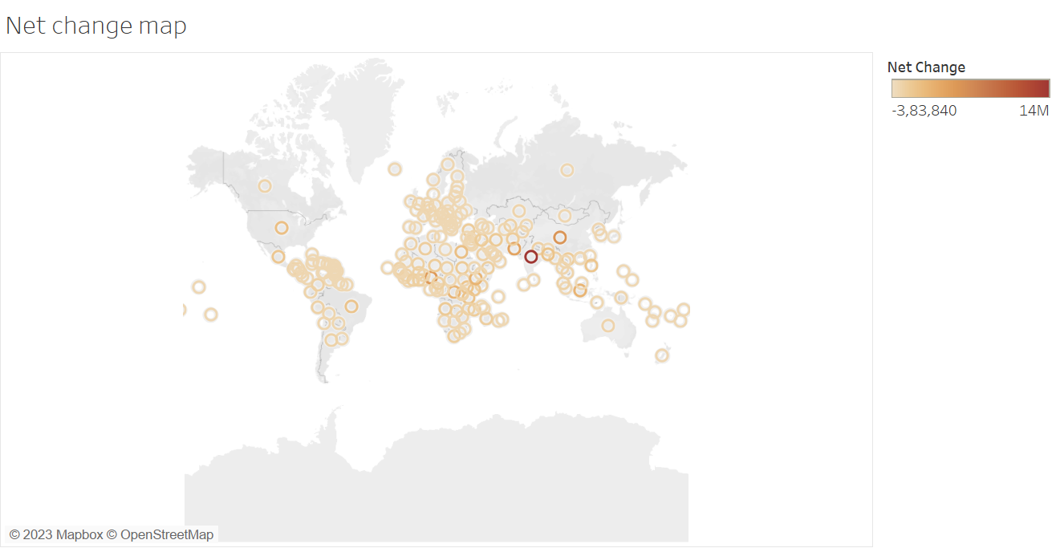

Fig. 2(b) Countries vs Population Net Change

# Discussion

In Section III, we used different types of visualizations, they valuable insights about population density and net population change across different countries. The population density map visually represents the concentration of population in various nations, offering insights for organizations like the World Health Organization (WHO), world leaders, and researchers. The WHO can assess healthcare needs and plan interventions in high-density areas, while world leaders can understand regional disparities, plan infrastructure development, and allocate resources effectively. Researchers can analyze the map to study demographic trends, migration patterns, and environmental impacts. Notably, India shows the highest net population change, indicating the possibility of surpassing China as the most populated country in the future. Positive net population change suggests a youthful population with high birth rates and potential growth, while negative net population change may indicate aging populations or factors contributing to decline. These insights contribute to evidence-based decision making and sustainable development strategies.

# Conclusion

In summary, the data visualizations created using Tableau have provided meaningful insights into population density and net population change across different countries. The population density map has visually depicted the concentration of population, helping to identify regions with high population density. Additionally, the comparison of countries based on net population change has revealed trends such as India's potential to become the most populated country in the future.

##### References

[1] Anadhu M “World Population” by year 2020 ‘ Kaggle ,

Available:<https://www.kaggle.com/datasets/anandhuh/countries-in-the-world-by-population-2022>