DOCKER ASSESSMENT

1. Create docker image for any sample application (any language) and list out the commands to run the application

Docker Commands

a) docker build --tag calculationapp .
b) docker images
c) docker run --name cal -p 8080:8080 calculationapp

3. Create a docker container for web application and DB (any DB) and make sure that webapp should be able to insert/update data to DB.

Docker Commands

a)docker-compose build
b)docker images
c)docker-compose up

please check below image here we have containers sql_db for postgres DB and currency-exchange-service for springboot

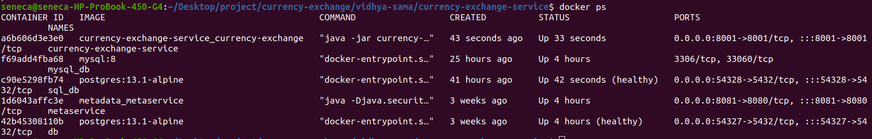

4. Create a custom network and add the applications/containers to it and make sure the communication between containers is successful.

Docker Commands

Here two containers are a)Mysql b)springbootApp

1)docker network create currency-mysql
2)docker network ls
3)docker container run --name mysql_db --network currency-mysql -e MYSQL_ROOT_PASSWORD=root -e MYSQL_DATABASE=currency mysql:8
4)Using the exec command we can also inspect if the database named currency is created successfully.
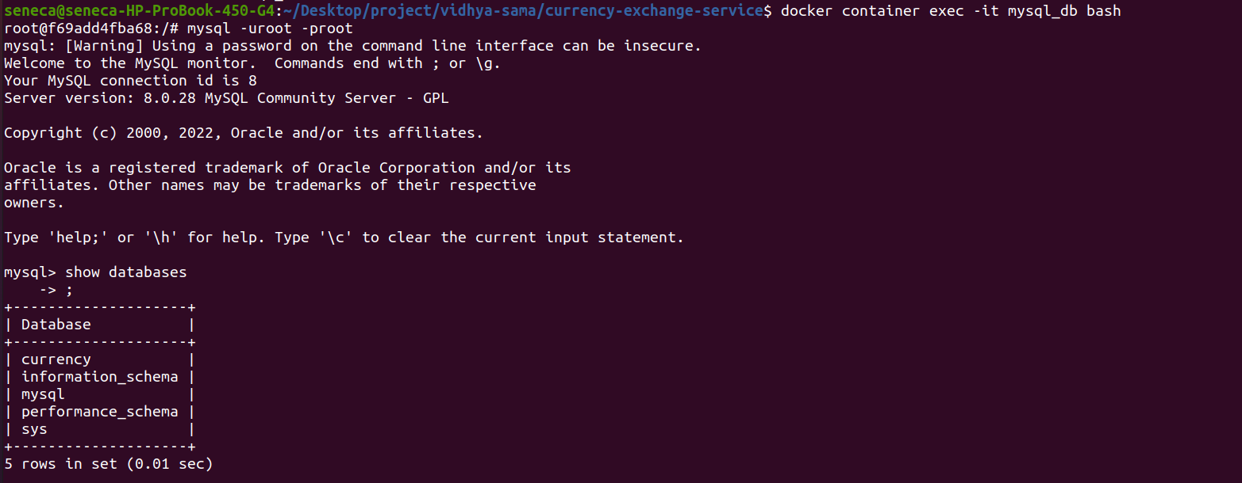

5)docker build --tag currency-exchange .
6)docker container run --network currency-mysql --name currency-exchange -p 8100:8100 currency-exchange
7)inspect if data inserted in table
