**Bug Report**

**ID- 001**

**Title:** Active Count does not match the actual number of active equipment

**Description:**

Active Status Count below the Heading Equipment List is not correct. The value is one more than the number of active equipment displayed.

**Steps to Reproduce**

1. Navigate to 'https://qa-assignment-omega.vercel.app'

2.Observe count

**Expected Result**

Active count should show the number of active equipments in the list

**Actual Result**

Active count is one more than the actual number of active equipment present

**Environment**

- URL: https://qa-assignment-omega.vercel.app

- Browser/OS: Chrome/mac OS

**Evidence**

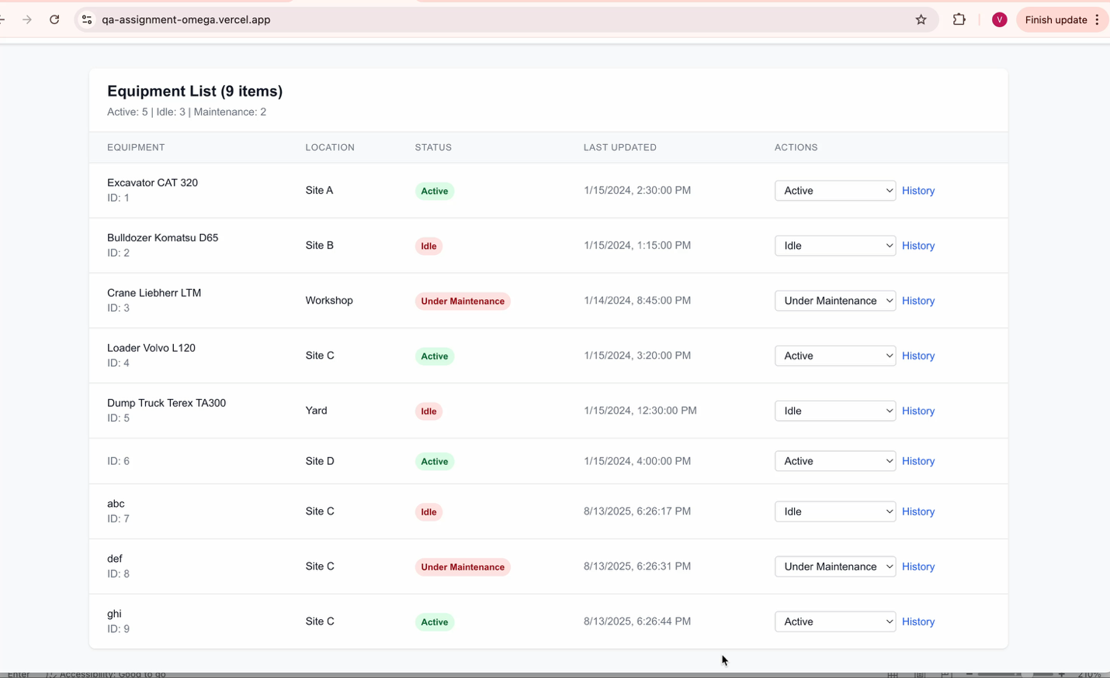

**Priority**

High

**Testcase ID**

EST_001

**Bug Status** New

**ID- 002**

**Title:** Unable to click history link for equipment with status Under Maintenance

**Description:**

Unable to click history link for any equipment with status Under Maintenance. History Popup does not appear on clicking history link.

**Steps to Reproduce**

1. Navigate to 'https://qa-assignment-omega.vercel.app'

2.Check for any equipment with hist

**Expected Result**

Active count should show the number of active equipments in the list

**Actual Result**

Active count is one more than the actual number of active equipment present

**Environment**

- URL: https://qa-assignment-omega.vercel.app

- Browser/OS: Chrome/mac OS

**Evidence**

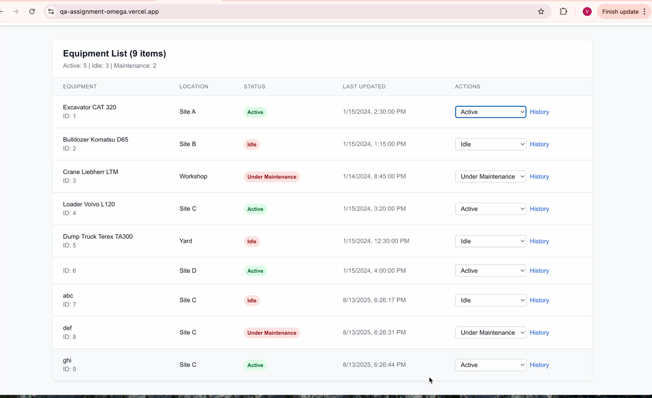

**Priority**

High

**Testcase ID**

EST_001

**Bug Status** New

**ID- 003**

**Title:** Status Badge color for Idle status is not yellow

**Description:**

Status Badge color for Idle status is red not yellow.

As per requirement Idle (Yellow) - Equipment is available but not in use

**Steps to Reproduce**

1. Navigate to 'https://qa-assignment-omega.vercel.app'

2.Check for any equipment with status Idle

3.Observe the Status Badge color

**Expected Result**

Status Badge color for Idle status should be Yellow

**Actual Result**

Status Badge color for Idle status is Red

**Environment**

- URL: https://qa-assignment-omega.vercel.app

- Browser/OS: Chrome/mac OS

**Evidence**

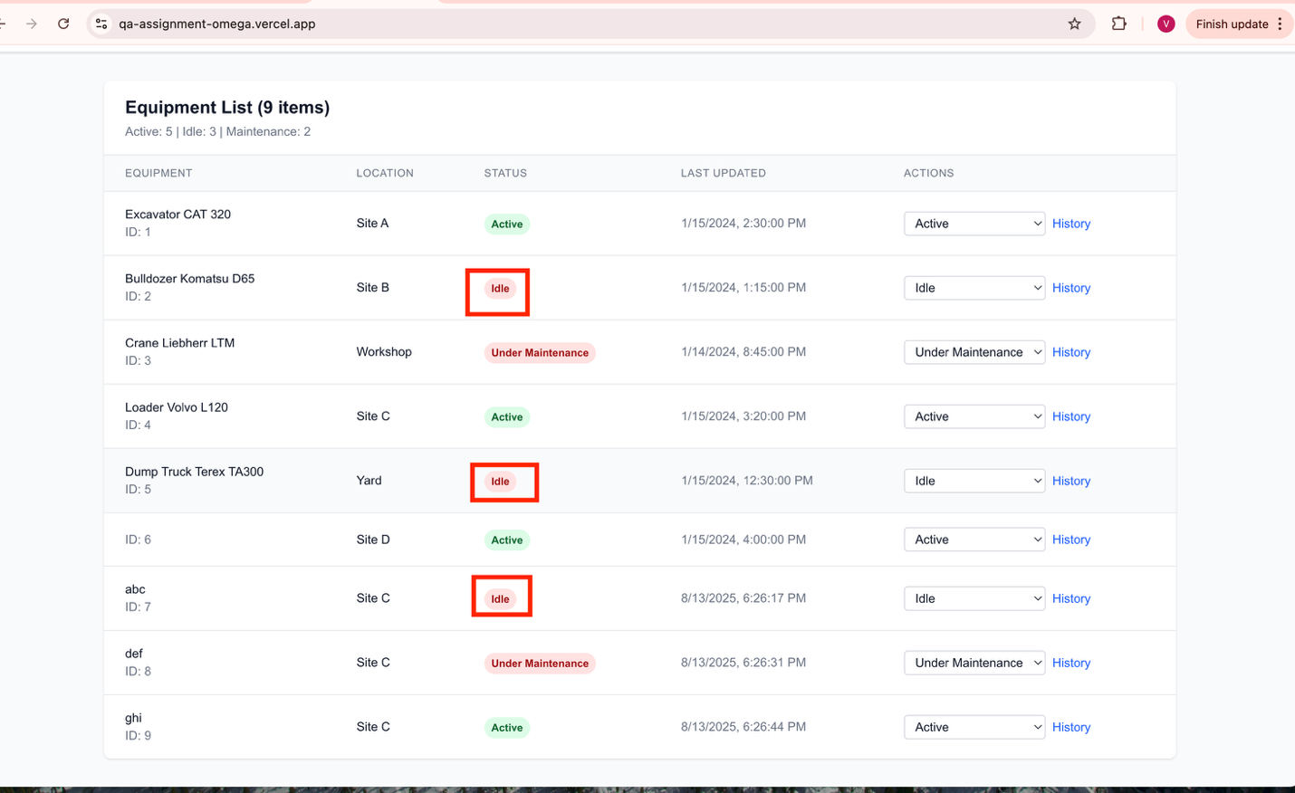

**Priority**

High

**Testcase ID**

EST_003

**Bug Status** New

**ID- 004**

**Title:** No Maximum limit on Equipment name and location while Adding Equipment

**Description:**

While Adding Equipment, Equipment Name and Location can be given long strings no validation for maximum characters. Better to provide maximum limit for the fields.

API should provide maximum limit error.

**Steps to Reproduce**

1. Navigate to 'https://qa-assignment-omega.vercel.app'

2.Click on Add Equipment

3.Enter the details Equipment Name and location to long string

Test Data- smvlxjczdtolbjxttgxmpqqxzztyozdfmdpfoowhrbycciriqmbribvxniafmfuclbblpofoxqydqszcibdbopjeaocryzepmfkwdrxqykciydzgdmsfjjmxzouqgkul

**Expected Result**

There should be a maximum limit for input fields

API should provide error message “Maximum characters exceeded, maximum limit is 100 characters. API Response Status – 400/412

**Actual Result**

Accepts any long strings as input

API response is 200

**Environment**

- URL: https://qa-assignment-omega.vercel.app

- Browser/OS: Chrome/mac OS

**Evidence**

**Priority**

Low

**Testcase ID**

EST_007

**Bug Status** New

**ID- 005**

**Title:** Error message no shown on updating status from Under Maintenance to Active/Idle

**Description:**

For any Equipment in status Under Maintenance, while updating status to Active/ Idle no error message is shown.

API throws error message – “Cannot change status of equipment under maintenance”

**Steps to Reproduce**

1. Navigate to 'https://qa-assignment-omega.vercel.app'

2.Check for any equipment with status Under Maintenance

3.Change the staus to Active/ Idle

**Expected Result**

For Equipment’s Under Maintenance status – the status cannot be updated. Then field should be disabled for the equipment’s with status or show the API error message when user tries to perform action.

**Actual Result**

Nothing happens on changing status for equipment’s with status Under Maintenance.

Field not disabled/ Error message not shown to user.

**Environment**

- URL: https://qa-assignment-omega.vercel.app

- Browser/OS: Chrome/mac OS

**Evidence**

**API Curl-**

curl 'https://qa-assignment-omega.vercel.app/api/equipment/3/status' \

-H 'accept: */*' \

-H 'accept-language: en-US,en;q=0.9' \

-H 'content-type: application/json' \

-H 'origin: https://qa-assignment-omega.vercel.app' \

-H 'priority: u=1, i' \

-H 'referer: https://qa-assignment-omega.vercel.app/' \

-H 'sec-ch-ua: "Not)A;Brand";v="8", "Chromium";v="138", "Google Chrome";v="138"' \

-H 'sec-ch-ua-mobile: ?1' \

-H 'sec-ch-ua-platform: "Android"' \

-H 'sec-fetch-dest: empty' \

-H 'sec-fetch-mode: cors' \

-H 'sec-fetch-site: same-origin' \

-H 'user-agent: Mozilla/5.0 (Linux; Android 6.0; Nexus 5 Build/MRA58N) AppleWebKit/537.36 (KHTML, like Gecko) Chrome/138.0.0.0 Mobile Safari/537.36' \

--data-raw '{"status":"Active","changedBy":"Operator"}'

Response-

{"success":false,"error":"Cannot change status of equipment under maintenance"}

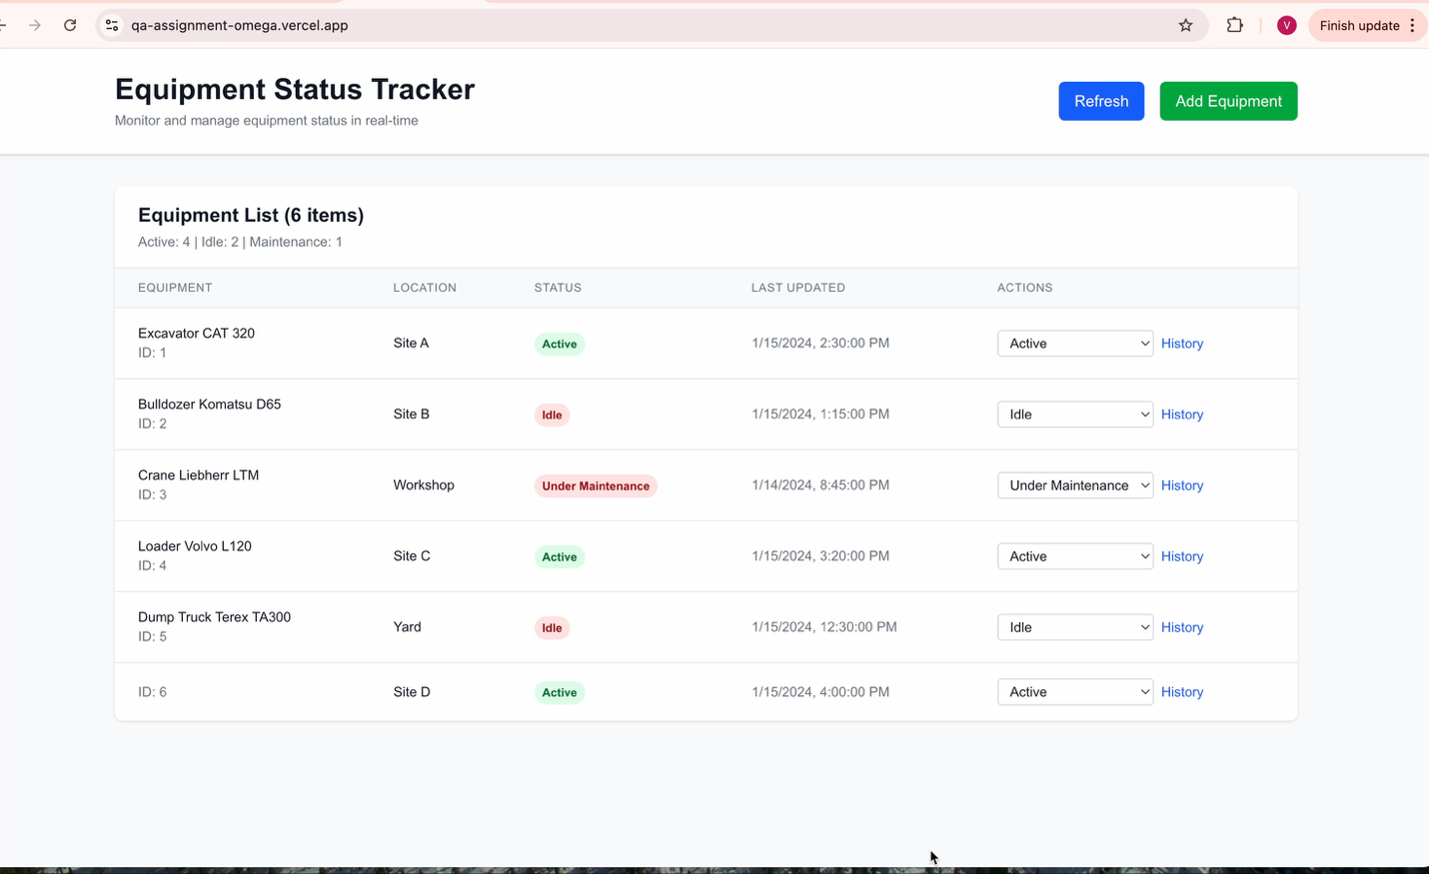

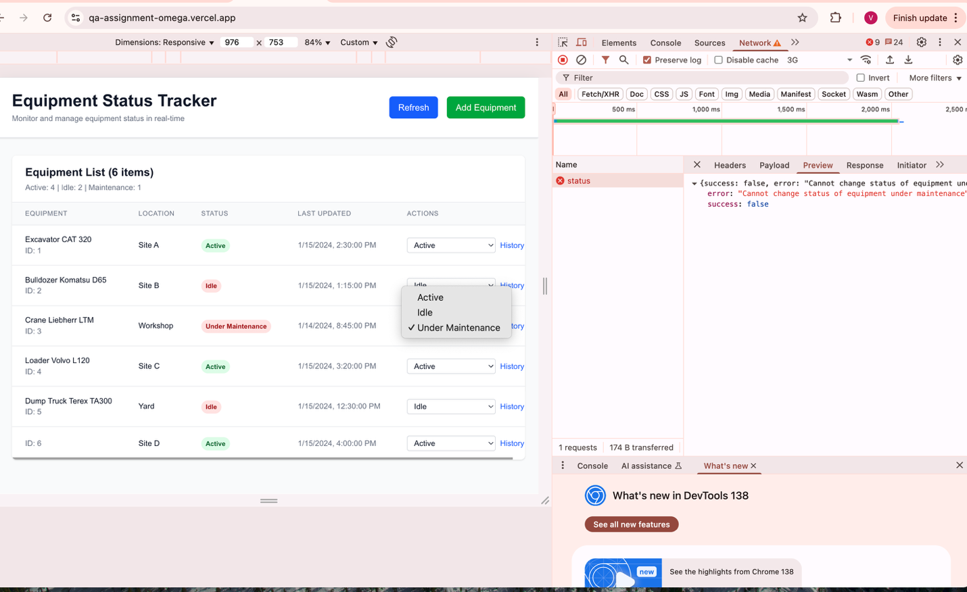

**Priority**

High

**Testcase ID**

EST_008

**Bug Status** New

**ID- 006**

**Title:** Status update does not happen in real time

**Description:**

Real-time Status Updates - Changes reflect immediately is the requirement. But changes reflect only on refresh on opening on other tabs.

**Steps to Reproduce**

1. Navigate to 'https://qa-assignment-omega.vercel.app' on one tab- Tab1

2. Navigate to 'https://qa-assignment-omega.vercel.app' on second tab- Tab2

3.Change status in Tab1 and observe the change in Tab2

**Expected Result**

Real-time Status Updates, Changes reflect immediately without refresh

**Actual Result**

Changes reflect immediately on same Tab, but real time status update doesnot happen in other tabs.

**Environment**

- URL: https://qa-assignment-omega.vercel.app

- Browser/OS: Chrome/mac OS

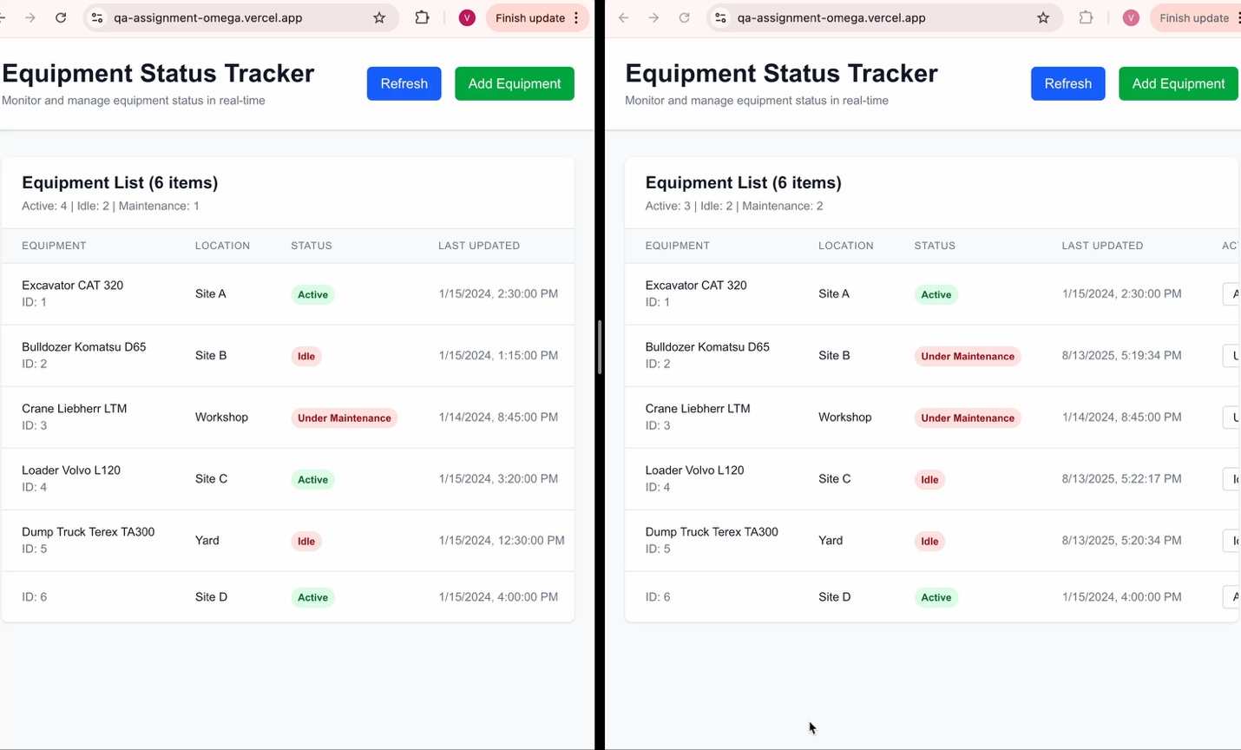**Evidence**

**Priority**

High

**Testcase ID**

EST_009

**Bug Status** New

**ID- 007**

**Title:** More than 10 entries are not shown on Status History- no pagination

**Description:**

On status History modal all the status of the equipment is not displayed. Only recent 10 entries are displayed.

**Steps to Reproduce**

1. Navigate to 'https://qa-assignment-omega.vercel.app'

2.Any equipment with more than 10 status history

3.Check all the status history updates are shown

**Expected Result**

Complete history of status updates should be visible

**Actual Result**

More than 10 entries are not shown on Status History- no pagination

**Environment**

- URL: https://qa-assignment-omega.vercel.app

- Browser/OS: Chrome/mac OS

**Evidence**

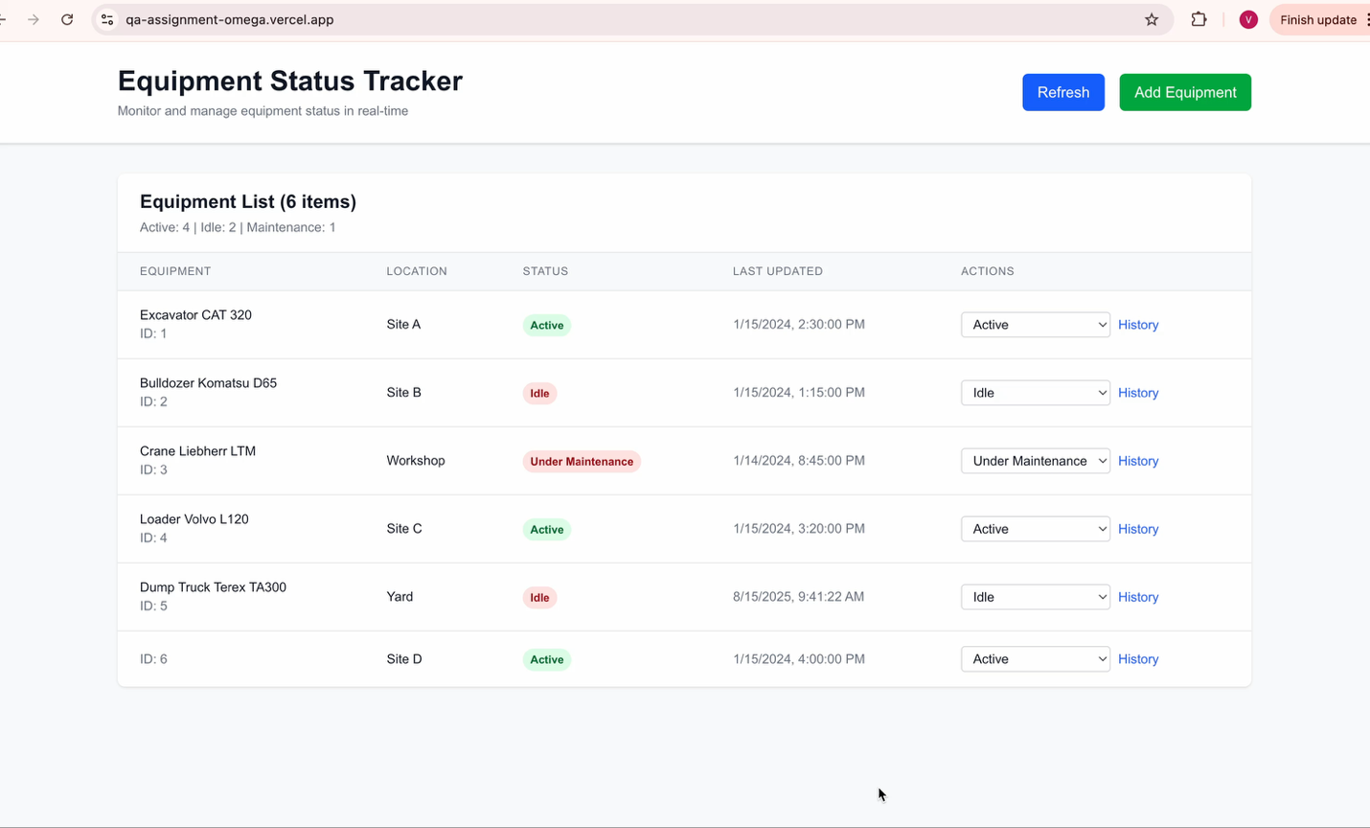

**Priority**

High

**Testcase ID**

EST_013

**Bug Status** New

**ID- 008**

**Title:** History record is displayed on changing status to same status from dropdown

**Description:**

For an equipment with status as Eg- Active change the status with dropdown and select status Eg- Active. As there is no change in status here, no need of history record.

**Steps to Reproduce**

1. Navigate to 'https://qa-assignment-omega.vercel.app'

2.Change status for any equipment to the same status it was in

**Expected Result**

History record should be displayed for complete status change

**Actual Result**

History record is displayed when there is no change in status also.

**Environment**

- URL: https://qa-assignment-omega.vercel.app

- Browser/OS: Chrome/mac OS

**Evidence**

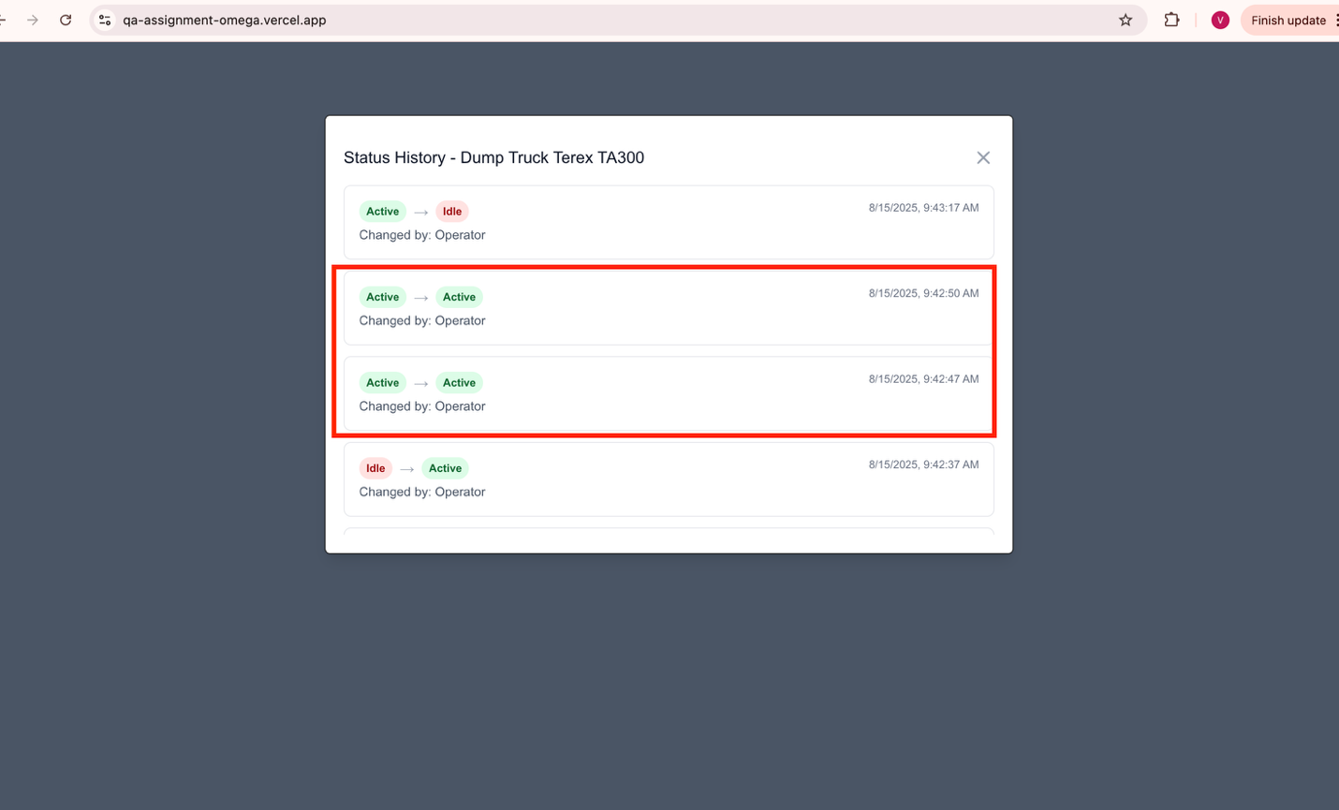

**Priority**

Low

**Testcase ID**

EST_013

**Bug Status** New

**ID- 009**

**Title:** Pressing ESC does not close the history and add equipment modal

**Description:**

For Keyboard navigation – on pressing ESC does not close the history and add equipment modal

**Steps to Reproduce**

1. Navigate to 'https://qa-assignment-omega.vercel.app'

2.Click Add Equiment

3. Press ESC

5.Click History link

6.Press ESC

**Expected Result**

For Keyboard navigation – on pressing ESC should close modal

**Actual Result**

Pressing ESC does not close the history and add equipment modal

**Environment**

- URL: https://qa-assignment-omega.vercel.app

- Browser/OS: Chrome/mac OS

**Evidence**

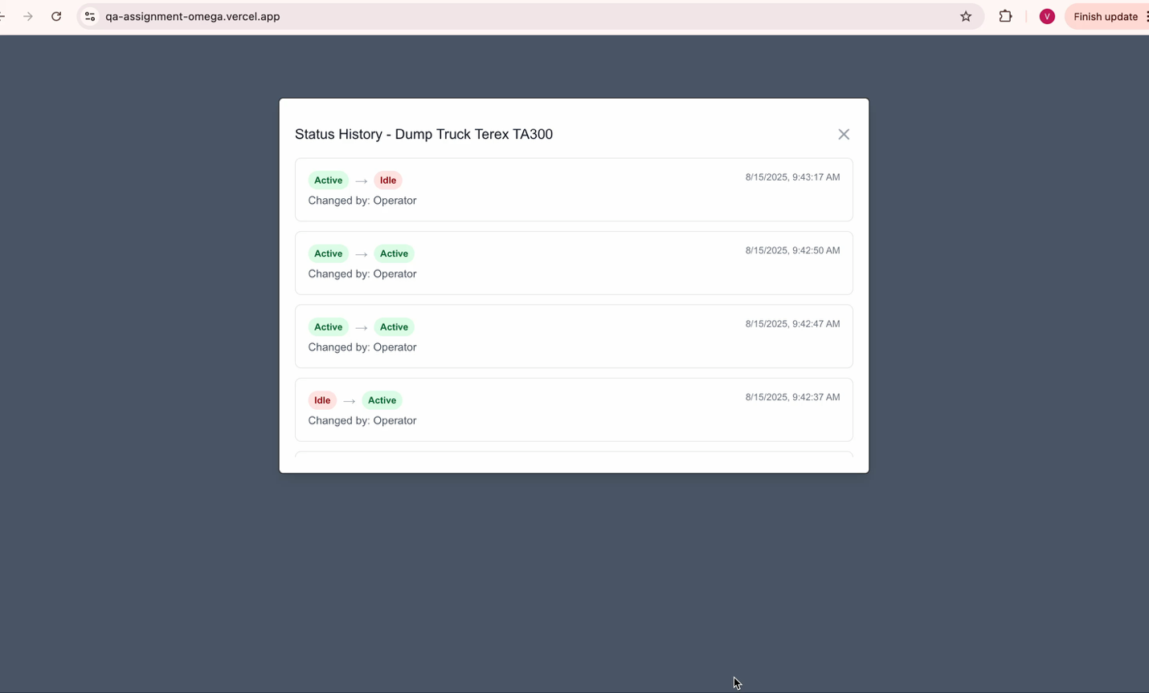

**Priority**

Low

**Testcase ID**

EST_015

**Bug Status** New

**ID- 010**

**Title:** No Error message from API on passing invalid id on history

**Description:**

GET History API with invalid id gives response status 200

**Steps to Reproduce**

curl --location 'https://qa-assignment-omega.vercel.app/api/equipment/99999/history'

**Expected Result**

Response status should be 400

Error Message should be displayed – “Equipment not found

**Actual Result**

Response status is 200

**Environment**

- URL: https://qa-assignment-omega.vercel.app

- Browser/OS: Chrome/mac OS

**Evidence**

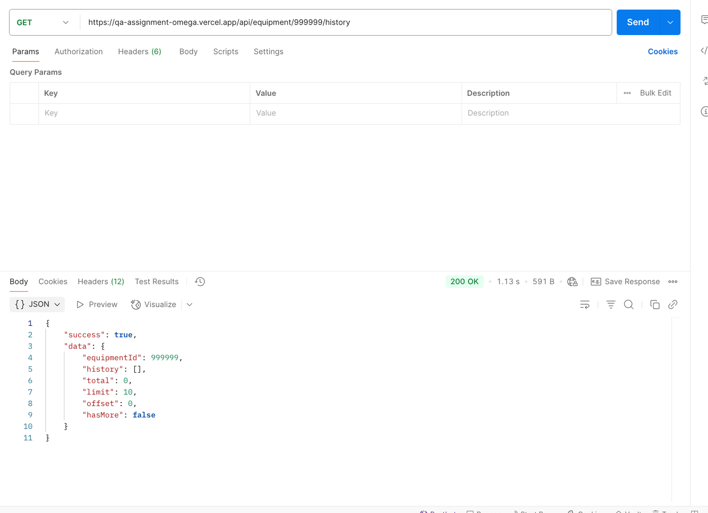

**Priority**

Low

**Testcase ID**

EST_023

**Bug Status** New

**ID- 011**

**Title:** No Error message from API on passing invalid type on history

**Description:**

GET History API with invalid id type gives response status 200

**Steps to Reproduce**

curl --location 'https://qa-assignment-omega.vercel.app/api/equipment/invalid/history'

**Expected Result**

Response status should be 400

Error Message should be displayed – “Equipment not found

**Actual Result**

Response status is 200

**Environment**

- URL: https://qa-assignment-omega.vercel.app

- Browser/OS: Chrome/mac OS

**Evidence**

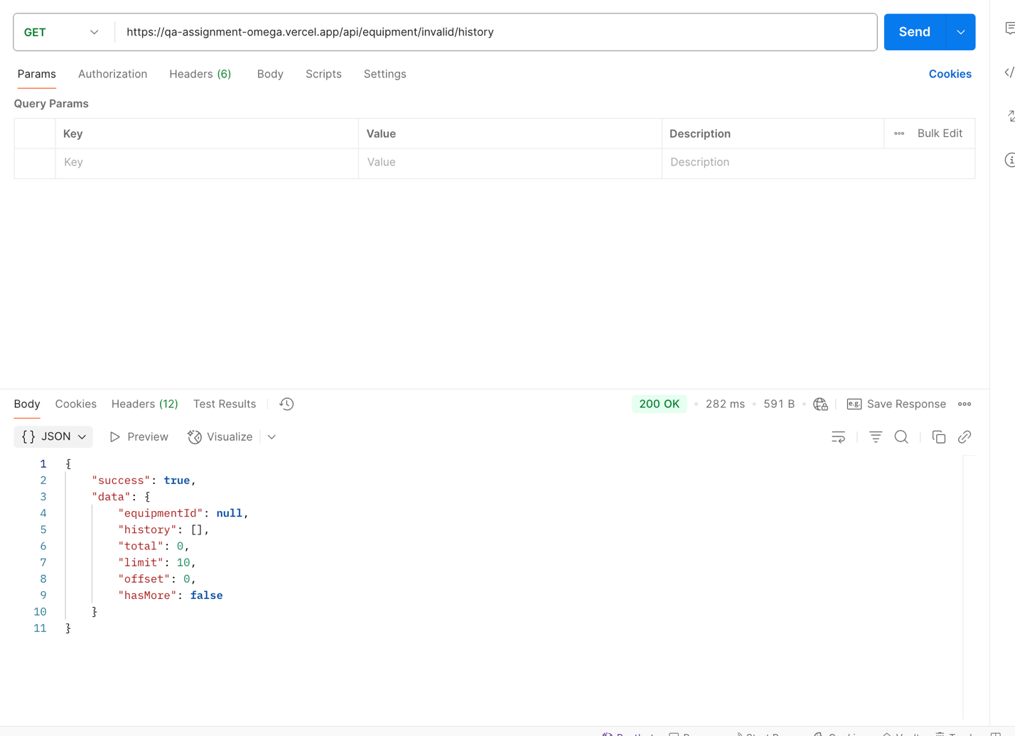

**Priority**

Low

**Testcase ID**

EST_023

**Bug Status** New