**FINAL PROJECT DOCUMENTATION**

**Chatbot using IBM Watson Assistant**

**Description:**

Deploying a chatbot using IBM Watson Assistant involves several steps, including creating an Assistant, defining intents and entities, configuring dialog flows, and integrating it into your application or website.

## **Introduction:**

● Deploying a chatbot can offer numerous benefits to businesses and organizations. Here are some key reasons why you might need to deploy a chatbot is for Consistency,24/7Availabilit,Cost-Efficiency,Data Collection and Analysis, Enhanced User Engagement ,Marketing and Sales Support ,Adaptability.

● There were several notable chatbot-oriented projects and initiatives across various industries and domains they are Google Assistant

Amazon Alexa ,Apple

**Section 1: Executive Summary:**

1. Project Initiation:
   1. Define the specific use case and objectives for deploying a chatbot using IBM Watson Assistant within your organization.
2. IBM Cloud Setup:
   1. Set up an IBM Cloud account if you don't already have one.
3. Watson Assistant Instance Creation:
   1. Create an instance of Watson Assistant within IBM Cloud.
4. Skill Development:
   1. Develop a chatbot "skill" within Watson Assistant, defining intents, entities, and dialog flows based on the desired conversation structure.

**Section 2: Project Overview:**

1. Create an IBM Cloud Account: If you don't have an IBM Cloud account, sign up for one at [IBM](https://cloud.ibm.com/registration) [Cloud](https://cloud.ibm.com/registration).
2. Set Up Watson Assistant:

○ Log in to your IBM Cloud account.

○ Go to the [Watson](https://cloud.ibm.com/catalog/services/watson-assistant) [Assistant](https://cloud.ibm.com/catalog/services/watson-assistant) service in the IBM Cloud catalog. Create an instance of Watson Assistant.

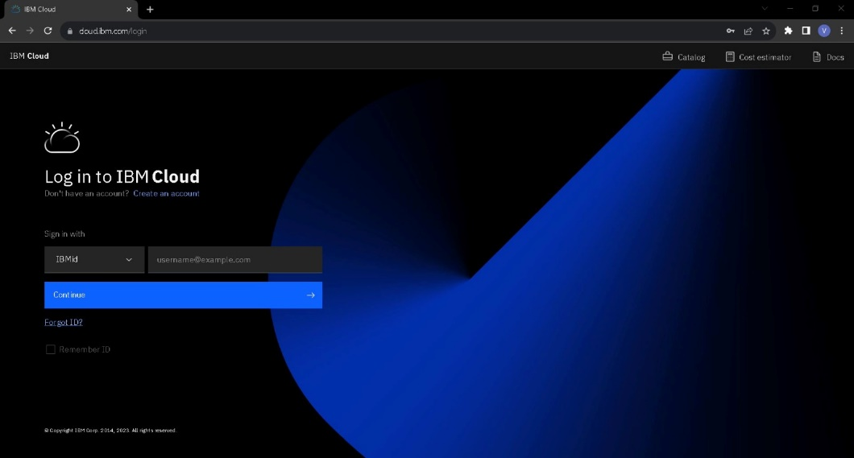

Create a Skill:

○ Inside your Watson Assistant instance, create a new Skill.

○ Define Intents, Entities, and Dialog nodes based on your chatbot's requirements. These are the building blocks of your chatbot's conversation flow.

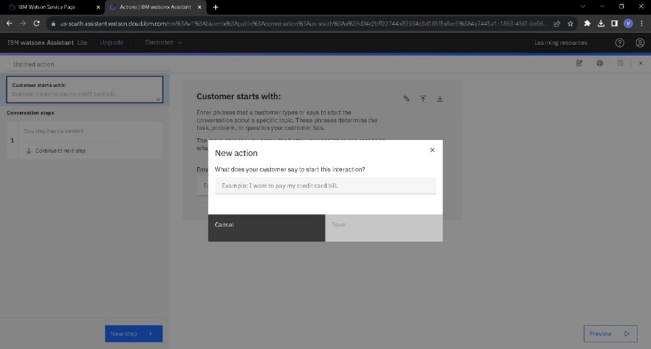

1. Configure Assistant Settings:

Configuring Assistant's settings, including its name as ***ELECTROBOT***, description, and language preferences as **English**

* Inside your Watson Assistant instance by using this link :

[https://cloud.ibm.com/services/conversation/crn%3Av1%3Abluemix%3Apublic%3Aconversatio n%3Aeu-gb%3Aa%2Fb6e25b7f08f5411b81e7aaa5645e7706%3Ae9c4028f-cae4-4025-b805-3b2](https://cloud.ibm.com/services/conversation/crn%3Av1%3Abluemix%3Apublic%3Aconversation%3Aeu-gb%3Aa%2Fb6e25b7f08f5411b81e7aaa5645e7706%3Ae9c4028f-cae4-4025-b805-3b281113163c%3A%3A?paneId=manage)

[81113163c%3A%3A?paneId=manage](https://cloud.ibm.com/services/conversation/crn%3Av1%3Abluemix%3Apublic%3Aconversation%3Aeu-gb%3Aa%2Fb6e25b7f08f5411b81e7aaa5645e7706%3Ae9c4028f-cae4-4025-b805-3b281113163c%3A%3A?paneId=manage)

* Create a logo for your chatbot assistant:

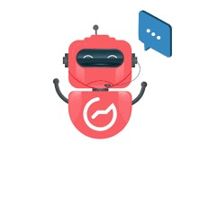

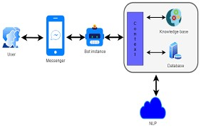

**Section 3:User Experience (UX) Strategy:**

**UX Design Principles Employed in the Chatbot:**

1. User-Centered Design: The chatbot's design is centered around the needs and preferences of the users. It focuses on delivering a seamless and intuitive experience that aligns with users' goals.
2. Conversational UI: The chatbot employs a conversational user interface, emulating natural human language. It uses chat-based interactions to make users feel like they're having a conversation with a real person.
3. Clarity and Simplicity: The design emphasizes simplicity and clarity in both the language used and the visual elements. This ensures that users can easily understand and navigate the chatbot.
4. Personalization: The chatbot incorporates personalization by learning from user interactions and preferences. It tailors responses and recommendations based on individual user data and history.
5. Feedback and Error Handling: The chatbot provides clear feedback to users, acknowledging their queries or commands and offering assistance when a user encounters an error or misunderstanding. It guides users back on track when necessary.
6. Progressive Disclosure: Complex information or features are revealed gradually as users need them. This prevents overwhelming users with too much information upfront and helps them progressively explore the bot's capabilities.
7. Accessibility: The chatbot is designed to be accessible to all users, including those with disabilities. It adheres to accessibility standards to ensure a wide range of users can interact with it.

[https://web-chat.global.assistant.watson.appdomain.cloud/preview.html?backgroundImageURL= https%3A%2F%2Feu-gb.assistant.watson.cloud.ibm.com%2Fpublic%2Fimages%2Fupx-e9c402 8f-cae4-4025-b805-3b281113163c%3A%3A32394f0a-d343-44e4-9093-65c60adcf28b&integrati onID=50e24d36-d6db-40a7-bb15-5bddb8b394a0&region=eu-gb&serviceInstanceID=e9c4028fcae4-4025-b805-3b281113163c](https://web-chat.global.assistant.watson.appdomain.cloud/preview.html?backgroundImageURL=https%3A%2F%2Feu-gb.assistant.watson.cloud.ibm.com%2Fpublic%2Fimages%2Fupx-e9c4028f-cae4-4025-b805-3b281113163c%3A%3A32394f0a-d343-44e4-9093-65c60adcf28b&integrationID=50e24d36-d6db-40a7-bb15-5bddb8b394a0&region=eu-gb&serviceInstanceID=e9c4028f-cae4-4025-b805-3b281113163c)

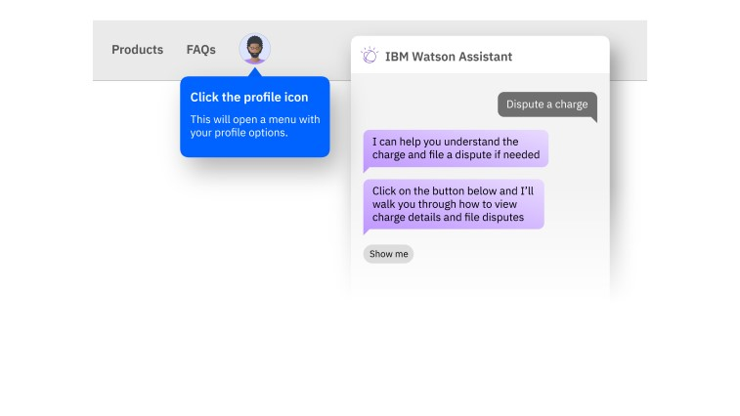

**Section 4:AI and Natural Language Processing (NLP):**

1. Natural Language Processing (NLP):

NLP is a core component of chatbots that enables them to understand and generate human language. Here's how it enhances user interactions:

Text Understanding: NLP algorithms parse user inputs to extract meaning, intent, and entities. For example, if a user types, "Book a flight from New York to London," NLP can recognize the intent (booking a flight) and extract entities (New York and London) for further processing.

Sentiment Analysis: NLP can analyze the sentiment of user messages to determine whether they are happy, sad, or neutral. This information can help the chatbot respond appropriately, showing empathy when needed.

Language Translation: NLP can be integrated with translation services, allowing chatbots to communicate with users in their preferred language, breaking down language barriers.

1. Machine Learning and AI:

AI and machine learning are used in chatbots to continuously improve their performance and personalize interactions:

Intent Recognition: Machine learning models can be trained to recognize user intents based on historical data. This allows chatbots to better understand user requests and provide relevant responses.

Personalization: AI algorithms can analyze user data and preferences to personalize responses. For example, a chatbot for an e-commerce website might recommend products based on a user's past purchases.

Contextual Understanding: AI can help chatbots maintain context throughout a conversation. For instance, if a user asks, "Tell me more about the iPhone," the chatbot can remember that the user is referring to Apple products.

Chatbot Learning: Some chatbots employ reinforcement learning to improve their responses over time. They learn from user feedback and adjust their behavior accordingly.

Integration with External Data: AI-driven chatbots can access external databases, APIs, or information sources to provide users with up-to-date and accurate information. For example, a weather chatbot can fetch real-time weather data from an external source.

3. Enhanced User Interactions:

The integration of AI and NLP technologies enhances user interactions in several ways:

Faster Response Times: Chatbots can process and respond to user queries instantly, improving efficiency and reducing wait times.

24/7 Availability: Chatbots can operate around the clock, providing users with support and information at any time, which is especially useful for global businesses.

Consistency: Chatbots provide consistent responses regardless of the time or number of queries, ensuring a uniform user experience.

Multi-Platform Accessibility: Chatbots can be integrated into websites, messaging apps, and other platforms, making it easy for users to access information or assistance where they are most comfortable.

Scalability: AI-powered chatbots can handle a high volume of concurrent interactions, ensuring that all users receive timely responses.

**Section5:Integration with Existing Systems:**

1. Integration Options:

* Determine how you want to integrate your chatbot. Common options include:
* Web Widget: For adding the chatbot to your website.
* REST API: For integrating with mobile apps or custom interfaces.
* Messaging Platforms: For integrating with platforms like Facebook Messenger or Slack.

2. Configure Integration:

- Depending on your chosen integration method, configure the settings and credentials.

* Implement the necessary code to connect your application with Watson Assistant using the chosen integration method.
* Integrate the Watson Assistant with facebook messenger: select the **Integrate** option at the left bottom of the watson assistan page.
* 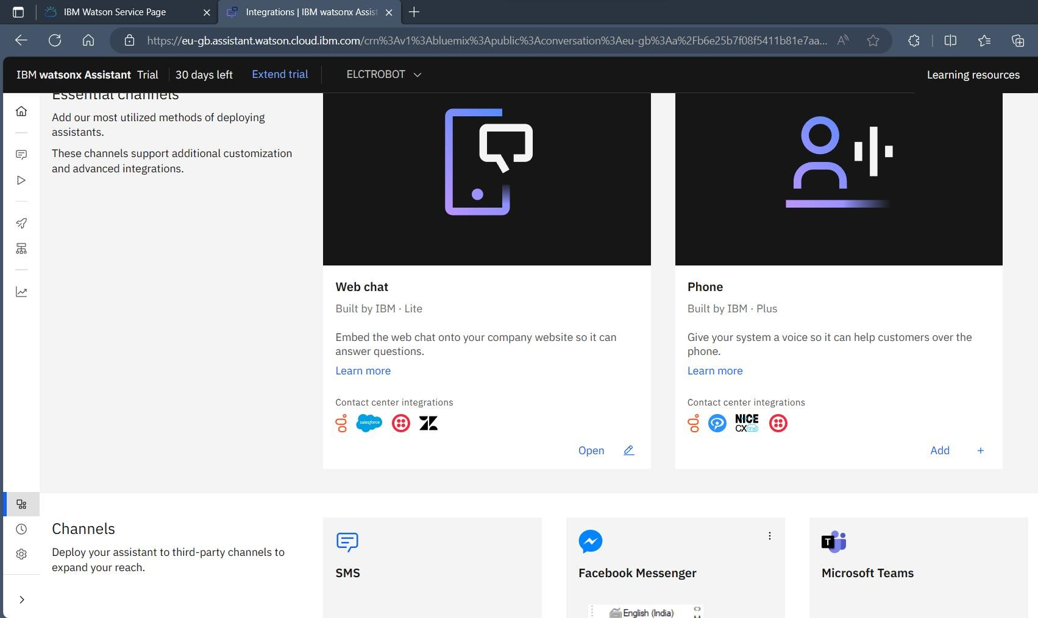
* After creating facebook paste the secret ID in the required field or if you already have an account copy the ID from it and paste the ID.

4. Develop and Deploy:

Deploy the code to your website, app, or messaging platform. You can integrate Watson Assistant into your application or website using the Watson Assistant API. To integrate it into a browser application, you might use the Watson Assistant Web Chat widget or create a custom frontend by creating an new app

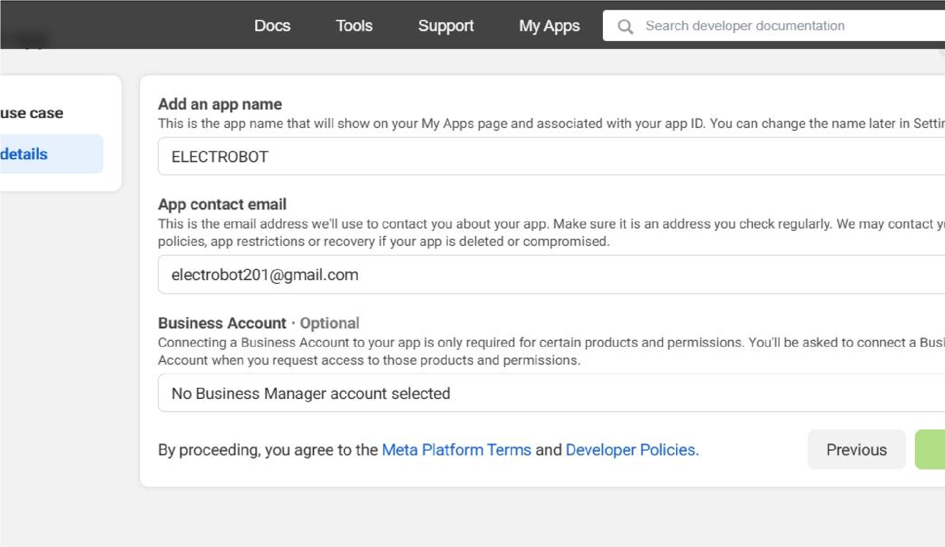

5. Test the Integrated Chatbot:

-

Test your integrated chatbot in its target environment to ensure it works as expected.

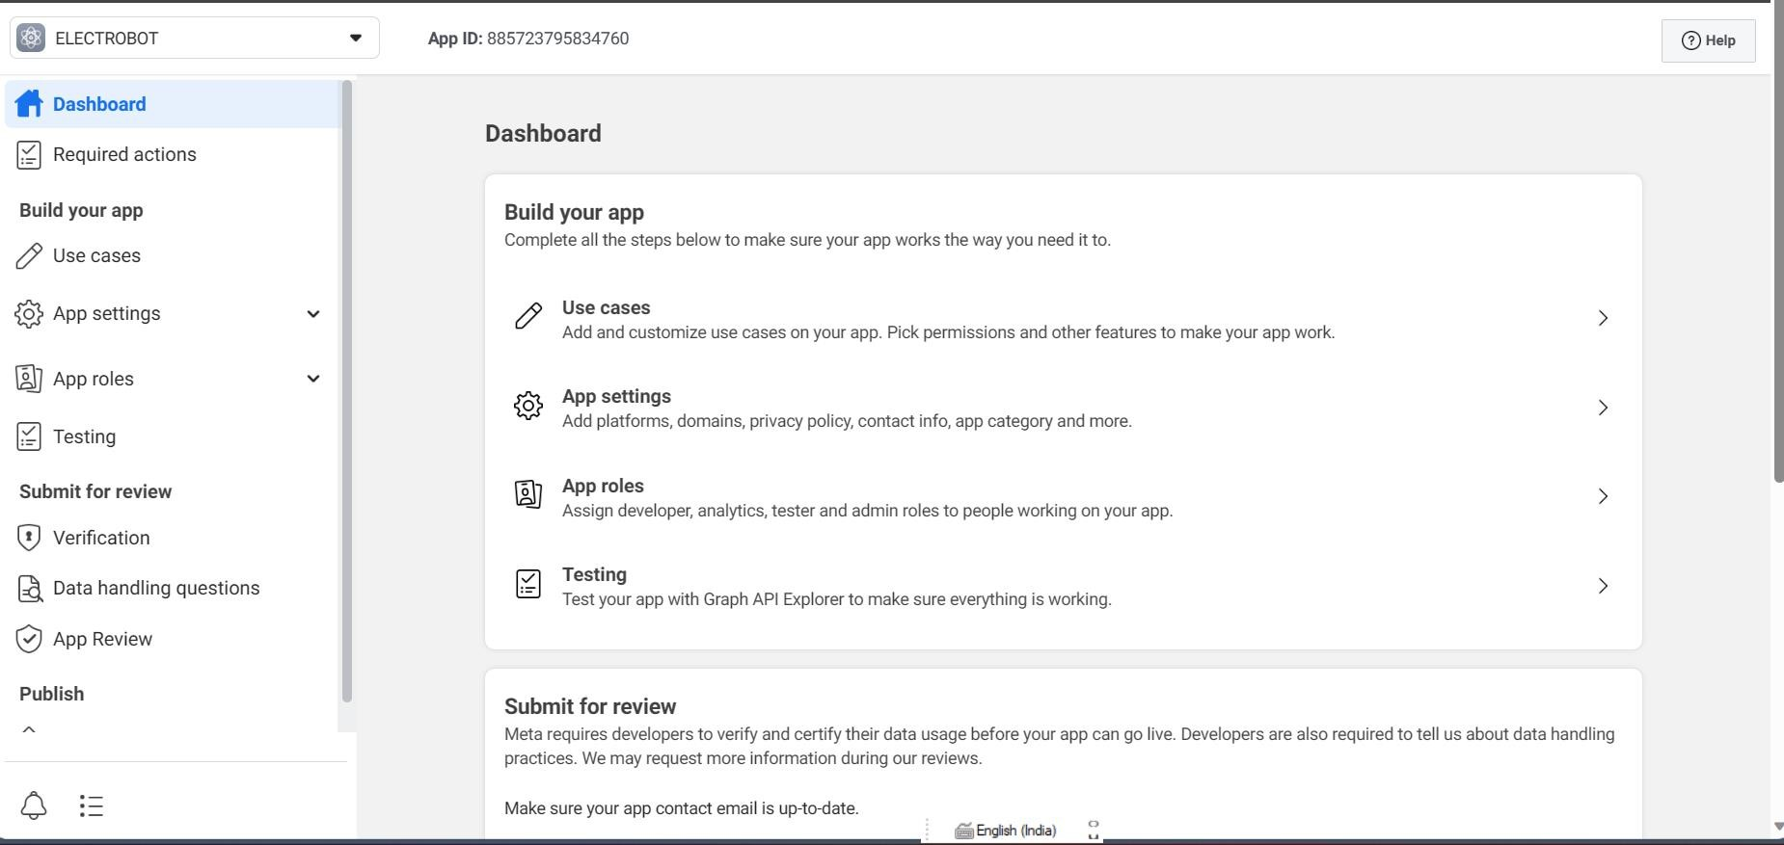

6. Monitor and Refine:

* Continuously monitor the chatbot's performance and user interactions.
* Use analytics and user feedback to improve the chatbot's responses and dialog flow.

7. Scale and Maintain:

* As your chatbot gains users, be prepared to scale your infrastructure accordingly.
* Regularly update and maintain your chatbot to keep it relevant and efficient.

**Section 6:User Training and Support:**

1. User Training Materials:

* Create user-friendly training materials, such as user guides, tutorials, and FAQs, to help users understand how to interact with the chatbot.
* Use clear and concise language, accompanied by visuals and step-by-step instructions.

2. Onboarding Sequence:

* Implement an onboarding sequence when users first interact with the chatbot. This can guide them on how to use the chatbot's features effectively.
* Provide explanations and examples of common commands or queries.

3. In-App/In-Chat Guidance:

* Offer in-chat guidance through on-screen prompts or tooltips that appear during the conversation.
* These prompts can inform users about available commands, features, or shortcuts.

4. Natural Language Assistance:

* Teach users how to interact with the chatbot using natural language. Explain that they can ask questions in a conversational manner.
* Provide examples of how to phrase queries effectively.

5. Feedback Mechanism:

- Include a feedback mechanism within the chatbot interface to allow users to report issues or provide suggestions.

**Conclusion:**

* It is very user friendly tool which helps in answering all kind of questions asked by the user.
* It can answer user questions at any time.
* Watson Assistant's NLU capabilities to understand user intents and entities accurately.
* user-friendly interface for chatbot interactions, whether it's on a website, mobile app, or other platforms.
* It will be useful platform for the users.

## **COLLEGE**: NANDHA COLLEGE OF TECHNOLOGY

## **TEAM MEMBERS**

1. C.MOHANA PREETA(Team leader)
2. S.MYTHILI
3. V.S.NAVIYA
4. T.VIDHYAA
5. M.DIVYASRIDHA