**23EEE214**

**MICROCONTROLLERS AND APPLICATIONS**  
  
  
**MINI PROJECT**

**EV Crash Detection & Safety Monitoring System using PIC16F877A**

**Team Members:**

1. Syed Faazil S - [CB.EN.U4ELC23051]
2. Theneshvar Jayakumar - [CB.EN.U4ELC23053]
3. Vidhyarth S E - [CB.EN.U4ELC23057]

**ABSTRACT**

Electric Vehicles (EVs) are gaining popularity for their environmental and cost advantages. However, safety after a crash is a major concern. A sudden fault or collision can damage key systems and leave passengers unaware of internal issues.

This project presents a simple crash detection and recovery system using the PIC16F877A microcontroller. It monitors battery voltage, battery temperature, and motor current to check the condition of the EV. Crash detection is simulated using a push button input, upon which the system displays an ‘Crash Detected’ message on the LCD screen.

The motor current is sensed using an ACS712 sensor to check if it is functioning correctly. Battery health is tracked using voltage and temperature readings. These simple indicators help identify problems without needing complex hardware.

The system is affordable, compact, and suitable for electric two-wheelers. It continues to work even if the main controller fails, offering a layer of safety and information for post-crash situations. This makes EVs more reliable and user-friendly in real-world use.

**INTRODUCTION**

Electric Vehicles (EVs) rely on multiple sensors for safe operation. However, a crash event or sensor failure can disable the entire system, causing inconvenience and potential hazards. This project aims to develop an EV Crash Safety Check & Recovery System using a PIC16F877A microcontroller to ensure post-crash safety and operational recovery.

The system monitors three key aspects of an EV: the battery, the motor, and crash impact. A temperature sensor monitors battery health. An ACS712 current sensor is used to sense motor activity and identify issues like stalling or overload. Crash detection is simulated using a push button, which acts as a trigger to represent an impact event.

If a fault or crash is detected, the system alerts the user through a buzzer and displays the warning on an LCD. It works as an independent safety module and can continue functioning even if the main EV controller is damaged.

This system provides a simple, low-cost way to improve safety in electric two-wheelers. It ensures the rider is aware of issues after a crash and supports quick recovery or maintenance, making EVs safer and more reliable for everyday use.

**SYSTEM DESCRIPTION**

The **EV Crash Detection and Safety Monitoring System** uses the **PIC16F877A** microcontroller as its central control unit. It monitors the electric vehicle’s battery and motor conditions to identify faults or crash-related anomalies and immediately triggers safety alerts when needed.

* Checks battery temperature and voltage for 10 seconds using an LM35 temperature sensor and DC Voltage sensor.
* Compares temperature and voltage readings against preset safety thresholds.
* Flags abnormal temperature and voltage as a possible internal fault or battery failure.
* Turns ON the motor for 5 seconds after battery check.
* Measures motor current using an ACS712 sensor.
* Identifies any unusual current as a sign of fault or crash damage.
* Uses a push button for crash simulation; pressing it triggers a “Crash Detected” message on the LCD.
* Activates a buzzer and displays fault messages if any issues are detected.
* Provides timely alerts to prevent further risk.

The entire setup is powered through the PIC development board using an external adapter. All components are assembled on a Breadboard for easy integration into EV prototypes or research vehicles.

The system is cost-effective, reliable, and designed with future upgrades in mind, such as wireless alerts or automatic shutdown. Its modular design makes it ideal for educational use and EV safety applications.

**WORK FLOW:**

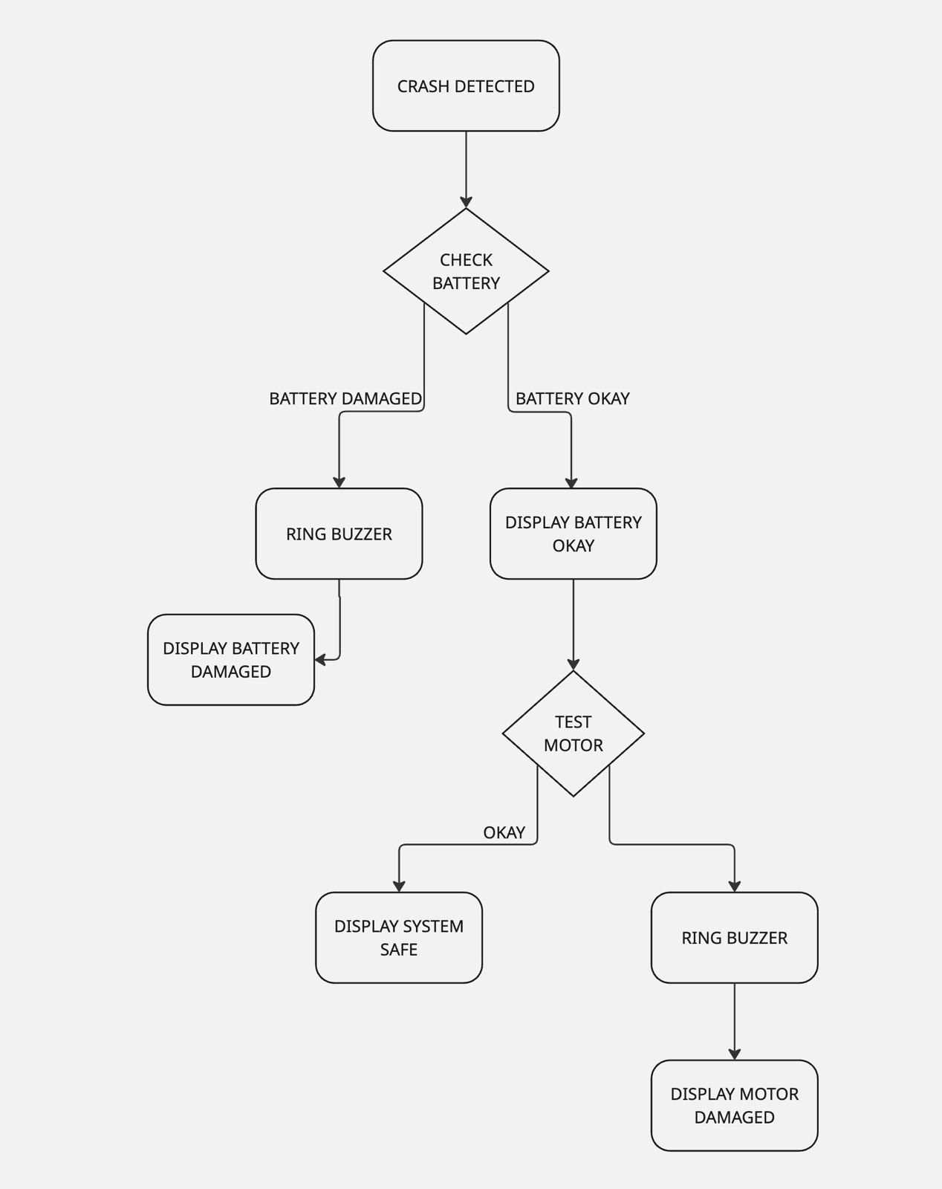

**COMPONENTS USED**

**1. Hardware Components**

* **PIC16F877A Microcontroller**

Acts as the central processing unit, handling sensor inputs and system logic.

* **LM35D Temperature Sensor**

Measures the battery temperature and provides analog signals to the microcontroller.

* **0 – 25V DC Voltage Sensor Module** – for measuring battery voltage
* **ACS712A - 5A Current Sensor**

Measures motor current to detect issues like stalls, overloads, or disconnections.

* **L293D – Motor Driver**

To drive the motor using signals from microcontroller.

* **16x2 LCD Display**

Displays real-time sensor readings and system alerts.

* **Buzzer**

Provides audible alerts during fault or crash conditions.

* **CP2102 USB to Serial Converter**

Interfaces the PIC development board with the PC for program uploading.

* **Power Adapter (for PIC Development Board)**

Powers the microcontroller system independently of the EV battery.

* **Push Button** (for crash simulation)
* **9V Battery** (for testing battery status)
* Breadboard(for assembling the circuit)

**2. Software Tools**

* **MPLAB X IDE**

Used for writing, editing, and managing the embedded C code for the project.

* **XC8 Compiler**

Compiles the C code into a HEX file compatible with the PIC16F877A microcontroller.

* **rhydoLABz Bootloader Tool**

Uploads the HEX file to the microcontroller using the CP2102, without requiring a PICkit.

* **CP2102 Driver**

Enables communication between the PC and microcontroller through the CP2102 USB-to-Serial interface.

**RESULT**

The EV Crash Detection and Safety Monitoring System was successfully implemented using the PIC16F877A microcontroller. The system operated in two phases: battery monitoring and motor testing.

During the battery monitoring phase, the system measured temperature using the LM35 sensor for 10 seconds. These values were displayed on a 16x2 LCD and checked against predefined safe thresholds. When high temperature was detected, a buzzer alert and warning message were triggered on the display.

In the motor testing phase, the motor was turned ON for 5 seconds, and the current drawn was measured using the ACS712 sensor. Faults such as motor stalls or disconnections were detected based on abnormal current readings. Alerts were provided through the buzzer and LCD.

Crash simulation was implemented using a push button. When pressed, the system interpreted it as a crash and displayed “Crash Detected” on the LCD screen.

All components performed reliably, and sensor readings aligned with expected values during testing.

**CONCLUSION**

The developed system effectively detects faults in the battery and motor sections of an electric vehicle. It also supports crash simulation using a push button, with alerts shown on the LCD. The system is simple, low-cost, and reliable—making it suitable for academic and prototype EV safety projects. With minor upgrades like wireless alerts or auto shutdown, its safety features can be further enhanced.

**References:**

* **“Automatic Monitoring and Controlling System for Vehicles using PIC Microcontroller”-***International Journal of Trend in Scientific Research and Development (IJTSRD)*

*https://www.ijtsrd.com/papers/ijtsrd26499.pdf*

* **“Electric Vehicle Safety Issues and the Solutions”-***Highlights in Science, Engineering and Technology*

<https://www.researchgate.net/publication/370576472_Electric_Vehicle_Safety_Issues_and_the_Solutions>

* **“Crash Safety of Hybrid and Battery Electric Vehicles”-***National Highway Traffic Safety Administration (NHTSA)*

www-nrd.nhtsa.dot.gov/departments/esv/22nd/files/22ESV-000096.pdf