🌐 Matribhasha — Interview Master Guide
Complete System Architecture, Technical Schemas, Visual Diagrams, and STAR Interview Q&A
――――――――――――――――――――――――――――――――――――――――――――――――――――――――――

1. Executive Summary & Pitch
📌 30-SECOND ELEVATOR PITCH: "Matribhasha is an open-source, AI-powered multilingual literature and translation platform designed to preserve and democratize Indian regional literature. Built with Next.js 15, TypeScript, MongoDB, and IndicTrans translation microservices, it enables synchronized multi-language reading, community-driven crowd translation with granular page versioning, and Vivar—a bite-sized cultural story feed."

Problem Statement: India has 22 scheduled languages and hundreds of regional dialects, yet over 80% of digital literature and web content is locked in English or Hindi. Regional literature suffers from low discoverability, high manual translation costs, and an absence of collaborative tooling.
The Solution & Core Value: Matribhasha connects readers, AI models, and human contributors into a unified ecosystem with granular page version control, dual-role workflows (reading and translating), real-time progress bookmarks, and cultural quote sharing.

2. High-Level System Architecture
The platform follows a modular full-stack architecture leveraging Next.js 15 App Router, combining serverless API endpoints with decoupled domain modules, storage adapters, and an AI translation fallback cascade:
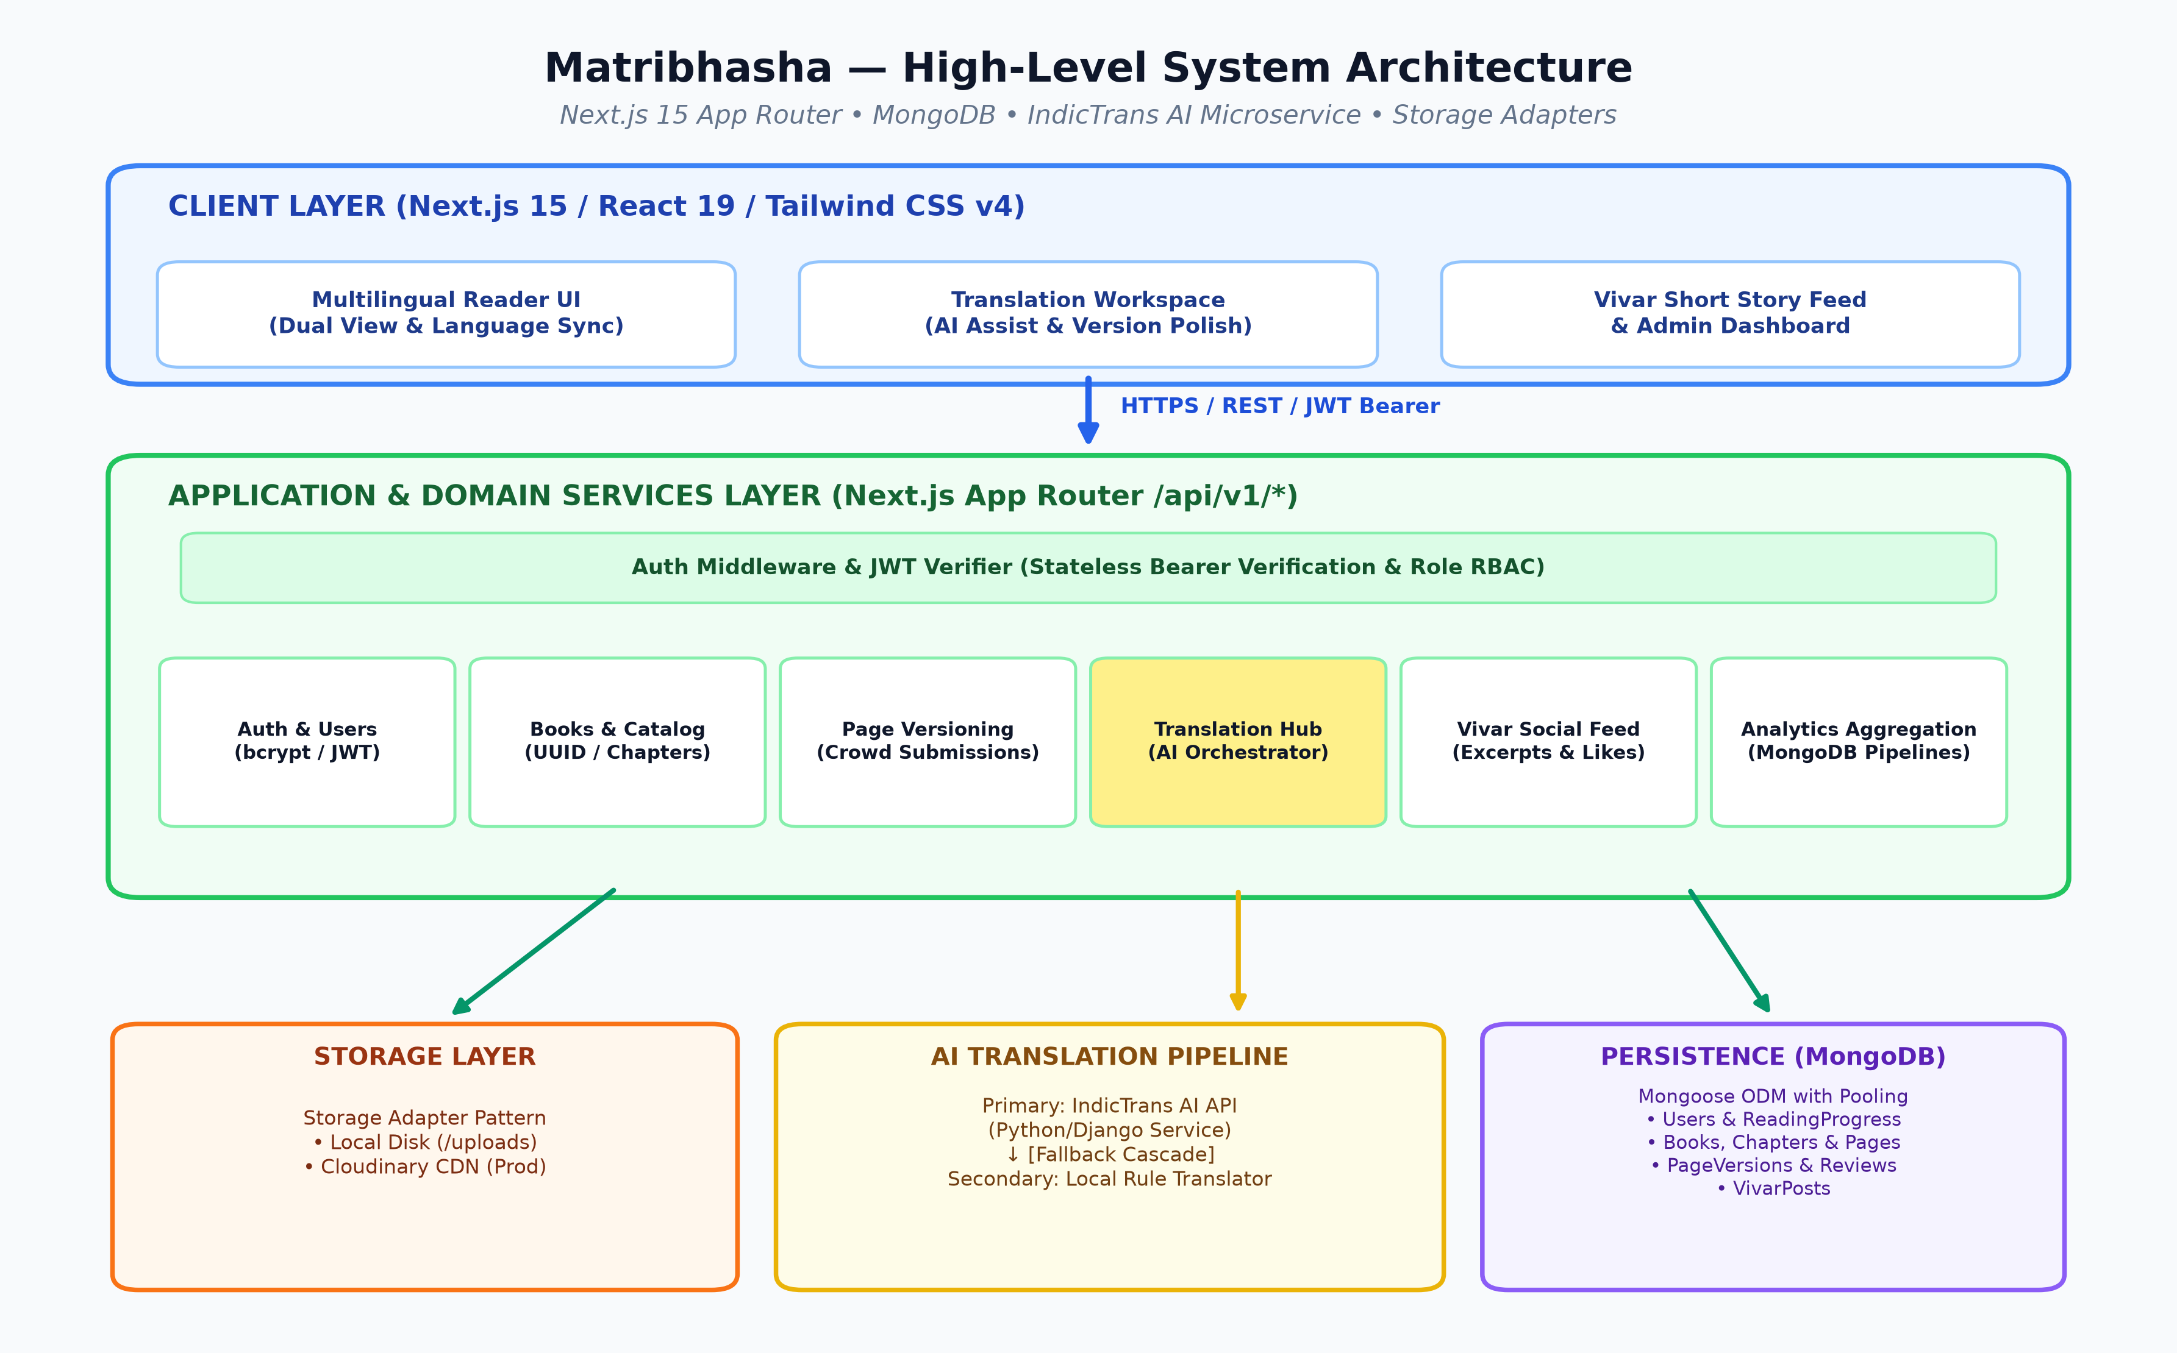
Figure: Matribhasha Full-Stack System Architecture Diagram

3. Database Schema & Data Models (ERD)
The database layer utilizes MongoDB with Mongoose ODM. It employs a normalized three-tier model (Book -> Page -> PageVersion) to support granular multi-version crowdsourced translations while maintaining high read throughput:
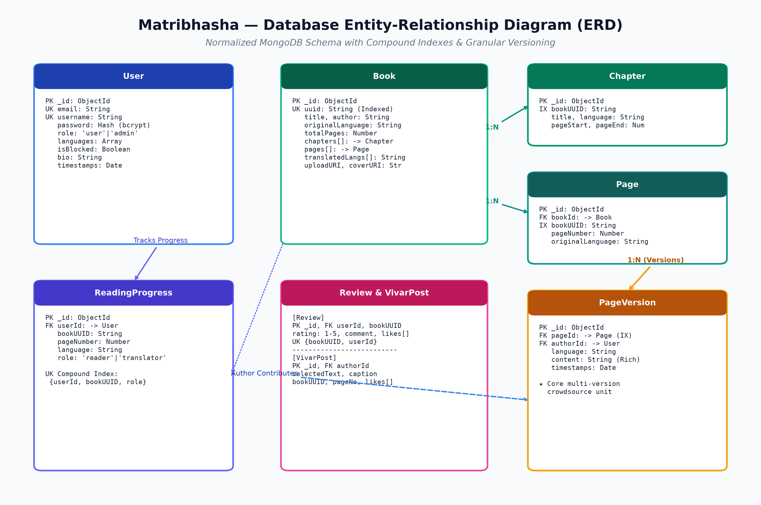
Figure: Entity-Relationship Diagram & MongoDB Schema Architecture
Core Schema Reference:
Model | Key Fields & Types | Indexes / Constraints | Role in Architecture
User | name, username, email, password (hashed), role, languages[], bio, isBlocked | email (UK), username (UK sparse) | Auth & community profile management
Book | uuid, title, author, originalLanguage, totalPages, chapters[], pages[], uploadURI, coverURI | uuid (UK, indexed) | Core catalog entity & master container
Chapter | bookUUID, title, language, pageStart, pageEnd | bookUUID (Indexed) | Logical navigation unit within books
Page | bookId, bookUUID, pageNumber, originalLanguage | bookUUID + pageNumber | Physical anchor for granular versioning
PageVersion | pageId (FK), authorId (FK), language, content | pageId (Indexed) | Stores independent translation versions per page
Review | bookUUID, userId (FK), rating (1-5), title, comment, likes[] | bookUUID + userId (UK) | Book ratings and community reviews
ReadingProgress | userId (FK), bookUUID, pageNumber, language, role | userId + bookUUID + role (UK) | Remembers reading & translator page bookmarks
VivarPost | selectedText, caption, bookUUID, bookTitle, pageNumber, language, likes[] | authorId, createdAt | Bite-sized social snippet & viral acquisition loop

4. Core Workflows & Data Flows

4.1. Collaborative Translation & Versioning Lifecycle
The translation workflow connects human contributors with IndicTrans AI inference and resilient local fallbacks:
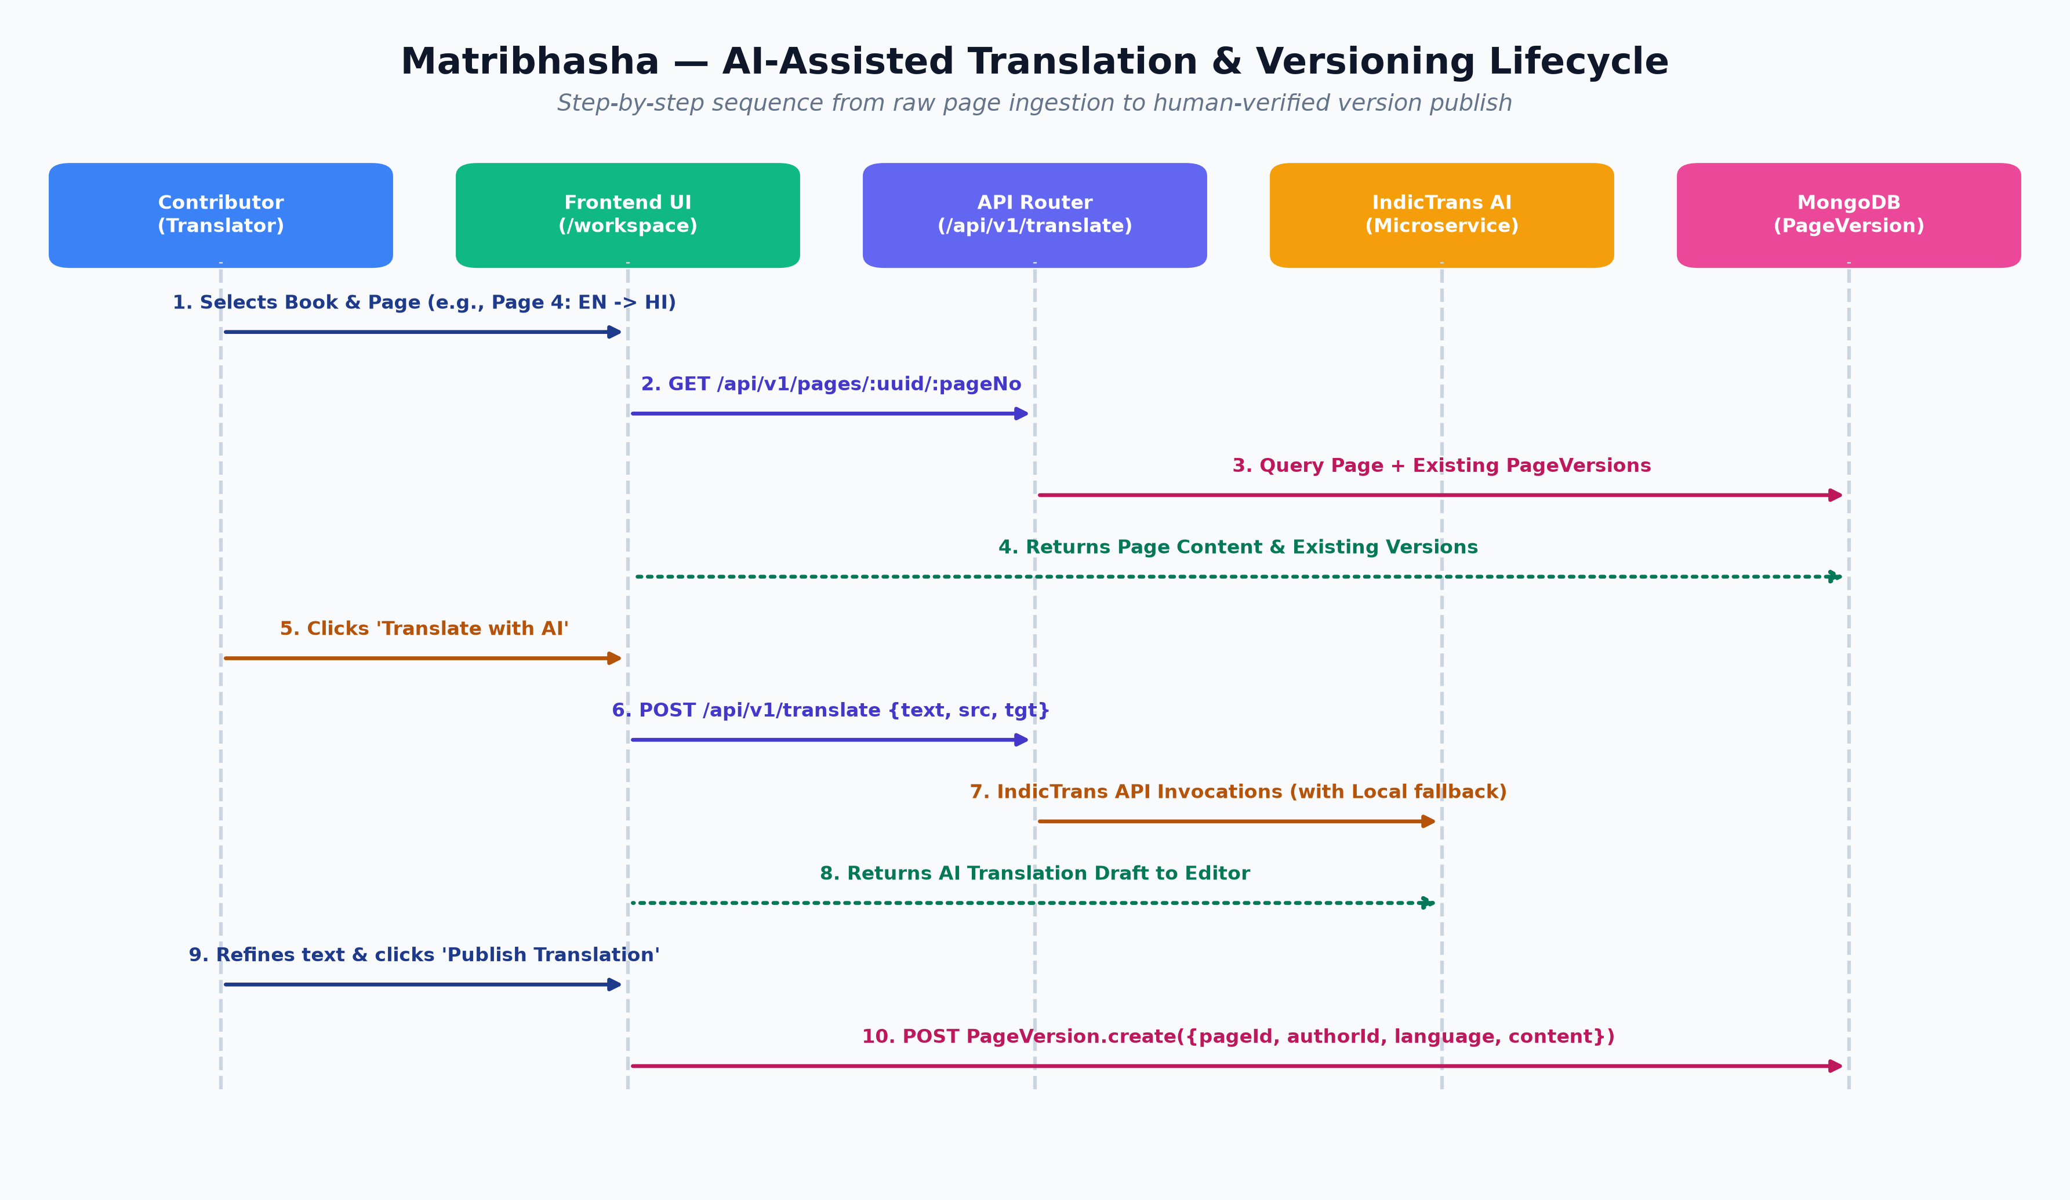
Figure: Sequence Diagram: AI-Assisted Page Translation & Versioning Lifecycle

4.2. Vivar Social Feed & Reading Engine Loop
Vivar provides a viral growth loop connecting casual excerpt browsers into active book readers and translators:
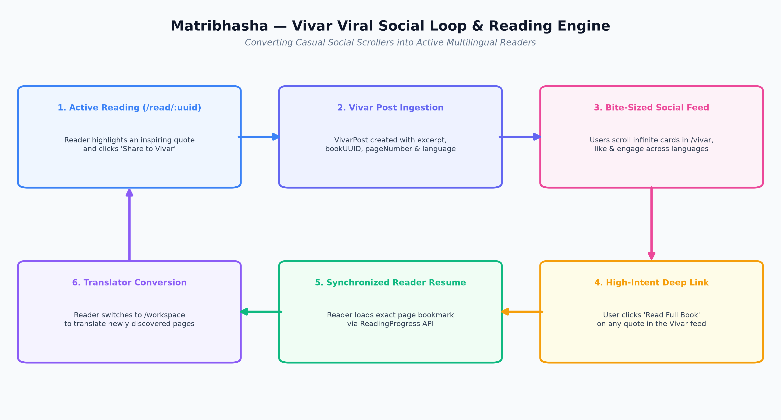
Figure: Vivar Social Growth Loop & Synchronized Reading Engine

5. RESTful API Architecture & Endpoints
Category | Method | Endpoint | Auth Level | Description
Auth | POST | /api/v1/signup | Public | Registers user with bcrypt password hash & returns JWT
Auth | POST | /api/v1/login | Public | Authenticates credentials & returns 7-day JWT Bearer token
Books | GET | /api/v1/books | Public | Search, filter by language/genre, and paginate book catalog
Books | POST | /api/v1/books | Admin / Auth | Upload new book metadata, cover art, and document files
Books | GET | /api/v1/books/:uuid | Public | Fetch book metadata, total chapters, pages, and stats
Pages | GET | /api/v1/pages/:uuid/:pageNo | Public | Fetch original page content and available translations
Pages | POST | /api/v1/pages/:uuid/:pageNo | Auth | Submit a new human or AI translation version
Translate | POST | /api/v1/translate | Auth | Real-time AI translation with automatic fallback cascade
Vivar | GET | /api/v1/vivar | Public | Paginated feed of short cultural quotes and snippets
Vivar | POST | /api/v1/vivar | Auth | Post quote excerpt directly from reader highlight
Progress | GET / POST | /api/v1/users/progress | Auth | Sync reader or translator current page bookmark
Analytics | GET | /api/v1/admin/analytics | Admin | Aggregation stats (books, versions, top authors, monthly growth)

6. Key Technical Decisions & Trade-offs
• 1. Granular Page-Level Versioning vs. Monolithic Whole-Book Translation: Translating an entire 300-page book in one go hits LLM context windows, incurs high GPU costs, and overwhelms human volunteers. Splitting books into discrete PageVersion documents lowers the contribution threshold to just 5 minutes per page and allows parallel community translation.
• 2. Storage Adapter Pattern (Cloudinary + Local Disk): Implemented an abstract StorageAdapter interface with LocalStorageAdapter and CloudinaryStorageAdapter. This enables zero-cost, offline local development without external dependencies, while production can effortlessly switch to Cloudinary CDN via environment variables without changing any domain code.
• 3. Translation Orchestrator with Graceful Fallback Strategy: Rather than tightly coupling the app to a single AI endpoint, the translation service wraps IndicTrans with an automated fallback to a local rule/dictionary engine. If the AI microservice is down, cold-booting, or rate-limited, the user experience never breaks.
• 4. Compound Database Indexes for Concurrency & Zero Data Duplication: Used MongoDB compound unique indexes on Review (bookUUID + userId) and ReadingProgress (userId + bookUUID + role). This enforces data integrity and isolates reader/translator states directly at the database engine level with zero application lock overhead.

7. Interview Q&A Cheatsheet (STAR Format)

Q1: Tell me about Matribhasha and why you built it.
• Situation: India's regional literary wealth is largely unavailable digitally in native regional languages.
• Task: Design an open-source, scalable platform uniting AI translation models with community crowd-polishers.
• Action: I built a Next.js 15 App Router platform with MongoDB, structured around granular page versioning, an IndicTrans AI translation microservice, and Vivar (a quote-sharing social loop).
• Result: Delivered an accessible reading & translation workspace supporting 10+ Indic languages with sub-second version switching and real-time progress bookmarks.

Q2: How did you design the database to handle multiple community translations per page?
• Situation: A book can have dozens of translations across languages, and multiple users might submit different translations for the exact same page.
• Task: Avoid giant bloated documents while maintaining fast reading queries and full version attribution.
• Action: I designed a 3-tier hierarchy: Book (metadata) -> Page (physical book coordinates) -> PageVersion (individual language submissions with authorId).
• Result: Enabled concurrent multi-language translation with zero data redundancy and instant version switching.

Q3: How do you handle failure or latency from external AI translation services?
• Situation: AI models running on GPU servers can suffer cold starts, network latency, or quota exhaustion.
• Task: Ensure contributors never face a broken UI or blocked workflow.
• Action: I implemented a Vendor Strategy Pattern in translate.service.ts. If the primary IndicTrans API fails, the orchestrator catches the exception and immediately invokes the local fallback translator.
• Result: Achieved continuous availability and a seamless translator experience with automatic error telemetry.

Q4: How does the Vivar feature drive user growth and engagement?
• Situation: Casual users often hesitate to commit to reading full books online.
• Task: Create a low-friction viral discovery mechanism for regional literature.
• Action: I built Vivar—a short-form vertical feed of memorable book quotes. Readers can highlight text in the book reader and publish it in one click. Feed readers can like snippets and click 'Read Full Book' to jump directly to that page.
• Result: Created a high-converting acquisition loop converting social feed browsers into active book readers.

8. Security & Production Engineering Highlights
✔ Stateless Authentication: Secure JWT signing with 7-day expiration and bcrypt password hashing with salt rounds.
✔ Role-Based Access Control (RBAC): Strict route protections isolating regular users from admin catalog management and platform telemetry.
✔ Connection Pool Caching: Global Mongoose cache singleton preventing connection exhaustion in serverless Next.js edge and lambda environments.
✔ Aggregation Performance: Optimized MongoDB aggregation pipelines for dashboard metrics computing counts, multi-version ratio, and top authors in sub-50ms.

