STUDENT PERFORMANCE DASHBOARD – DATA ANALYTICS PROJECT-2

Data Analytics Project Documentation
Submitted By:
Vidhya Karthikeyan
Role:
Junior Data Analyst
Tools Used:
Python, Pandas, Matplotlib, Jupyter Notebook
Dataset:
Student Performance Dataset

Part 1 – Data Loading

1.1 Import Required Libraries
The required Python libraries were imported before starting the analysis.

Code
import pandas as pd
import matplotlib.pyplot as plt
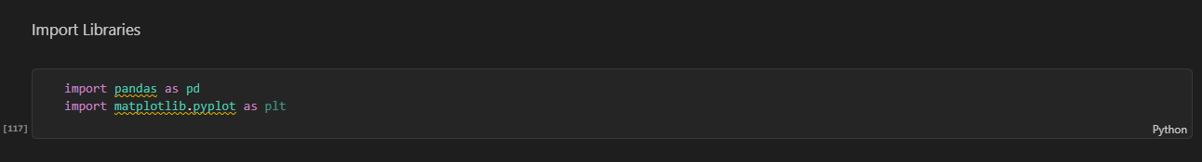1.2 Loading the Dataset

Code

df = pd.read_csv("student_performance_2000.csv")
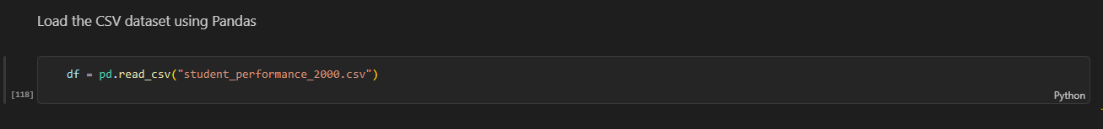

1.3 Displaying the First Five Rows

Code
df.head()
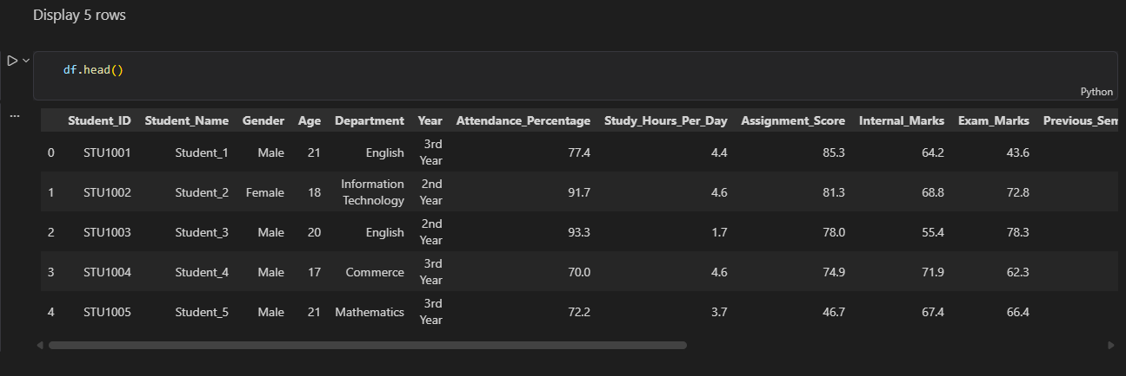

1.4 Dataset Information
The info() function was used to understand the structure, number of records, column types, and non-null values in the dataset.
Code
df.info()
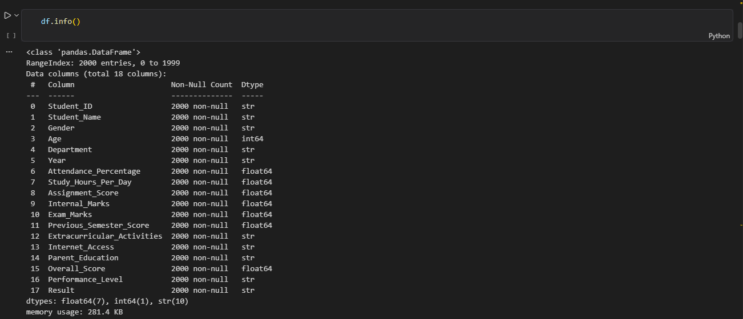
2. Part 2 – Data Cleaning
2.1 Checking Missing Values

Missing values were checked using the isnull().sum() function.

Code
missing_values = df.isnull().sum()
print("Missing values in each column:")
display(missing_values)
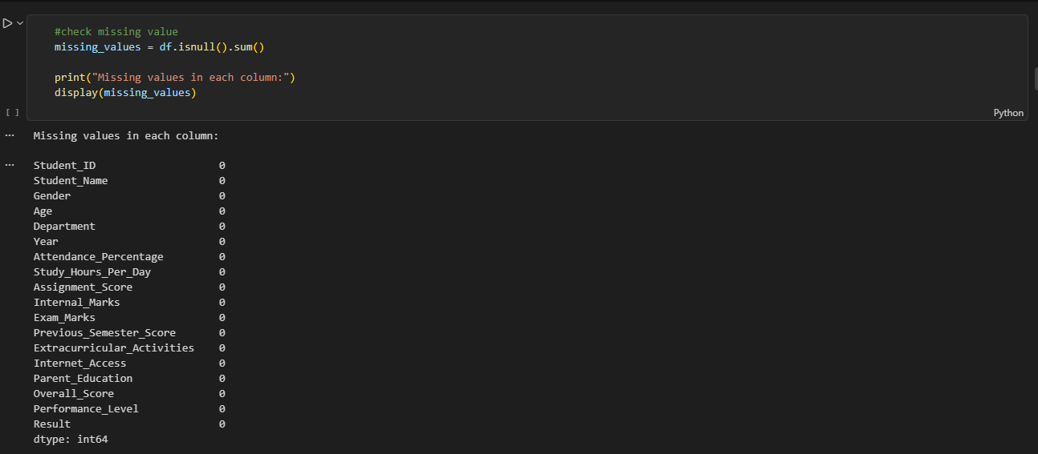

2.2 Removing Duplicate Records
print("Duplicate records:", df.duplicated().sum())
df = df.drop_duplicates()
print("Duplicate records after removal:", df.duplicated().sum)
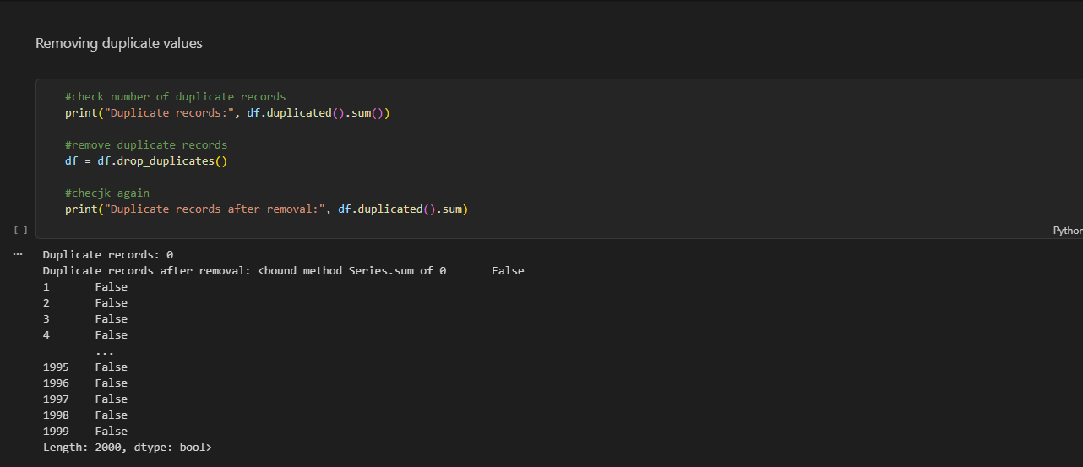

2.3 Correcting Spelling Mistakes
Product spelling inconsistencies were checked and corrected using the replace() function.

Code
df['Gender'] = df['Gender'].replace({
'Mlae': 'Male',
'Fmale': 'Female'
})
df['Department'] = df['Department'].replace({
'CSEe': 'CSE',
'ITt': 'IT',
'ECEe': 'ECE'
})
df['Performance_Level'] = df['Performance_Level'].replace({
'Averge': 'Average',
'Godd': 'Good',
'Excellnt': 'Excellent',
'Pooor': 'Poor'
})
df['Result'] = df['Result'].replace({
'Pss': 'Pass',
'Fal': 'Fail'
})
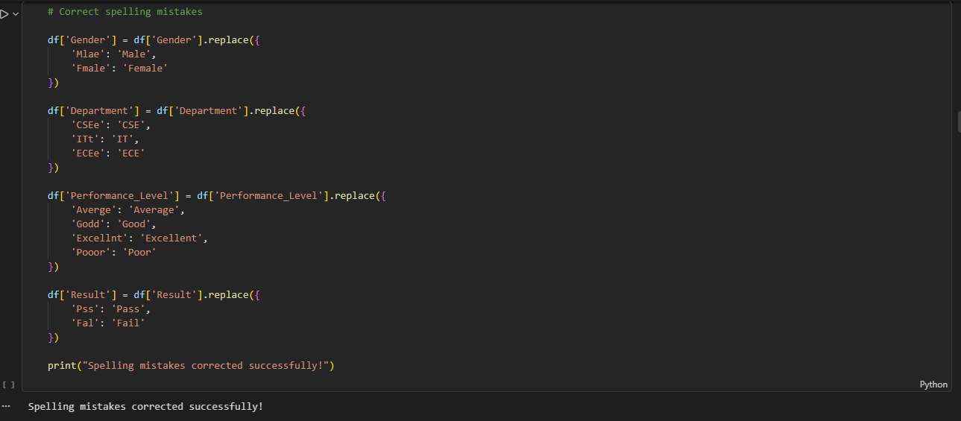

2.4 Converting Date into Datetime Format
The Date column was converted into datetime format using the pd.to_datetime() function.

Code
df['Year'] = pd.to_numeric(df['Year'], errors='coerce')
print(df['Year'].dtype)
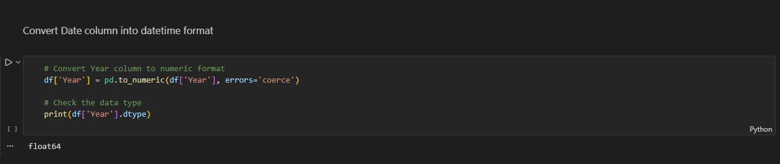
Part 3 — Data Processing Tasks
3.1 Create a new column:

Code
df['Performance_Category'] = pd.cut(
df['Overall_Score'],
bins=[0, 40, 60, 75, 90, 100],
labels=['Poor', 'Average', 'Good', 'Very Good', 'Excellent']
)
print(df[['Overall_Score', 'Performance_Category']].head())
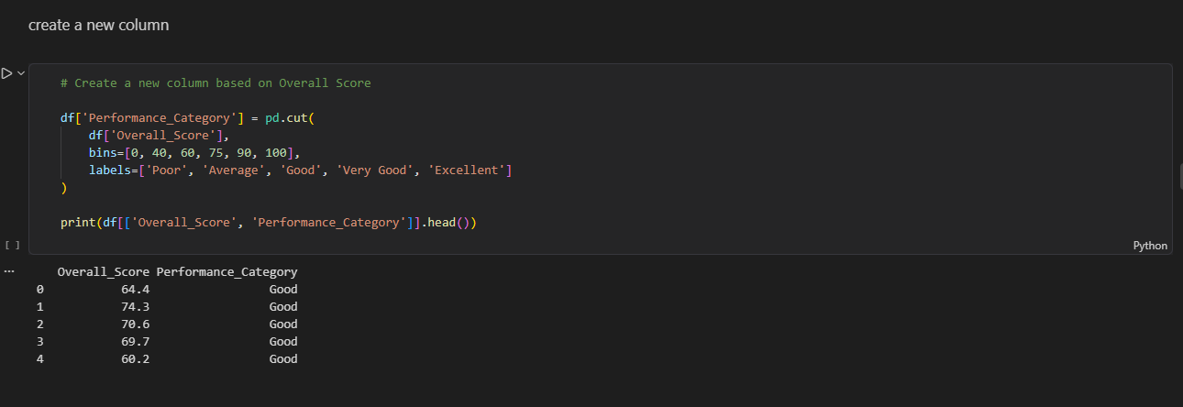

3.2 Calculating Total Marks

Code
df['Total_Marks'] = (
df['Assignment_Score'] +
df['Internal_Marks'] +
df['Exam_Marks']
)
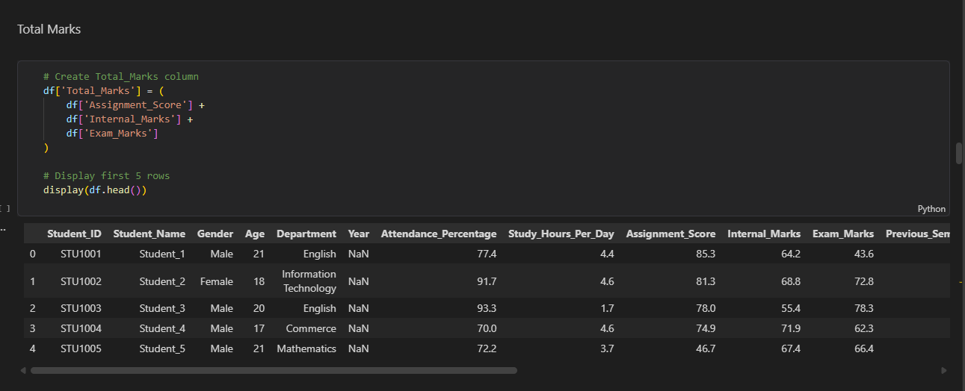
3.3 Calculating Average Marks

Code
df['Average_Marks'] = (
df['Assignment_Score'] +
df['Internal_Marks'] +
df['Exam_Marks']
) / 3

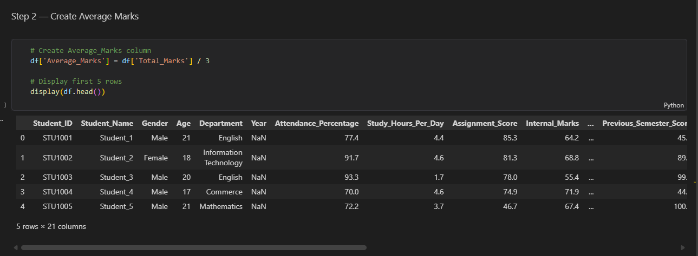
Part 4 – Data Analysis
4.1 Calculating Overall Student Performance

Code
# Find average overall score
average_score = df['Overall_Score'].mean()
print("Average Overall Score:", average_score)
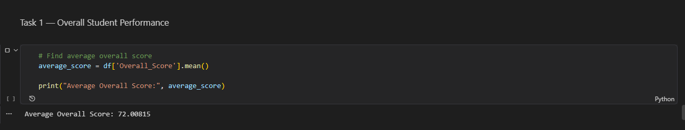
4.2 Top Performing Student
Code
# Find student with highest overall score
top_student = df.loc[df['Overall_Score'].idxmax()]
print("Top Performing Student:")
display(top_student)
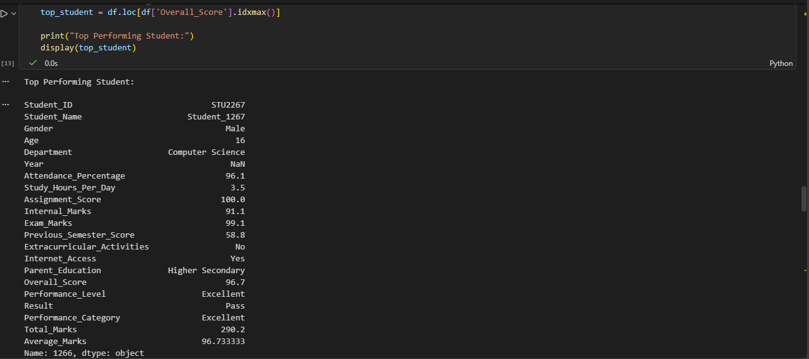

4.3 Best Performing Class
Code
# Find average score for each gender
gender_performance = df.groupby('Gender')['Overall_Score'].mean()

# Find gender with highest average score
best_gender = gender_performance.idxmax()
best_gender_score = gender_performance.max()
print("Best Performing Gender:", best_gender)
print("Average Score:", best_gender_score)

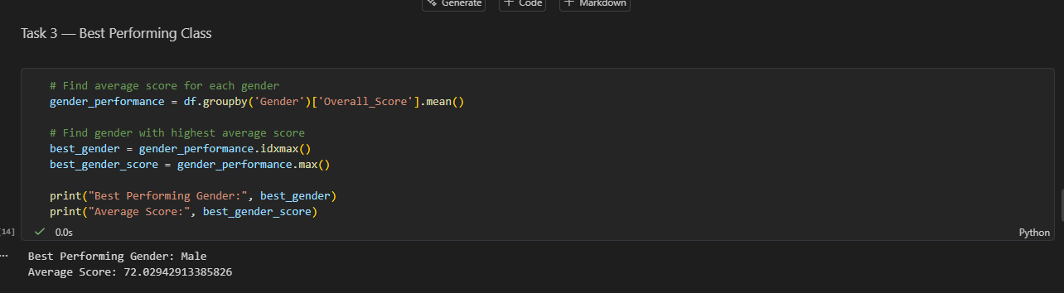

4.4 Gender Analysis
Code
# Find average score for each gender
gender_analysis = df.groupby('Gender')['Overall_Score'].mean()
print("Average Overall Score by Gender:")
display(gender_analysis)
Performance Analysis

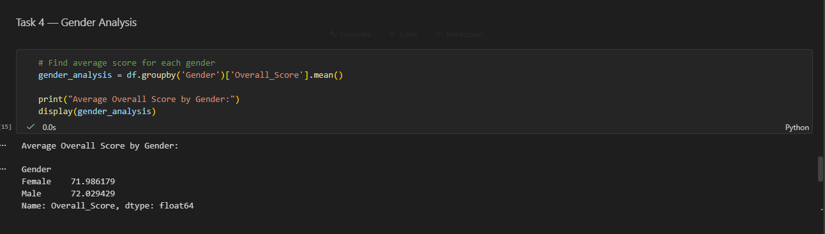
4.5 Analyzing Performance Levels

Code

# Find average overall score for each performance level
performance_analysis = df.groupby('Performance_Level')['Overall_Score'].mean()

print("Average Score by Performance Level:")
display(performance_analysis)

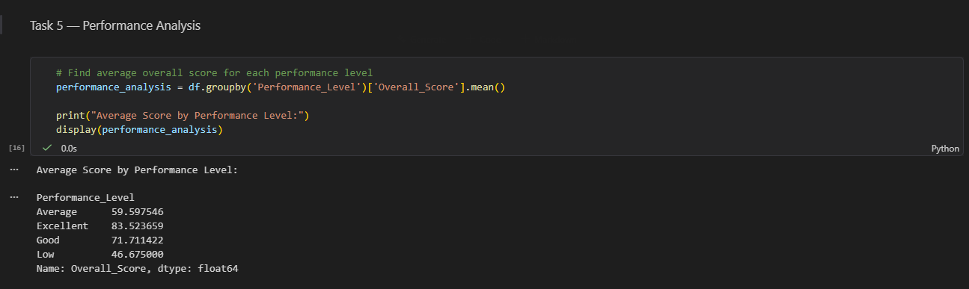

Part 5 — Data Visualization

5.1 Bar Chart: Average Score by Gender

Code
# Calculate average score by gender
gender_score = df.groupby('Gender')['Overall_Score'].mean()

# Create Bar Chart
gender_score.plot(kind='bar')
plt.title('Average Overall Score by Gender')
plt.xlabel('Gender')
plt.ylabel('Average Overall Score')
plt.show()

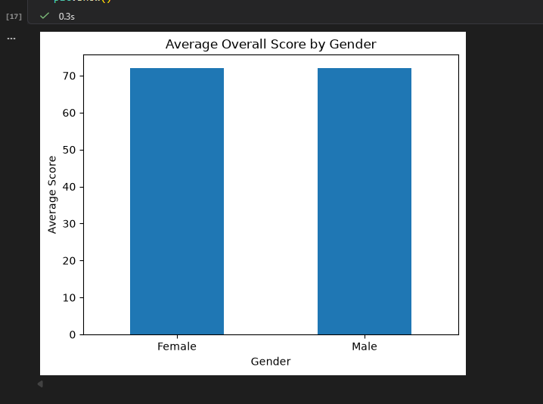
5.2 Pie Chart: Performance Level Contribution

Code
# Count students in each performance level
performance_count = df['Performance_Level'].value_counts()

# Create Pie Chart
performance_count.plot(
kind='pie',
autopct='%1.1f%%'
)
plt.title('Performance Level Distribution')
plt.ylabel('')
plt.show()
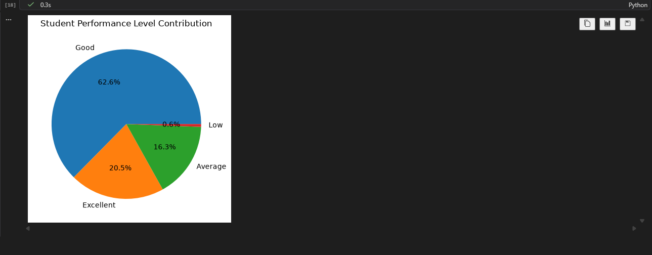

Line Chart: Student Score Trend

Code
# Calculate average score based on Previous Semester Score
score_trend = df.groupby('Previous_Semester_Score')['Overall_Score'].mean()

# Create Line Chart
score_trend.plot(kind='line', marker='o')

plt.title('Previous Semester Score vs Overall Score')
plt.xlabel('Previous Semester Score')
plt.ylabel('Average Overall Score')
plt.grid(True)
plt.show()
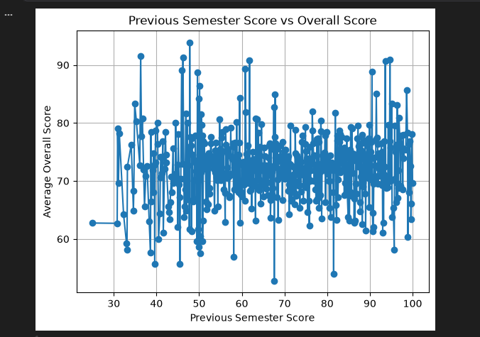

Part 6 — Student Performance Insights

Code
print("1. Students with higher previous semester scores tend to have higher overall scores.")
print("2. Assignment and internal marks contribute to overall student performance.")
print("3. Some students achieve significantly higher overall scores than the average.")
print("4. Performance levels show the distribution of high and low performing students.")
print("5. Average overall scores vary among different student groups.")

Insights
The analysis provides the following key insights:
- Students with higher previous semester scores tend to have higher overall scores.
- Assignment and internal marks contribute to overall student performance.
- Some students achieve significantly higher overall scores than the average.
- Performance levels show the distribution of high and low performing students.
- Average overall scores vary among different student groups.

Part 7 — Recommendations

Code
print("1. Provide additional coaching and study support for students with low scores.")
print("2. Conduct regular assessments to identify students who need improvement.")
print("3. Encourage students to improve their assignment and internal assessment performance.")

Recommendations
- Provide additional coaching and study support for students with low scores.
- Conduct regular assessments to identify students who need improvement.
- Encourage students to improve their assignment and internal assessment performance.

