Load Detection Algorithm

NILM has two main segments: Load Detection, and Load Identification.

Load detection is commonly done by detecting sudden “spikes in power readings. There is a lot of background ‘noise’ on the mains readings, and this causes load detection of small-power events to be hidden, which can lead to inaccurate readings and results. Due to this, the signals need to be processed before we can use their data for NILM.

In order to extract the “event”, we need to find the edges (i.e transient).

Step1: Median filter algorithm:

We first apply a median filter algorithm to the signal. The median filter algorithm replaces each signal record with the median of its neighbors, within a specified predefined distance ‘d’. This ‘d’ ctis like a window, which slides over the entire window. This has the effect of “smoothing” out the signal.

Picking a suitable d value is important. More information on picking the ‘d’ value can be found in Section 2 - Part A, of detection2.pdf.

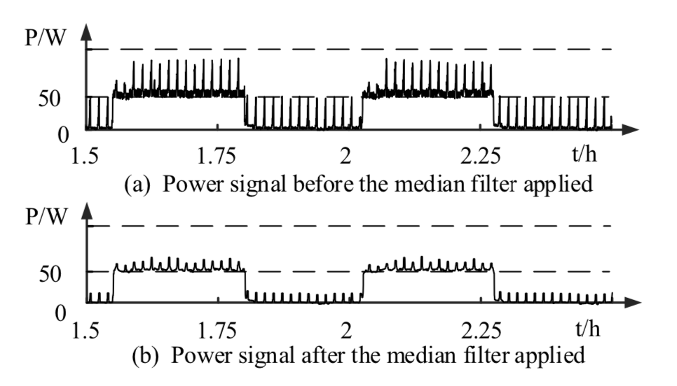

Implementations of median filter algorithm are available in the scipy library, python.

<https://docs.scipy.org/doc/scipy/reference/generated/scipy.signal.medfilt.html>

Step1 makes the edges much more clear.

Step2: Power ripple mitigation algorithm;

If we look at the above image of a graph after applying Step1, we notice the presence of continuous small spikes in power, or ‘ripples’. These ripples can block out smaller events from taking place, and need to be removed.

Extensive instructions on this procedure is available from the end of Page2 of detection2.pdf.

Steps 1 and 2 allow us to read spikes in power of graphs more accurately. However, this just allows us to detect changes in power output. Now, we need to match these changes in power, to create events.This is done using an event pairing algorithm. Information on creating this event pairing algorithm can be found on page3 of detection2.pdf.

This algorithm allows us to detect the following changes :

1. On-off event
2. Multi-on, one off event
3. One on-event, multi-off event