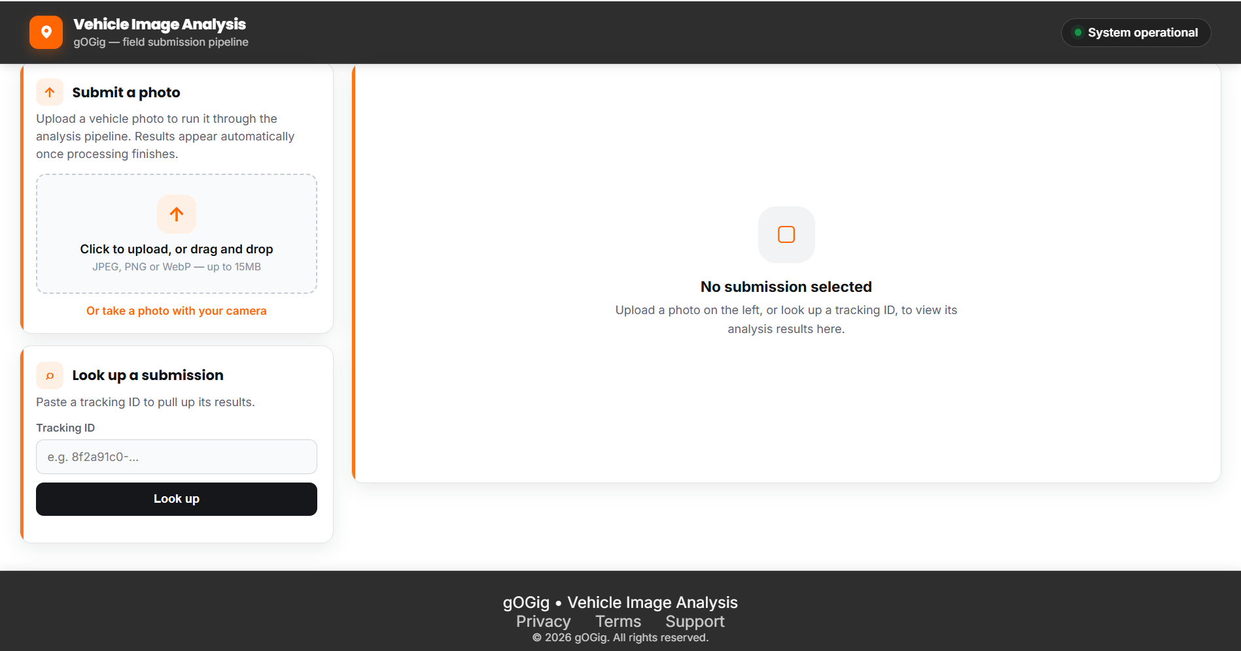
Vehicle Image Analysis Dashboard – Initial Interface

OUTPUTS:
Test Case: Vehicle Image Analysis – Needs Review
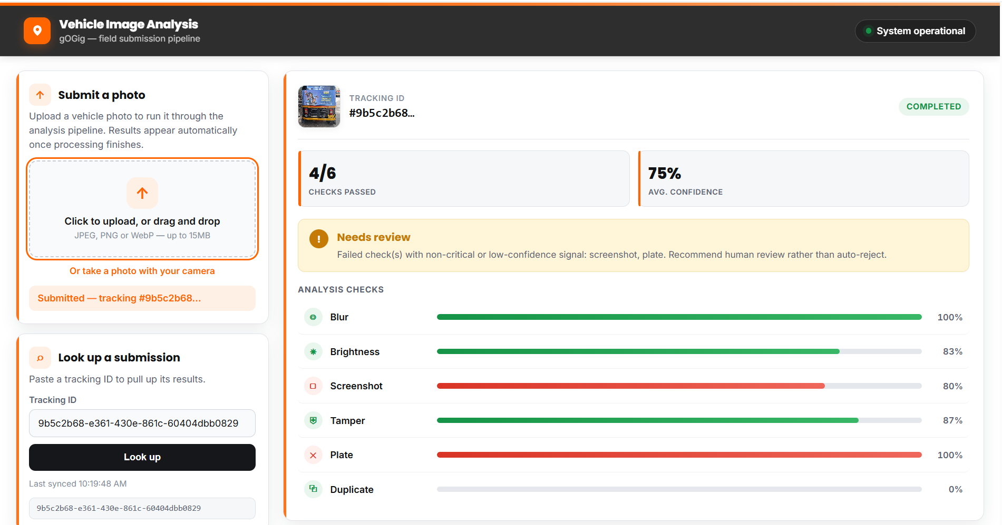
To verify that the system correctly analyzes a submitted vehicle image and identifies cases where some checks fail but do not require automatic rejection.
Test Result
The uploaded image was successfully processed and received a “Needs Review” recommendation.
- Checks Passed: 4/6
- Average Confidence: 75%
- Status: Completed
- Recommendation: Needs Review

Test Case: Duplicate Image Detection
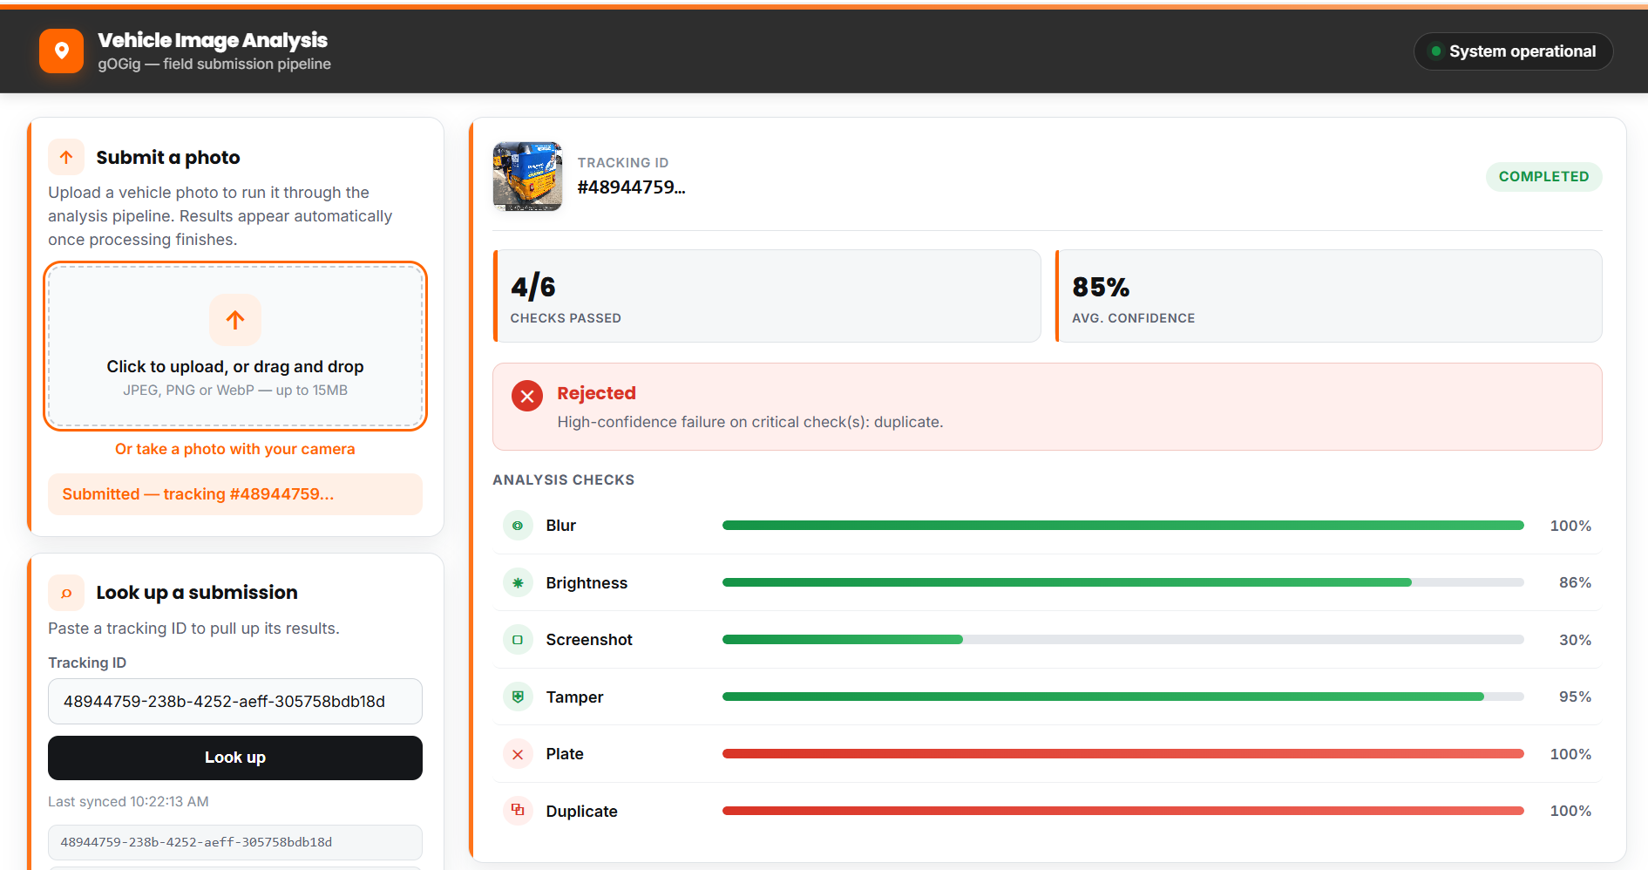
Test Result
The uploaded image was successfully processed and received a “Rejected” recommendation.
- Checks Passed: 4/6
- Average Confidence: 85%
- Status: Completed
- Recommendation: Rejected
- Reason: The image was identified as a duplicate with 100% confidence.

Test Case: Duplicate Vehicle Image Detection and Rejection
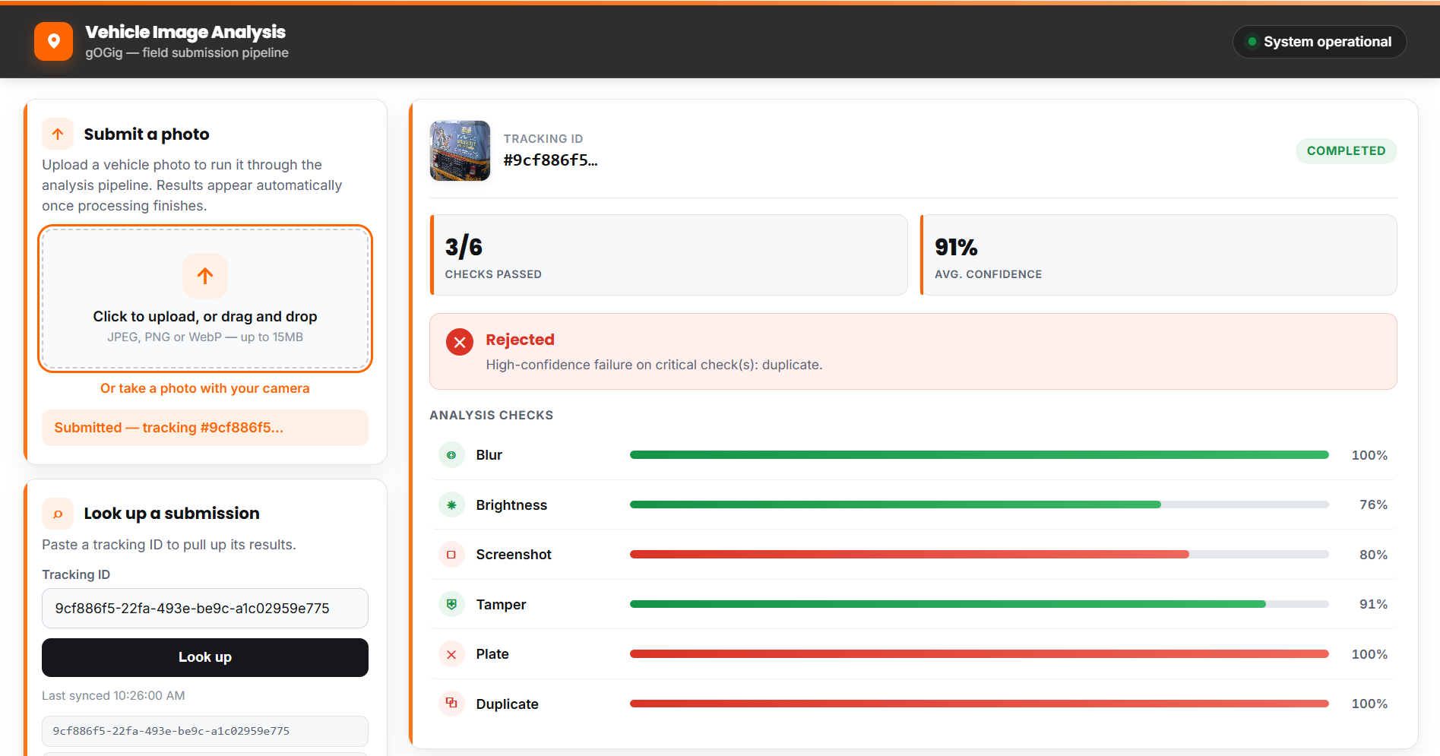
Test Result
The uploaded image was successfully processed and received a “Rejected” recommendation.
- Checks Passed: 3/6
- Average Confidence: 91%
- Status: Completed
- Recommendation: Rejected
- Reason: A duplicate image was detected with 100% confidence, which is a critical check failure.

Test Case: Vehicle Image Analysis with Non-Critical Plate Check Failure
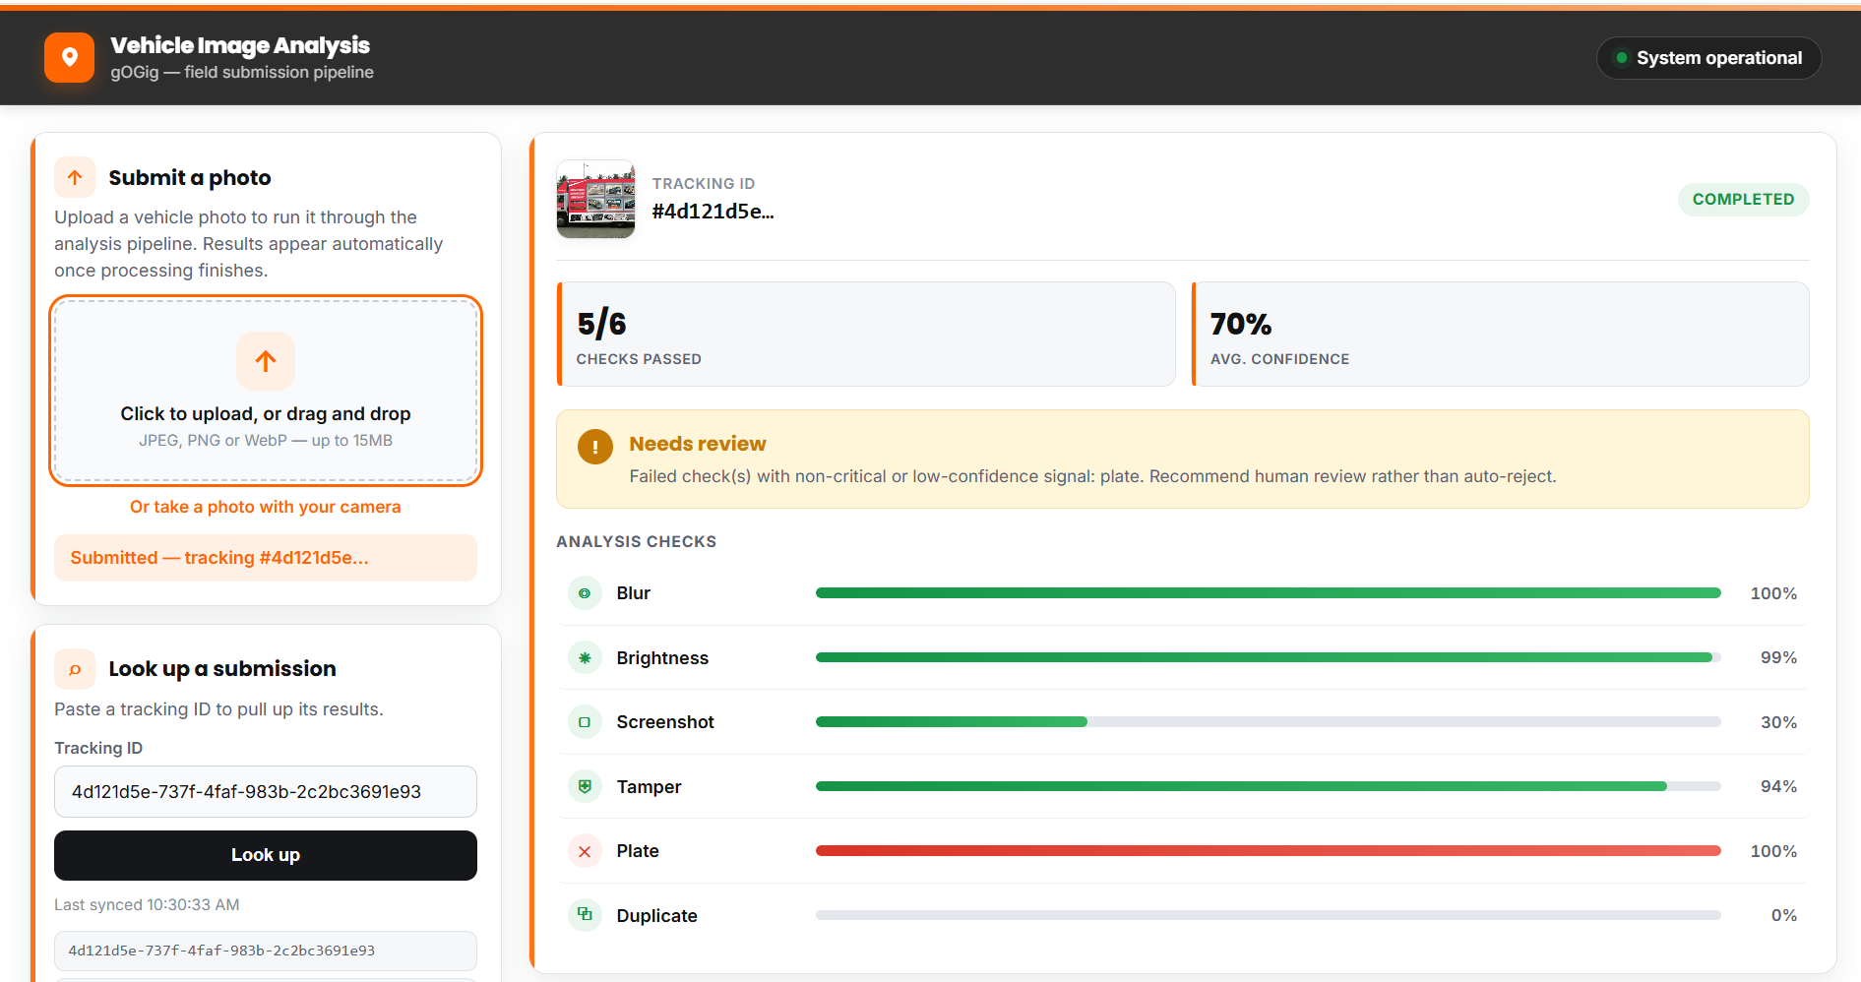
Test Result
The uploaded image was successfully processed and received a “Needs Review” recommendation.
- Checks Passed: 5/6
- Average Confidence: 70%
- Status: Completed
- Recommendation: Needs Review
- Reason: The Plate check failed, while the other checks passed. Since the plate failure was treated as a non-critical or low-confidence signal, the system recommended human review instead of automatic rejection.

Test Case: Different Vehicle Image
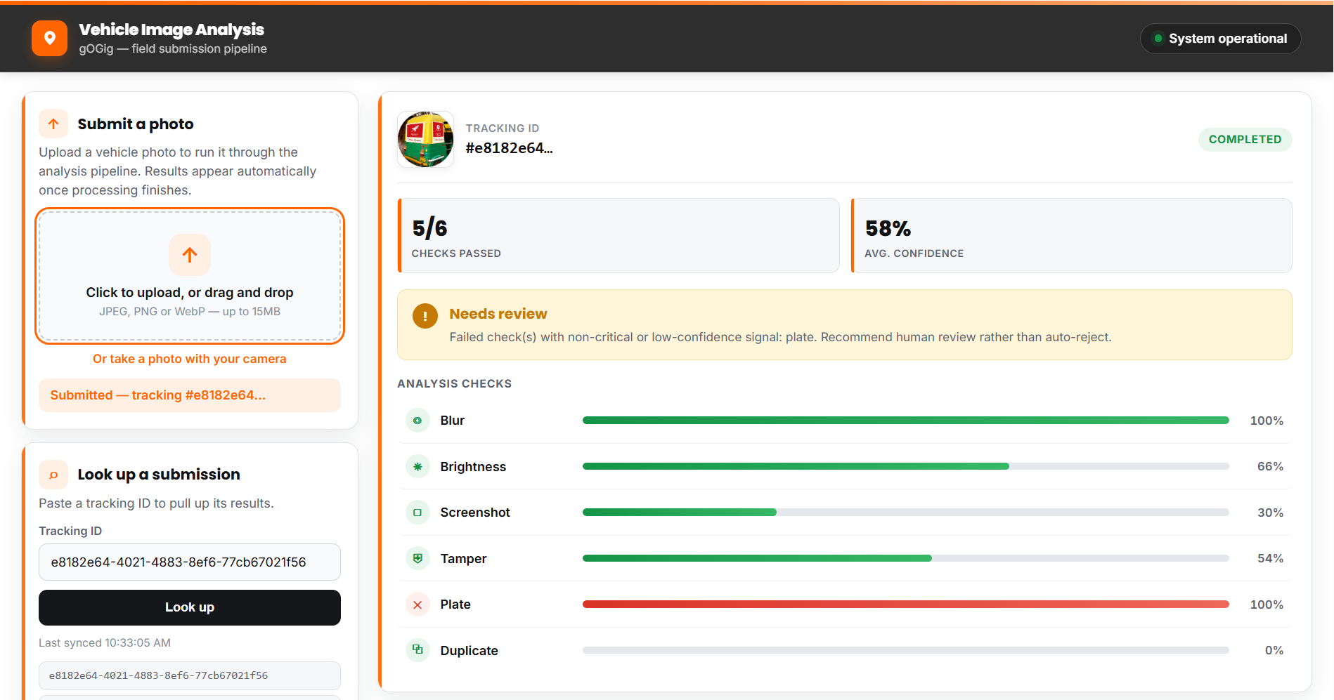
Test Result – Different Vehicle Image
The uploaded image was successfully processed and received a “Needs Review” recommendation.
- Checks Passed: 5/6
- Average Confidence: 58%
- Status: Completed
- Recommendation: Needs Review
- Failed Check: Plate
- Duplicate Check: Passed (0%)
Reason: The image was a new vehicle image, so it was correctly identified as not a duplicate. However, the plate check failed, resulting in a human-review recommendation despite the other checks passing.

