Titanic Dataset is a dimensional table in the Datasets package, with information about the future of travelers on social class, gender, age, survival etc. according to the future of Titanic. To make it suitable for the association rule mining, we rebuild the raw information as a titanic, where each row represents a person.

Function apriori () Mine frequent item sets, association rules or association hyperedges using the Apriori algorithm. The Apriori algorithm employs level-wise search for frequent item sets.

Default settings:

* minimum support: supp = 0.1
* minimum confidence: conf = 0.8
* maximum length of rules: maxlen = 10

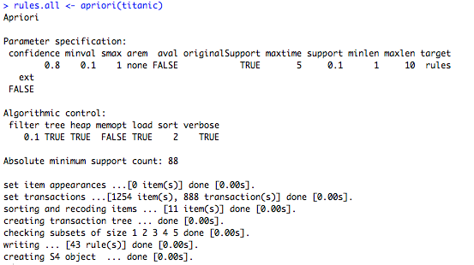





Rule: 2 does not give any special knowledge except Rule: 1, because rules: 1 tells us that all the 3nd class children have survived. When a rule (such as: 2) is a super rule of the second rule (: 1) and the former has the same or lower lift, the former rule (: 2) is considered unnecessary. I have the comparison 4, 7 and 8 rules respectively with other unnecessary rules 3, 6 and 5 in the above results.

