**Homework 6  
Criteo Ad Click**

**Forward Feature Selection   
 Logistic Regression**

Vidit Kalani

MSCS 6520 Business Analytics

Spring 2018

Prof. RJ Nowling

* I choose all features to build my logistic regression forward model. And I work 8 round and my high accuracy is .7462.
* I stop after 8 Round because my accuracy going up but is still in 74%.
* Round 1 my highest accuracy is coming from all features which is .7461. and second highest is X2 + X 11 which is 0.7431.
* Round 2 my highest accuracy is coming from 4 different features selection which is .7438 but I choose X2 + X11 + X17 for next Round.
* Round 3 my highest accuracy is coming from 4 different features selection which is .7438 but I choose X2 + X11 + X17 + X10 for next Round.
* Round 4 my highest accuracy is coming from X2 + X11 + X17 + X10 + X14 which is .7439.
* Round 5 my highest accuracy is coming from X2 + X11 + X17 + X10 + X14 + X21 which is .7447.
* Round 6 my highest accuracy is coming from X2 + X11 + X17 + X10 + X14 + X21 + X18 which is .7452.
* Round 7 my highest accuracy is coming from X2 + X11 + X17 + X10 + X14 + X21 + X18 + X13 which is .7454.
* Round 8 my highest accuracy is coming from X2 + X11 + X17 + X10 + X14 + X21 + X18 + X13 + X3 which is .7462.
* Round 9 I did multinomial selection, and my high accuracy is .7466.

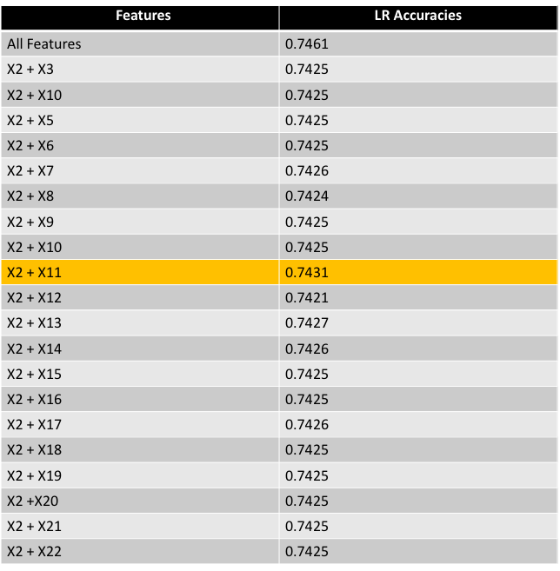

ROUND 1 FORWORDING MODEL

ROUND 2 FORWORDING MODEL :

In this model the accuracy is going up compare to previous Round

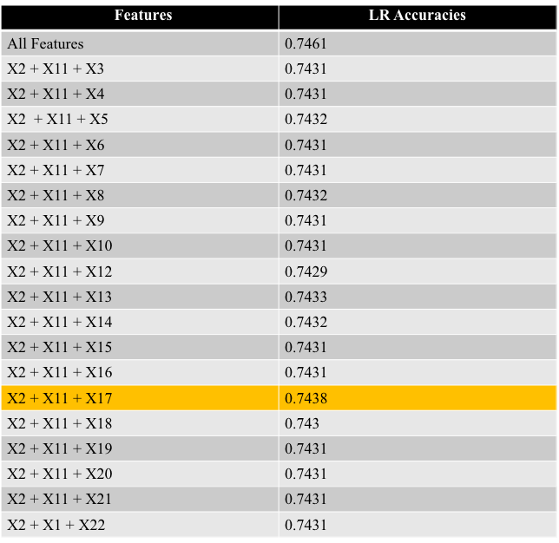

ROUND 3 FORWORDING MODEL:

In this Round the accuracy is going up compare to previous Rounds but the high accuracy is same.

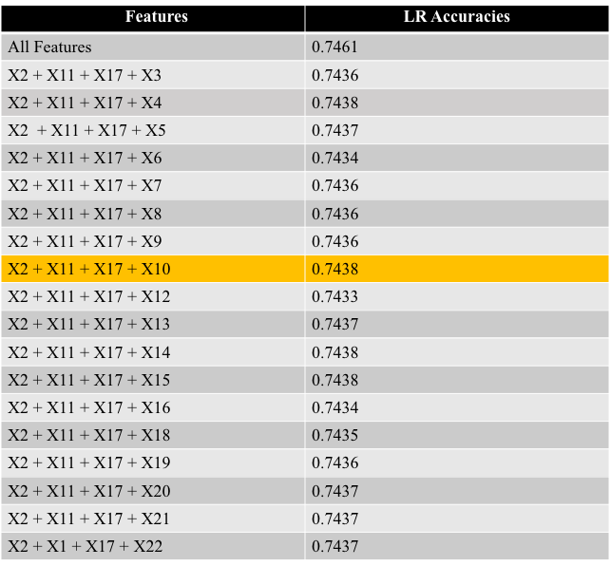

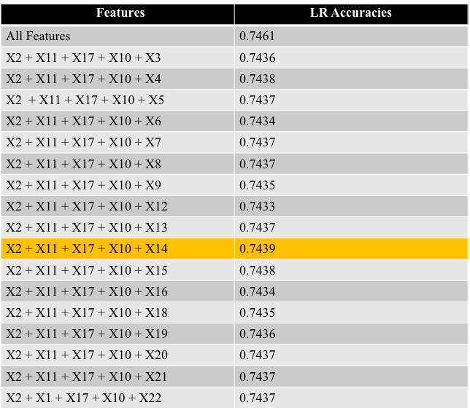

ROUND 4 FORWORDING MODEL:

In this Round the accuracy is not going up but its stable compare to Round 3

ROUND 5 FORWORDING MODEL :

In this Round the accuracy going up compare to previous Rounds

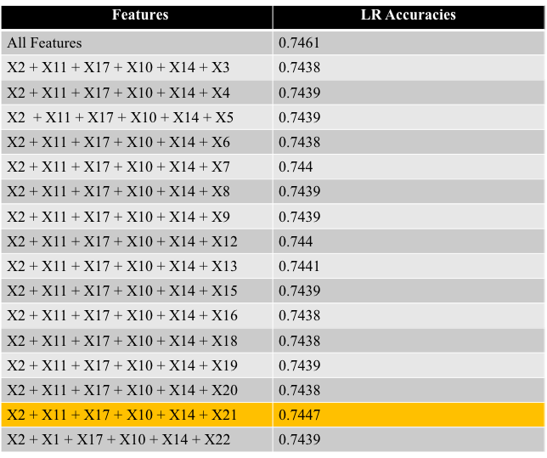

ROUND 6 FORWORDING MODEL :

In this Round the accuracy going up compare to previous Rounds.

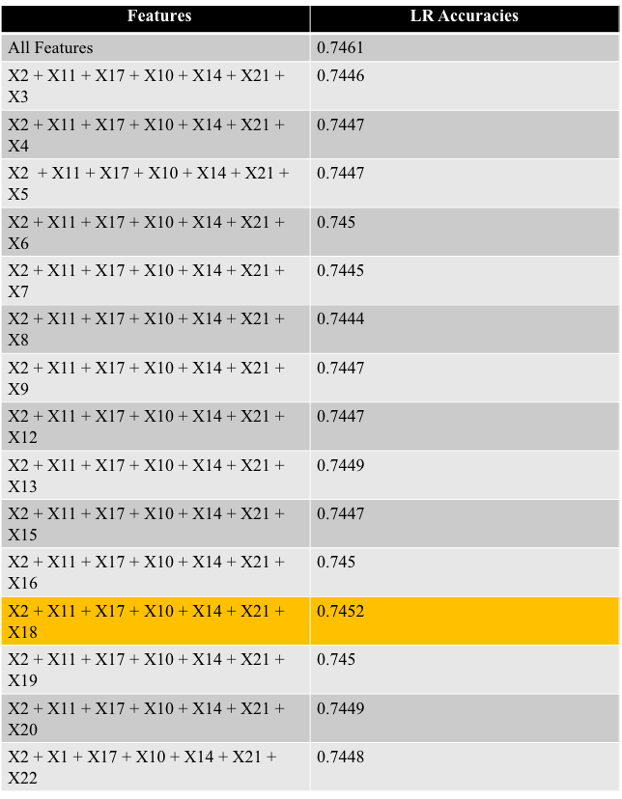

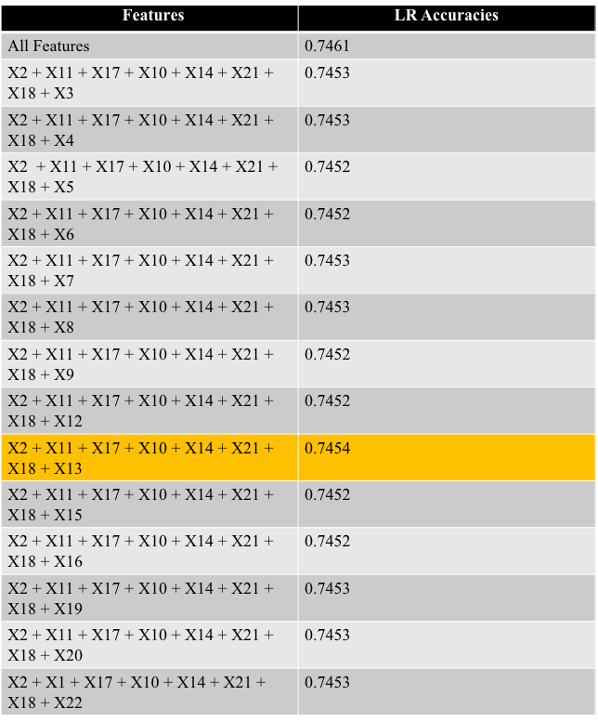

ROUND 7 FORWORDING MODEL :

In this Round the accuracy going up compare to previous Rounds.

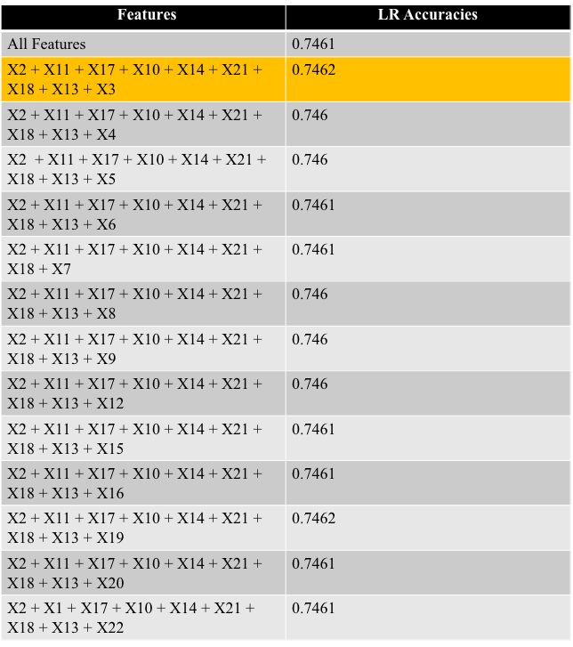

ROUND 8 FORWORDING MODEL :

In this Round the accuracy going up compare to previous Rounds.

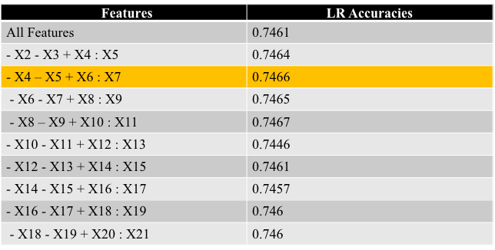

ROUND 9 Multinomial:

In this multinomial model my high accuracy is 0.7466. its high compare to Forward Selection Model.

BoxPlot:

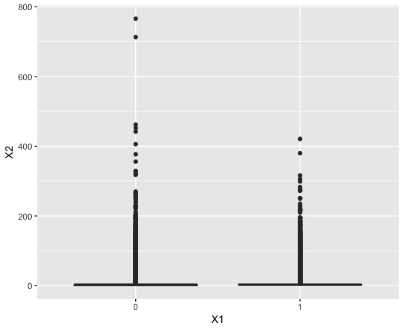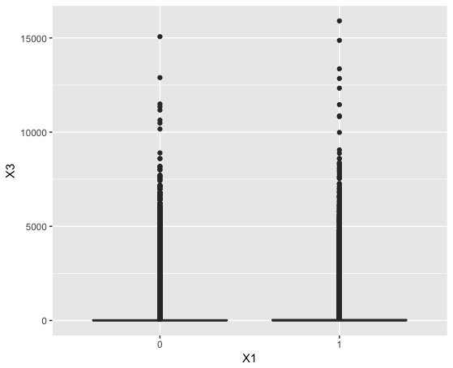

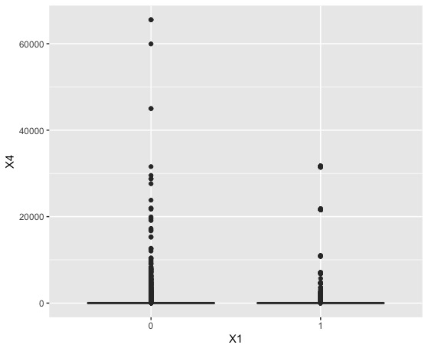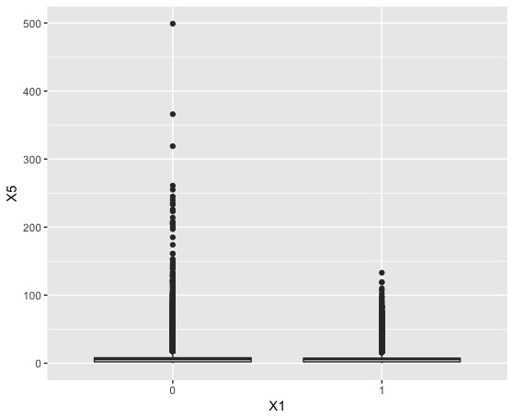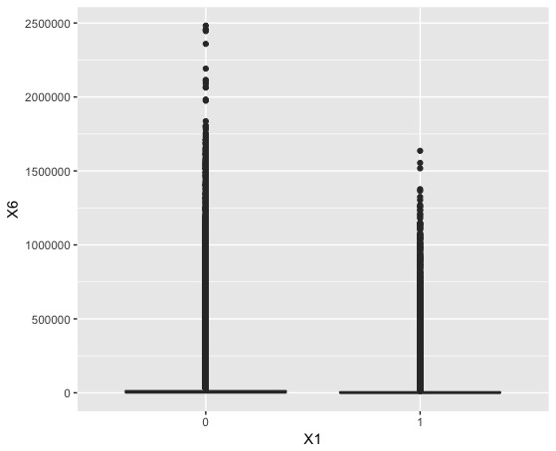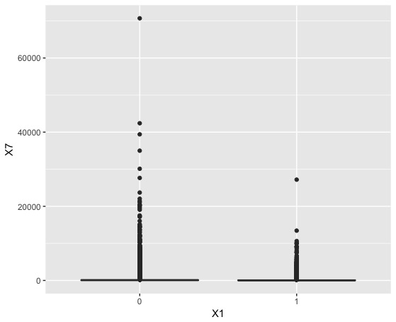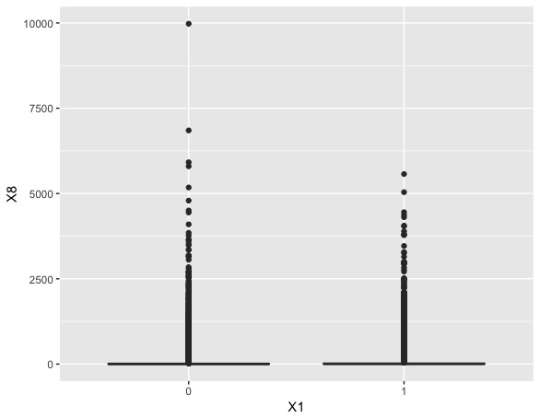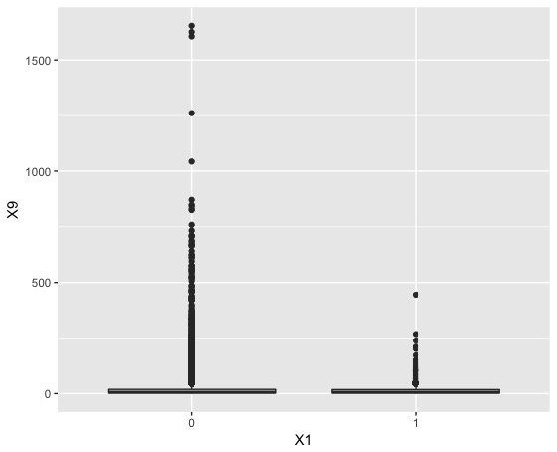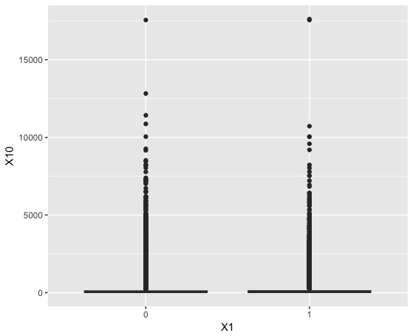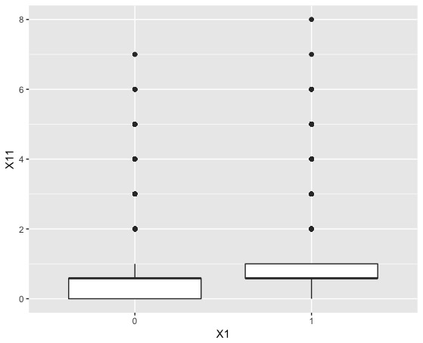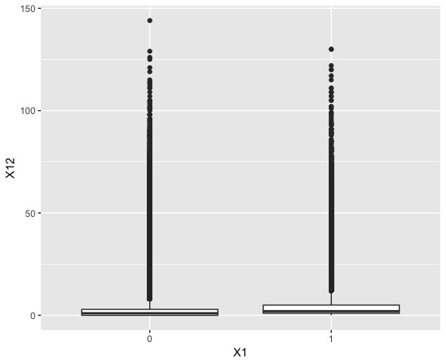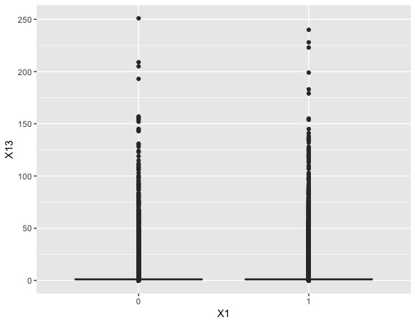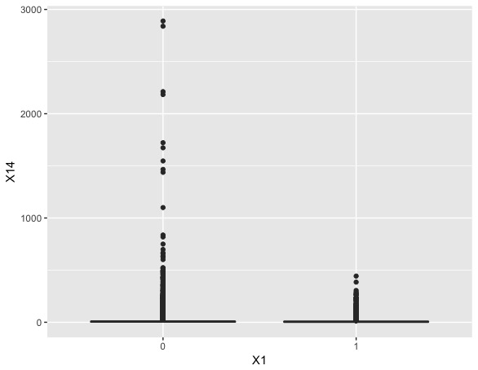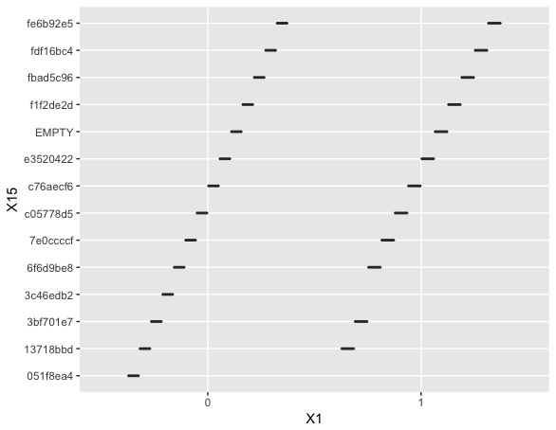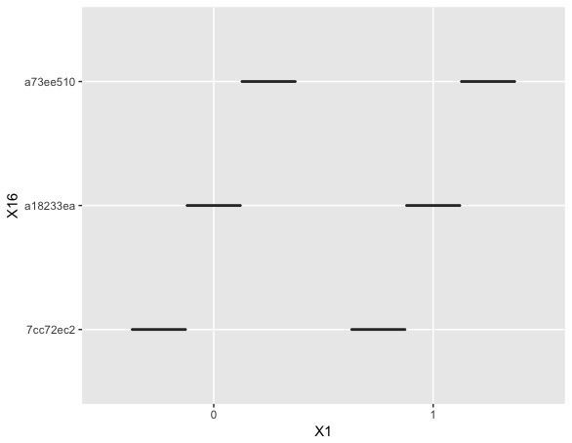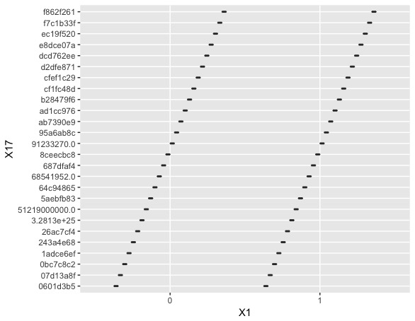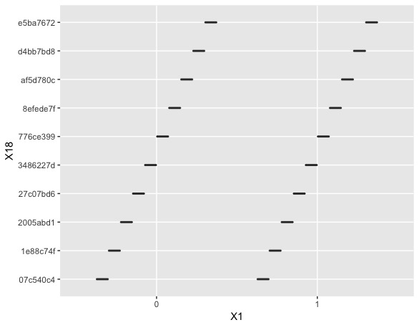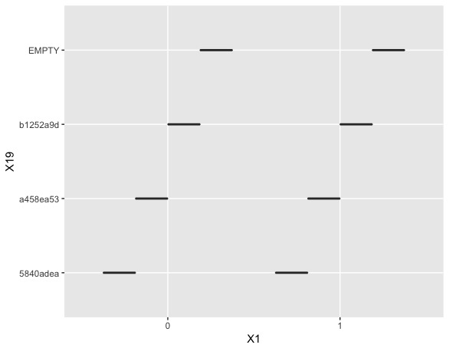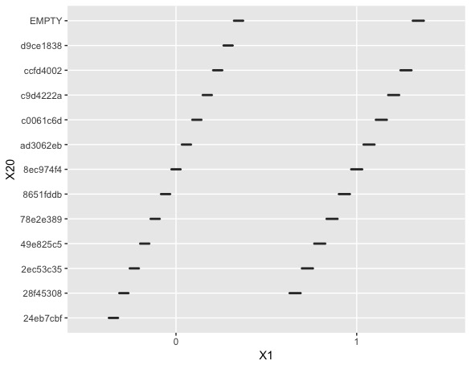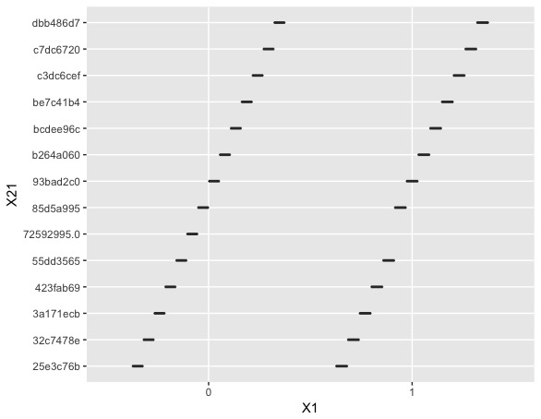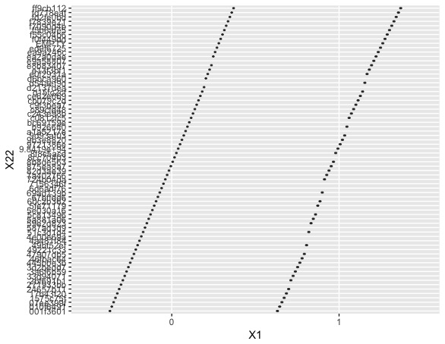

Jitter Plot:

