* This is the Borrower Table

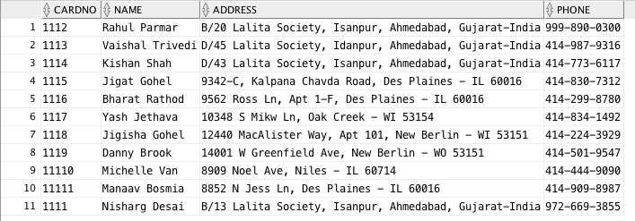

* This is the Book_Authors Table

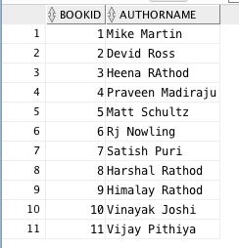

* This is a Book_Copies Table

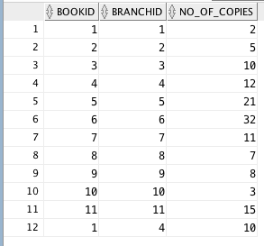

Here I did all BOOKID AND All BranchID but for more learn how my table is response when I put the different BOOKID with Different BranchID. And its work, you can see in my table.

* This is a Book_Loans Table

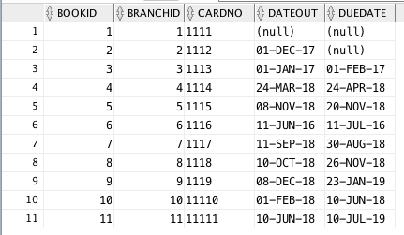

In above table, I have some issue with date format. I try the MM-DD-YYYY and DD-MM-YYYY. But this above you can see in table I can only this format is work in this table. I try to do the MM-DD-YYYY and DD-MM-YYYY, but I don’t know how to do with DATE DATA_TYPE.

* This is a Library Branch table

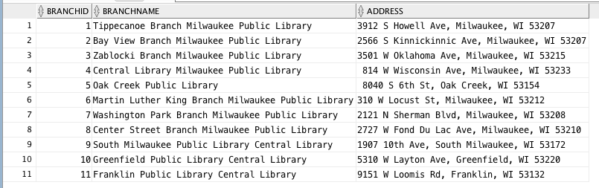

In above table, I used all real Library Branch and Address in Milwaukee, Oak Creek, Greenfield and Franklin.

* This is a Publisher Table

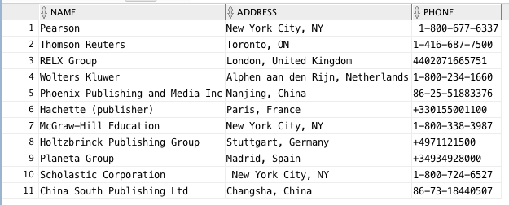

In Above the table you can see, I try different format Phone Number and its work with any format.

* This is a Book Table

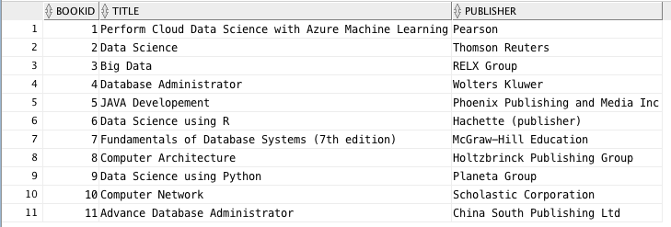

* The CardNo A1111 which I don’t want in my table because the Card No A1111 is wrong .

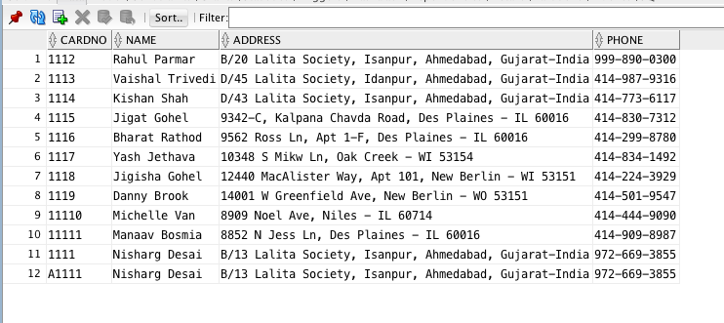

* Here I am going to delete above row number 12 data from BORROWER Table

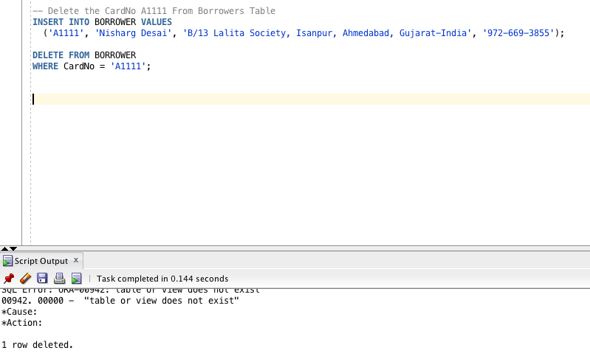

* Here I insert the another colume which BookId 1 and BranchID 04

