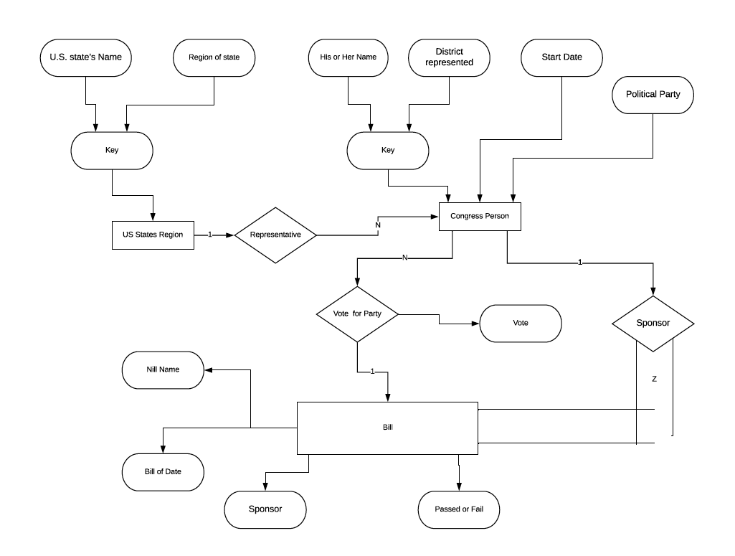

Assumption:

1. Each CONGRESS_PERSON can represent one district and one district is represented by one CONGRESS_MAN.
2. Bill is sponsored by one CONGRESS_MAN.
3. Every BILL has different name.

Above ER Diagram has three entity type:

1. US_STATE_REGION: this is representing states and regions in US.
2. CONGRESS_PERSON: who are elected from various states and they are related to US_STATE_REGION by relationship REPRESENTATIVE.
3. BILL: Each bill is related to CONGRESS_PERSON, who presents it and it is voted by all CONGRESS_MAN.

Unable to Capture using ER modeling constructs

1. Can’t capture US States name (e.g. Texas, New York, California)
2. Can’t capture whose domain is {North East, Midwest, Southwest, West}).
3. Can’t capture proposed law for bill.
4. Can’t capture domain is {YES, NO})and the congressperson(s) who sponsored – i.e., proposed – the bill.
5. Can’t capture domain of vote attribute is {Yes, No, Abstain, Absent}).