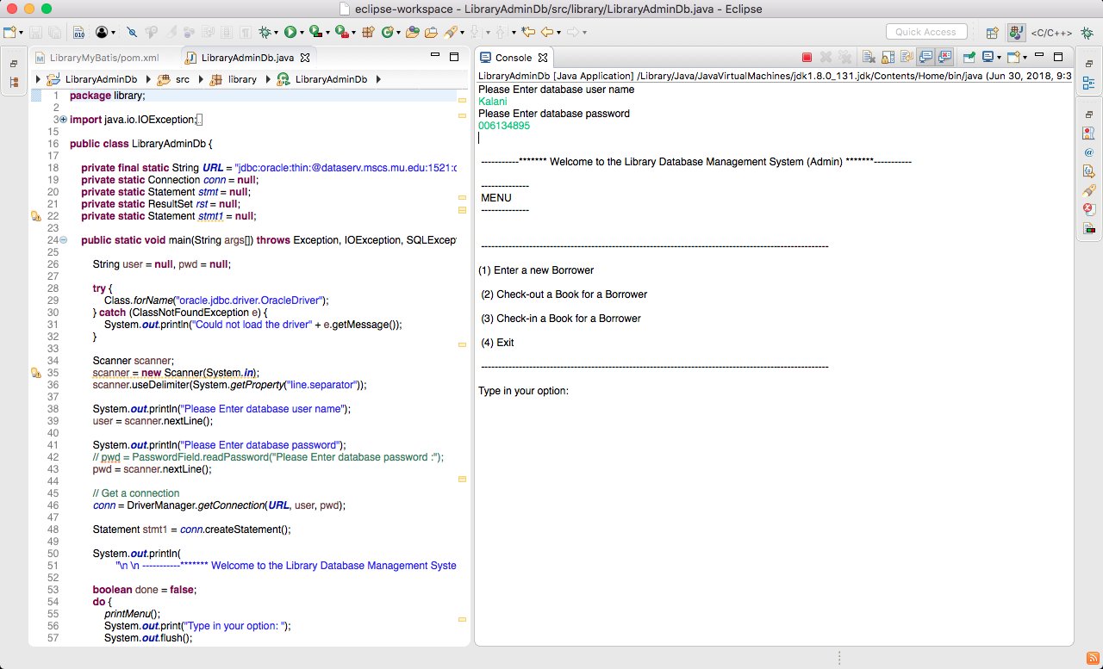

* Above picture it’s a first page when I login using my username and password.

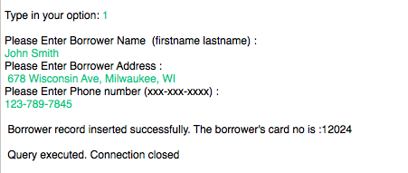

* Above the picture I put some value in my database.

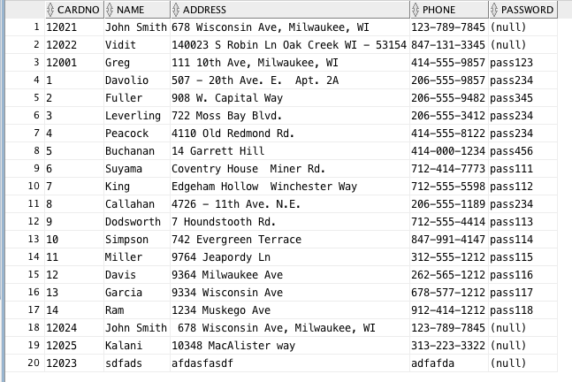

* Above picture you can see I put some more data in the database using application.

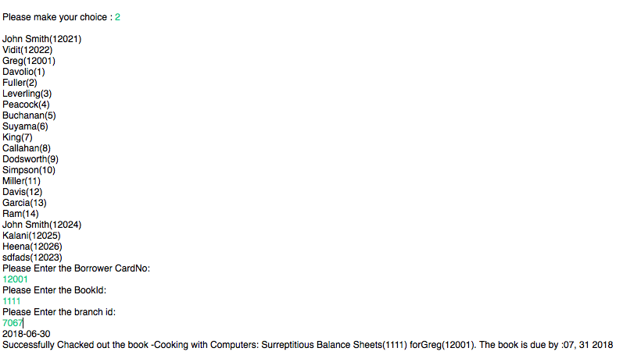

* 2nd option select. Its work successfully.

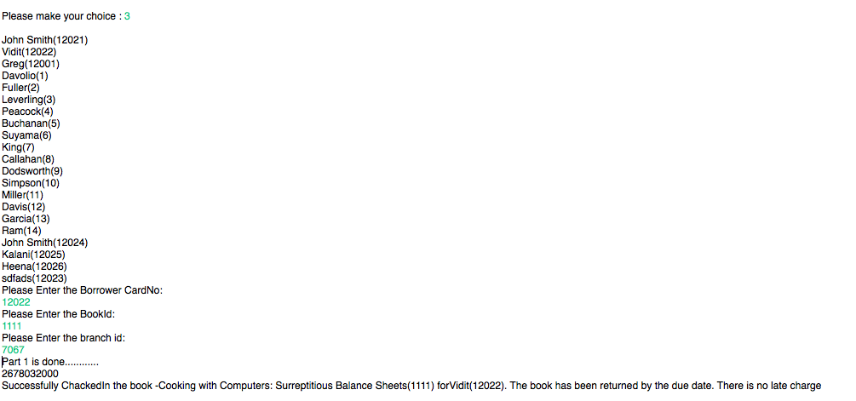

* In 3rd option I select, and its work you can see that.