Assignment 3
DSAA
- Vidit Jain
- 201501021

Q2.
Ans :- On applying DCT followed by Quantization and dequantization and IDCT the resultant image got somewhat pixelised and blury because of quantization. Result of the 3 mentioned 8*8 boxes is as follows :
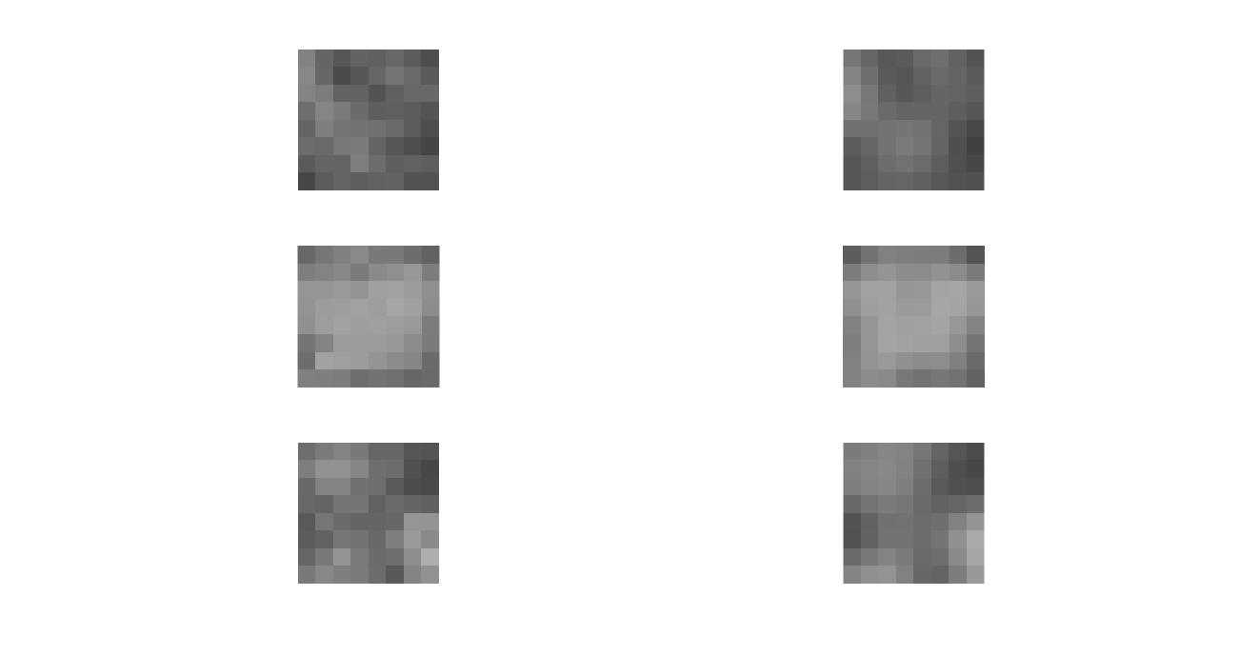
Q3.
Ans :- After applying only DCT and quantization most of the values due to quantization got reduced and specifically the values at lower rightmost area becomes zero which result in the blackening of image and completly different from the original image because we didn’t apply dequantization and IDCT.

Q4.
Ans:- As we increase the value of c the distortion amount also increased as for value of c = 10 the amount of distortion is very high as it is easily be seen by naked eyes.
The minimum value of c for which the distortions of the reconstructed image are just perceptible is 4, i.e. for c=4.

Below is the values of RMSE and Entropy values for different values of c.

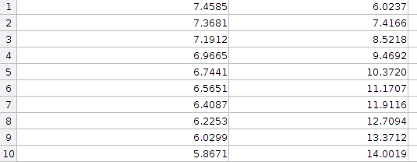
C | Entropy | RMSE |

Q5.
Ans :- From the above table we can see that if we increase value of c Entropy of image decreases whereas the RMSE value increase as on increasing value we are quantizing it with more extent so the number of unique values are decreasing so does the entropy whereas it is getting more deviated to its original value so RMSE value is increasing.

Entropy vs RMSE graph ( RMSE on x axis, Entropy on Y axis)

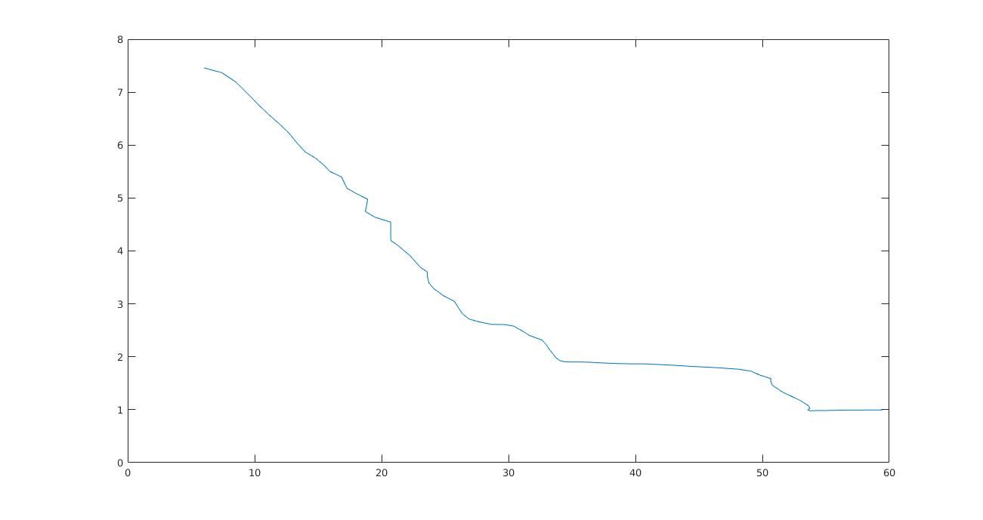
Q6.
Ans:- By experimenting on 20 different images we concluded that DCT matrix is better over DFT for compressing images as the RMSE value for DFT is more than as in DCT so more blurring and pixelisation in case of DFT. Below is the graph for the difference of RMSE value of DFT – RMSE value of DCT with number( 1-20).
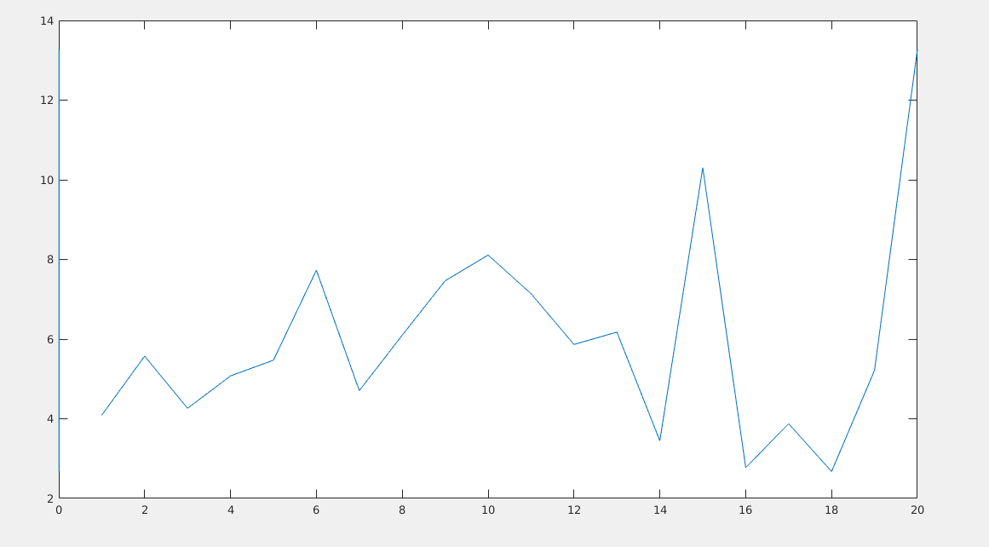
Q7.
Ans :- By experimenting on different channels i.e. Y, Cb and Cr channels we see that on adding noise to Y channel and keeping the other channels value same we saw that there is more graininess in the image as compared to adding noise to Cb or Cr channel. Below is the result of the experiment on a sample image

