Python Assignment Solutions

1. Grade Checker
This program takes a score as input and prints the grade based on the given conditions using if-else statements.

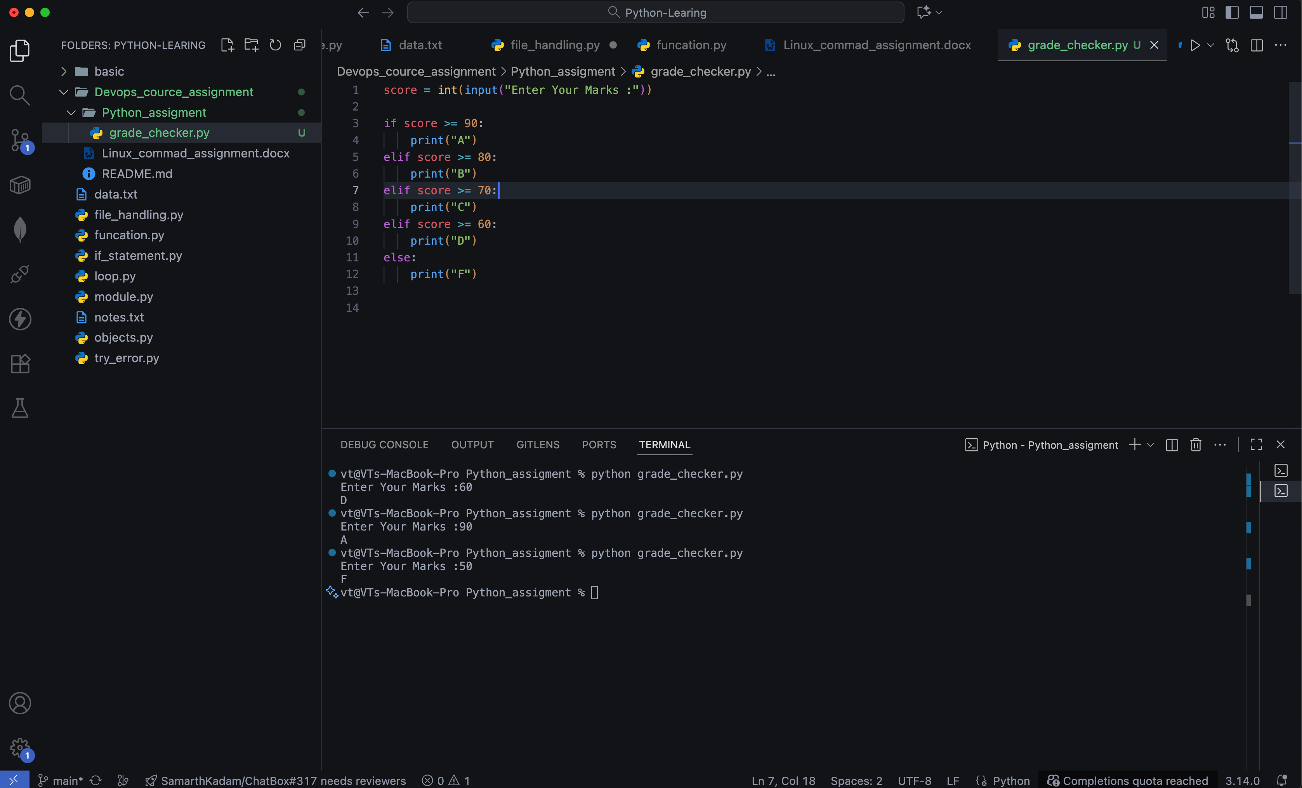

2. Student Grades (Dictionary)
We used a dictionary to store student names as keys and their grades as values. Users can add, update, and print grades.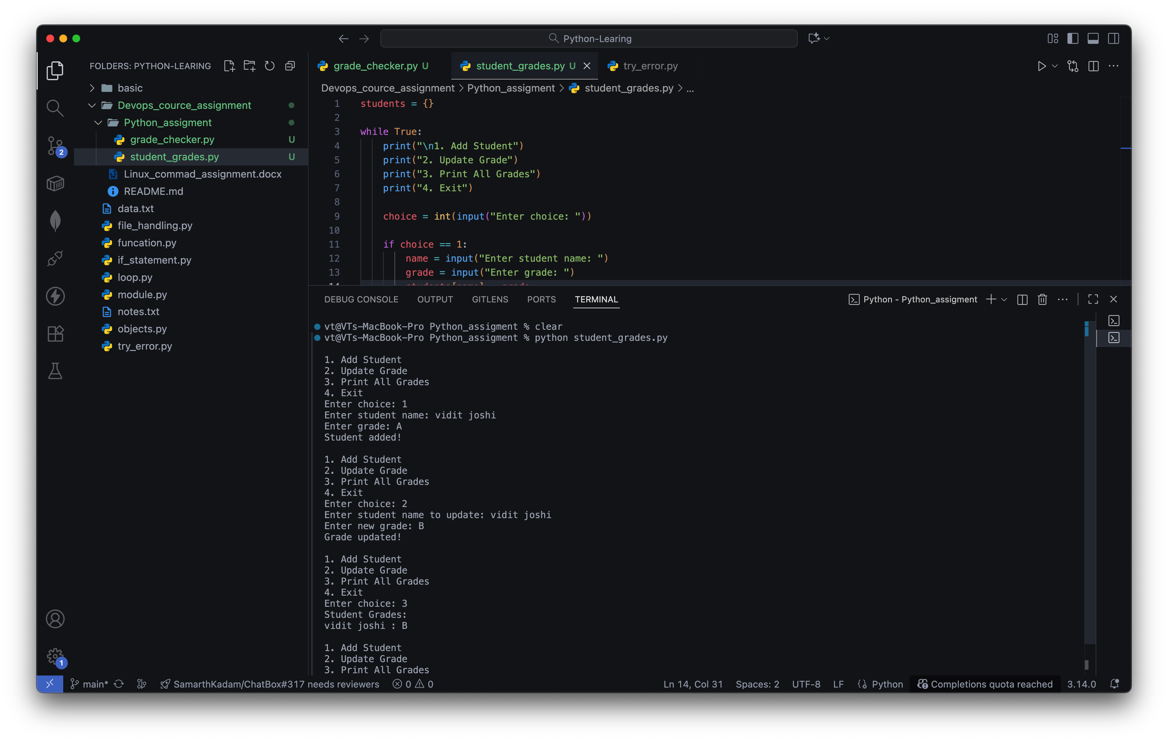

3. Write to a File
This program creates a text file and writes content to it using the write() function and open() in write mode.
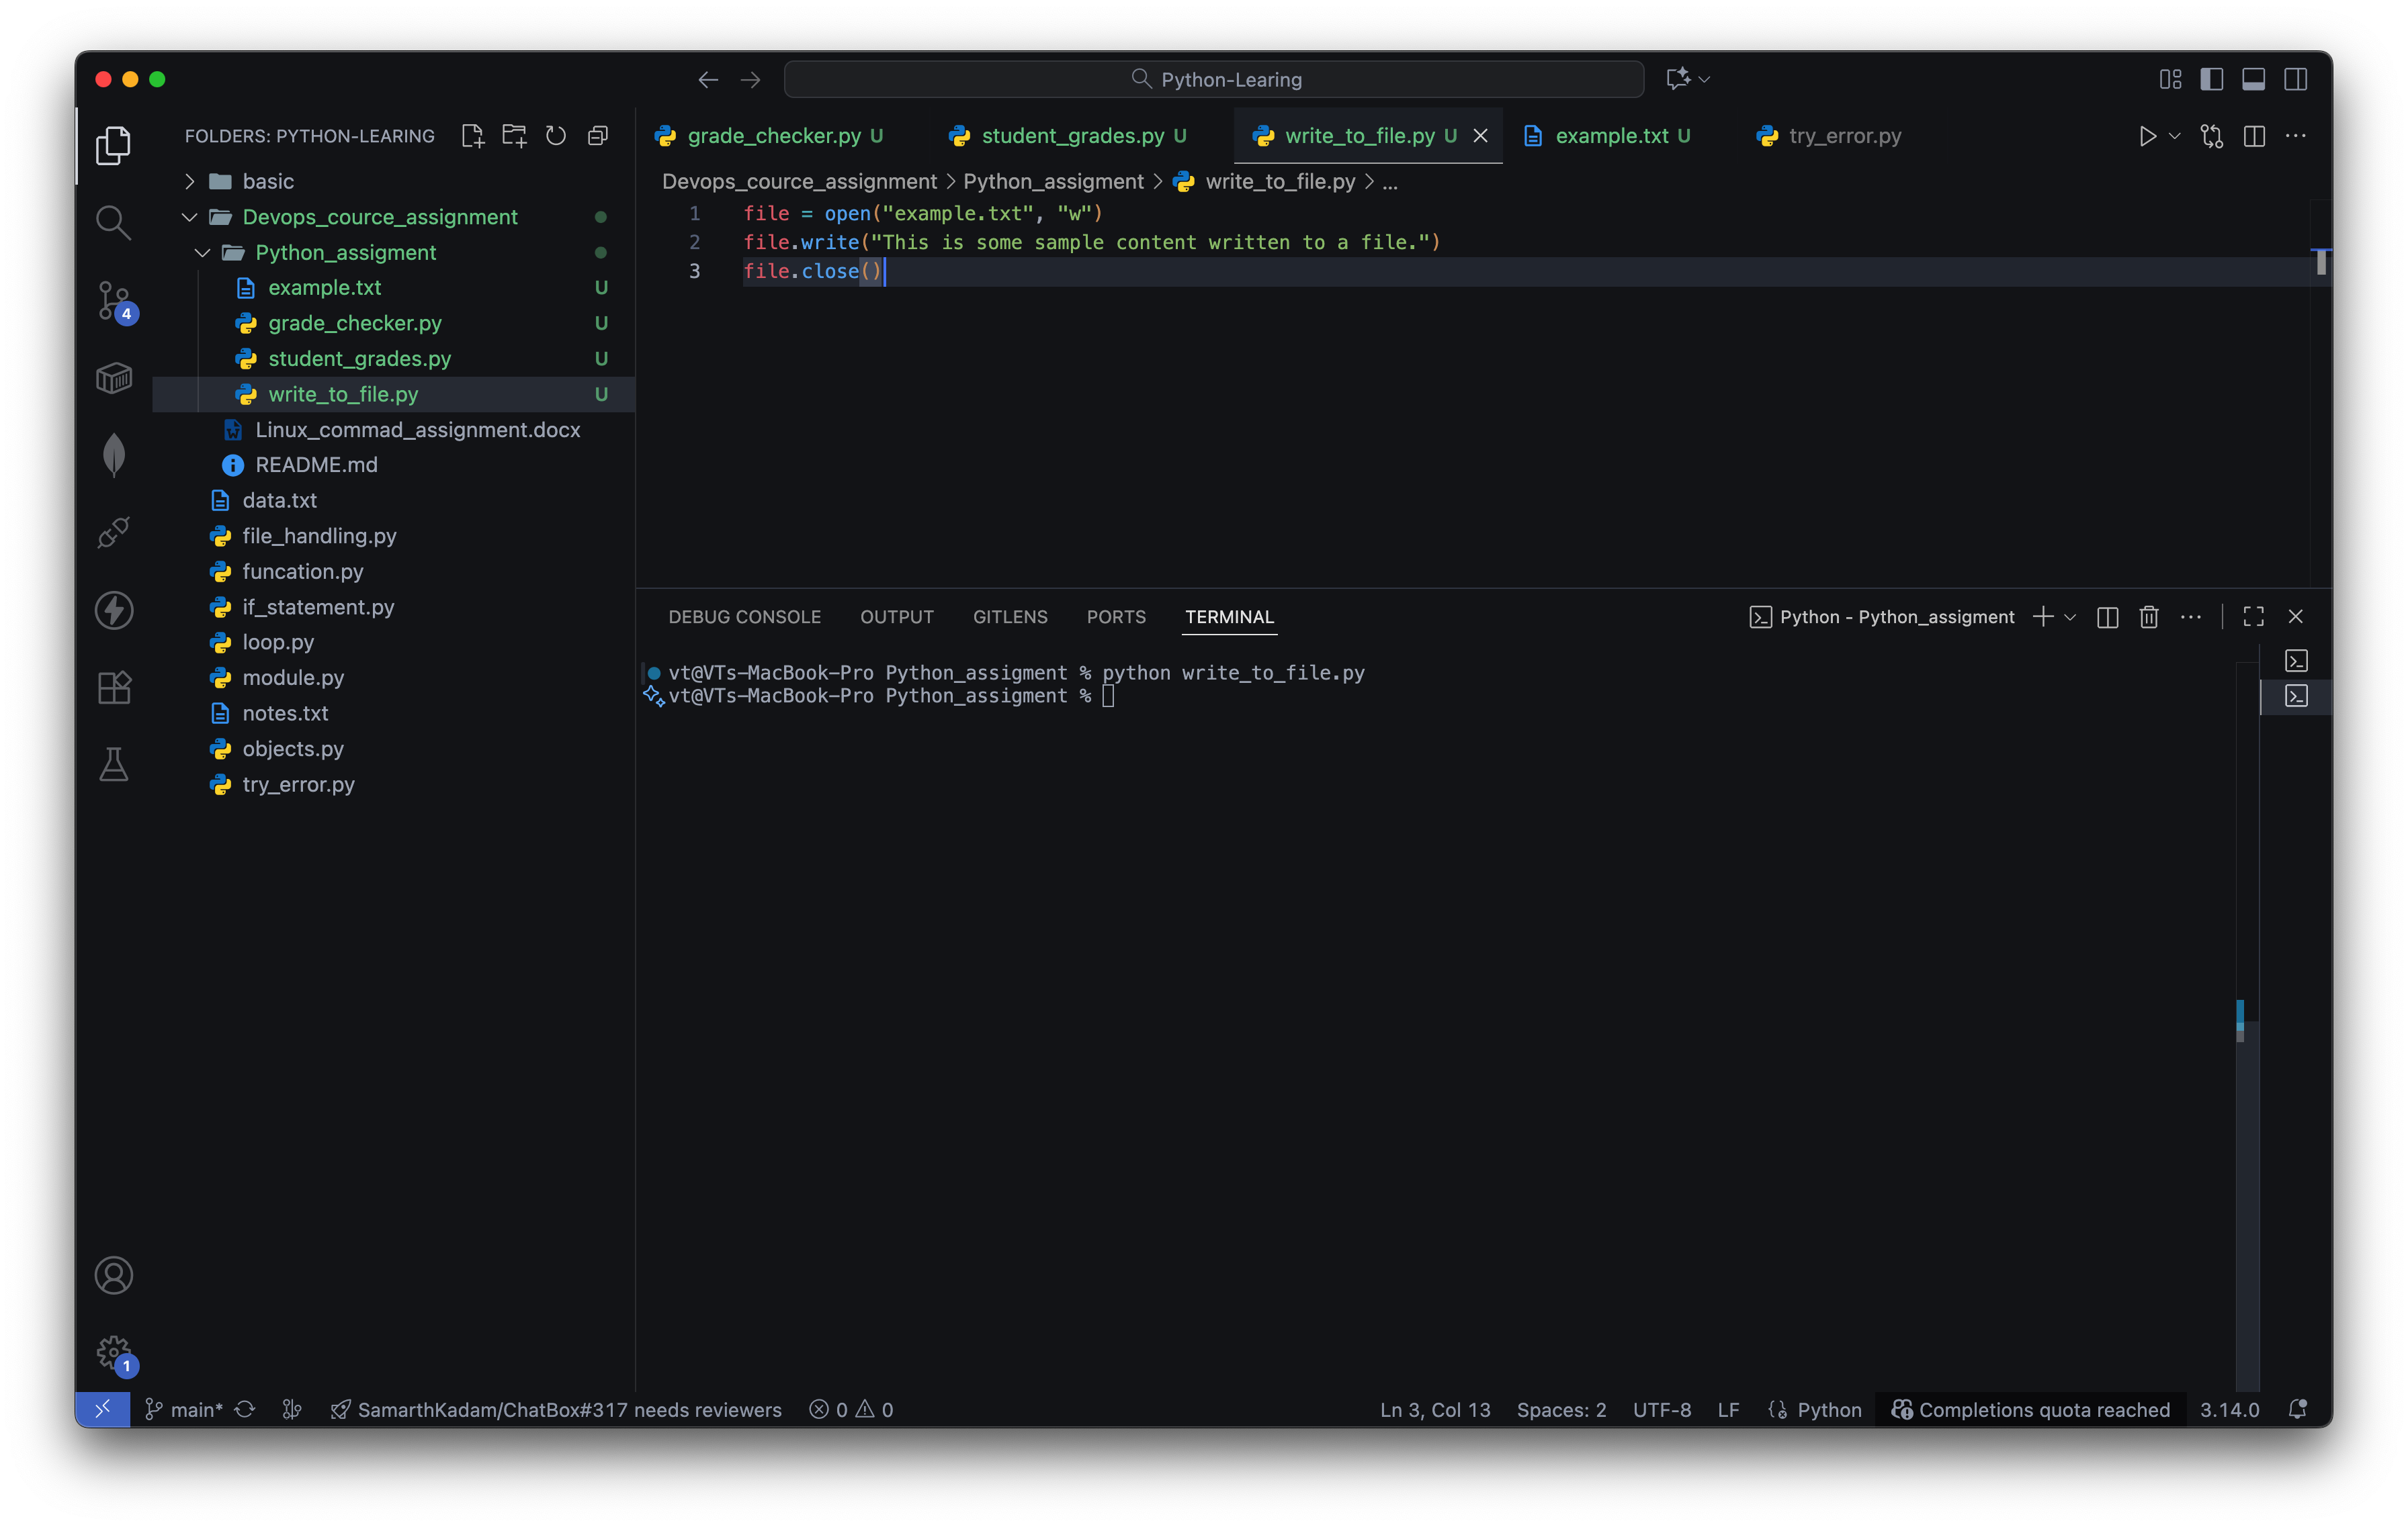

4. Read from a File
This program reads content from a text file using open() in read mode and file.read()