Linux Command Line Assignment
Name:Vidit Joshi
Date: 2/10/2025
GitHub Repository Link: https://github.com/Viditjoshi
Portfolio: https://portfolio-bice-beta-1rg9h4asvx.vercel.app/
Linkedln: linkedin.com/in/vidit-joshi-9828aa255

1. Creating and Renaming Files/Directories
Commands:
mkdir test_dir
cd test_dir
touch example.txt
mv example.txt renamed_example.txt
ls
Explanation: Create a directory, add a file, and rename it using basic file management commands.
Screenshot:
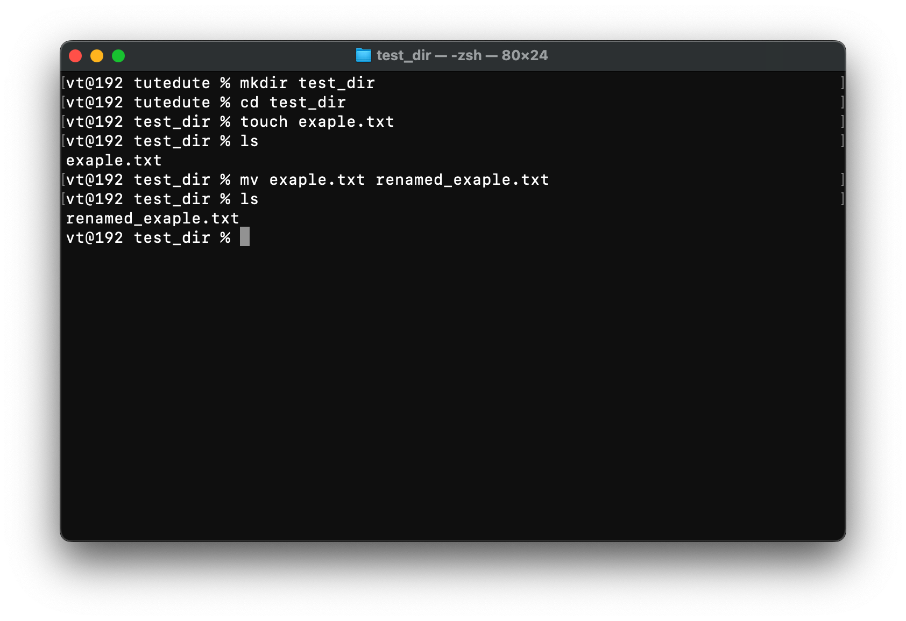

2. Viewing File Contents
Commands:
cat /etc/passwd
head -n 5 /etc/passwd
tail -n 5 /etc/passwd
Explanation: Display file contents, and show only the first or last few lines using head and tail.
Screenshot:
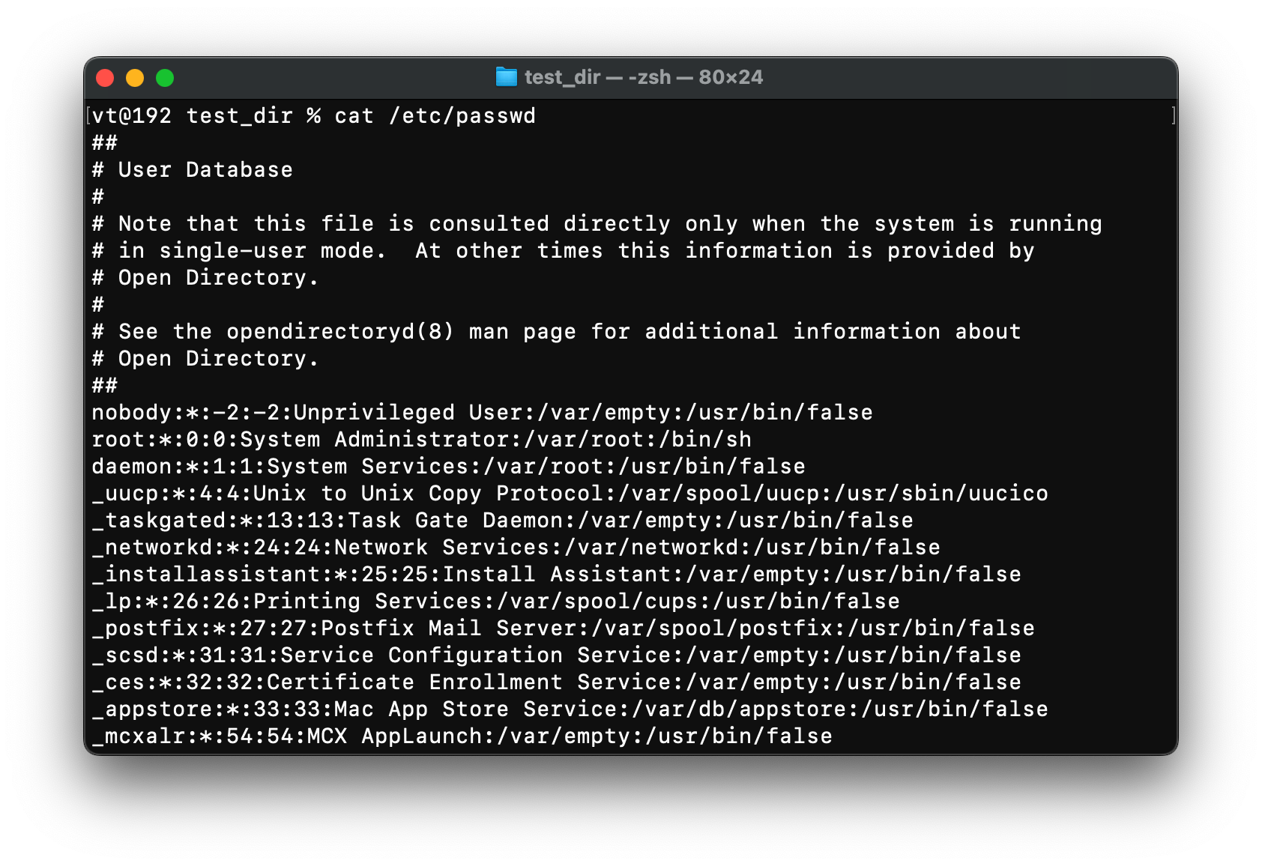

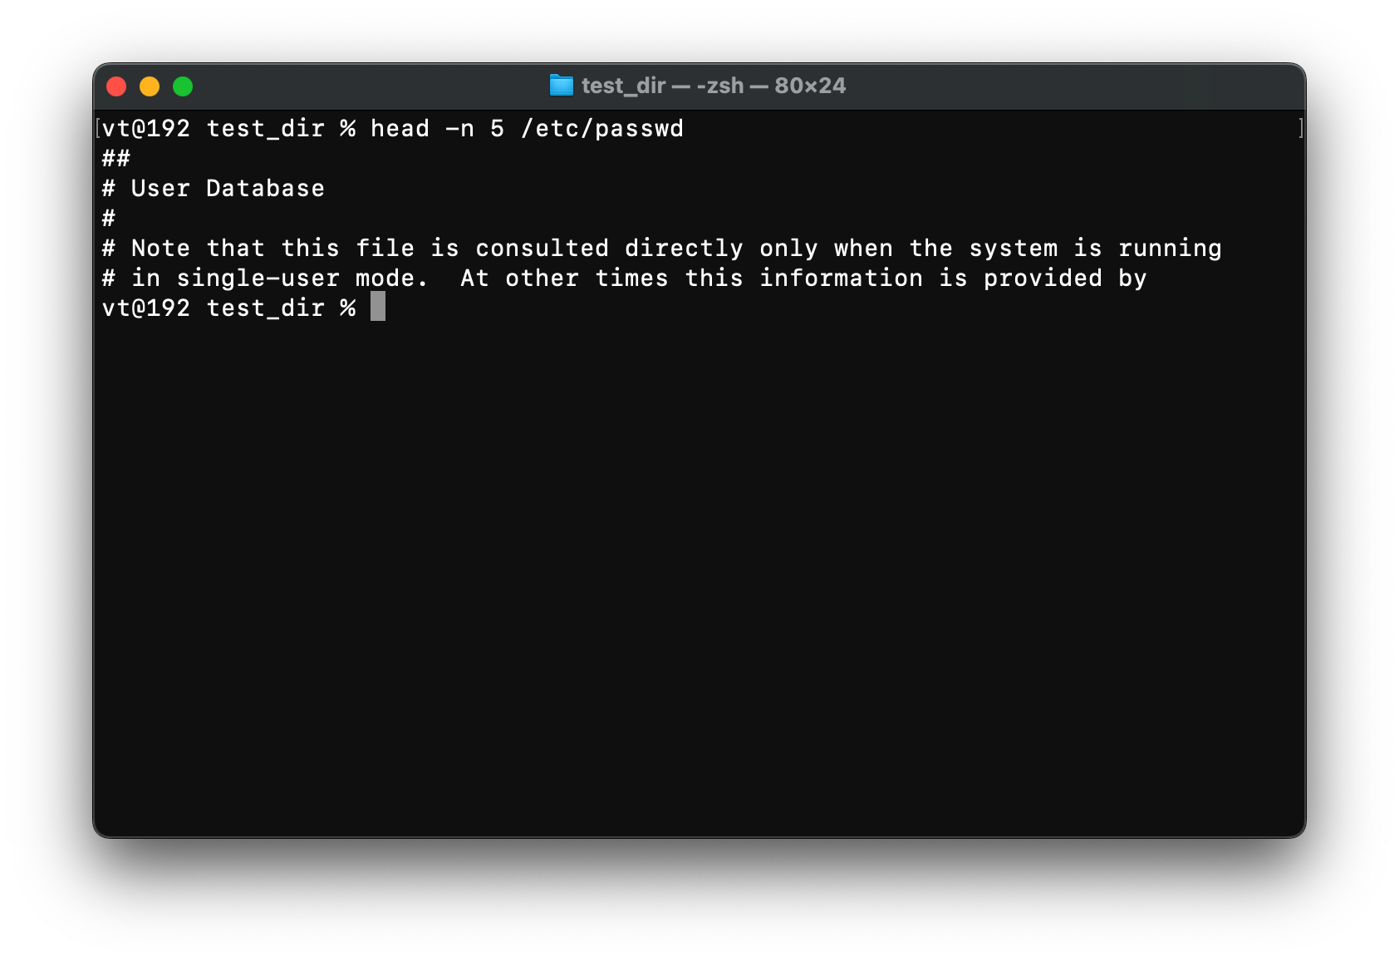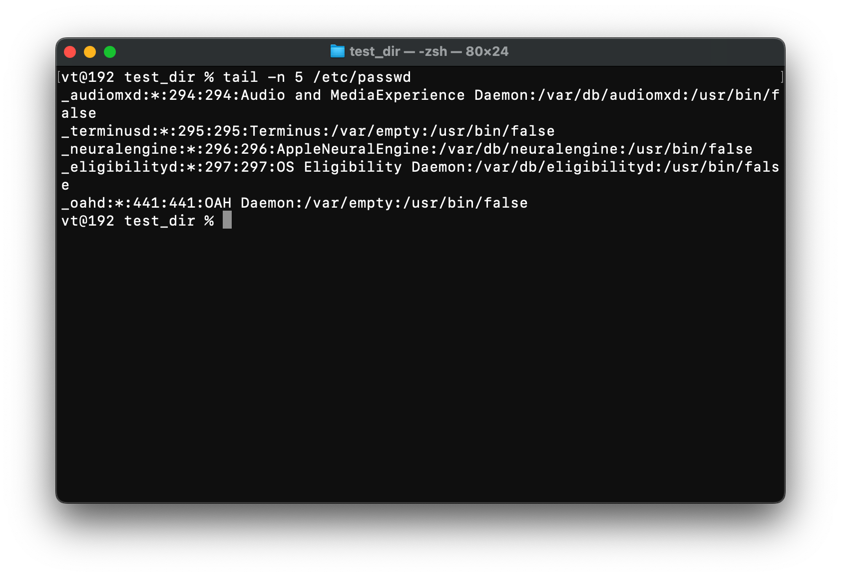

3. Searching for Patterns
Commands:
grep "root" /etc/passwd
Explanation: Search for all lines containing the word "root" in /etc/passwd.
Screenshot: 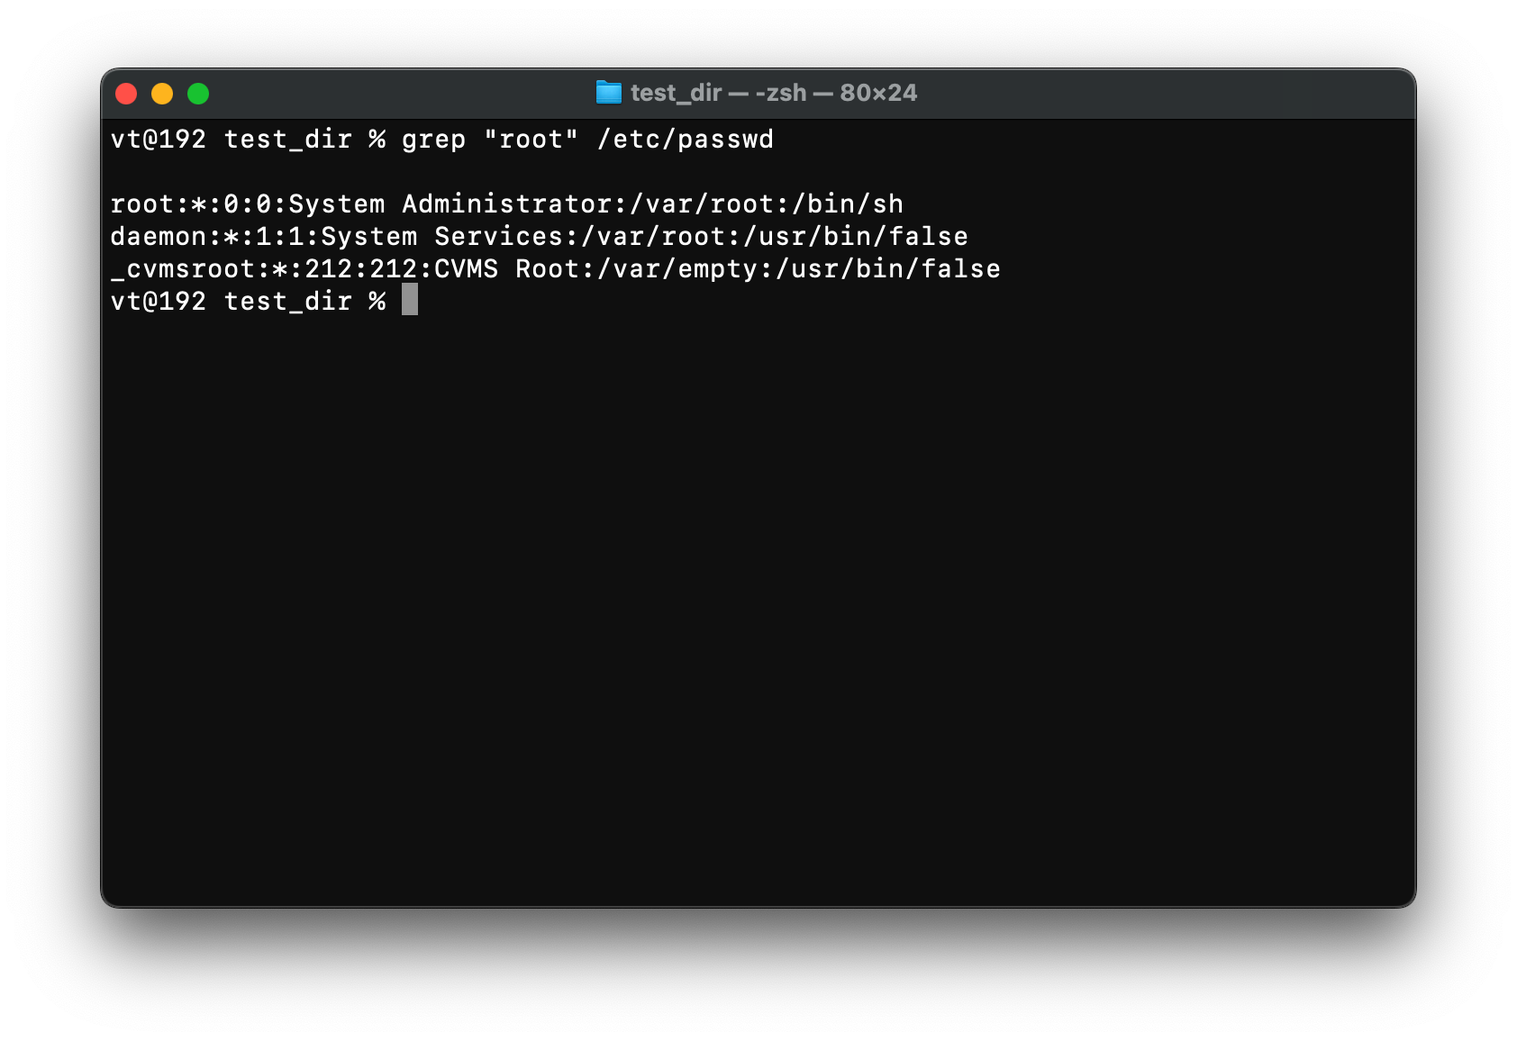

4. Zipping and Unzipping
Commands:
cd ..
zip -r test_dir.zip test_dir
unzip test_dir.zip -d unzipped_dir
ls
Explanation: Compress and decompress directories using zip and unzip.
Screenshot:
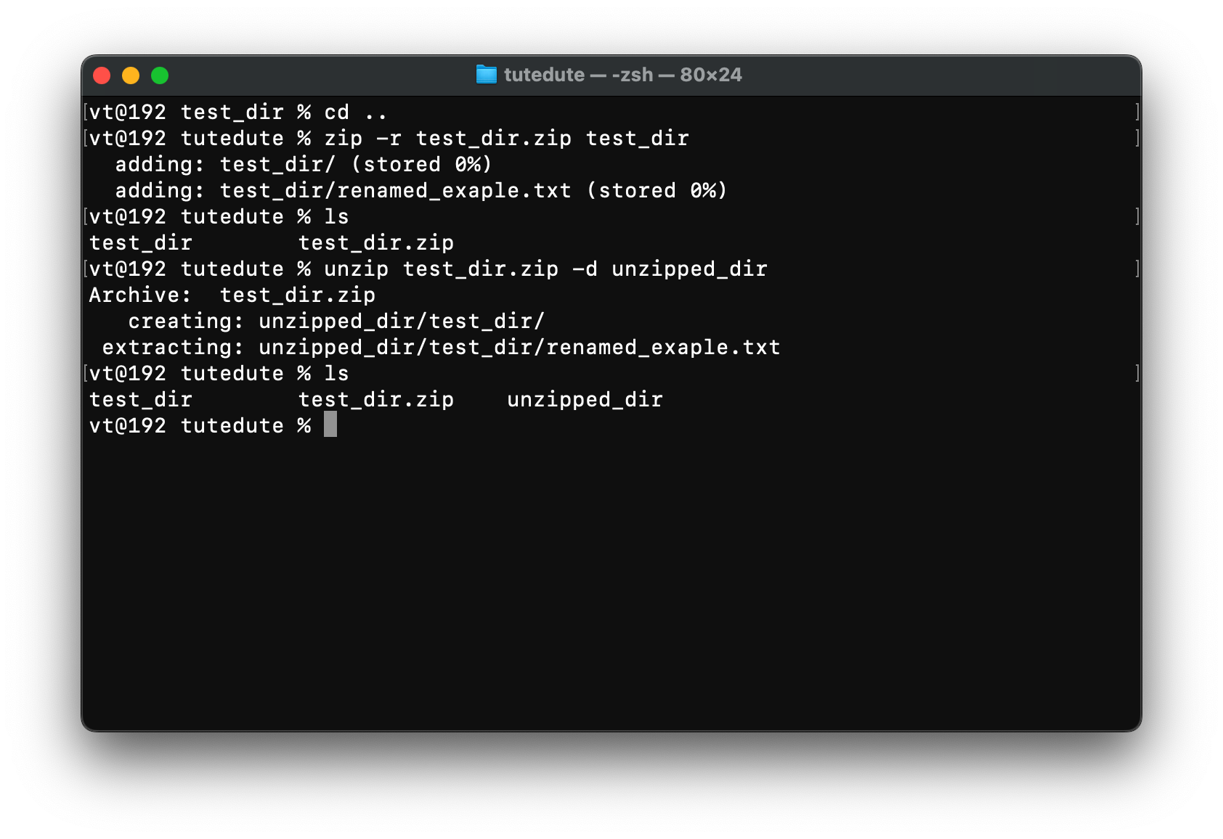

5. Downloading Files (macOS Version)
Commands:
wget https://example.com/sample.txt
ls
Explanation: Use wget to download files. since macOS does not include wget by default. I download wget using brew install wget

Screenshot: 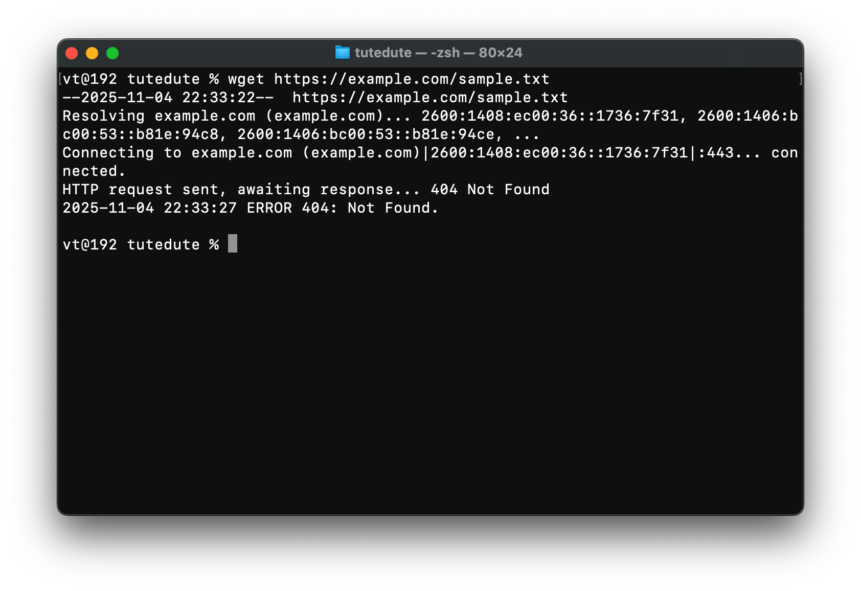
here this link not working so I install other file like that 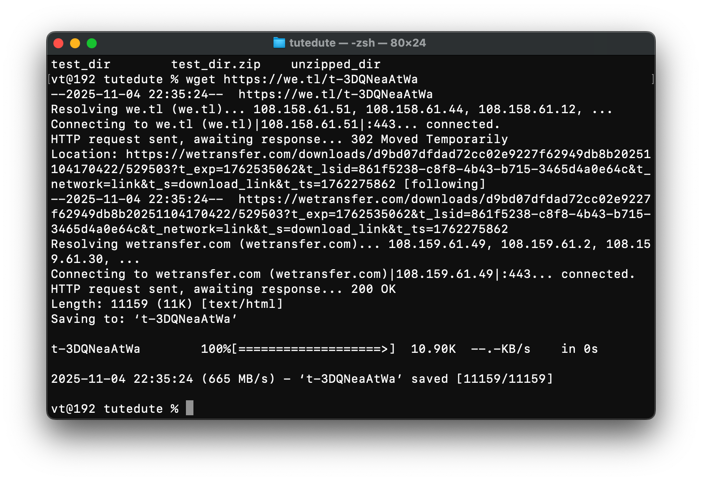

6. Changing Permissions
Commands:
touch secure.txt
chmod 444 secure.txt
ls -l secure.txt
Explanation: Change permissions to make a file read-only for everyone.
Screenshot:
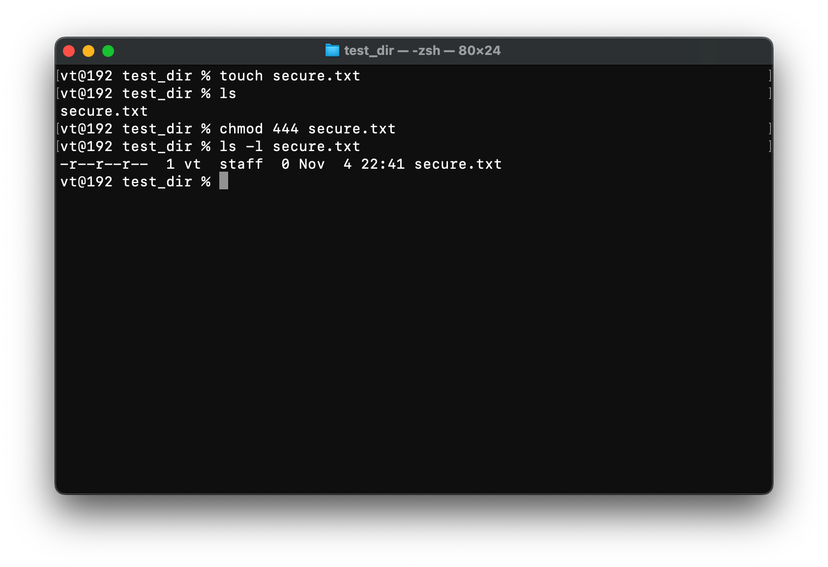

7. Working with Environment Variables
Commands:
export MY_VAR="Hello, Linux!"
echo $MY_VAR
Explanation: Set and view an environment variable using export and echo.
Screenshot:
