SINGLE SOUND ORCHESTRA
Linnea Goodwin | Trinity West | Isabel Ferris
University of Victoria  goodwinc@uvic.ca | University of Victoria  trinitywest@uvic.ca | University of Victoria  author3@ismir.edu

ABSTRACT
This project aims to create a unique, orchestrated musical composition using only a single audio clip: a 5-second segment of Suzanne Vega’s Tom’s Diner. In the spirit of plunderphonics, music composed from existing recordings [1], all instrumentation will be based on DSP operations performed on said clip (i.e. flat magnitude reconstruction, FFT bin filtering, concatenative synthesis, granular synthesis, etc.). These techniques will all be applied in different combinations with different parameters and the end result will be an orchestral piece of music all made from one sound.
- LINNEA GOODWIN - PROGRESS
1.1 High-Level Status Coverage

Table 1 summarizes my Objective 1 tasks. All code can be found at this link.

Table 1: status of tasks
Task | Description | Status | Evidence
P1 | Explore assigned techniques | Complete | Four notebooks; FFT bin filtering, KS strings, reverb, concat. synthesis
P2 | Simple Melody | Complete | final_melody.wav, arranged in Audacity
P3 | Combine assigned techniques | Complete | 11 combination sounds in the combos notebook
P4 | Combine techniques with other group members’ | In Progress | 2 combinations so far, one used in P2
P5 | Research and implement new techniques | Not started | N/A
P6 | Share findings with group members | Complete | Materials in shared repository
P7 | Convert non-python work to python | Not pursued | Only non-python work is in Audacity; didn’t feel it necessary to convert

1.2 Technique Exploration (P1)

1.2.1 FFT Bin Filtering

My FFT bin filtering tools decide which bins to zero based on bin loudness, rather than where they sit in the spectrum as a lowpass or highpass filter would. My tools can keep the K loudest bins and K quietest bins; I also implemented a rank window that keeps only bins ranked between two magnitude positions (for example the 100th to 400th loudest), a random strategy that draws K bins without replacement (weighted by magnitude) and a frame-based strategy that applies the top-K rule to each STFT frame separately, with frames of 2^15 samples. Reducing the number of bins in a sound creates a sustained, tonal texture, and doing this on a per-frame basis keeps some of the movement of the clip. The lowest-K implementation creates a noise-like residue, which I later used for the hi-hat for P2.

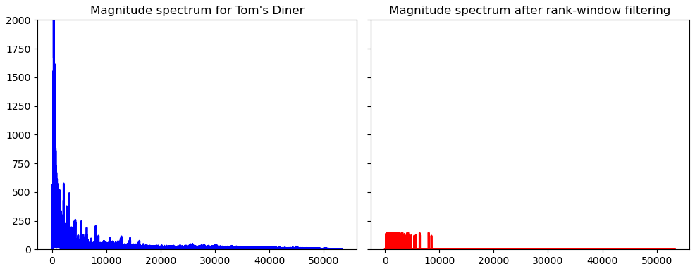
Figure 1: Magnitude spectrum of Tom’s Diner before and after running a rank-band bin filter of the 1000-1300th loudest FFTbins

1.2.2 Karplus-Strong String Synthesis

Karplus–Strong synthesis models a plucked string as a delay line whose output is fed back through a mild lowpass (an average of two adjacent samples), so high frequencies die away faster than low ones, as on a real string [2]. Usually, the initial excitation of the string is a burst of noise; I replaced it with the clip itself. I did this in 4 ways: using a 1000-sample slice of the clip as the delay line, feeding the entire clip through the string as continuous excitation, using a short excerpt as a one-time pluck, and a nonlinear variant that passes the feedback through a tanh equation. Whereas the KS algorithm is associated with the following difference equation:
$y\left[n\right]=x\left[n\right]+α\left(y\left[n-N\right]+y\left[n-N-1\right]\right)$ (1)
My nonlinear tanh version implements:
$y\left[n\right]=x\left[n\right]+tanh\left(y\left[n-D\right]+y\left[n-D-1\right]\right)$ (2)
Which saturates the sound.

1.2.3 Reverb and Spatialization

I built a ping-pong delay that alternates echoes between the left and right channels as an introduction to the concept before sinking my teeth into a python implementation of Freeverb, a Schroeder-style reverberator [3]. On a high level, my understanding of this algorithm is that the audio is run through eight parallel comb filters and four allpass filters in series before being offset by 23 samples. Comb filters involve adding a delayed version of a signal to itself, and allpass filters involve phase-shifting each frequency from the input signal [4]. I unfortunately used some AI to get an implementation of this working because this was my first introduction to the concept and I was a little lost.

In terms of utilization, I used the Freeverb implementation in two ways: a pad (which involves setting an infinite reverberation time in the comb filter for an indefinitely sustained wash) and a swell (which involves reversing the clip, reverberating it, then reversing it again to build the reverb tail into the sound).

1.2.4 Concatenative Synthesis

Concatenative synthesis involves building a new sound by cutting existing audio into units and reassembling them [5]. I tried to work on some implementations of this technique that utilized librosa’s note onset detection, but the clip we’re using for this project is a rendition of Tom’s Diner with drum backing and horn accompaniment, which created too much noise for the onset detection to gather any useful information. As such, I divided the clip up manually. I did this by slicing a grid with 8th notes, 16th notes, and manual parsing of syncopated notes. I used these segment arrays to rearrange the clip manually, randomly, based on segment loudness, based on segment pitch (i.e. swapping each instance of an A note with a different A note), and by layering segments on top of each other.

1.3 Combining Techniques (P3)

Chaining my tools produces new sounds that are completely removed from their original context of Tom’s Diner. I built eleven chains with order as a creative variable. The nonlinear string became a favourite final stage, appearing in three chains. My combinations can be found here, and listened to here.

1.4 Simple Melody (P2)

This deliverable best shows what I envision our final project will look like. I created a melody with 4 instruments: a marimba created from an inverted KS string with full excitation passed through a Freeverb pad and random bin filtering; a hi-hat created from a lowest-K bin filter; a bass drum created from a rank-window filter put through a nonlinear KS string and lowpassed with Trinity’s crude filter; and additional percussion created with a clip of Tom’s Diner rearranged in order of volume put through a Freeverb swell and sent into a KS resonator as the delay line. I did not convert the arrangement to python as per P7 as I felt it unnecessary and too complex.

1.5 Combining with Group Members’ Techniques (P4)

TBD

1.6 Next Steps

My immediate next step after I’m satisfied with the sounds I’ve created by combining techniques with my group members’ is to create sheet music for a composition using these sounds and convert it to a midi file. If a technique can’t be cleanly mapped to a midi note (i.e. concatenative synthesis), I will omit it from the composition and arrange that section myself as per Objective 2’s P4. If I have time, I will move on to P5; I do not anticipate being able to do this in time as I have several other large projects due in other classes.
- TRINITY WEST – PROGRESS
  - High Level Status Coverage
Table 1 summarizes my status of the Objective 1 tasks, all code corresponding to these tasks can be found at this link.
Table 1: status of tasks
Task | Description | Status | Evidence
P1 | Explore assigned techniques | Complete | Five folders in technique_exploration containing exploration; automatic orchestration, autotune, flat magnitude reconstruction, magnitude spectrum manipulation, and time stretching
P2 | Simple Melody | Complete | Each folder in technique_exploration has an audio folder that contains various sounds and melodies created using that technique.
P3 | Combine assigned techniques | Complete | Many combination sounds in technique_combinations/audios combining techniques that were explored.
P4 | Combine techniques with other group members’ | In Progress | Combined reverb and magnitude spectrum manipulation. May do others.
P5 | Research and implement new techniques | Complete | Time Stretching was investigated which was not originally assigned.
P6 | Share findings with group members | Complete | Materials in shared repository
P7 | Convert non-python work to python | Not pursued | No non-python work was done.

  - Technique Exploration (P1)
The following is a summary of the work done to explore automatic orchestration, autotune, flat magnitude reconstruction, magnitude spectrum manipulation, and time stretching.

    - Automatic Orchestration

Automatic orchestration involves automatically assigning instruments to notes of an unorchestrated score, while some more advanced methods involve assigning sounds, articulations, and dynamics to notes of an unorchestrated score or even changing the score itself [6]. In my research, I found that methods of implementing automatic orchestration could be explored as an entire project itself. Due to the complexity in the implementation, I decided to table those findings and save the research to potentially go back to when working on objective 2 of our project. See more in depth research notes in the Automatic_Orchestration.ipynb.

    - Autotune

Autotune adjusts and corrects the pitch of recorded instruments [7]. In my exploration, I experimented with two basic autotune algorithms consisting of monophonic pitch extraction, then mapping and pitch shifting each pitch to a target pitch within the defined scales. In the basic autotuning function it pitch shifts each audio frame independently using the librosa.effects.pitch_shift function, whereas the PSOLA method pitch shifts by manipulating the pitch synchronous wave segments. I tested these with various scales ranging from low register to high register to get a grasp of the effects they had on the audio.

The following three plots compare the original vocals, basic autotuned vocals, and PSOLA autotuned vocals. Each plot will show the target scale notes as red dashed lines.

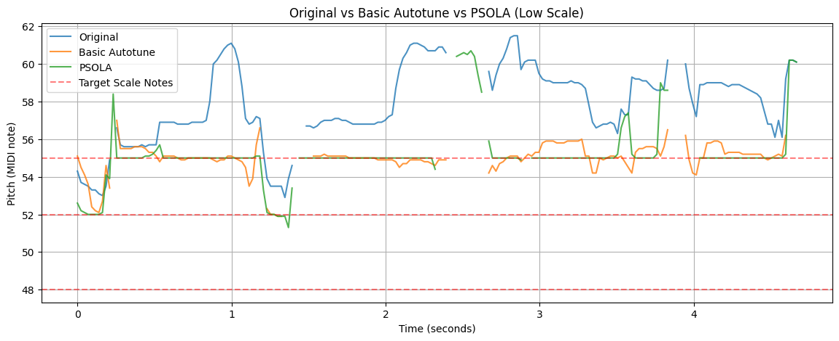
Figure 2: Pitch Contour of Original Vocals vs Autotuned Vocals vs PSOLA Autotuned Vocals Shifted to the Low Register Scale

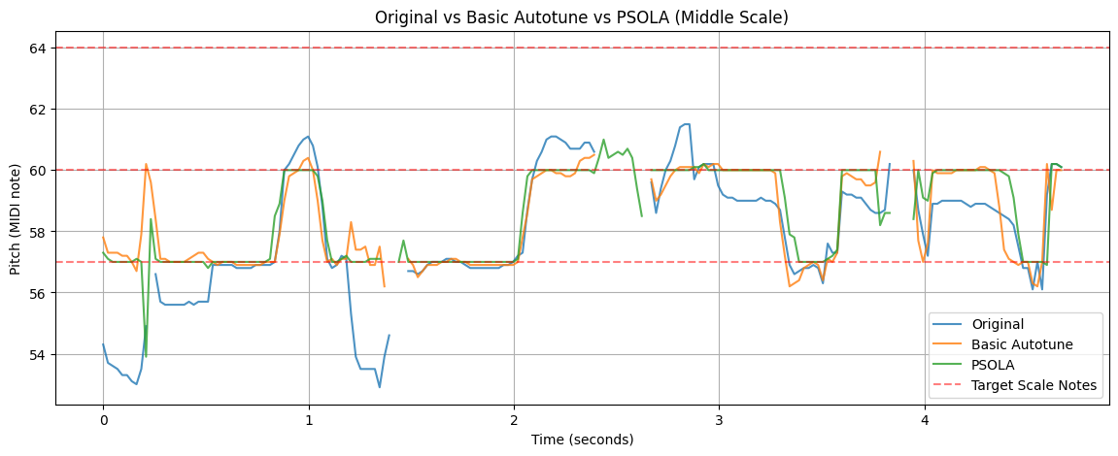
Figure 3: Pitch Contour of Original Vocals vs Autotuned Vocals vs PSOLA Autotuned Vocals Shifted to the Middle Register Scale

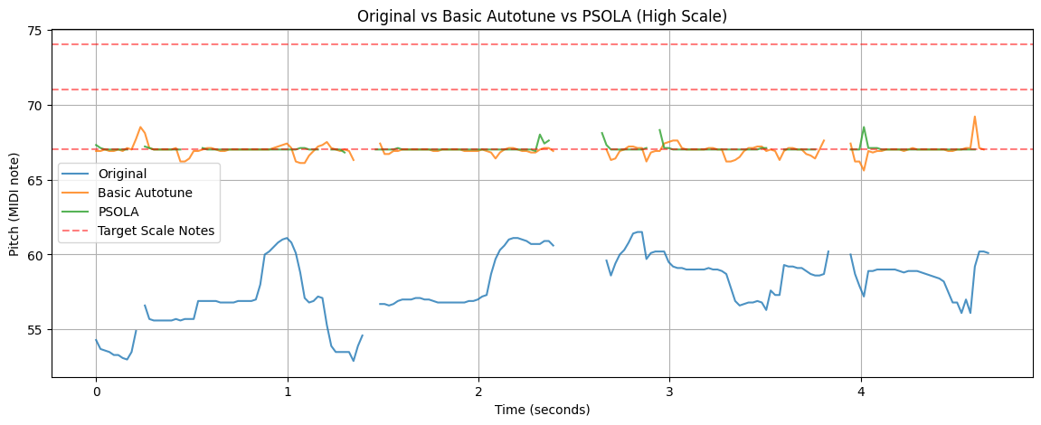
Figure 4: Pitch Contour of Original Vocals vs Autotuned Vocals vs PSOLA Autotuned Vocals Shifted to the High Register Scale

Notice how the autotuned vocals don’t move up and down as naturally as the original audio but that you can see the peaks and drops mostly line up even though they are occurring at different pitches now. From these plots we can see that the basic autotune and PSOLA autotune produce a relatively stable contour but they both contain some abrupt deviations in certain sections. Based on the middle scale the results of the basic autotune produce a bit better of a pitch contour and the middle scale would likely be the most common use case. However, the spikes and deviations in these plots are probably due to inaccurate pitch estimates, so this is not a super reliable form of evaluating the results if you do not listen to the audio as well.

Based on the audio, PSOLA autotuned audios sound more robotic and less real, while the basic autotuned audios sound more natural and resemble the original sound better.

    - Flat Magnitude Reconstruction
Flat magnitude reconstruction consists of manipulating the magnitude spectrum of sound to make the magnitude of all sinusoids in the signal equal. FMR causes all the frequency information to disappear, causing a noisy texure and the phase spectrum is preserved. [8] It has also been found that the phase spectrum primarily contributes to speech intelligibility, meaning that lyrics can still be understood when FMR is applied to audio [9].

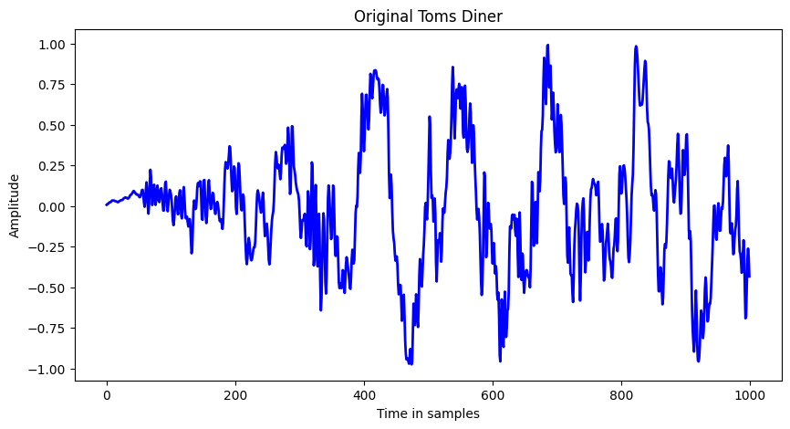
Figure 5: Original Toms Diner (Amplitudes Over Time)

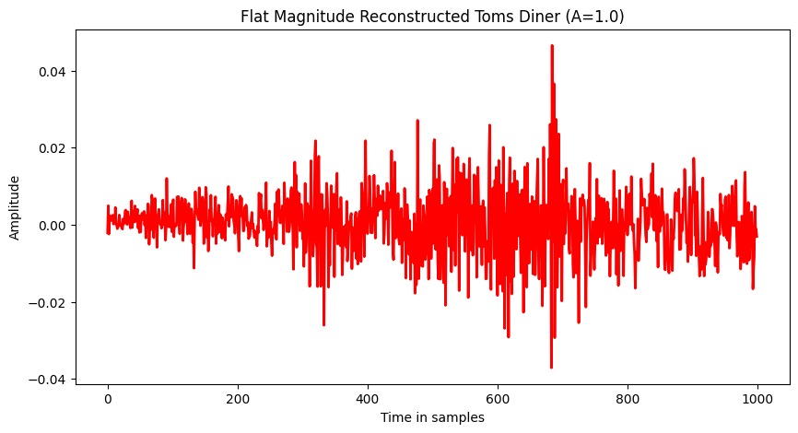
Figure 6: Flat Magnitude Reconstructed Toms Diner (Amplitudes Over Time)

Notice the amplitude still fluctuates a bit. This is because we were setting the magnitudes of the frequency components to the same value (not to be confused with the amplitudes). Every frequency component now has a magnitude of 1.0 and each component still has its original phase.

When we reconstructed the signal using the inverse fourier transform, all of the frequency components were added together, and constructive interference (aligned sinusoids) and destructive interference (opposing sinusoids) create the large and small peaks.

We can also see that the maximum amplitude of the reconstructed wave is significantly lower than the original maximum amplitude. This is because we have reduced the magnitude of the stronger frequency components and increased the weaker frequency components to all the same magnitude, so now their combined peaks are generally smaller.
    - Magnitude Spectrum Manipulation

Magnitude Spectrum Manipulation consists of manipulating the frequency domain representation in different ways. Crude filtering (or filtering) is one application of magnitude spectrum manipulation where certain frequencies (i.e., a percentage of the magnitude spectrum) are set to zero, causing the associated frequencies in that range to disappear. [8]

There are four main families of filtering effects [10]:
- High-pass filters: Allows only frequencies above a frequency threshold (aka cut-off frequency) through the filter, used to reduce low frequencies. [10]
- Low-pass filters: Allows only frequencies below the cut-off frequency through the filter, used to reduce high frequencies. [10]
- Band-pass filters: Allows only frequencies between an upper threshold and a lower threshold through the filter. Often used to isolate a specific part of the audio signal. [10]
- Band-stop or band-rejection filters: Removes the frequencies between a lower threshold and an upper threshold, and keeps the frequencies outside of it. [10]

In my exploration, I applied all the four main filtering effects (individually) to the Toms Diner audio and made a melody composed of sections of audio from the four different filtered audios. I think this would be a good method to extract parts of the audio that sound like lower and higher notes, I wasn’t successful at using it to extract a certain instrumental part of the audio signal after testing many different thresholds for band-pass filters.

  - Technique Exploration Beyond Assigned Techniques

I decided to look into time stretching because I think slowing or speeding up audio can have fun effects that could be useful when composing a new song.

    - Time Stretching

Time stretching, also known as time-scale modification (TSM), is a technique used to change the duration of an audio recording without modifying its original pitch. For example, it can be used to slow down or speed up audio without making the voice sound lower or higher.

I explored two techniques of time stretching: WSOLA (Waveform Similarity Overlap-Add) using the python module PyTSMod (which has a built-in WSOLA function) and a phase vocoder using the librosa module (which has a built in phase vocoder function).

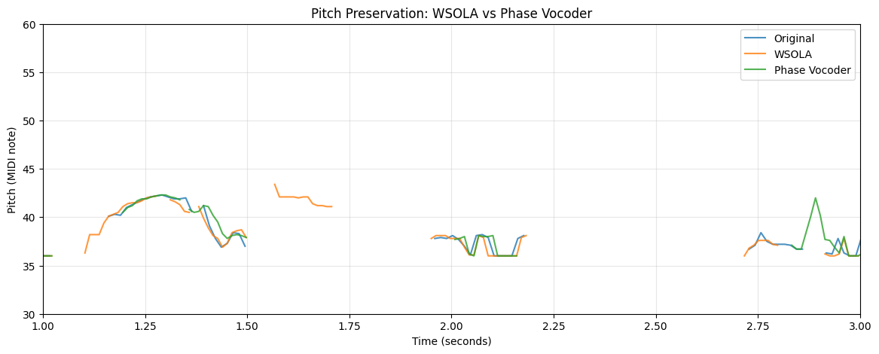

Figure 7: Pitch Preservation in Time Stretching Methods.

From this plot, we can deduce that both techniques generally preserve pitch, as you can see the WSOLA (orange) and phase vocoder (green) closely follow the original. However, WSOLA shows slightly more pitch irregularities in places where the original signal’s voice was undetected (the gaps in the blue line).

Both seem to produce good quality audio, and listening to the produced audio I could not hear any obvious distortion, so they both worked pretty well in this use case.

I also generated a short melody consisting of slowed and sped up audios of Tom’s Diner.

  - Melodies and Combining Assigned Techniques (P2 and P3)
In each technique exploration, I generated sounds and melodies using the techniques I explored and using combinations of techniques. These can be found in the audio folders in the form of wav files in each of the technique exploration folders. Each individual technique and combination of technique produced interesting audios and I’m confident many of these will help add effects to the final musical composition. Also,, time stretching and autotuning allowed me to make a fun remix.

  - Combining with another group members’ techniques (P4)

Due to the lack of time at the end, I was only able to have time to combine one of my techniques with reverb.

    - Magnitude Spectrum Manipulation (Filtering) combined with Reverb

In my exploration, I experimented with the order by testing filtering before reverb and then reverb before filtering. I did this with 3 filters; low-pass, high-pass, and band pass. Filtering first changes the sounds that gets given to the reverb algorithm whereas filtering afterward removes some frequencies from the reverbed audio, so the tone was likely to change depending on the order in which these techniques are applied.

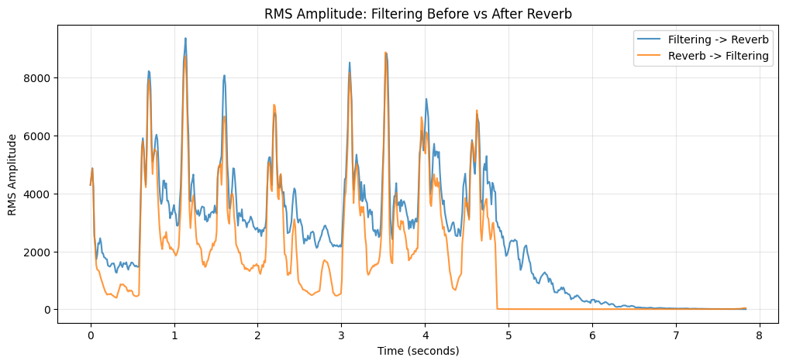

Figure 8: RMS Amplitude: Filtering Before vs After Reverb

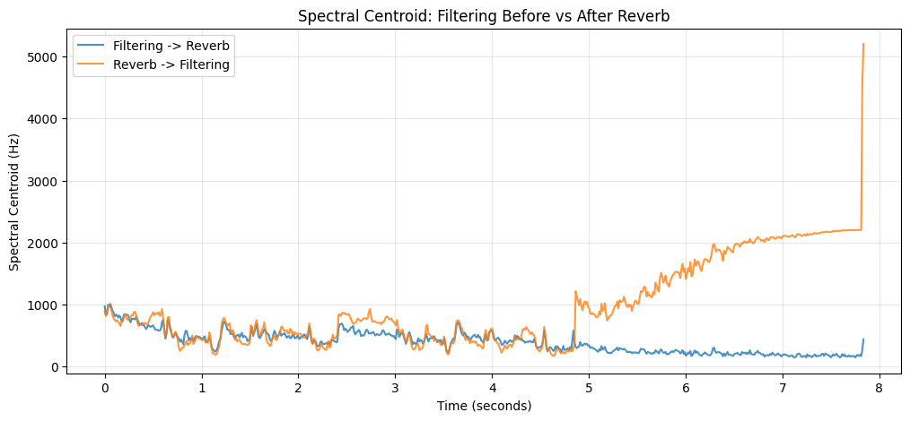

Figure 9: Spectral Centroid: Filtering Before vs After Reverb

The audio from filtering before reverb definitely had a more interesting effect, the sound produced sounded more “noisy”. Particularly the low filtered reverb sounded almost as if you were listening to the song in an underground tunnel. In the RMS Amplitude plot (Figure 8) we can see that filtering first produces a more gradual decay from the reverb and that the amplitude trends higher except at certain peaks (which you can also hear in the audio).

The audio from doing the reverb first made the filtering have a less drastic effect on the overall sound produced, the original pitch was preserved a lot better too. In the RMS Amplitude plot (Figure 8) we can see that reverbing first reduces the amplitude faster at the end. In the Spectral Centroid plot (Figure 9), we can see that reverbing first causes much brighter sound at the end even though that is when the song is supposed to be getting quieter (although that is probably because the measurements of frequency get more unreliable as they approach zero/silence).

  - Next Steps

Once I finish my exploration of combinations of techniques, my next step will be to begin to develop the application that will take the short Tom’s Diner audio clip, along with the midi file of the musical composition that Linnea writes to create a midi mapper that will generat the audio for the composition. First I will make the UI mockups and do a few iterations after getting feedback from my group, then I will build a frontend and a bit of the back end to support the application.

The github README.md has been updated to reflect that my objective 2 goals have now changed.
- ISABEL FERRIS – PROGRESS
Aaa
- REFERENCES
- M. Blackwell, Plunderphonics, 1st ed. New York, NY, USA: Bloomsbury Academic, 2025, doi: 10.5040/9798765119518.
- W. C. Pirkle, “Karplus-Strong Plucked String Model,” in Designing Software Synthesizer Plugins in C++, 2nd ed., United Kingdom: Routledge, 2021, pp. 207–224. doi: 10.4324/9781003052203-13.
- J. O. Smith, “Freeverb,” in Physical Audio Signal Processing, CCRMA, Stanford University. [Online]. Available: https://ccrma.stanford.edu/~jos/pasp/Freeverb.html
- P. Dutilleux, M. Holters, S. Disch, and U. Zölzer, “Filters and Delays,” in DAFX, 2nd ed., U. Z&ouml;lzer, Ed., Chichester, UK: Wiley, 2011, pp. 47–81. doi: 10.1002/9781119991298.ch2.
- C. Ó Nuanáin, P. Herrera, and S. Jordá, “Rhythmic Concatenative Synthesis for Electronic Music: Techniques, Implementation, and Evaluation,” Computer music journal, vol. 41, no. 2, pp. 21–37, June 2017, doi: 10.1162/COMJ_a_00412.
- Handelman, E., Sigler, A., & Donna, D. (2012). Automatic orchestration for automatic composition. In Proceedings of the AAAI Conference on Artificial Intelligence and Interactive Digital Entertainment (Vol. 8, Issue 4, pp. 43–48). https://doi.org/10.1609/aiide.v8i4.12562
- How does AutoTune work? The science behind pitch correction. (n.d.-b). AutoTune. https://www.antarestech.com/blog/the-science-behind-auto-tune?srsltid=AYCX9vKiRnSOQeDIUF0_00O7EB8DCJ6QT-bus7lAQDN1mPHl-V7_l1RC
- GitHub - gtzan/mir_book: Support material for Music Information Retrieval by George Tzanetakis. (n.d.). GitHub. https://github.com/gtzan/mir_book/tree/master
- Paliwal, K. K., & Alsteris, L. D. (2004). On the usefulness of STFT phase spectrum in human listening tests. Speech Communication, 45(2), 153–170. https://doi.org/10.1016/j.specom.2004.08.001
- Réveillac, J. (2018). Filtering effects. In Wiley eBooks (pp. 81–104). https://doi.org/10.1002/9781119467014.ch4
- Driedger, J. (2011d). Time-Scale modification Algorithms for music audio signals [Master’s thesis, Saarland University]. https://audiolabs-erlangen.de/content/05_fau/professor/00_mueller/01_group/2011_DriedgerJonathan_TSM_MasterThesis.pdf

