LOAN DEFAULT PREDICTION SYSTEM

Table of Contents
1 | Executive Summary
2 | Project Overview
3 | Brief Research on the Real-World Problem
4 | Stakeholder Analysis
5 | Functional Requirements
6 | Non-Functional Requirements
7 | Requirements Analysis
8 | Technology Stack
9 | Overall System Architecture
10 | Data Flow Diagram (DFD)
11 | Module Interaction Diagram
12 | Database Design (ER Diagram)
13 | Design Strategy
14 | Development Roadmap
15 | Milestones
16 | Assumptions
17 | Constraints
18 | Risk Analysis
19 | Testing Strategy
20 | Future Enhancements
21 | Conclusion

1. Executive Summary
Loan default is a significant credit-risk concern for banks and non-banking financial companies (NBFCs). Traditional credit assessment can depend heavily on manual review, fixed rules, historical experience, and fragmented information. These approaches may consume time, produce inconsistent assessments, and make it difficult to communicate why a particular applicant has been assigned a given level of risk. The proposed Loan Default Prediction System addresses this problem through a web-based machine-learning application that estimates the probability of loan default from structured applicant and loan information.
The proposed system combines a React and Tailwind CSS interface with a FastAPI backend and a Python-based machine-learning service. An XGBoost classifier is planned as the principal predictive model because it is suitable for structured tabular data and can capture non-linear relationships. SHAP will provide local and global explanations so that users can understand which input features contributed to a prediction. PostgreSQL will store users, applicant records, predictions, and generated reports. Docker will support reproducible deployment, while GitHub will provide version control and collaborative development.
Primary target users are loan officers, risk analysts, bank managers, and system administrators. Applicants may interact with the system through a controlled application interface, while operational users receive risk scores, prediction explanations, dashboards, and reports. The system is intended to support—not replace—human credit decisions. Its outputs should be treated as decision-support information and validated against institutional policies, applicable law, data quality requirements, and responsible-AI practices.
Expected benefits include faster preliminary risk assessment, consistent application of the trained model, improved transparency through explanations, centralized analytics, and a foundation for model monitoring. The first version will use publicly available or appropriately licensed financial data and will focus on a controlled prototype rather than direct integration with production banking systems. The project is feasible within an academic development cycle because its architecture separates the presentation, business, data, and machine-learning concerns and permits each layer to be tested independently.

2. Project Overview

2.1 Introduction
The Loan Default Prediction System is an AI-enabled web application designed to estimate whether a loan applicant is likely to default. The system accepts relevant financial, demographic, employment, and loan attributes, validates them, transforms them into model-ready features, executes a trained classifier, and returns a probability and risk category together with an explanation.

2.2 Background
Credit institutions evaluate applicants using information such as income, existing obligations, credit history, loan amount, employment stability, and repayment history. Machine learning can learn relationships between such variables and historical repayment outcomes. A production-grade implementation requires more than model accuracy: it also requires secure data handling, validation, monitoring, explainability, auditability, and clear human oversight.

2.3 Existing System
- Manual review of application documents and financial information.
- Rule-based eligibility and credit-score thresholds.
- Spreadsheets or disconnected internal tools for analysis and reporting.
- Human review of exceptions and borderline cases.

2.4 Limitations of Current Approach
- Manual processing can increase turnaround time.
- Different reviewers may interpret borderline cases differently.
- Static rules may not capture complex interactions between variables.
- Reasons for a decision may not be presented consistently.
- Fragmented records make portfolio-level analysis more difficult.

2.5 Proposed Software
The proposed software centralizes application capture, prediction, explainability, analytics, and reporting behind a secure REST API. A modular architecture allows the machine-learning model to be updated without redesigning the entire interface.

2.6 Objectives
- Provide a web-based interface for entering and validating loan-applicant information.
- Generate a default probability and interpretable risk level.
- Provide SHAP-based explanations for individual predictions.
- Maintain prediction and applicant records in PostgreSQL.
- Provide dashboards and reports for authorized users.
- Support batch prediction through CSV upload.
- Establish a foundation for model monitoring and future deployment.

2.7 Scope
Category | In Scope | Out of Scope
Data | Public/appropriately licensed structured financial data; input validation | Private bank data without authorization
ML | Training, validation, XGBoost prediction, SHAP explanations | Autonomous credit approval
Web | React UI, forms, dashboard, authentication | Native mobile application in v1
Backend | FastAPI REST services, validation, business logic | Direct core-banking replacement
Database | Users, applicants, predictions, reports | Enterprise data warehouse
Reporting | On-screen analytics and downloadable reports | Regulatory filing automation
Deployment | Dockerized prototype | Guaranteed production banking deployment

3. Brief Research on the Real-World Problem

3.1 What Is Loan Default?
Loan default occurs when a borrower fails to meet contractual repayment obligations according to the terms of a loan. The exact operational definition varies by product, institution, jurisdiction, and reporting standard. For a machine-learning project, the target label must therefore be defined explicitly—for example, default within a specified observation window or a documented delinquency threshold.

3.2 Why Prediction Is Needed
Credit institutions need to estimate the probability and potential consequences of repayment failure before and during the life of a loan. Better risk estimation can support prioritization of applications for review, portfolio analysis, early-warning processes, and allocation of credit-risk resources. A prediction model should be one component of a broader credit-risk framework rather than the sole determinant of approval.

3.3 Public Statistics and Evidence
The World Bank's Global Findex program reports that billions of adults globally have access to formal financial accounts, illustrating the scale of financial inclusion and the importance of responsible credit infrastructure. The IMF and World Bank also publish extensive indicators related to financial stability, credit, and non-performing loans. In India, the Reserve Bank of India publishes banking statistics and reports that demonstrate the continuing importance of asset quality and credit-risk management. These public sources are suitable for contextual research, while a project dataset should be separately documented and validated.

3.4 Current Challenges
- Incomplete or inconsistent applicant information.
- Class imbalance because defaults are often less frequent than non-defaults.
- Concept drift as borrower behavior and economic conditions change.
- Potential leakage when post-outcome information enters training data.
- Fairness and privacy concerns in automated risk assessment.
- Difficulty explaining complex models to operational users.
- Operational failure if model outputs are treated as certain rather than probabilistic.

3.5 How AI Can Improve Decision Support
Machine learning can process multiple structured variables simultaneously and identify non-linear relationships that are difficult to encode manually. Explainability methods can show feature contributions for individual predictions. Automated dashboards can aggregate predictions by risk category, period, or portfolio segment. However, AI improves decision support only when the training data is representative, the target definition is sound, performance is evaluated with appropriate metrics, and governance controls are maintained.

4. Stakeholder Analysis
Stakeholder | Role | Needs
Loan Applicant | Provides application information and may receive application status | Clear forms, privacy, understandable status information
Loan Officer | Reviews applications and risk information | Fast prediction, probability, explanation, notes, reports
Bank Manager | Oversees portfolio and operational outcomes | Dashboard, aggregate risk trends, KPIs, reports
Risk Analyst | Validates model and analyzes risk patterns | Metrics, feature importance, data quality, monitoring
System Administrator | Maintains accounts, configuration, and system health | User management, audit logs, model/version controls

5. Functional Requirements
ID | Description | Priority
FR-01 | User Registration | High
FR-02 | Secure Login and Logout | High
FR-03 | Role-Based Access Control | High
FR-04 | Loan Application Form | High
FR-05 | Input Validation and Data Quality Checks | High
FR-06 | Default Probability Prediction | High
FR-07 | Risk-Level Classification | High
FR-08 | SHAP Local Explanation | High
FR-09 | Global Model Analytics | Medium
FR-10 | Applicant and Prediction History | High
FR-11 | Dashboard and KPI Visualization | Medium
FR-12 | Report Generation and Download | Medium
FR-13 | Batch CSV Upload | Medium
FR-14 | Admin Panel | Medium
FR-15 | Model Version Management | Medium
FR-16 | Model Monitoring Metrics | Medium
FR-17 | Audit Logging | High
FR-18 | Error Handling and User Notifications | High
FR-19 | Health Check Endpoint | Medium
FR-20 | Data Export for Authorized Users | Medium

6. Non-Functional Requirements
ID | Area | Requirement | Priority
NFR-01 | Performance | Typical prediction API response should target <2 seconds under normal prototype load. | High
NFR-02 | Scalability | Stateless API design should permit horizontal scaling. | Medium
NFR-03 | Security | Passwords, tokens, and sensitive fields must be protected using appropriate controls. | High
NFR-04 | Availability | The prototype should recover cleanly from routine service failures. | Medium
NFR-05 | Reliability | Repeated valid inputs should produce deterministic results for a fixed model version. | High
NFR-06 | Maintainability | Modules and interfaces should be documented and independently testable. | High
NFR-07 | Usability | Forms and prediction results should be understandable to non-technical users. | High
NFR-08 | Responsiveness | The interface should work on desktop and common tablet/mobile widths. | Medium
NFR-09 | Explainability | Each prediction should provide understandable feature contributions where supported. | High
NFR-10 | Privacy | Applicant data should be collected minimally and access-controlled. | High
NFR-11 | Compatibility | System should support current major browsers and Dockerized execution. | Medium
NFR-12 | Logging | Authentication, prediction, errors, and administrative events should be logged without exposing secrets. | High
NFR-13 | Auditability | Predictions should retain model version and timestamp metadata. | Medium
NFR-14 | Portability | Application should be runnable through documented environment configuration. | Medium

7. Requirements Analysis

7.1 User Requirements
- Applicants need a clear, accessible application form with validation feedback.
- Loan officers need a rapid prediction result and concise explanation.
- Managers need aggregate dashboards and downloadable reports.
- Risk analysts need model-performance and feature-level information.
- Administrators need secure user, model, and audit controls.

7.2 System Requirements
- A browser-based React client communicating with FastAPI through HTTPS in deployment.
- A Python ML service capable of loading a versioned XGBoost model.
- A PostgreSQL database with transactional persistence.
- Authentication and authorization middleware.
- Structured API responses and consistent error handling.
- Containerized services for repeatable setup.

7.3 Business Requirements
- Reduce the time required for preliminary risk assessment.
- Improve consistency of risk-screening information.
- Provide transparent decision-support evidence.
- Enable management reporting and portfolio visibility.
- Reduce operational dependence on spreadsheets.
- Support future integration with institutional systems without redesigning the core architecture.

8. Technology Stack
Layer | Technology | Reason
Presentation | React | Component-based UI and reusable stateful views
Styling | Tailwind CSS | Rapid, consistent responsive styling
API | FastAPI | Typed Python APIs, validation, high-performance async support
Programming | Python | ML ecosystem and backend integration
ML | XGBoost | Strong baseline for structured/tabular classification
Explainability | SHAP | Local and global feature-attribution analysis
Database | PostgreSQL | Reliable relational persistence and SQL support
Deployment | Docker | Reproducible environments and service isolation
Version Control | GitHub | Source control, collaboration, issue tracking
Testing | Pytest / Playwright (planned) | Backend and end-to-end validation

9. Overall System Architecture

9.1 High-Level Architecture Diagram

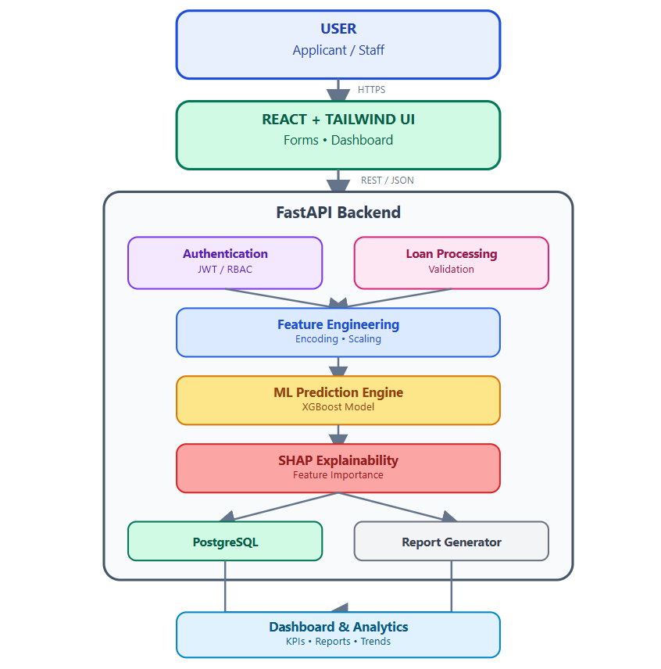

9.2 Component Descriptions
Component | Responsibility
User | Initiates applications, reviews prediction information, or performs administrative/analytical tasks according to role.
React Frontend | Collects input, renders validation messages, calls REST endpoints, and visualizes prediction and dashboard data.
Authentication Module | Validates credentials, creates sessions/tokens, and enforces role permissions.
FastAPI Backend | Coordinates business logic, validation, prediction calls, persistence, and reporting.
Feature Engineering | Cleans, encodes, scales or transforms inputs exactly as required by the trained model.
ML Prediction Engine | Loads the selected model version and returns a probability plus derived risk category.
SHAP Explainability | Calculates feature contributions to communicate why the model produced a particular result.
PostgreSQL | Stores users, applicants, predictions, reports, and metadata.
Report Generator | Transforms selected records and analytics into a structured report.
Dashboard | Displays aggregate risk trends, counts, distributions, and selected performance indicators.

10. Data Flow Diagram

10.1 DFD Level 0 – Context Diagram
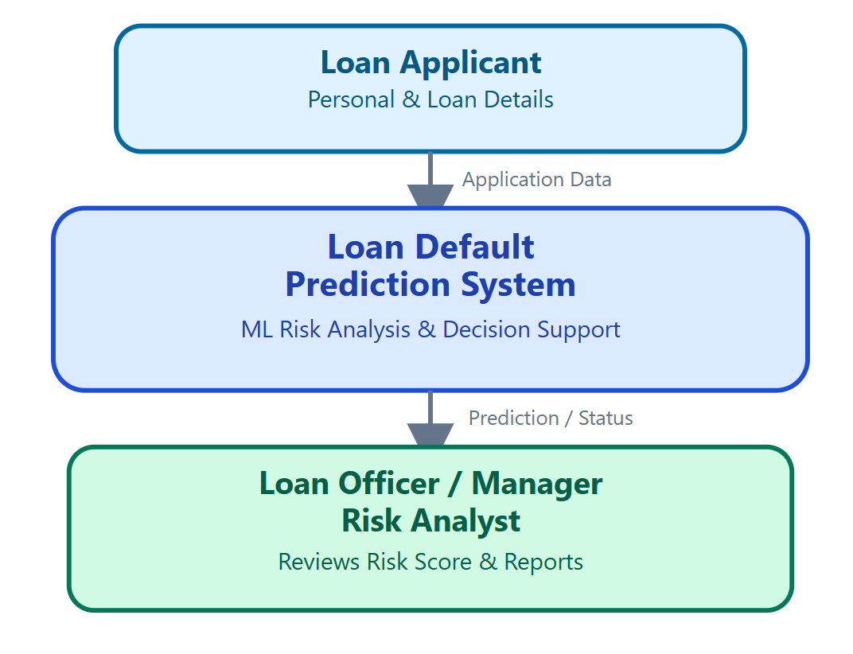
At Level 0, the complete application is treated as a single process. Applicant information enters the system; the system processes it and provides prediction, explanation, status, or analytics to authorized users.

10.2 DFD Level 1
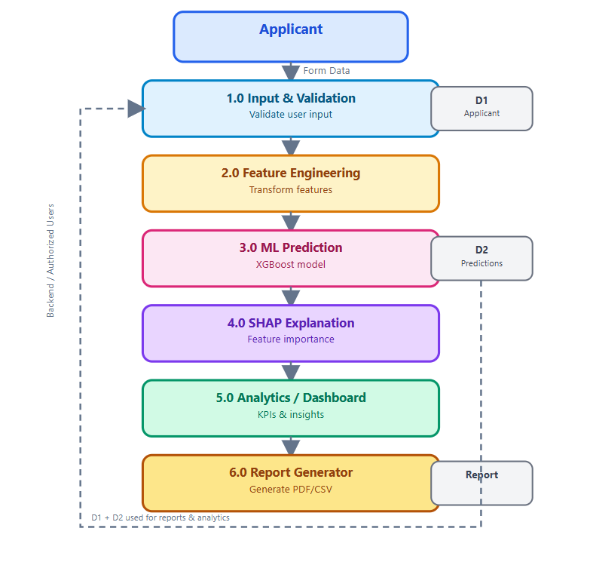
Level 1 decomposes the application into input validation, feature engineering, prediction, explanation, analytics, and reporting. Database stores preserve the applicant and prediction history required for auditing and dashboard queries.

11. Module Interaction Diagram

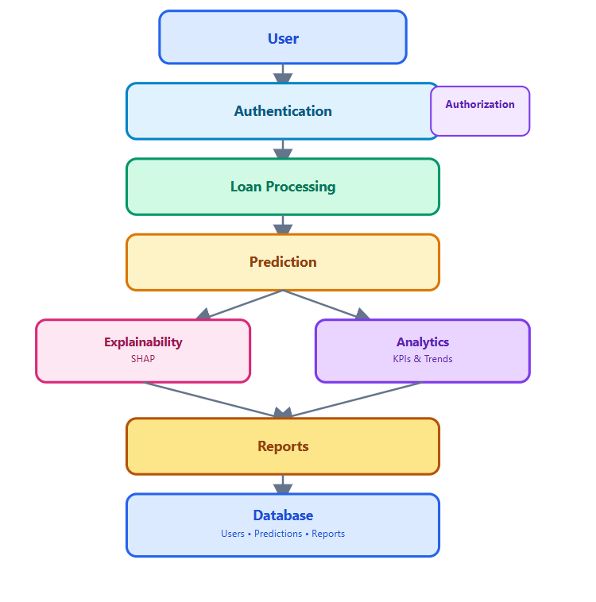

11.1 Request–Response Flow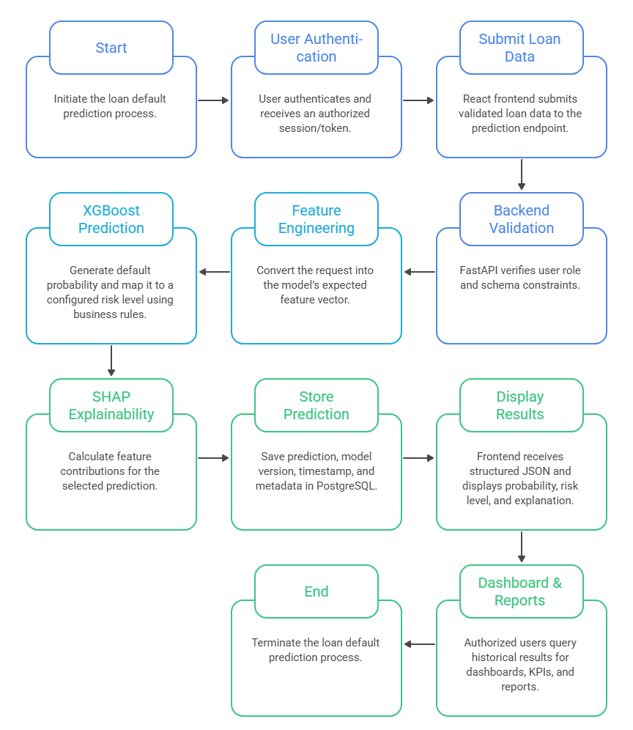

12. Database Design

12.1 ER Diagram

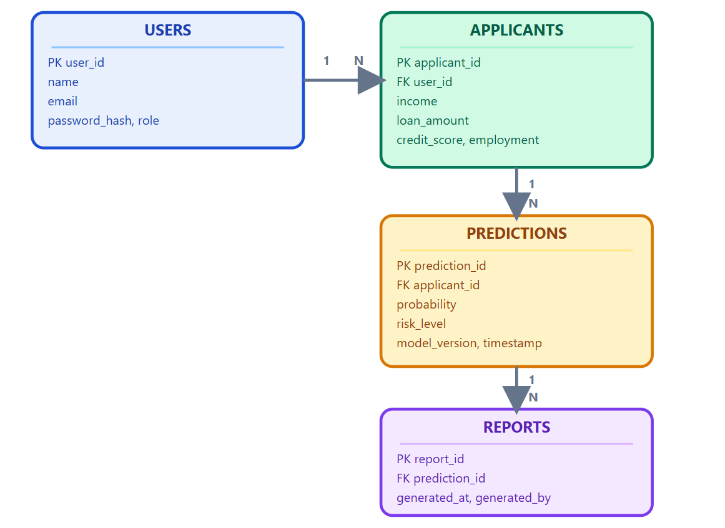

12.2 SQL-Style Schema Descriptions
Table | Schema Description
Users | user_id BIGINT PRIMARY KEY; name VARCHAR(120) NOT NULL; email VARCHAR(255) UNIQUE NOT NULL; password_hash TEXT NOT NULL; role VARCHAR(30) NOT NULL; created_at TIMESTAMP NOT NULL.
Applicants | applicant_id BIGINT PRIMARY KEY; user_id BIGINT REFERENCES users(user_id); income NUMERIC(14,2); loan_amount NUMERIC(14,2); credit_score INTEGER; employment VARCHAR(100); created_at TIMESTAMP NOT NULL.
Predictions | prediction_id BIGINT PRIMARY KEY; applicant_id BIGINT REFERENCES applicants(applicant_id); probability NUMERIC(6,5) NOT NULL; risk_level VARCHAR(30) NOT NULL; model_version VARCHAR(50) NOT NULL; timestamp TIMESTAMP NOT NULL.
Reports | report_id BIGINT PRIMARY KEY; prediction_id BIGINT REFERENCES predictions(prediction_id); generated_at TIMESTAMP NOT NULL; generated_by BIGINT REFERENCES users(user_id); report_type VARCHAR(50).

Security note: the conceptual requirement 'password' is represented as password_hash in the physical design. Plain-text passwords must never be stored. Production deployment should also apply encryption in transit, appropriate database access controls, backups, retention rules, and secret management.

13. Design Strategy

13.1 Modular Architecture
The system is decomposed into independently maintainable modules: authentication, loan processing, feature engineering, prediction, explainability, analytics, reporting, and persistence. Each module exposes a clear interface and has defined inputs and outputs.

13.2 MVC Pattern
The web application follows an MVC-inspired separation: React components represent the presentation layer; FastAPI route handlers and services provide controller/application behavior; PostgreSQL models and repositories represent persistent data. The ML service is treated as a specialized domain component.

13.3 REST APIs
Resources are exposed through versioned HTTP endpoints using JSON. Example endpoints include POST /api/v1/auth/login, POST /api/v1/predictions, GET /api/v1/predictions/{id}, GET /api/v1/dashboard/summary, POST /api/v1/reports, and POST /api/v1/predictions/batch.

13.4 Stateless Backend
Prediction requests should not depend on in-memory session state. Authentication can use securely managed tokens, while persistent application state resides in PostgreSQL. Statelessness supports horizontal scaling and simplifies deployment.

13.5 Separation of Concerns
UI presentation, business rules, ML inference, database access, and reporting are kept separate. This reduces coupling and permits model replacement, database migration, or UI redesign with limited impact on unrelated components.

14. Development Roadmap
Phase | Hours | Deliverables
Research | 4 | Problem definition, dataset survey, domain research
Planning | 4 | SRS, scope, requirements, acceptance criteria
UI Design | 5 | Wireframes, form flow, dashboard structure
Backend Design | 6 | API contracts, auth flow, service architecture
ML Planning | 6 | Target definition, features, validation and explainability plan
Database Design | 4 | ER model, schema, relationships, indexing plan
Documentation | 5 | Architecture, diagrams, risk/testing plan, final SRS

Total planned effort: 34 hours.

14.1 Gantt-Style Schedule
Phase | Workload | Indicative Window
Research | ■■■■ | Days 1–2
Planning | ■■■■ | Days 2–3
UI Design | ■■■■■ | Days 3–5
Backend Design | ■■■■■■ | Days 5–7
ML Planning | ■■■■■■ | Days 6–8
Database Design | ■■■■ | Days 8–9
Documentation | ■■■■■ | Days 9–11

15. Milestones
ID | Milestone | Output
M1 | Problem and objective definition | Approved problem statement and measurable objectives
M2 | Requirements baseline | Functional/non-functional requirement set
M3 | Architecture baseline | Component and deployment architecture
M4 | UI blueprint | Application and dashboard wireframe
M5 | ML plan | Dataset, target, features, metrics and explainability plan
M6 | Database baseline | ER model, normalized schema and relationships
M7 | Quality plan | Risk and testing strategy
M8 | Week 1 submission | Complete planning and architecture SRS

16. Assumptions
- The project can access a public or appropriately licensed structured financial dataset.
- The dataset contains a reliable target label or can be transformed into one using a documented rule.
- Training and test data can be separated without leakage.
- Users have modern web browsers and network access in the intended deployment environment.
- Model predictions are treated as probabilistic decision support rather than guaranteed outcomes.
- Required Python, Node.js, Docker and PostgreSQL development environments are available.
- Risk thresholds can be configured and approved by the project owner.
- Sensitive production banking information is not required for the academic prototype.
- SHAP explanations are technically feasible for the selected model and feature representation.
- Project requirements may evolve after prototype testing and stakeholder review.

17. Constraints
- Academic project time and team capacity may limit production-grade hardening.
- Public datasets may not represent the exact population of a particular bank or NBFC.
- Class imbalance may reduce the usefulness of accuracy as a sole metric.
- Historical data can contain bias, missingness, or measurement inconsistencies.
- Real banking APIs and core systems are outside the prototype boundary.
- Regulatory and legal requirements differ by jurisdiction and product.
- Compute resources may constrain extensive hyperparameter tuning.
- Explainability methods provide model-based attributions, not causal proof.
- Internet-dependent services may be unavailable during local development.
- Deployment security controls will need additional engineering before real financial use.

18. Risk Analysis
Risk | Probability | Impact | Mitigation
Data imbalance | High | High | Use stratified splits, class-aware metrics, threshold analysis and suitable class weighting.
Overfitting | Medium | High | Cross-validation, regularization, early stopping and independent test data.
Data leakage | Medium | High | Define feature cutoff time and perform preprocessing inside training pipelines.
API failure | Medium | Medium | Timeouts, validation, structured errors, health checks and retry-safe operations.
Security breach | Medium | High | HTTPS, hashed passwords, RBAC, input validation, secrets management and logging.
Poor user input | High | Medium | Schema validation, ranges, required fields and clear error messages.
Model drift | Medium | High | Versioning, performance monitoring and periodic retraining review.
Unclear explanation | Medium | Medium | Use SHAP summaries, plain-language labels and analyst review.
Dataset representativeness | Medium | High | Document population limits and avoid unsupported generalization.
Unauthorized access | Medium | High | Role-based permissions, token expiration, audit logs and least privilege.
Database corruption/loss | Low | High | Backups, transactions, migration controls and recovery testing.
Incorrect risk threshold | Medium | High | Document threshold rationale and validate with domain stakeholders.

19. Testing Strategy

19.1 Unit Testing
Test individual validation functions, feature transformations, probability-to-risk mapping, authentication helpers, report builders, and database repository methods. Tests should include valid, invalid, boundary, null, and malformed inputs.

19.2 Integration Testing
Verify complete flows across FastAPI routes, feature engineering, model inference, SHAP generation, and PostgreSQL persistence. The objective is to ensure that independently correct components work correctly together.

19.3 API Testing
Test HTTP status codes, request schemas, authorization, response schemas, error messages, duplicate requests, and invalid payloads. Prediction endpoints should be checked for consistent model-version metadata and safe failure behavior.

19.4 UI Testing
Verify navigation, authentication, form validation, responsive layouts, dashboard rendering, accessibility basics, and prediction-result presentation. End-to-end tests should cover an applicant entering data and an authorized officer retrieving the result.

19.5 Model Validation
Evaluate the model using a held-out test set and appropriate classification metrics such as ROC-AUC, PR-AUC, precision, recall, F1-score, confusion matrix, and calibration where relevant. Because default is generally a risk-sensitive minority outcome, the evaluation should not rely on accuracy alone. Thresholds should be selected using documented business and risk considerations.

19.6 Acceptance Criteria
- All high-priority functional requirements have passing test cases.
- Unauthorized users cannot access protected prediction or reporting endpoints.
- Valid prediction requests return probability, risk level, model version, and explanation data.
- Invalid inputs produce controlled validation errors.
- Stored predictions can be retrieved with correct timestamps and applicant references.
- Dashboard totals reconcile with the underlying authorized records.

20. Future Enhancements
Enhancement | Purpose
MLflow | Experiment tracking, model registry, reproducible model versions and lifecycle management.
EvidentlyAI | Data quality, model performance, drift and monitoring dashboards.
Cloud Deployment | Deploy frontend, API, database and model services using managed cloud infrastructure.
Real Bank APIs | Integrate approved credit, account or verification services subject to contracts and regulatory controls.
Email Alerts | Notify authorized staff about configured risk events, reports or workflow states.
Drift Monitoring | Compare production feature distributions and performance against training baselines.
Multi-bank Support | Introduce tenant isolation, configurable policies, model versions and bank-specific thresholds.
Advanced Governance | Add model cards, fairness analysis, approval workflows, audit trails and periodic validation.
Human-in-the-Loop Review | Route uncertain or high-impact cases to qualified reviewers rather than making autonomous decisions.
Continuous Learning | Support controlled retraining pipelines after data-quality and model-validation checks.

21. Conclusion
The Loan Default Prediction System provides a feasible architecture for an academic AI-enabled credit-risk prototype. It combines a responsive React interface, FastAPI services, PostgreSQL persistence, XGBoost classification, and SHAP-based explainability in a modular design. The architecture separates user interaction from business logic, machine-learning inference, data storage, and reporting, making the solution easier to test and evolve.
From a business perspective, the system is designed to reduce the effort required for preliminary risk screening, improve consistency of analytical information, and give authorized users a clearer view of risk patterns. From a technical perspective, the proposed stack is widely supported, Docker enables reproducible environments, and REST APIs provide a practical integration boundary. The use of public or appropriately licensed data keeps the initial prototype achievable without requiring access to proprietary banking systems.
The system should nevertheless be positioned as decision support. A prediction is not a guarantee of future repayment, and an explanation of a machine-learning output is not proof of causality. Before any real-world financial deployment, the model would require representative data, rigorous validation, security controls, privacy safeguards, governance, monitoring, legal and regulatory review, and appropriate human oversight. With these boundaries clearly documented, the Week 1 plan establishes a strong foundation for subsequent UI, backend, database, machine-learning, and testing implementation.

Appendix A – Suggested Initial REST API Contract
Method | Endpoint | Purpose | Response
POST | /api/v1/auth/login | Authenticate user |  | Access token/session metadata
POST | /api/v1/applicants | Create applicant record |  | Applicant ID
GET | /api/v1/applicants/{id} | Retrieve authorized applicant |  | Applicant data
POST | /api/v1/predictions | Run prediction |  | Probability, risk, explanation
GET | /api/v1/predictions/{id} | Retrieve prediction |  | Prediction details
POST | /api/v1/predictions/batch | Run CSV batch |  | Batch result summary
GET | /api/v1/dashboard/summary | Dashboard KPIs |  | Aggregated metrics
POST | /api/v1/reports | Generate report |  | Report metadata
GET | /api/v1/reports/{id} | Download report |  | Report file/stream
GET | /api/v1/health | Service health check |  | Service status

Appendix B – Recommended Model Evaluation Checklist
- Define default label and observation window before modeling.
- Remove post-outcome variables and verify temporal validity.
- Split data into training, validation and final test partitions.
- Use stratification when appropriate for imbalanced classification.
- Compare a simple baseline against XGBoost.
- Evaluate discrimination, class-specific performance and calibration.
- Inspect feature importance and SHAP explanations.
- Document limitations, population coverage and potential bias.
- Freeze the final test set before final model selection.
- Record model version, training data version and configuration.

