Screenshot 1: Signup Page Interface

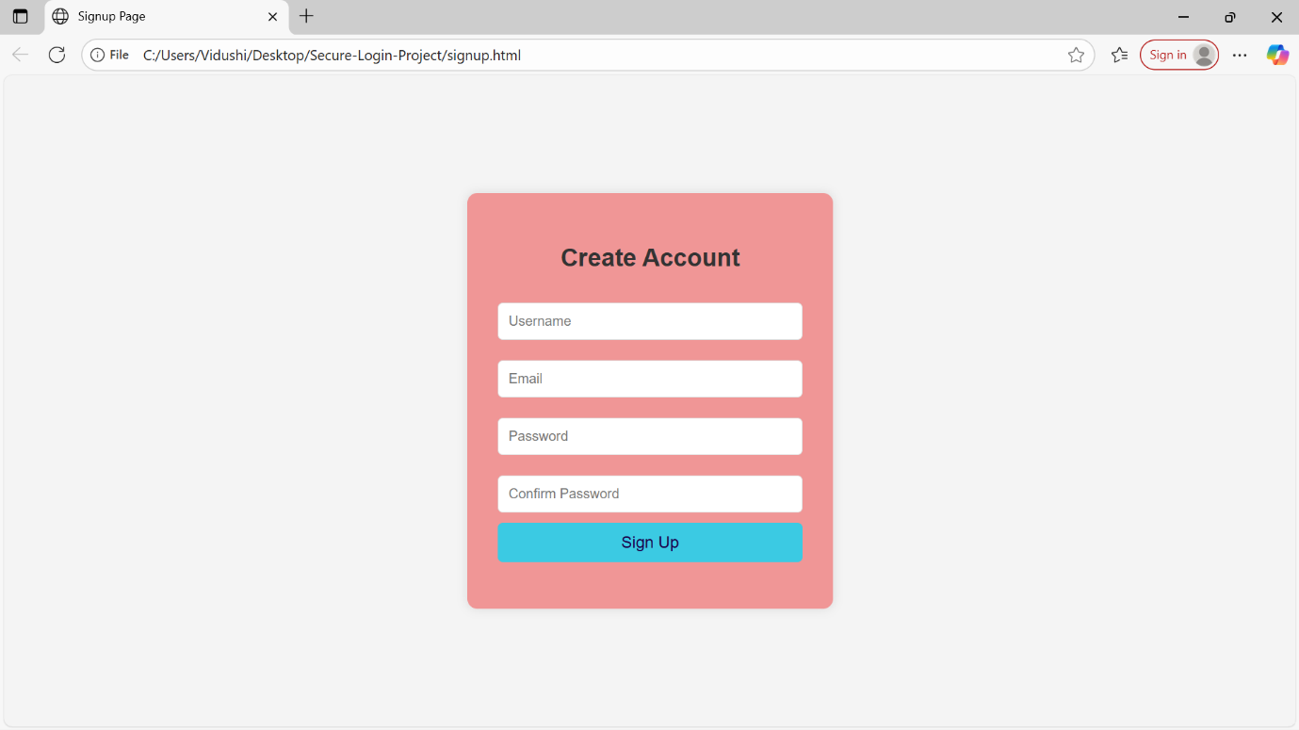

Screenshot 2: Login Page Interface

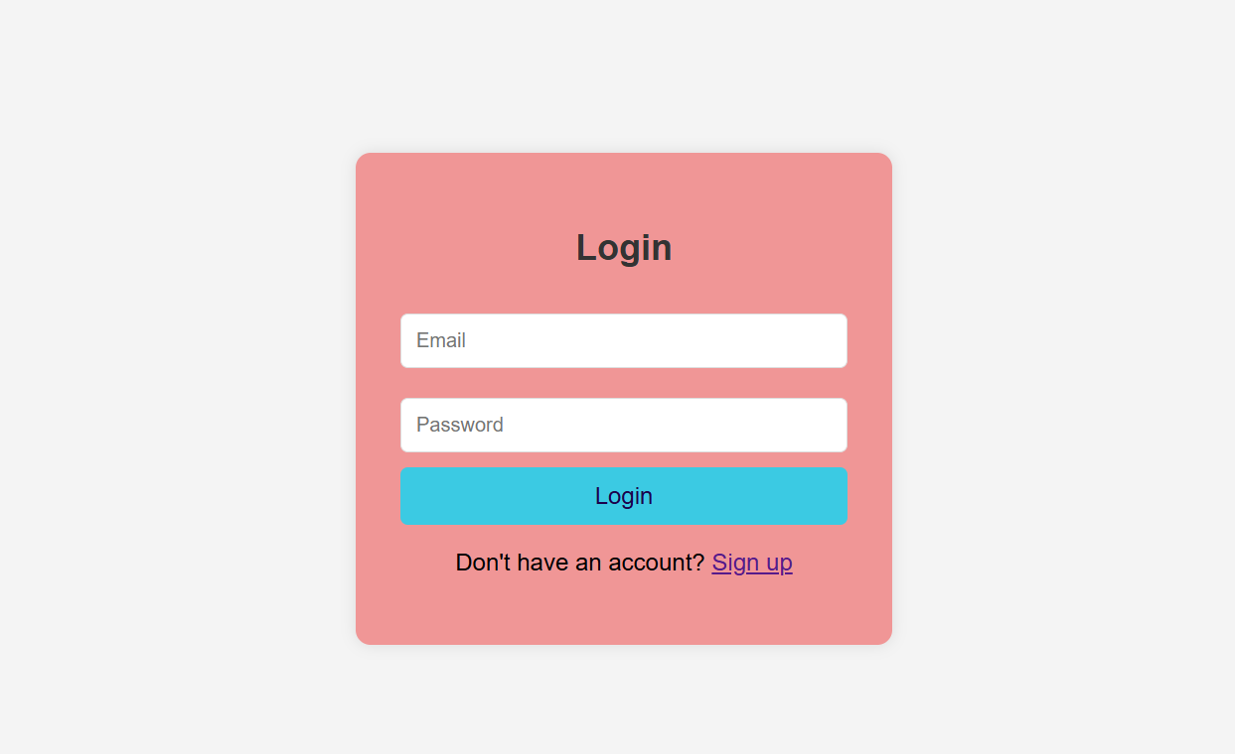

Screenshot 3: Dashboard After Successful Login
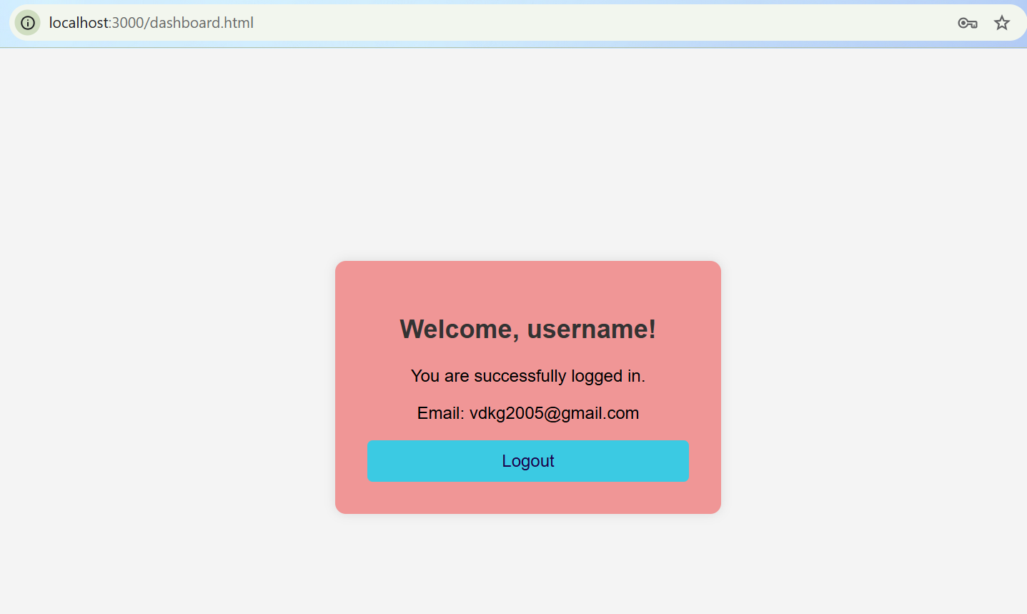

Screenshot 4: Server Running Successfully

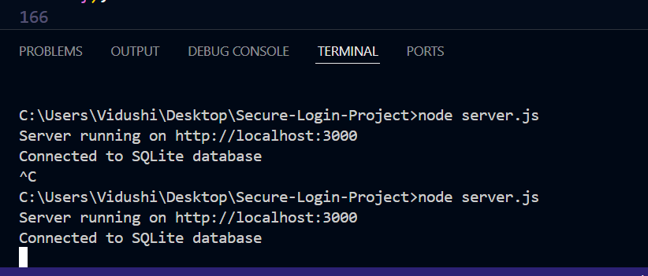

Screenshot 5: Successful Signup

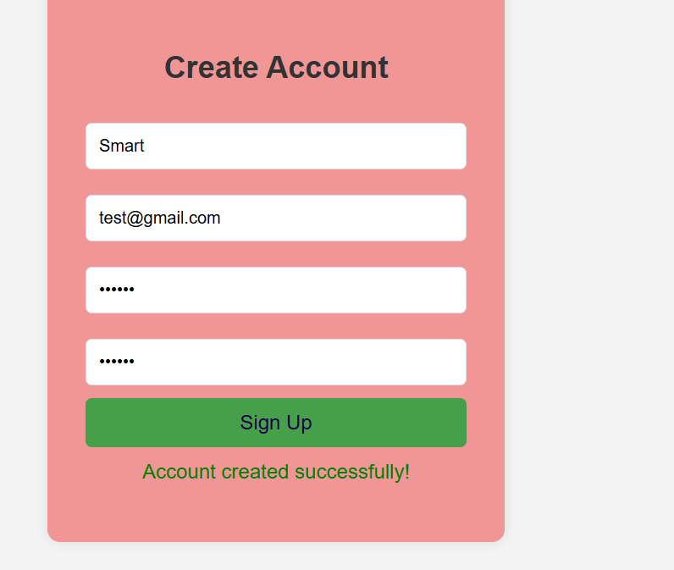
Screenshot 6: Successful Login

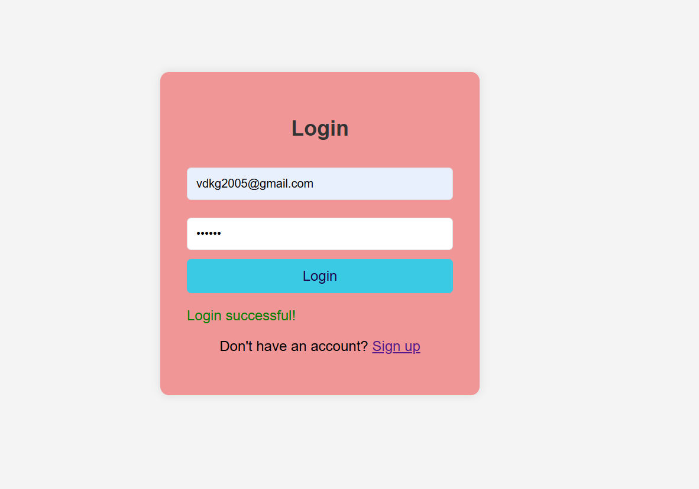

Screenshot 7: Logout Functionality
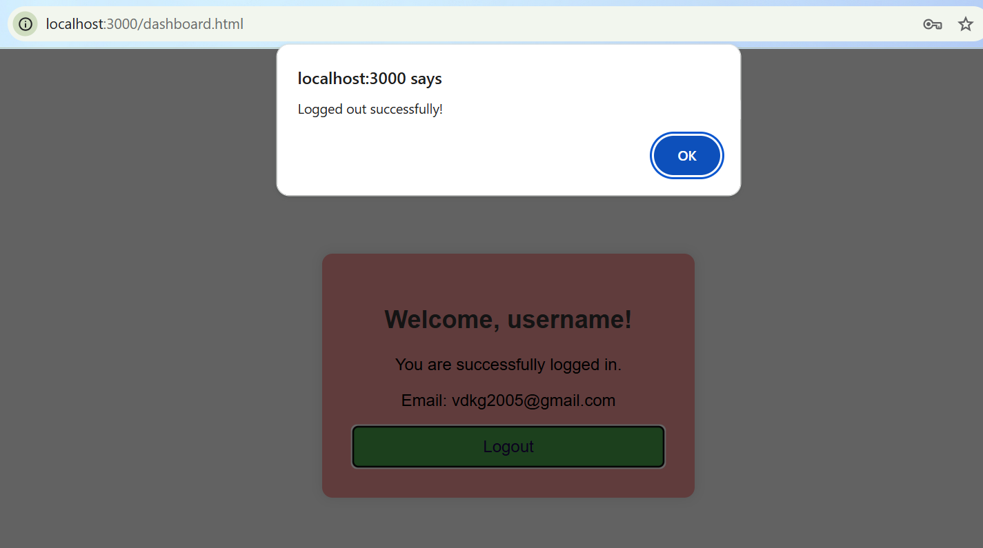

Screenshot 8: Database Showing Hashed Passwords
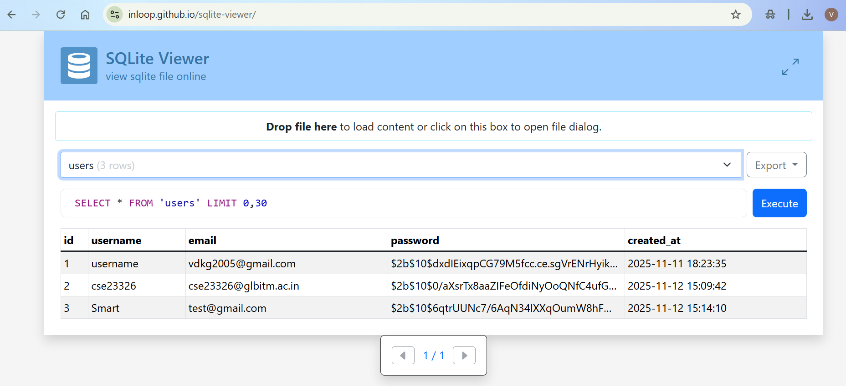

Screenshot 9: SQL Injection Test
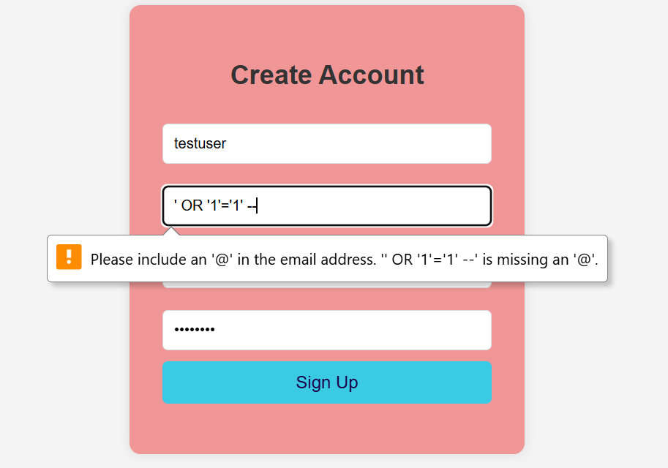

Screenshot 10: XSS Prevention Test
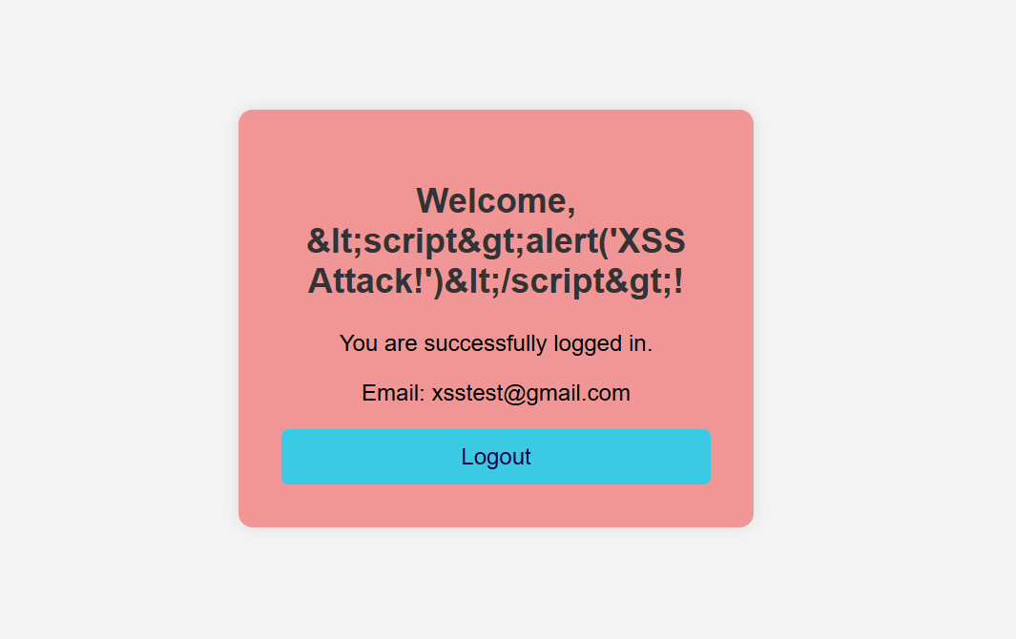

Screenshot 11: Client-Side Validation Error
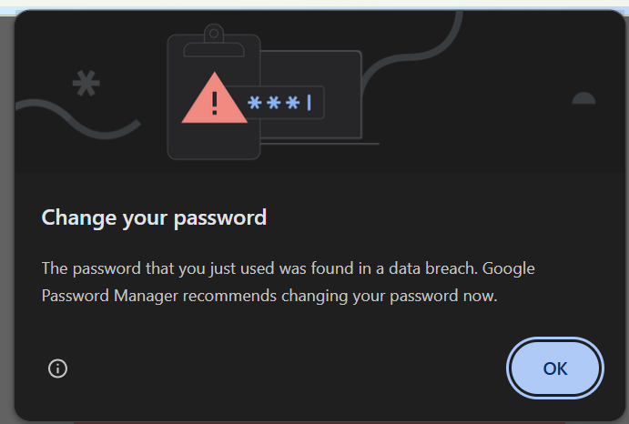

Screenshot 12: Server-Side Validation

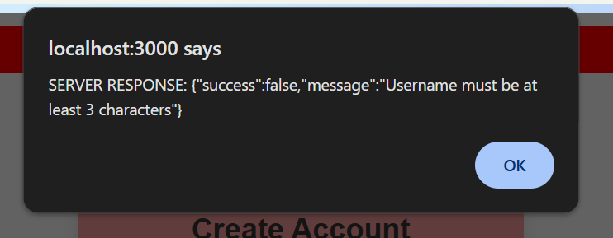
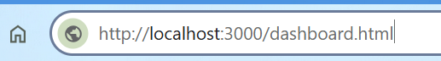
Screenshot 13: Unauthorized Access Attempt
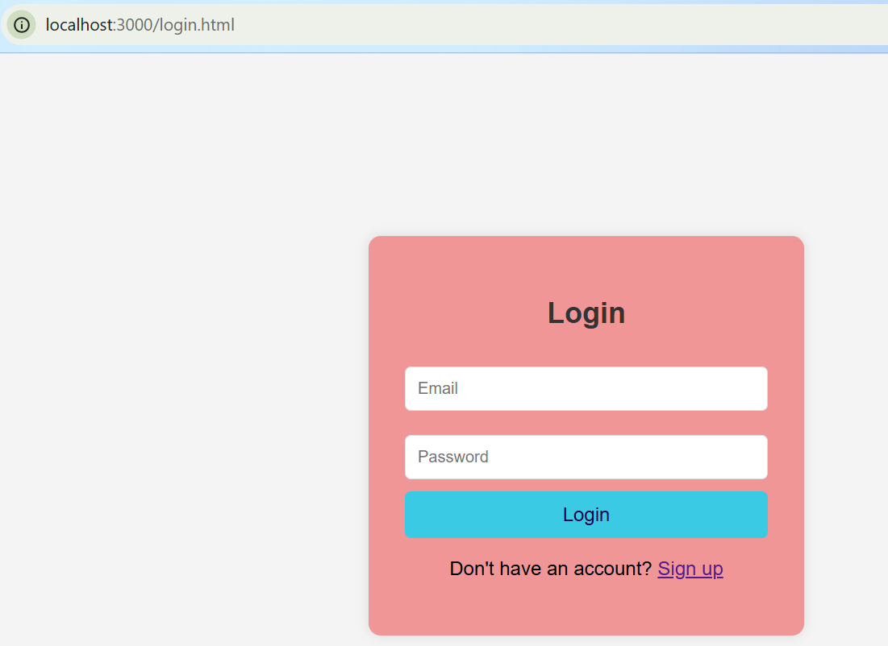

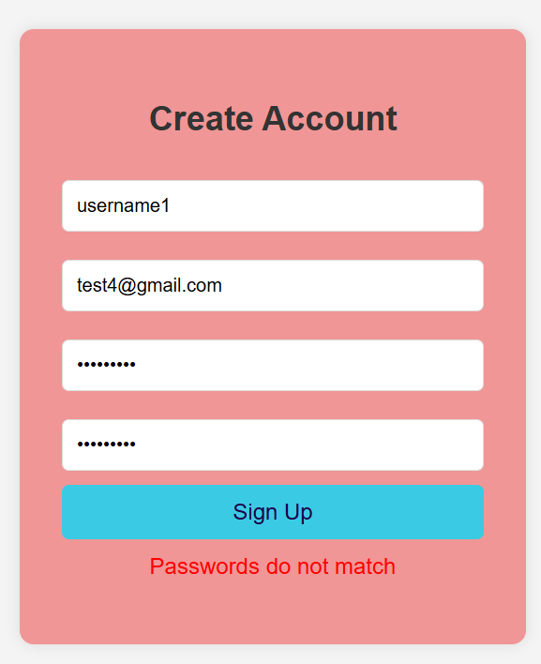
Screenshot 14: Session Persistence

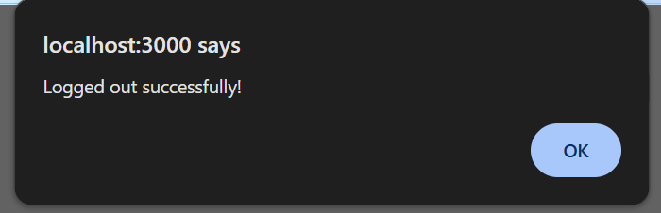
Screenshot 15: Successful Logout
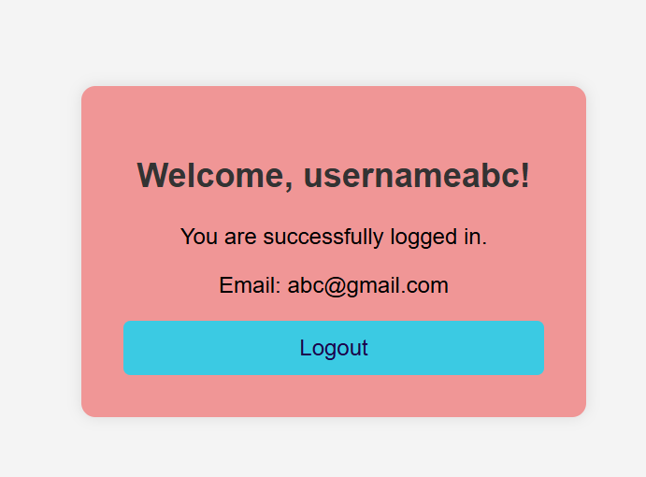
Screenshot 16: User Registration with Valid Data
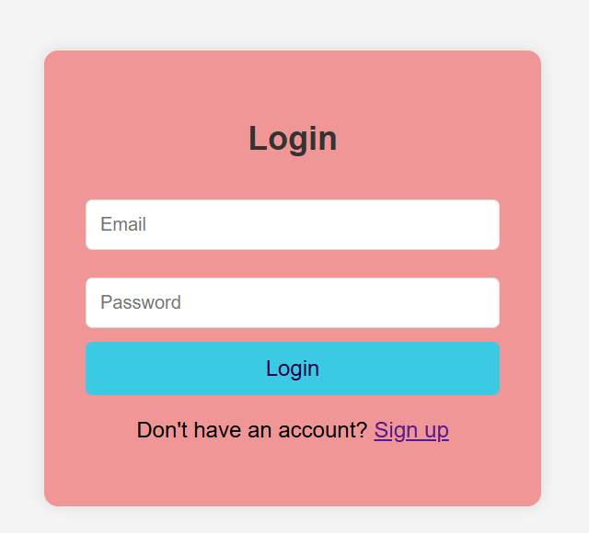

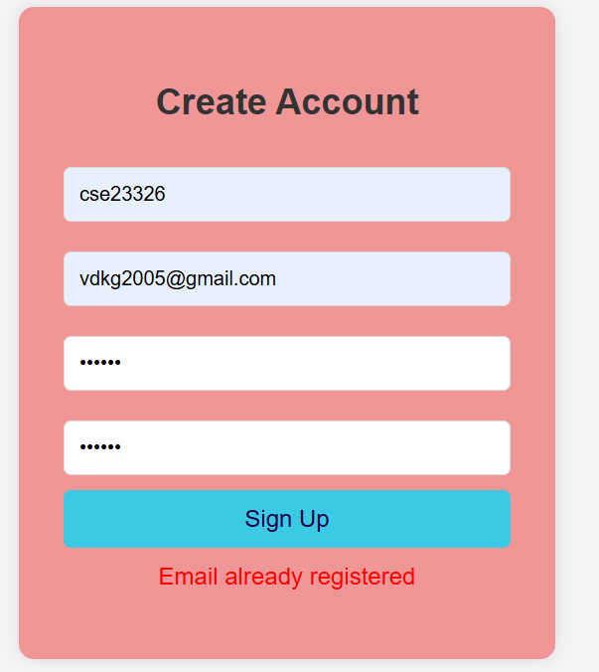
Screenshot 17: Duplicate e-mail prevention

Screenshot 18-Successful Login:
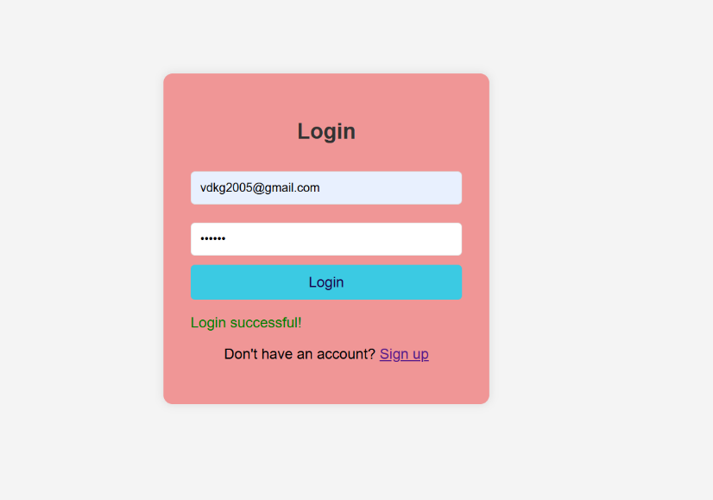

Screenshot 19: Invalid credentials error
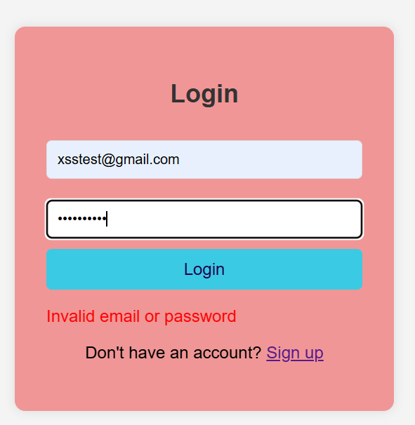

Screenshot 20: Password mismatch error

Screenshot 21: Sample Data in Database
