**Birla Institute of Technology and Science, Pilani**



**Designing and stress analysis of a pressure vessel**

Submitted By

**Vidushi Chitranshi  
2015A1PS0787P  
Date of Submission: 23/04/2018**

**Submitted to  
Dr. Bhanu Vardhan Reddy**

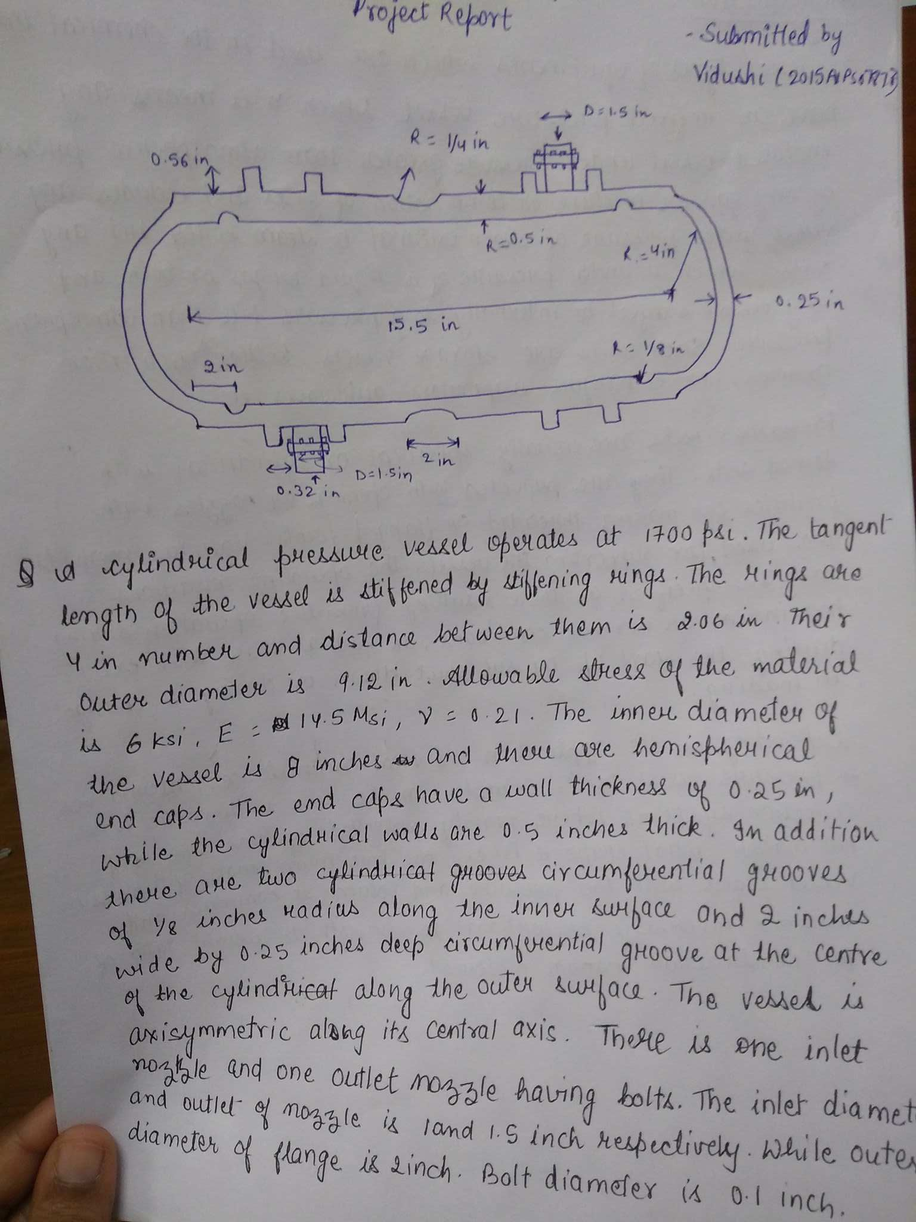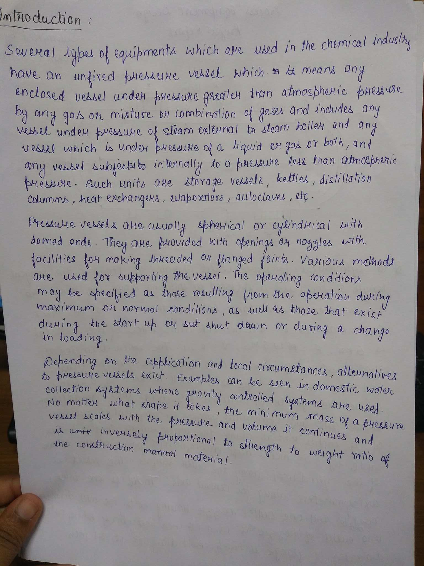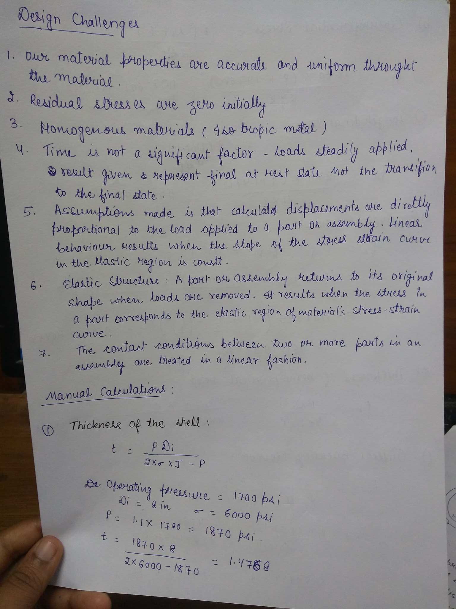

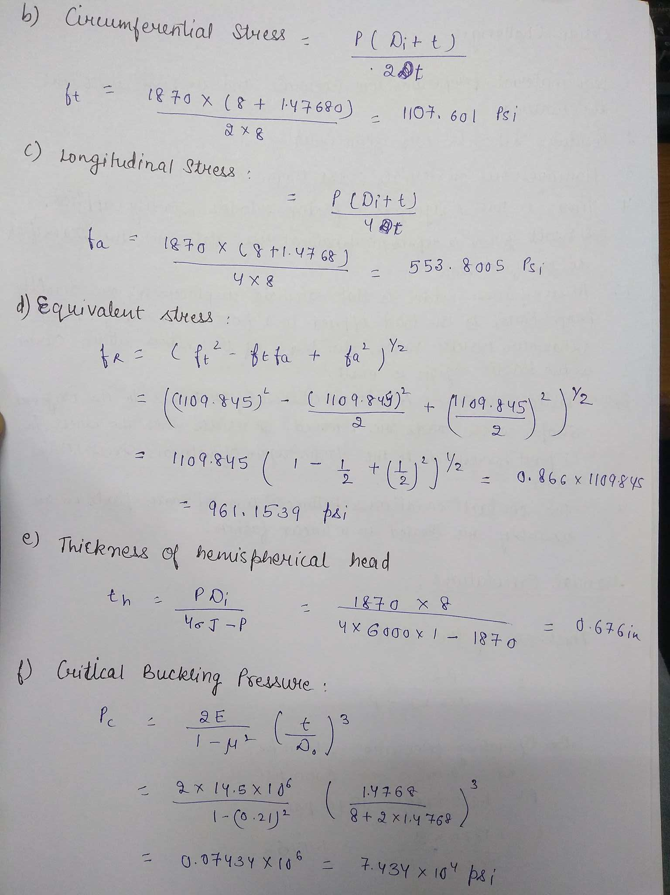

**Comparison:**

|  |  |  |  |
| --- | --- | --- | --- |
| S.no. | **Properties** | **Manual Calculations** | **CAD model**  **Solver (avg.)** |
| **1.** | Equivalent Stress | 961.1539 psi | 13120 psi |
| **2.** | Normal stress | 553.8005 psi | 7051.4 psi |

**Analysis:**

The results from CAD Model software analysis and manual calculations differ due to following major reasons:

1. **Geometry :** There are two side grooves and one central groove which has been neglected in the manual calculations. Inlet and outlet nozzles and flanges have also been not considered in the manual calculations. Thus the manual calculations do not take into account the variations due to these components.

2. **Method of solving :** Ansys uses von mises method i.e. method of the maximum distortion energy which suggests that yielding of a ductile material begins when the second deviatoric **stress** invariant reaches a critical value while the method used for manual calculations is method of shear strain energy theory which is based on the principle that the failure occurs when the maximum **shear strain energy** component for the complex state of **stress** system is equal to that at the yield point in the tensile test.

3. **Assumptions:** There are a number of assumptions taken in the solver of the software due to which the results may vary.

4. **Differences in the dimensions:** The geometry in the CAD model has some differences with the manual calculations including thickness of the head.

**Conclusions:**

There is a deviation in the results in the CAD solver and the manual calculations because the manual calculations consider only a normal cylinder as the vessel container with no other design considerations. Hence a lot of design components such as the flanges, gaskets, the reinforcement rings, the grooves the head covers are majorly responsible for the deviations. The deviations also reflect the differences due to different methodologies used such as Von mises method and method of shear strain.

**References:**

1. http://www.dosh.gov.my/index.php/en/faqs?view=topic&id=537

2. http://www.ecs.umass.edu/mie/labs/mda/fea/ditomaso/Chp3.htm

3. http://www.cae.tntech.edu/~chriswilson/FEA/ANSYS/ANSYSguide_fea-concepts.pdf

4. https://en.wikipedia.org/wiki/Von_Mises_yield_criterion

5. https://www.youtube.com/watch?v=i0jKSZvWY-8

6. https://www.youtube.com/watch?v=lVXviyD3_nA&t=1521s