  - SAP SuccessFactors

Multi-Agent MCP Prototype
  - Secure, read-only Employee Central analysis using synthetic SuccessFactors-style data

Prototype notice
Demonstration using synthetic SuccessFactors-style data. This application is not an SAP SuccessFactors system and is not production-ready.

Document | Project report
Version | 1.0
Date | 2026-08-26
Primary mode | Credential-free deterministic mock mode
Technology | Python 3.11, FastAPI, Streamlit, FastMCP, OpenAI Agents SDK

Prepared for local demonstration, coursework, architecture review and controlled testing

1. Executive summary
The SAP SuccessFactors Multi-Agent MCP Prototype demonstrates how authorized HR users can ask read-only questions about Employee Central-style data while preserving a strict security boundary. The application uses coherent synthetic data by default, requires no SAP credentials, and does not claim to be an SAP system.
All HR data access is mediated by narrow typed operations, server-side authorization, field allow-lists, deterministic validation, sanitization and structured audit logging. The provider interface allows the synthetic provider to be replaced later by a tenant-specific SuccessFactors OData V2 provider without redesigning the UI or tool schemas.
Current implementation status
The running /api/chat path uses deterministic mock routing to remain credential-free and inexpensive. Specialist-agent definitions exist, but live OpenAI Agents SDK delegation is not yet connected. Visible delegation traces are therefore explicitly labeled as deterministic mock plans.

2. Project objectives and boundaries
Area | Implemented approach
Goal | Evidence-based HR, position and data-quality answers for authorized prototype users.
Primary users | HR administrators, HRIS analysts, EC consultants, position specialists and data-quality teams.
Data source | Synthetic SuccessFactors-style Employee Central records in mock mode.
Operations | Read-only retrieval, search, effective dating, validation and bounded population analysis.
Explicit exclusions | Writes, arbitrary HTTP, raw OData clauses, Basic Authentication and prohibited HR fields.
Production status | Educational proof of concept; demonstration identity and SQLite are not production controls.

3. Architecture
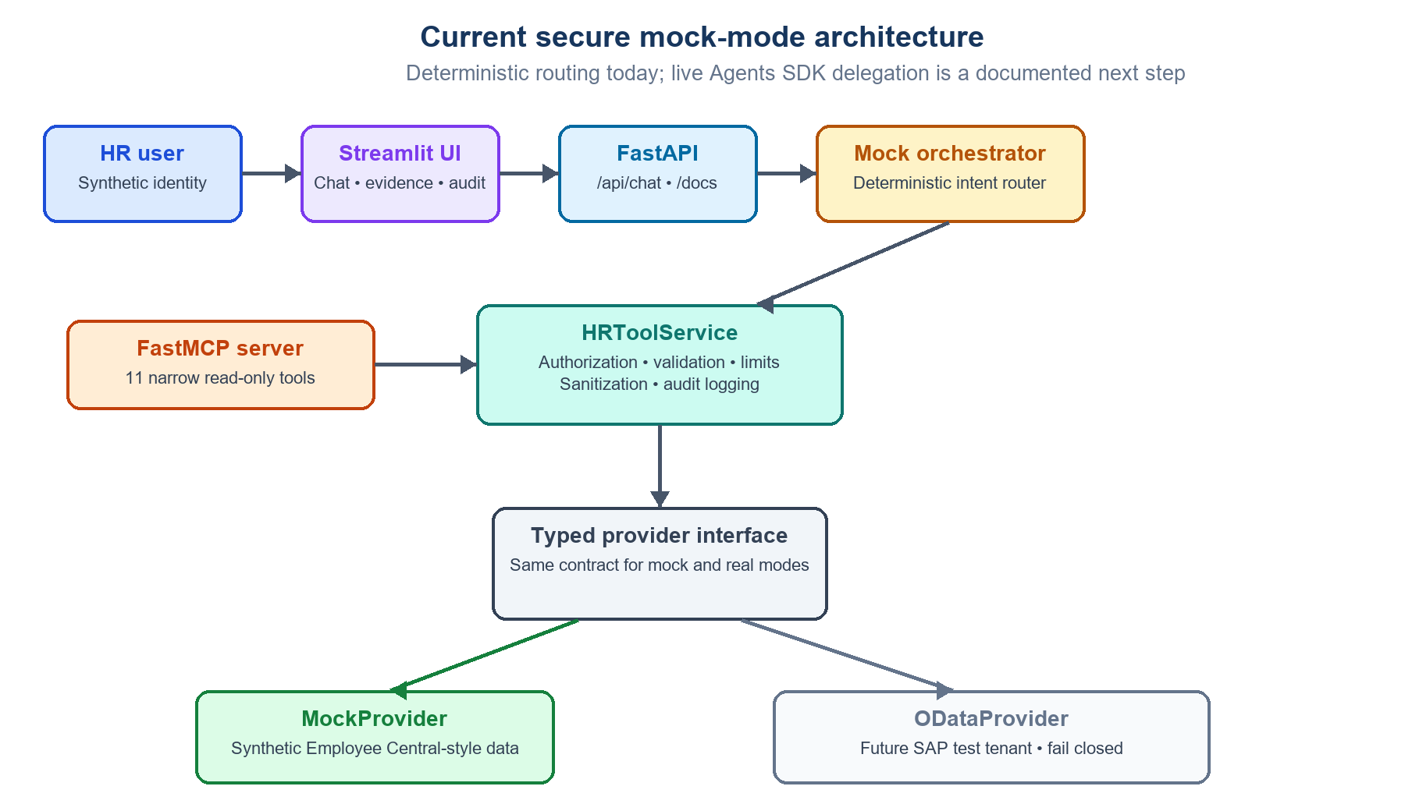
Figure 1. Current secure mock-mode architecture and provider replacement seam

3.1 Current mock-mode runtime
Step | Component | Responsibility
1 | Authorized HR user | Selects a synthetic identity and submits a read-only HR question.
2 | Streamlit UI | Collects the question/effective date and displays answers, evidence, tools, trace and audit events.
3 | FastAPI backend | Validates request schemas and exposes health, configuration, chat and audit APIs.
4 | Deterministic router | Maps supported question patterns to bounded read-only operations.
5 | HRToolService | Enforces identity, authorization, limits, sanitization and audit for every operation.
6 | Typed provider | Uses MockProvider now; preserves the seam for a future ODataProvider.
7 | Synthetic data | Supplies effective-dated employee, job, position and foundation-object records.

3.2 MCP boundary
The FastMCP server exposes narrow read-only tools that call the same HRToolService used by the deterministic API path. No tool accepts raw URLs, arbitrary entity names or model-generated OData fragments.

3.3 Target live-agent path
The target design places an HR Orchestrator above four bounded specialists. Specialists are invoked as tools; the Orchestrator retains final-response ownership. Authenticated identity and authorization context must be application controlled, not included as user prompt text.

3.4 Technology stack
Layer | Technology | Purpose in the prototype
Language/runtime | Python 3.11+ | Typed application, services, providers, validation and automation.
User interface | Streamlit 1.62 | Synthetic user selection, chat, effective dates, evidence, traces and audit viewing.
Application API | FastAPI + Uvicorn | Typed HTTP endpoints, OpenAPI documentation, health and chat APIs.
Agent framework | OpenAI Agents SDK | Manager-agent and specialist definitions; live execution is not yet connected.
MCP | Official MCP Python SDK + FastMCP | Eleven narrow read-only HR tools using strict server-side controls.
HTTP/OData | httpx | Controlled future calls to SuccessFactors OData V2 with explicit timeouts.
Schemas/settings | Pydantic v2 + pydantic-settings | Strict inputs/outputs, environment validation and fail-closed real mode.
Persistence | SQLite + SQLAlchemy 2.x | Prototype user rules and structured sanitized audit events.
Testing | pytest + pytest-asyncio | Credential-free unit, integration, security and regression testing.
Quality | Ruff + Mypy | Formatting, linting and useful static type checking.
Local configuration | python-dotenv | Development-only loading of placeholder environment configuration.
Packaging/deployment | pyproject.toml, PowerShell, Docker | Windows-first native execution and optional development containers.

Credential model
Mock mode requires no SAP or OpenAI credentials. Demo mode requires an OpenAI API key after live agent wiring. Real mode requires validated non-production SAP OAuth configuration and never falls back silently to mock data.

4. Specialist agents
Specialist | Responsibilities | Representative operations | Must never do
Employee Central | Employee, employment, job, manager, organization and effective-date interpretation. | Basic profile; job and employment information; manager relationship; effective-dated changes. | Retrieve prohibited fields, exceed population scope, invent facts or perform writes.
Position Management | Position details, incumbents, vacancies, hierarchy and organizational placement. | Get/search positions; foundation objects; position counts and missing-assignment analysis. | Treat missing incumbent as proven vacancy without evidence or accept raw OData.
Data Quality | Explain deterministic rule findings and separate errors from warnings. | Validate one employee or an authorized employee population. | Invent client-specific rules, correct data or upgrade warnings without evidence.
Security Review | Review requests and evidence for authorization, injection and prohibited-data exposure. | Approved-field verification; safe rejection; permission and write checks. | Retrieve HR data merely to grant access, expand permissions or reveal hidden prompts/secrets.

4.1 Compound deterministic delegation example
For a compound E1004 review, mock mode executes the following visible plan. It is a deterministic orchestration demonstration, not a claim of live model reasoning:
- HR Orchestrator (deterministic mock plan)
- Employee Central specialist -> get_employee_job_information
- Position Management specialist -> get_position
- Data Quality specialist -> validate_employee_data
- Security Review specialist -> approved-field verification
- HR Orchestrator -> final evidence-based answer

5. Security and authorization model
Security is enforced deterministically below the conversational layer. Agent instructions reinforce policy but are not the authorization mechanism.
Control | Implementation
Identity | Four synthetic users resolved server-side; explicitly unsuitable for production authentication.
Tool authorization | Each role has a server-owned allow-list of permitted operations.
Population scope | Restricted users can access only explicitly assigned synthetic employees.
Field controls | Central entity registry and field allow-lists; unknown and denied fields are dropped.
OData safety | Typed values, escaped literals, selected fields, capped $top and rejection of URLs/query fragments.
Existence protection | Unauthorized and unavailable records use an opaque public denial.
Audit | Correlation, user, role, tool, outcome, record count, duration and source are stored without full payloads.
Prompt injection | Requests for credentials, hidden prompts, raw OData, writes or prohibited data are rejected.

Prohibited data
Compensation, bank information, national/government identifiers, medical and disability information, emergency contacts, dependents, home address, personal email/phone, date of birth, gender and marital status are explicitly denied.

6. Synthetic data and supported analysis
Dataset | Volume | Coverage
Employees | 10 | E1001-E1010 with fictional names and employment records.
Job records | 14 | Historical, current, overlapping and future-dated scenarios.
Positions | 12 | P100-P111 with incumbents, vacancies and parent relationships.
Companies | 2 | Synthetic foundation objects.
Business units | 3 | Synthetic foundation objects.
Divisions | 4 | Synthetic foundation objects.
Departments | 6 | Synthetic foundation objects.

6.1 Intentional quality scenarios
Identifier | Scenario
E1001 | Valid current employee with historical job change.
E1002 | Overlapping effective-dated job records.
E1003 | Future-dated record that overlaps the current open-ended record.
E1004 | Assigned position P999 does not exist.
E1006 | Manager E9998 does not exist.
E1007 | Department mismatch and invalid foundation-object assignment.
E1008 | Terminated employee scenario.
E1010 | Missing position.
P109 | Only position without a parent position.

Exact exported records are available in test_data/employees.json, jobs.json, positions.json and foundation_objects.json. TEST_DATA.md documents the scenarios.

7. Interfaces and user experience

7.1 FastAPI endpoints
Endpoint | Purpose
GET / | Application notice and navigation.
GET /health and /ready | Liveness and readiness.
GET /api/config/public | Safe public mode and read-only status.
GET /api/demo-users | Synthetic roles and authorized scopes.
POST /api/chat | Question, effective date, evidence, tools, trace and correlation ID.
GET /api/audit/events | Role-filtered audit-event access.

7.2 Streamlit experience
- Synthetic user selector and role/scope summary
- Effective-date selection and example questions
- Direct evidence-based answers
- Tools-used and deterministic delegation-trace panels
- Sanitized evidence records and references
- Authorization-denial messaging and correlation IDs
- Role-filtered audit-event viewer

8. Testing and verification
At the time this report was generated, the latest executed verification reported 27 passing automated tests, successful Ruff linting and formatting, and successful Mypy checking across the source package.
Test area | Representative coverage
Core | Entity registry, allow-lists, sanitization, redaction, OData escaping and record limits.
Authorization | Role tools, restricted population and non-disclosure behavior.
API | Health, direct answers, effective dates, audit persistence and compound flows.
Data quality | Missing/invalid position, overlaps, manager absence and population scans.
Security | Prompt injection, prohibited fields, raw OData and absence of write endpoints.
MCP | Tool construction and approved read-only inventory.

Testing principle
Most tests are deterministic and require neither SAP nor OpenAI credentials. A small live-model smoke suite should be added only after Agents SDK execution is connected.

9. Running the prototype on Windows
From the project directory, run:
Set-ExecutionPolicy -Scope Process -ExecutionPolicy Bypass
.\scripts\setup_windows.ps1
.\scripts\run_ui_windows.ps1
Service | URL
Streamlit UI | http://127.0.0.1:8501
FastAPI | http://127.0.0.1:8000
API documentation | http://127.0.0.1:8000/docs
MCP | http://127.0.0.1:8001/mcp

The Windows UI launcher starts FastAPI automatically when the backend is unavailable. Keep the Streamlit terminal open while using the application.

10. Limitations and roadmap
Current limitation | Recommended next step
Deterministic pattern router supports an expanding but finite question vocabulary. | Connect the HR Orchestrator to the OpenAI Agents SDK and retain deterministic authorization/tool boundaries.
Visible delegation trace represents a deterministic mock plan. | Capture safe Agents SDK events without exposing chain-of-thought.
Real SAP OAuth is intentionally not configured. | Validate the exact tenant flow against SAP documentation and a non-production tenant.
Synthetic identity is locally selectable. | Replace with SSO, signed sessions and enterprise authorization mapping.
SQLite is a prototype audit store. | Use a managed, access-controlled and monitored audit platform.
Position and workforce analytics are bounded prototypes. | Add approved aggregate tools with scope-aware counts and explicit definitions.
Docker Compose is development-only. | Add hardened images, secrets management, network policy and production observability.

11. Definition of success
- The application runs locally in mock mode without SAP or OpenAI credentials.
- Only narrow read-only tools are available.
- Server-side authorization and population restrictions are enforced before provider access.
- Prohibited and unknown fields are removed before evidence reaches the conversational layer.
- Answers identify the data source and effective date and include evidence references.
- Every tool invocation creates a sanitized audit event.
- Unauthorized access does not disclose whether a record exists.
- Automated checks pass without weakening security controls.

Appendix A. Key project files
File | Purpose
README.md | Setup, modes, commands, troubleshooting and limitations.
ARCHITECTURE.md | Detailed component, sequence and trust-boundary design.
SECURITY.md | Threat model, controls, risks and production backlog.
TEST_DATA.md | Synthetic records and intentional quality scenarios.
SUCCESSFACTORS_ARCHITECTURE.excalidraw | Editable current/target architecture diagram.
src/sf_mcp_poc/api.py | FastAPI routes, deterministic router and mock orchestration.
src/sf_mcp_poc/service.py | Authorization-aware tool execution and validation.
src/sf_mcp_poc/mcp_server.py | Typed read-only FastMCP tool surface.
src/sf_mcp_poc/provider.py | Mock/OData provider abstraction and query builder.
tests/ | Unit, integration and security regression tests.

