SUPERSTORE SALES DATA WAREHOUSE
Data Warehousing and ETL Development
Designing a Star Schema and Building an SSIS Data Pipeline
EXTRACT → TRANSFORM → LOAD → ANALYZE
Item | Details
Prepared by | Group No:11
Institution | DSTI school of engineering
Course | Data Warehousing & ETL
Instructor | Nelson Gabriel Lopez Chirions
Submission | 1-11-2026
Reviewed against the submitted SSIS package, SQL scripts, source dataset, analytical workbooks and screenshots.

Executive Summary
This project builds a sales data warehouse for the Superstore dataset using Microsoft SQL Server and SQL Server Integration Services (SSIS). The source workbook contains 9,800 sales-line records with customer, product, location, date and sales information. The ETL workflow loads these records into a star-schema warehouse centred on Fact_Sales and supported by customer, product, location and date dimensions. A separate Ref_State table supplies state codes and 2020 population values for geographic enrichment.
The submitted evidence shows a completed SSIS package run and the expected warehouse row counts. The analysis shows Consumer customers contributing the most revenue, Technology leading the three broad product categories, the West leading the four regions, and strong revenue growth after 2016.
Two issues deserve attention before final submission. First, NULL LocationKey values are visible in the fact-table preview, so complete geographic referential integrity should not be claimed without a fresh validation. Second, the source workbook total and the supplied warehouse-analysis total differ slightly; that difference should be reconciled at row level rather than attributed to rounding without evidence.

Project at a Glance
Component | Observed result
Source sales records | 9,800
Distinct customers | 793
Distinct products | 1,861
Distinct locations | 628
Distinct order dates | 1,230
Distinct orders in source | 4,922
Source sales total | 2,261,536.7827
Supplied analytical-output total | 2,261,517.10

Contents
1. Introduction and Objectives
2. Dataset and Source Structure
3. Warehouse Architecture and Star Schema
4. ETL Implementation with SSIS
5. Warehouse Validation and Data Quality
6. SQL Analysis and Findings
7. Discussion, Limitations and Improvements
8. Conclusion
9. Group Member Contributions
10. References and Submitted Artifacts
Appendix A. Selected Validation Queries

1. Introduction and Objectives

1.1 Background
The source workbook stores customer, product, geographic and date information alongside individual sales lines. The purpose of the project is to turn that flat transactional structure into a dimensional warehouse that can be queried consistently for sales reporting.
Excel is used as the source, SSIS as the ETL layer, and SQL Server as the warehouse platform. The central design choice is a star schema: Fact_Sales stores measurable sales events, while four dimensions provide the descriptive context needed for analysis.

1.2 Objectives
- Extract the Superstore sales data from Excel through SSIS.
- Standardise source data types and derive attributes required by the warehouse.
- Build a star schema with Fact_Sales, Dim_Customer, Dim_Product, Dim_Location and Dim_Date.
- Resolve dimension keys in the fact load using SSIS Lookup transformations.
- Validate warehouse row counts and key completeness with SQL Server.
- Analyse customer segments, product performance, regional sales and sales trends.
- Document limitations and identify practical improvements for a more reliable ETL process.

2. Dataset and Source Structure
The main source is the supplied cleaned Superstore workbook. It contains 9,800 rows and 19 fields covering order identifiers, dates, shipping information, customer attributes, geography, product classification and Sales.
Source field | Role
Row ID | Source row identifier
Order ID | Business order identifier; one order may contain several lines
Order Date / Ship Date | Transaction and shipment dates
Ship Mode | Shipping service category
Customer ID / Name / Segment | Customer attributes
Country / City / State / Postal Code / Region | Location attributes
Product ID / Product Name | Product attributes
Category / Sub-Category | Product classification
Sales | Sales amount at source-line level
The second source, US_State_Population_2020.csv, contains State, StateCode and Population2020 and is used to enrich the location dimension. The supplied CSV contains 51 rows.

2.1 Source observations
- The source contains 11 records with a missing Postal Code.
- There are 4,922 distinct Order IDs across 9,800 sales-line records.
- Sales values contain more precision than the warehouse Sales column, which is defined as decimal(18,2).
- The source contains 49 distinct states in the sales data.
- ShipDays derived from Ship Date minus Order Date ranges from 0 to 7 days.

2.2 Dataset Choice Rationale

The cleaned Superstore dataset was selected because it represents a realistic transactional retail operation structured at the individual sales-line grain. Containing 9,800 records, the dataset provides sufficient breadth and complexity to model a multi-dimensional star schema satisfying industry and coursework requirements. It features event-driven transactional measures (Sales, transaction/ship dates) paired with distinct business entities: customer segmentation (Customer ID, Segment), multi-level product hierarchies (Category, Sub-Category), and geographic hierarchies (Country, City, State, Region, Postal Code). Additionally, the presence of real-world anomalies—such as missing postal codes and multi-line orders sharing an Order ID—provides an authentic ETL environment requiring systematic data typing, sorting, deduplication, surrogate key generation, and external demographic enrichment via reference data.

Item | Details
Dataset | Superstore Sales (cleaned Excel workbook): 9,800 sales lines, 19 fields, orders from 2015 to 2018
Second source | US_State_Population_2020.csv (51 rows): state code and 2020 population
Domain | Retail sales
Content | 793 customers, 1,861 products, 628 locations, 4,922 orders
Why we chose it | Transactional data that fits a star schema: one fact table and four dimensions
ETL work it requires | Data type conversion, derived columns (ShipDays, DateKey), cleaning of missing postal codes, lookups for surrogate keys, enrichment with the state CSV
Analysis it supports | Sales by customer segment, product category, region, state and time
Limitation | About 9,800 rows and no Quantity, Cost or Profit, so revenue only

3. Warehouse Architecture and Star Schema
The warehouse database is named SuperstoreDW in the submitted SQL scripts. Fact_Sales is the central table. Dim_Customer, Dim_Product, Dim_Location and Dim_Date provide the descriptive context for analysis. Ref_State is a supporting reference table rather than a fifth star-schema dimension.
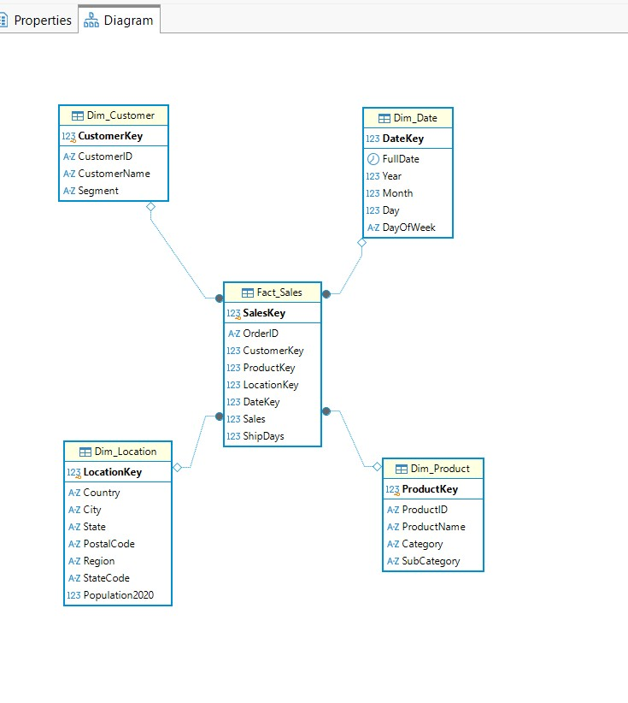
Figure 1. Submitted SQL Server star-schema diagram.
Table | Purpose | Key fields / measures | Rows shown
Fact_Sales | Sales-line fact table | SalesKey, OrderID, CustomerKey, ProductKey, LocationKey, DateKey, Sales, ShipDays | 9,800
Dim_Customer | Customer identity and segment | CustomerKey, CustomerID, CustomerName, Segment | 793
Dim_Product | Product identity and classification | ProductKey, ProductID, ProductName, Category, SubCategory | 1,861
Dim_Location | Geography and enrichment | LocationKey, Country, City, State, PostalCode, Region, StateCode, Population2020 | 628
Dim_Date | Calendar attributes | DateKey, FullDate, Year, Month, Day, DayOfWeek | 1,230
Ref_State | State reference | State, StateCode, Population2020 | 51 in source CSV

3.1 Fact grain
Fact_Sales represents one source sales line per loaded record. Therefore COUNT(SalesKey) measures sales-line records, not physical units and not necessarily distinct orders. Multiple fact rows can share the same OrderID.
Fact_Sales
Column | Data type | Key | Description | Source
SalesKey | int (identity) | PK | Surrogate key of the sales line | Generated
OrderID | varchar(50) |  | Business order identifier; one order can have several lines | Excel: Order ID
CustomerKey | int | FK → Dim_Customer | Customer who placed the order | Lookup on Customer ID
ProductKey | int | FK → Dim_Product | Product sold | Lookup on Product ID
LocationKey | int | FK → Dim_Location | Delivery location | Lookup on location attributes
DateKey | int | FK → Dim_Date | Order date as YYYYMMDD | Derived from Order Date
Sales | decimal(18,2) |  | Sales amount of the line (the only measure) | Excel: Sales
ShipDays | int |  | Days between order and shipment (0 to 7) | Derived: Ship Date − Order Date

Dim_Customer
Column | Data type | Key | Description | Source
CustomerKey | int (identity) | PK | Surrogate key | Generated
CustomerID | varchar(50) |  | Business customer identifier | Excel: Customer ID
CustomerName | varchar(100) |  | Customer full name | Excel: Customer Name
Segment | varchar(50) |  | Consumer, Corporate or Home Office | Excel: Segment

Dim_Product
Column | Data type | Key | Description | Source
ProductKey | int (identity) | PK | Surrogate key | Generated
ProductID | varchar(50) |  | Business product identifier | Excel: Product ID
ProductName | varchar(255) |  | Product name | Excel: Product Name
Category | varchar(100) |  | Furniture, Office Supplies or Technology | Excel: Category
SubCategory | varchar(100) |  | Sub-category (for example Phones, Chairs, Binders) | Excel: Sub-Category

Dim_Location
Column | Data type | Key | Description | Source
LocationKey | int (identity) | PK | Surrogate key | Generated
Country | varchar(50) |  | Country | Excel: Country
City | varchar(100) |  | City | Excel: City
State | varchar(100) |  | US state name | Excel: State
PostalCode | varchar(20) |  | Postal code, stored as text to keep leading zeros | Excel: Postal Code
Region | varchar(50) |  | West, East, Central or South | Excel: Region
StateCode | char(2) |  | Two-letter state abbreviation | Lookup on Ref_State
Population2020 | int |  | State population in 2020 | Lookup on Ref_State

Dim_Date
Column | Data type | Key | Description | Source
DateKey | int | PK | Date as YYYYMMDD (for example 20170315) | Derived from Order Date
FullDate | date |  | Calendar date | Excel: Order Date
Year | int |  | Calendar year | Derived
Month | int |  | Month number (1 to 12) | Derived
Day | int |  | Day of the month | Derived
DayOfWeek | varchar(20) |  | Day name (for example Monday) | Derived

Ref_State
Column | Data type | Key | Description | Source
State | varchar(100) | PK | US state name | US_State_Population_2020.csv
StateCode | char(2) |  | Two-letter state abbreviation | US_State_Population_2020.csv
Population2020 | int |  | State population in 2020 | US_State_Population_2020.csv

4. ETL Implementation with SSIS

4.1 Control flow
The submitted Package.dtsx contains a sequential control flow: Execute SQL Task → Load Ref_State → DimCustomer_product → Load Dim_Product → DimLocation_product → DimDate_product → Load_FactSales. The design loads reference and dimension data before the fact table so that the fact pipeline can resolve dimension keys.
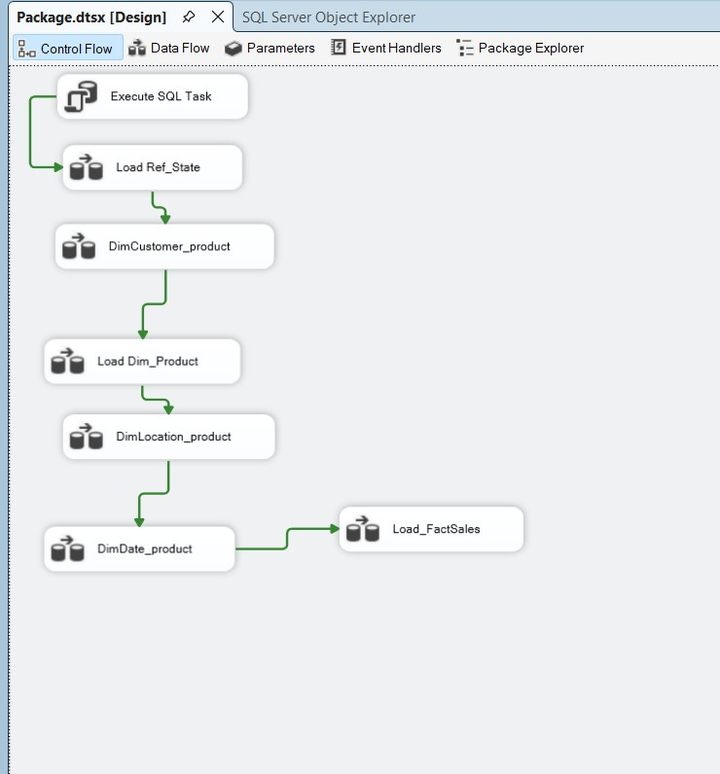
Figure 2. SSIS control-flow sequence.

4.2 Customer and product dimensions
The customer and product flows follow Excel Source → Data Conversion → Sort → OLE DB Destination. Data Conversion aligns source values with SQL Server target types. The Sort components are present in the package; their exact settings should be checked before claiming a specific deduplication rule.
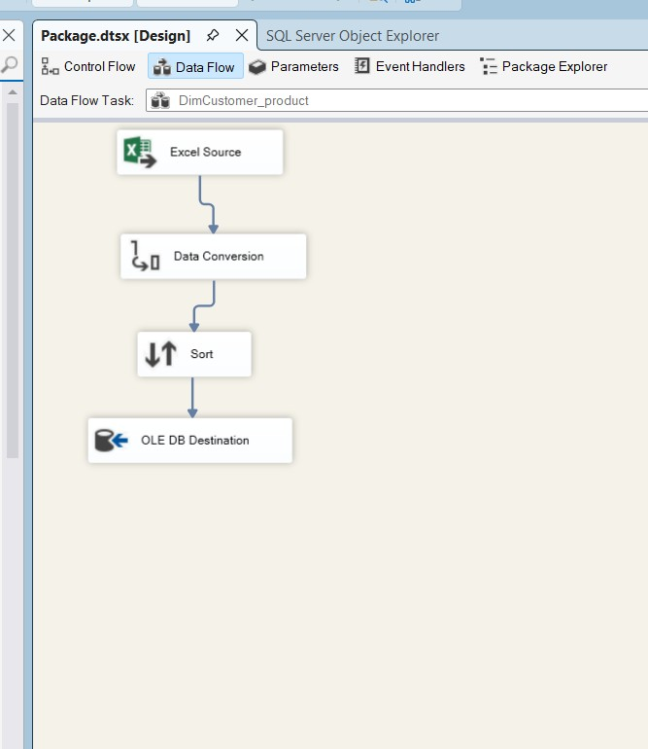
Figure 3. Customer dimension data flow.
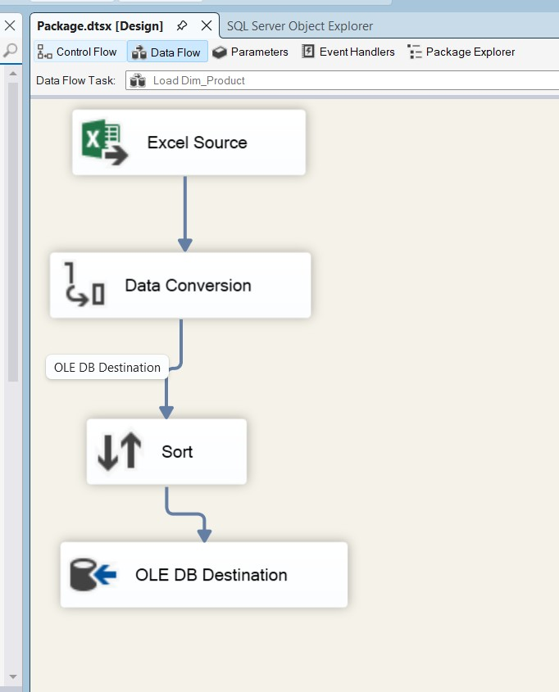
Figure 4. Product dimension loading flow.

4.3 Location and date dimensions
The location flow adds a Derived Column and Lookup. The Lookup is used with the state reference data to enrich location records. The date flow uses a Derived Column to populate calendar attributes used by the warehouse.
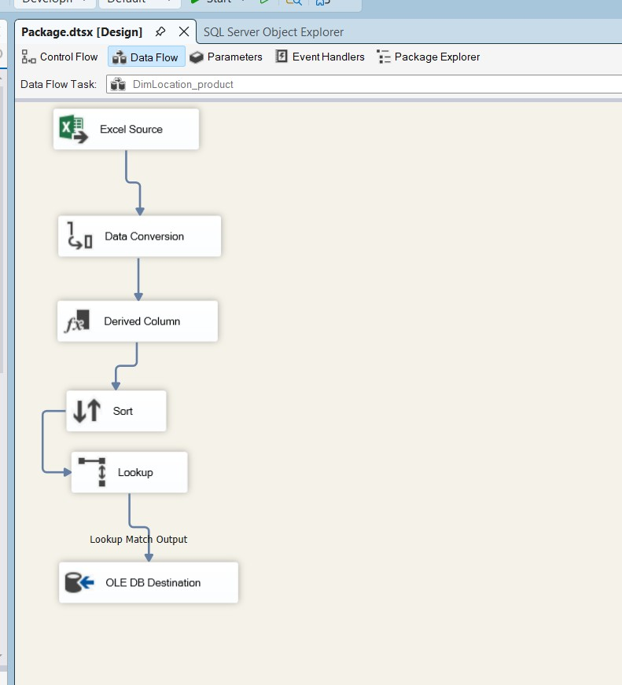
Figure 5. Location dimension data flow.
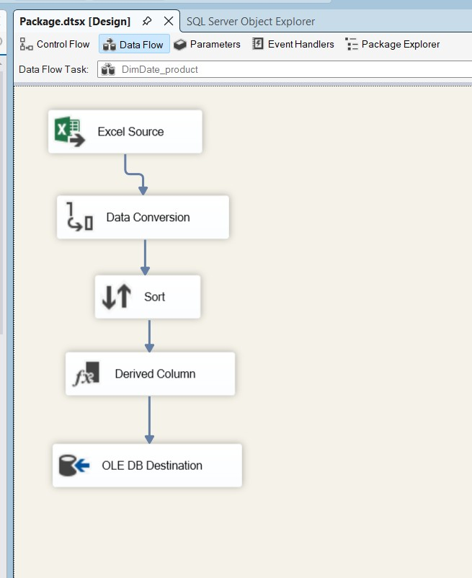
Figure 6. Date dimension data flow.

4.4 Fact_Sales loading
The fact flow starts with the Excel source, then applies a Derived Column and Data Conversion before several Lookup transformations and the final OLE DB Destination. The demonstrated execution shows 9,800 rows moving through the displayed pipeline.
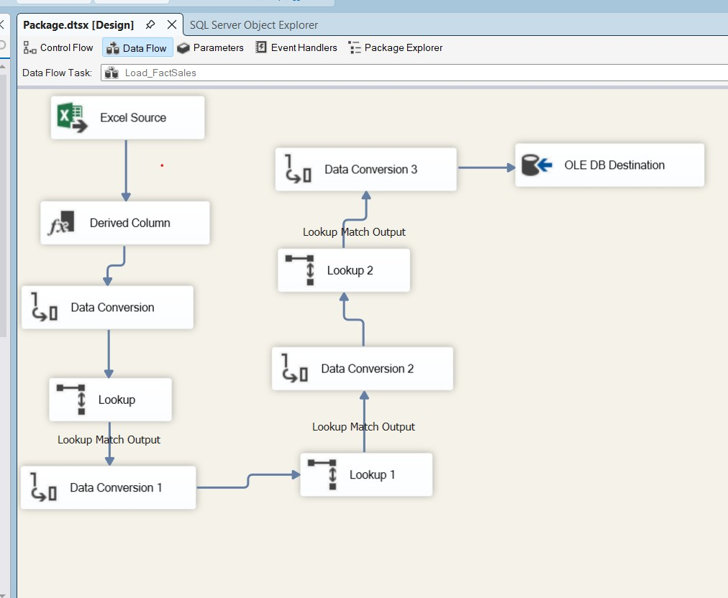
Figure 7. Fact_Sales transformation and lookup pipeline.
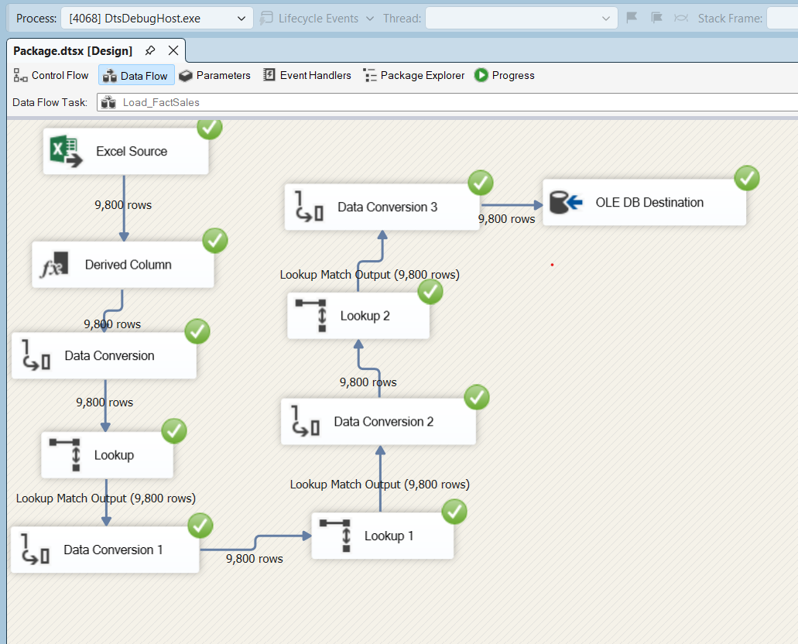
Figure 8. Demonstrated Fact_Sales execution with 9,800 rows.

5. Warehouse Validation and Data Quality
The project includes row-count validation and diagnostic SQL. The demonstrated warehouse counts are 9,800 Fact_Sales rows, 793 customers, 1,861 products, 628 locations and 1,230 dates.
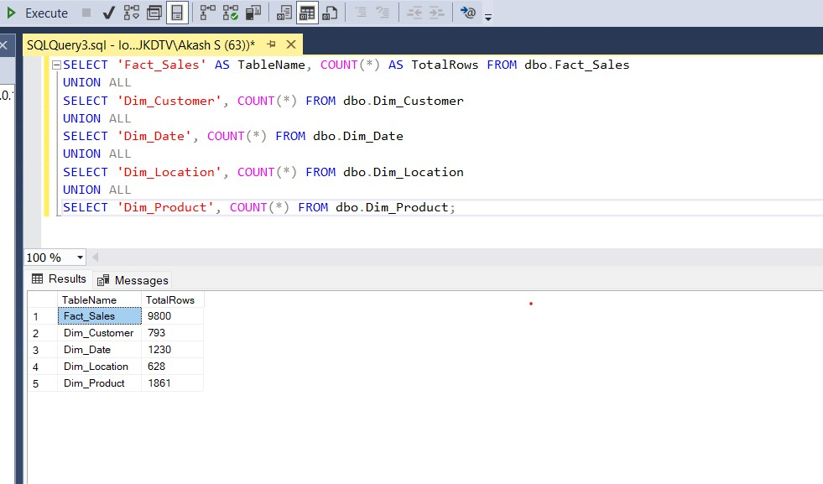
Figure 9. Submitted SQL Server validation view.

5.1 Location-key issue
NULL LocationKey values are visible in the supplied Fact_Sales preview. This is the most important quality issue in the current evidence. A green SSIS success indicator confirms component execution, but it does not by itself prove complete referential integrity.
The next validation step is to run the existing null-key and orphan-key checks and record the actual counts. The location Lookup should then be inspected for inconsistent State, City, Postal Code or other matching values.

5.2 Sales reconciliation
The source workbook sums to 2,261,536.7827, while the supplied analytical Excel outputs sum to 2,261,517.10. The gap is 19.6827. The row count remains 9,800, so the difference is not a simple row-count failure. The warehouse stores Sales as decimal(18,2), so precision should be checked, but the difference should not be attributed to rounding alone without a row-level comparison.
- Compare source Sales values with Fact_Sales.Sales using a stable source identifier.
- Identify the rows contributing to the difference.
- Confirm the SSIS destination mapping and Sales data type conversion.
- Record the final reconciled total after the check is completed.

5.3 Validation status
Check | Evidence | Status
Fact row count | 9,800 shown | Confirmed for demonstrated run
Dimension row counts | 793 / 1,861 / 628 / 1,230 | Confirmed for demonstrated run
Customer/product/date key completeness | Diagnostic SQL exists | Re-run and record
Location key completeness | NULL values visible | Needs correction or explanation
Source-to-fact sales total | Gap of 19.6827 identified | Needs investigation
Incremental/idempotent loading | Not demonstrated | Do not claim as implemented

6. SQL Analysis and Findings
The analysis focuses on revenue and transaction-line behaviour. Where COUNT(SalesKey) is used, the results are described as sales records rather than orders or units. Revenue is also kept separate from profitability because the warehouse does not contain cost or margin measures.

6.1 Customer segment performance
Segment | Sales records | Revenue | Distinct orders | Avg sale/record | Avg ship days
Consumer | 5,101 | 1,148,060.53 | 2,537 | 225.07 | 3.94
Corporate | 2,953 | 688,494.07 | 1,491 | 233.15 | 4.02
Home Office | 1,746 | 424,982.18 | 894 | 243.40 | 3.92
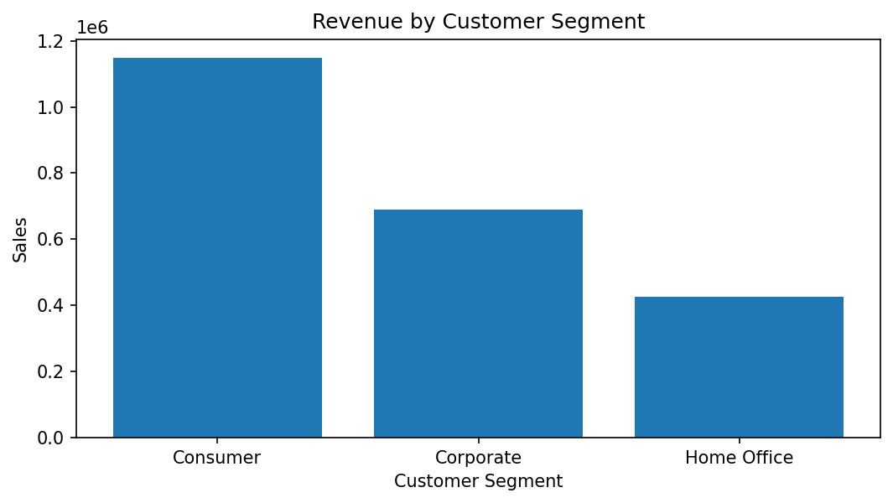
Figure 10. Revenue by customer segment, recreated from the submitted source dataset.
Consumer is the largest segment by both sales-record count and revenue. Home Office has the highest average sales per record, despite having the smallest total revenue. Average shipping duration is very similar across the three segments.

6.2 Product category and subcategory performance
Category | Subcategory | Sales records | Revenue
Technology | Phones | 876 | 327,782.45
Furniture | Chairs | 607 | 322,822.73
Office Supplies | Storage | 832 | 219,343.39
Furniture | Tables | 314 | 202,810.63
Office Supplies | Binders | 1,492 | 200,028.79
Technology | Machines | 115 | 189,238.63
Technology | Accessories | 756 | 164,186.70
Technology | Copiers | 66 | 146,248.09
Furniture | Bookcases | 226 | 113,813.20
Office Supplies | Appliances | 459 | 104,618.40
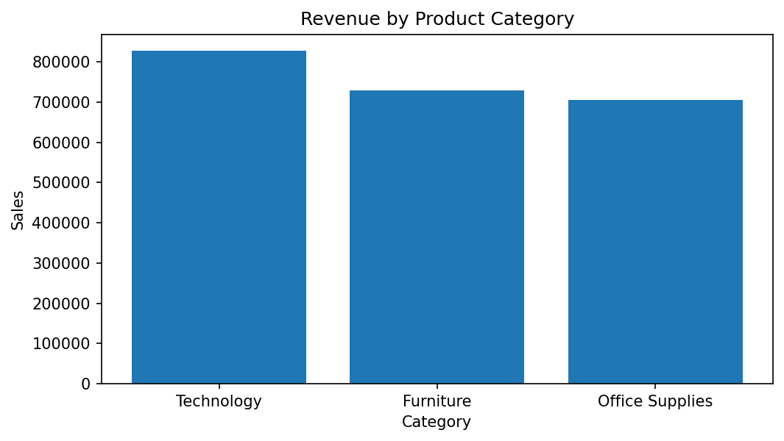
Figure 11. Revenue by broad product category.
Technology is the strongest broad category by revenue, followed by Furniture and Office Supplies. Phones and Chairs are the two leading subcategories by revenue in the supplied source results. These rankings describe revenue, not profitability.

6.3 Sales trend over time
Year | Revenue | Sales records | Distinct orders | YoY growth
2015 | 479,856.21 | 1,953 | 947 | —
2016 | 459,436.01 | 2,055 | 1,019 | -4.3%
2017 | 600,192.55 | 2,534 | 1,295 | 30.6%
2018 | 722,052.02 | 3,258 | 1,661 | 20.3%
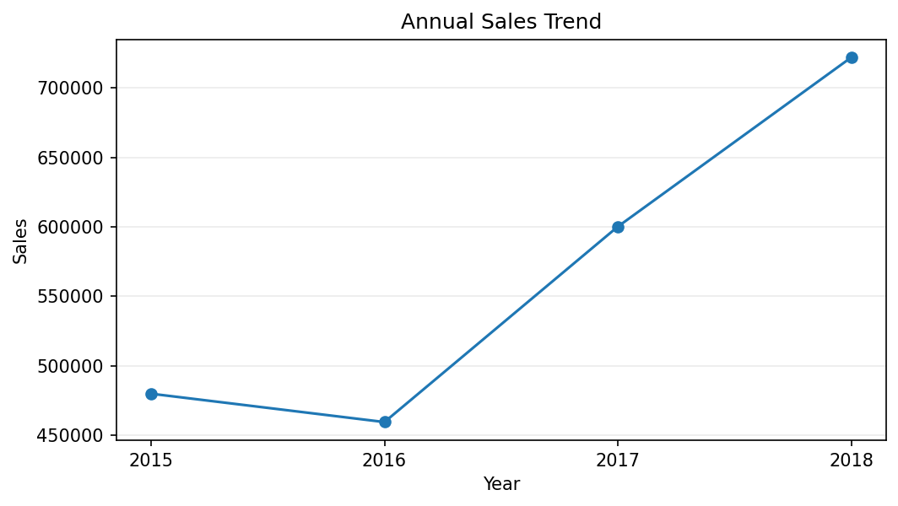
Figure 12. Annual revenue trend recreated from the source workbook.
Revenue fell by about 4.3% from 2015 to 2016, then increased by about 30.6% in 2017 and 20.3% in 2018. The dataset therefore shows a clear increase in annual sales after 2016, although the project does not establish the reasons for it.

6.4 Regional performance
Region | Revenue | Sales records | Share of source sales
West | 710,219.68 | 3,140 | 31.4%
East | 669,518.73 | 2,785 | 29.6%
Central | 492,646.91 | 2,277 | 21.8%
South | 389,151.46 | 1,598 | 17.2%
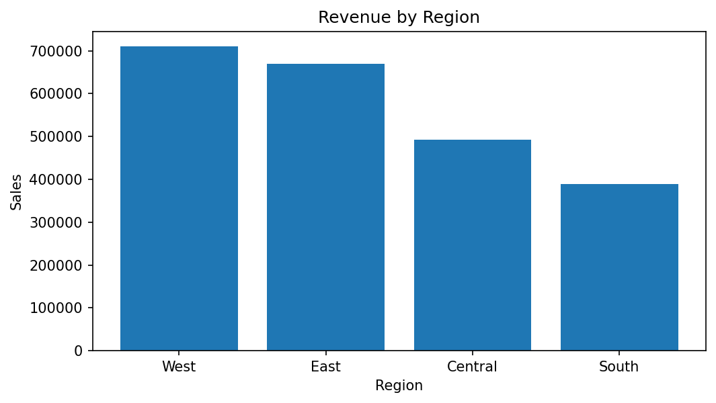
Figure 13. Revenue by region.
The West region has the highest revenue, followed by East, Central and South. This provides a useful geographic view, but the result should be read together with the location-key validation issue.

6.5 Highest-revenue products
Product | Category | Revenue
Canon imageCLASS 2200 Advanced Copier | Technology | 61,599.82
Fellowes PB500 Electric Punch Plastic Comb Binding Machine with Manual Bind | Office Supplies | 27,453.38
Cisco TelePresence System EX90 Videoconferencing Unit | Technology | 22,638.48
HON 5400 Series Task Chairs for Big and Tall | Furniture | 21,870.58
GBC DocuBind TL300 Electric Binding System | Office Supplies | 19,823.48

7. Discussion, Limitations and Improvements
The project achieves its main academic purpose: it demonstrates the complete path from a transactional spreadsheet to a dimensional SQL Server warehouse and then uses SQL to produce business-oriented summaries. The SSIS package, schema and analysis files provide a coherent implementation rather than a report-only exercise.

7.1 Limitations
- NULL LocationKey values are visible in the fact preview, so geographic referential completeness is not yet proven.
- The source and supplied warehouse-analysis totals differ by 19.6827 and need reconciliation.
- The warehouse contains Sales and ShipDays but no Quantity, Cost or Profit.
- Some original query aliases call COUNT(SalesKey) 'TotalOrders' or 'UnitsSold'; these labels overstate what the measure represents.
- The original trend chart uses generic labels and can be difficult to interpret.
- The evidence does not demonstrate incremental loading, SCD handling, production scheduling or a formal reject/error table.

7.2 Recommended improvements
- Normalize location matching fields before Lookup and route unmatched records to an exception output.
- Run row-count, null-key and orphan-key checks automatically after each major load.
- Reconcile source and warehouse sales totals as part of ETL acceptance testing.
- Use COUNT(DISTINCT OrderID) for questions that specifically concern orders.
- Add Quantity, Cost and Profit if unit-volume and profitability analysis is required.
- Rebuild charts with explicit titles, units and Year-Month labels.
- Introduce incremental loading and audit timestamps if the project is extended to a recurring refresh.
- Use SCD logic only when historical changes to customer or product attributes need to be preserved.

8. Conclusion
The Superstore Sales Data Warehouse project demonstrates a complete academic ETL workflow from Excel to SQL Server. SSIS is used to transform source data and populate a star schema containing Fact_Sales and four analytical dimensions. The demonstrated package run processed 9,800 sales records, and the warehouse outputs provide the expected dimension counts.
The analysis shows that Consumer customers contribute the most revenue, Technology is the leading broad product category, the West is the leading region, and annual revenue rises strongly after 2016. The project also demonstrates an important practical lesson: successful pipeline execution is not the same as complete data validation. The visible LocationKey issue and the source-to-warehouse sales reconciliation gap should be resolved or explicitly documented before claiming a fully validated warehouse.
With those checks completed, the solution provides a solid foundation for further reporting or a business-intelligence dashboard and demonstrates practical skills in dimensional modelling, SSIS development, SQL Server design, validation and data analysis.

9. Group Member Contributions

The submitted report contains placeholders for group members, but the project package does not provide verified names or individual responsibilities. The placeholders are therefore retained rather than inventing information.

Full Name | Tasks
Rohan Sundarbhai Dantani | Dataset preparation / exploration
Nimma Vidwan Reddy | Warehouse schema / SQL
Akash Sriramadasu | SSIS package / ETL implementation
Kondisetty naga vamsi | SQL analysis / reporting / charts

10. References and Submitted Artifacts
- Superstore_Sales_Dataset_Clean (1).xlsx — primary sales source.
- US_State_Population_2020.csv — state code and 2020 population reference.
- Package.dtsx — SSIS ETL package.
- SuperstoreDW.dtproj — SSIS project configuration.
- SuperstoreDW_CreateTables.sql — warehouse DDL, foreign-key definitions, stored procedure and indexes.
- SuperstoreDW_Analysis.sql — validation and analytical SQL.
- last 3 Queries to generate charts.txt — SQL used for the three submitted chart workbooks.
- Revenue by Customer Segment.xlsx — segment analysis output.
- Sales by Category.xlsx — category/subcategory analysis output.
- Sales Over Time.xlsx — monthly sales analysis output.
- SSIS and SQL Server screenshots supplied with the project — implementation and execution evidence.

Appendix A. Selected Validation Queries

-- Warehouse row counts
SELECT 'Fact_Sales' AS TableName, COUNT(*) AS TotalRows FROM dbo.Fact_Sales
UNION ALL SELECT 'Dim_Customer', COUNT(*) FROM dbo.Dim_Customer
UNION ALL SELECT 'Dim_Product', COUNT(*) FROM dbo.Dim_Product
UNION ALL SELECT 'Dim_Location', COUNT(*) FROM dbo.Dim_Location
UNION ALL SELECT 'Dim_Date', COUNT(*) FROM dbo.Dim_Date;
-- Null foreign keys
SELECT COUNT(*) AS FactRows,
SUM(CASE WHEN CustomerKey IS NULL THEN 1 ELSE 0 END) AS NullCustomerKey,
SUM(CASE WHEN ProductKey IS NULL THEN 1 ELSE 0 END) AS NullProductKey,
SUM(CASE WHEN LocationKey IS NULL THEN 1 ELSE 0 END) AS NullLocationKey,
SUM(CASE WHEN DateKey IS NULL THEN 1 ELSE 0 END) AS NullDateKey
FROM dbo.Fact_Sales;
-- Distinct orders by segment
SELECT c.Segment,
COUNT(DISTINCT f.OrderID) AS DistinctOrders,
COUNT(*) AS SalesRecords,
ROUND(SUM(f.Sales),2) AS Revenue
FROM dbo.Fact_Sales f
JOIN dbo.Dim_Customer c ON f.CustomerKey = c.CustomerKey
GROUP BY c.Segment
ORDER BY Revenue DESC;
-- Warehouse sales total for reconciliation
SELECT ROUND(SUM(Sales),2) AS WarehouseSales
FROM dbo.Fact_Sales;

Individual Contribution to the Project

Name: Nimma Vidwan Reddy
Role: Warehouse Schema / SQL
Project Component: SuperstoreDW_Analysis.sql / Excel Outputs

My main role in the Superstore Sales Data Warehouse and ETL Project was to design the warehouse schema and analyse the sales data using SQL. I focused on understanding what the data showed about the Superstore's sales performance and making the results easier for others to understand.
Once the data was loaded into the SQL Server data warehouse, I worked on the SuperstoreDW_Analysis.sql file to write and execute SQL queries against the fact and dimension tables, such as sales revenue, customer segments, product categories, and sales trends.
A key part of my role was designing the data warehouse schema. I structured the database using a Star Schema with a central Fact_Sales table connected to dimension tables for customers, products, dates, and regions. I defined primary and foreign key relationships to maintain referential integrity, applied appropriate data types and constraints to support the ETL loading process, and created indexes on frequently joined columns to optimise query performance.
One of the main tasks I worked on was customer segment analysis. I compared the sales performance of Consumer, Corporate, and Home Office customers to find out which group contributed the most revenue. This helped us understand how different customer groups affected the overall sales of the business.
I also analysed product categories and subcategories to identify which types of products generated the highest revenue. This gave us a better understanding of product performance and helped us highlight important findings in our report.
Another part of my work was analysing sales trends over time. I used SQL queries to study sales across different years and months. By comparing these results, I was able to observe how sales changed over time and identify patterns in the data.
Overall, my contribution was mainly focused on warehouse schema design and SQL analysis. Working on this part of the project helped me improve my SQL skills, understand how to design and query a data warehouse, and learn how to analyse data from a data warehouse. It also gave me practical experience in turning raw sales information into useful insights that can support business decisions.

