**DAILY ONLINE ACTIVITIES SUMMARY**

|  |  |  |  |  |  |  |  |  |
| --- | --- | --- | --- | --- | --- | --- | --- | --- |
| **Date:** | 18/05/2020 | | | | | **Name:** | Priya Nagari | |
| **Sem & Sec** | Fourth SEM section B | | | | | **USN:** | 4AL18CS063 | |
| **Online Test Summary** | | | | | | | | |
| **Subject** | | Complex analysis, probability and statistical methods | | | | | | |
| **Max. Marks** | | **30** | | **Score** | | |  | |
| **Certification Course Summary** | | | | | | | | |
| **Course** | The complete Adroid app development Masterclass:Build apps | | | | | | | |
| **Certificate Provider** | | | Udemy | | **Duration** | | | 29 hours |
| **Coding Challenges** | | | | | | | | |
| **Problem Statement:**1. To check whether given two strings are anagrams.  2.To count number of triplet in an given array. | | | | | | | | |
| **Status:** | | | | | | | | |
| **Uploaded the report in Github** | | | | | YES | | | |
| **If yes Repository name** | | | | | [**Priya_Nagari**](https://github.com/alvas-education-foundation/Priya_Nagari)  **link:**<https://github.com/alvas-education-foundation/Priya_Nagari> | | | |
| **Uploaded the report in slack** | | | | | YES | | | |

**Online Test Details:**

The online test was about curve fitting and statistical method(module:4). There were 30 questions and the duration :30 minutes. The questions were optimal and were easy. The score for the test was not displayed .

**Snapshot**: not taken

**Certification Course Details:**

**Name of the course**: The complete Adroid app development Masterclass:Build apps

**Certificate Provider**: Udemy

total duration is 29 hours.

In the first day I gone through the introduction part .which includes installation and set of Android studio which is used build android apps and also some simple app projects.

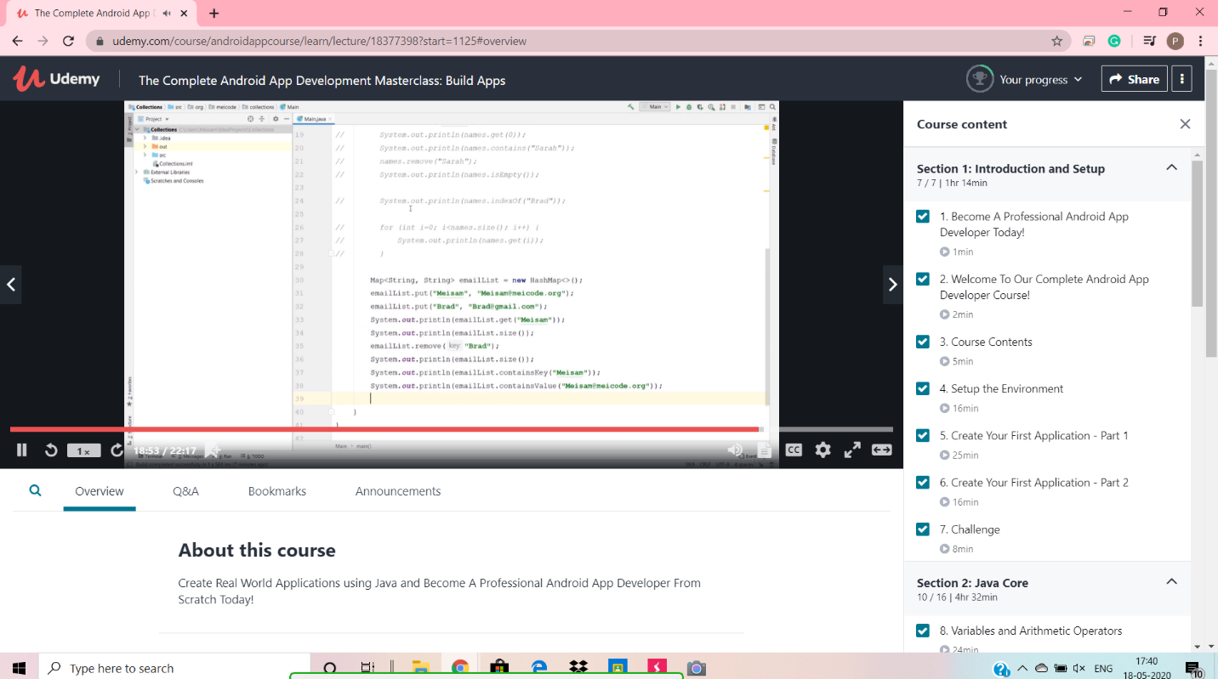

**Online Coding Details:**

Problem 1: (using C language) Check whether the two given strings are anagram or not.

Solution: uploaded in github

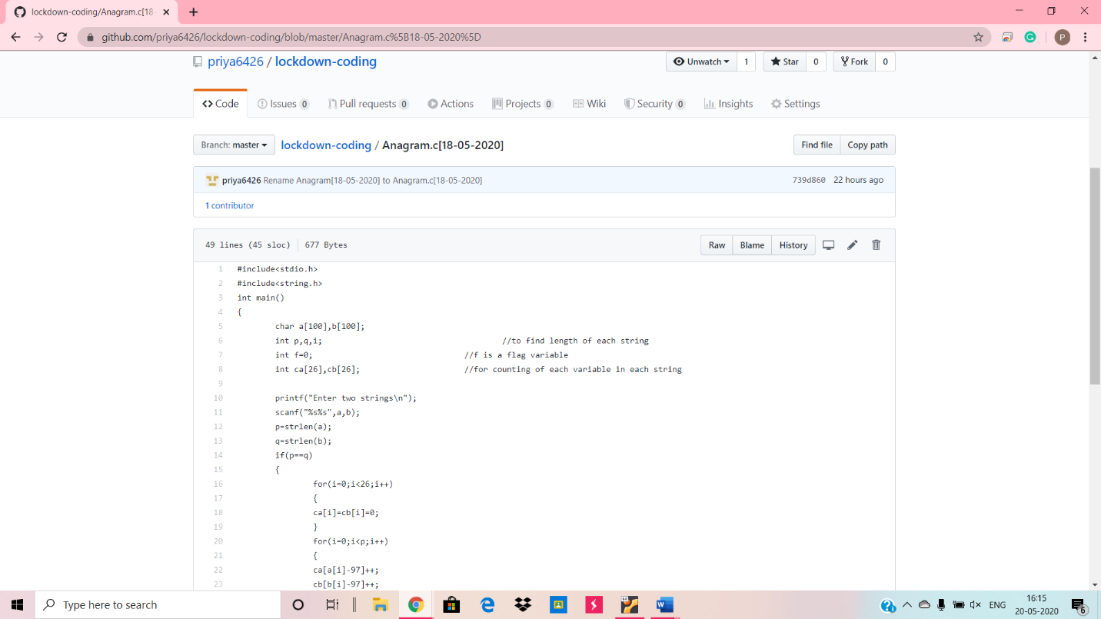

Problem 2: (Using c) To count number of triplet in an given array.

