**DAILY ONLINE ACTIVITIES SUMMARY**

|  |  |  |  |  |  |  |  |  |
| --- | --- | --- | --- | --- | --- | --- | --- | --- |
| **Date:** | 19/05/2020 | | | | | **Name:** | Priya Nagari | |
| **Sem & Sec** | Fourth SEM section B | | | | | **USN:** | 4AL18CS063 | |
| **Online Test Summary** | | | | | | | | |
| **Subject** | | Design and Analysis of Algorithms. | | | | | | |
| **Max. Marks** | | **30** | | **Score** | | | 14 | |
| **Certification Course Summary** | | | | | | | | |
| **Course** | The complete Adroid app development Masterclass:Build apps | | | | | | | |
| **Certificate Provider** | | | Udemy | | **Duration** | | | 29 hours |
| **Coding Challenges** | | | | | | | | |
| **Problem Statement:** 1. To check whether one string is a sub sequence of another string  2. To find the short palindrome of a string  . | | | | | | | | |
| **Status:** | | | | | | | | |
| **Uploaded the report in Github** | | | | | YES | | | |
| **If yes Repository name** | | | | | [**Priya_Nagari**](https://github.com/alvas-education-foundation/Priya_Nagari)  **link:**<https://github.com/alvas-education-foundation/Priya_Nagari> | | | |
| **Uploaded the report in slack** | | | | | YES | | | |

**Online Test Details:**

The online test was about Introduction to the subject and asymptotic notations(module:1). There were 25 questions and the duration was 30 minutes. The score that I received was 14/30.

**Snapshot**: not taken

**Certification Course Details:**

**Name of the course**: The complete Adroid app development Masterclass:Build apps

**Certificate Provider**: Udemy

total duration is 29 hours.

After completing introductory part ,I have gone through java core object oriented concepts which is required one to learn coding in java for developing android app.

**Snapshot:**

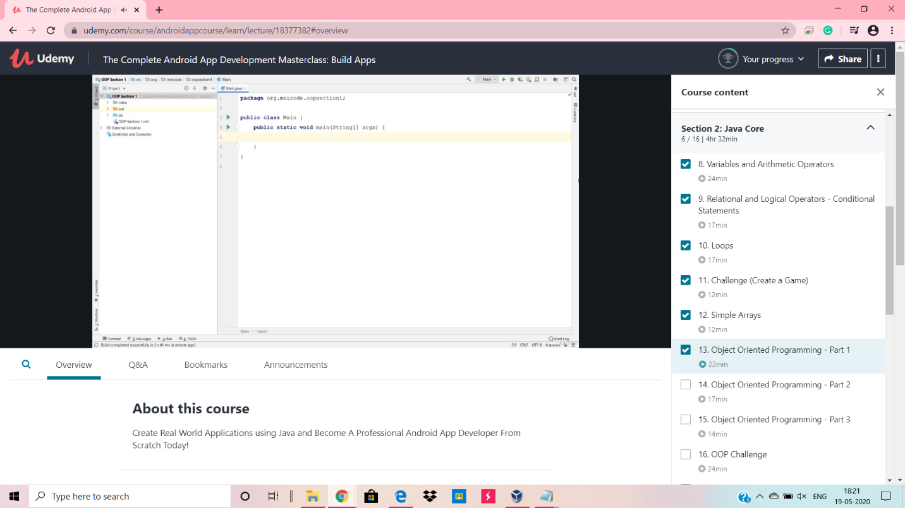

**Online Coding Details:**

Problem **:** 1. To check whether one string is a sub sequence of another string.

**Snapshot:**

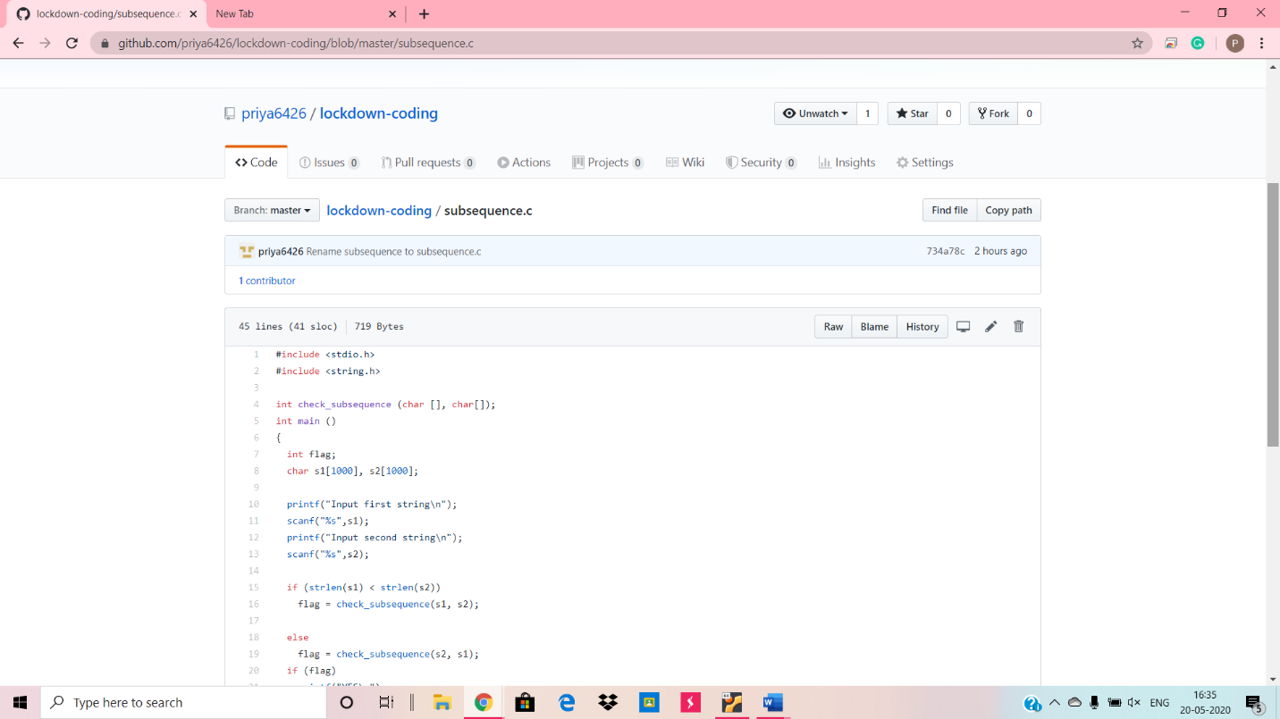

Problem 2: To find the short palindrome of a string

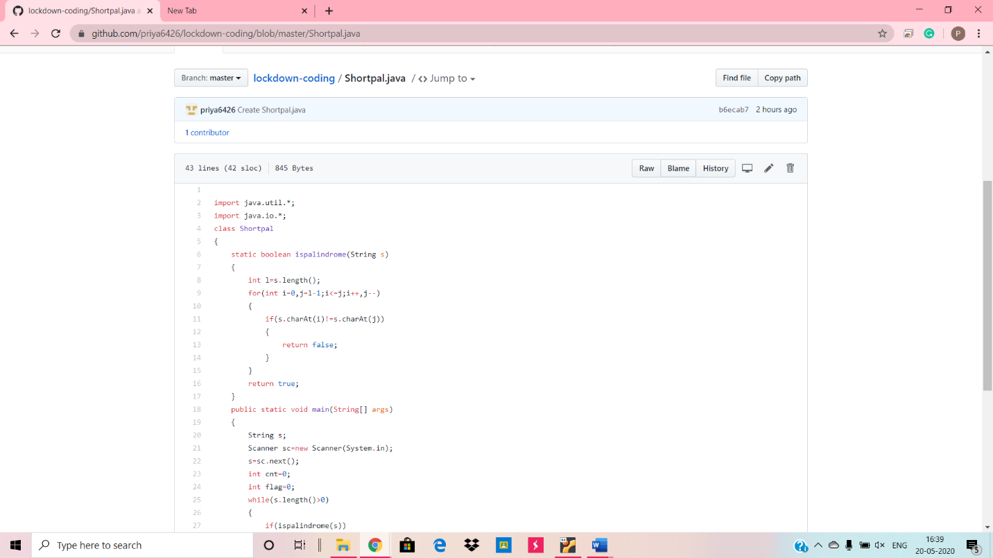**Snapshot:**