**DAILY ONLINE ACTIVITIES SUMMARY**

|  |  |  |  |  |  |  |  |  |
| --- | --- | --- | --- | --- | --- | --- | --- | --- |
| **Date:** | 21/05/2020 | | | | | **Name:** | Priya Nagari | |
| **Sem & Sec** | Fourth SEM section B | | | | | **USN:** | 4AL18CS063 | |
| **Online Test Summary** | | | | | | | | |
| **Subject** | | Microcontroller and embedded systems | | | | | | |
| **Max. Marks** | | **30** | | **Score** | | | 25 | |
| **Certification Course Summary** | | | | | | | | |
| **Course** | The complete Adroid app development Masterclass:Build apps | | | | | | | |
| **Certificate Provider** | | | Udemy | | **Duration** | | | 29 hours |
| **Coding Challenges** | | | | | | | | |
| **Problem Statement:**1. C program to check odd or even thread.  2. C program to reverse a linked list. | | | | | | | | |
| **Status:** | | | | | | | | |
| **Uploaded the report in Github** | | | | | YES | | | |
| **If yes Repository name** | | | | | [**Priya_Nagari**](https://github.com/alvas-education-foundation/Priya_Nagari)  **link:**<https://github.com/alvas-education-foundation/Priya_Nagari> | | | |
| **Uploaded the report in slack** | | | | | YES | | | |

**Online Test Details:**

The online test was ARM EMBEDDED SYSTEMS & ARM PROCESSOR FUNDAMENTALS (module:1).There were 30 questions and the duration :40 minutes. The questions are mcq type.The score for the test was 25.

**Snapshot**:

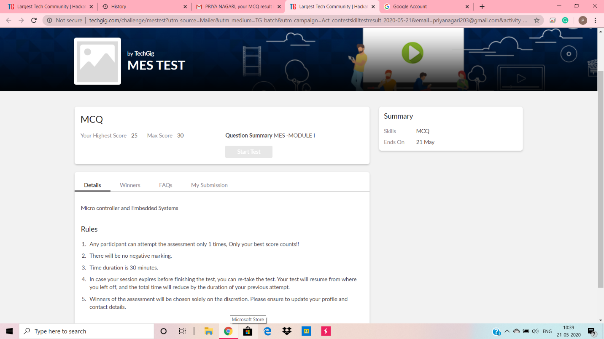

**Certification Course Details:**

**Name of the course**: The complete Adroid app development Masterclass:Build apps

**Certificate Provider**: Udemy

total duration is 29 hours.

As previous day it was about Object oriented concepts ,today I had learnt about basic concepts of user interfaces.

**Snapshot**:

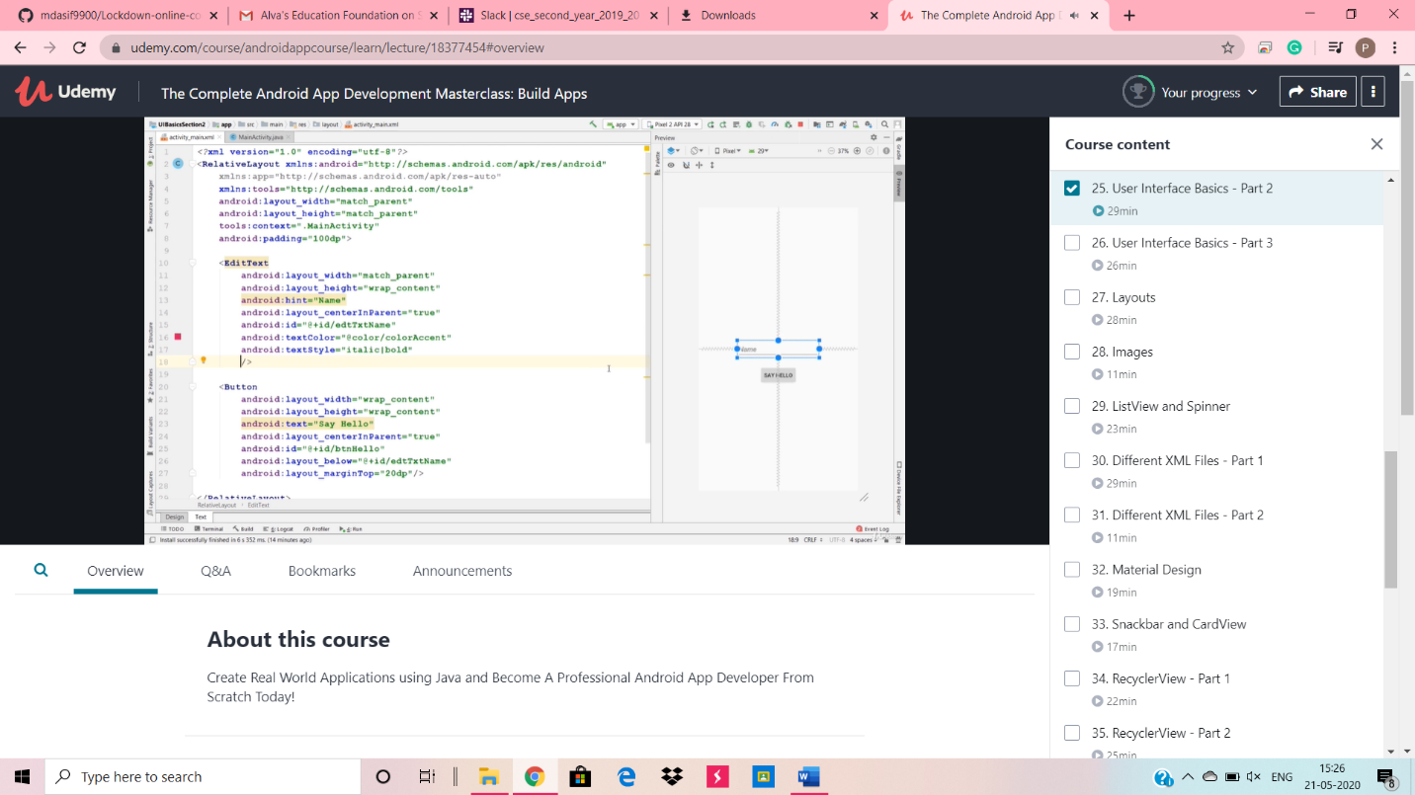

**Online Coding Details:**

1.C program to check odd or even thread.

Solution: uploaded in github

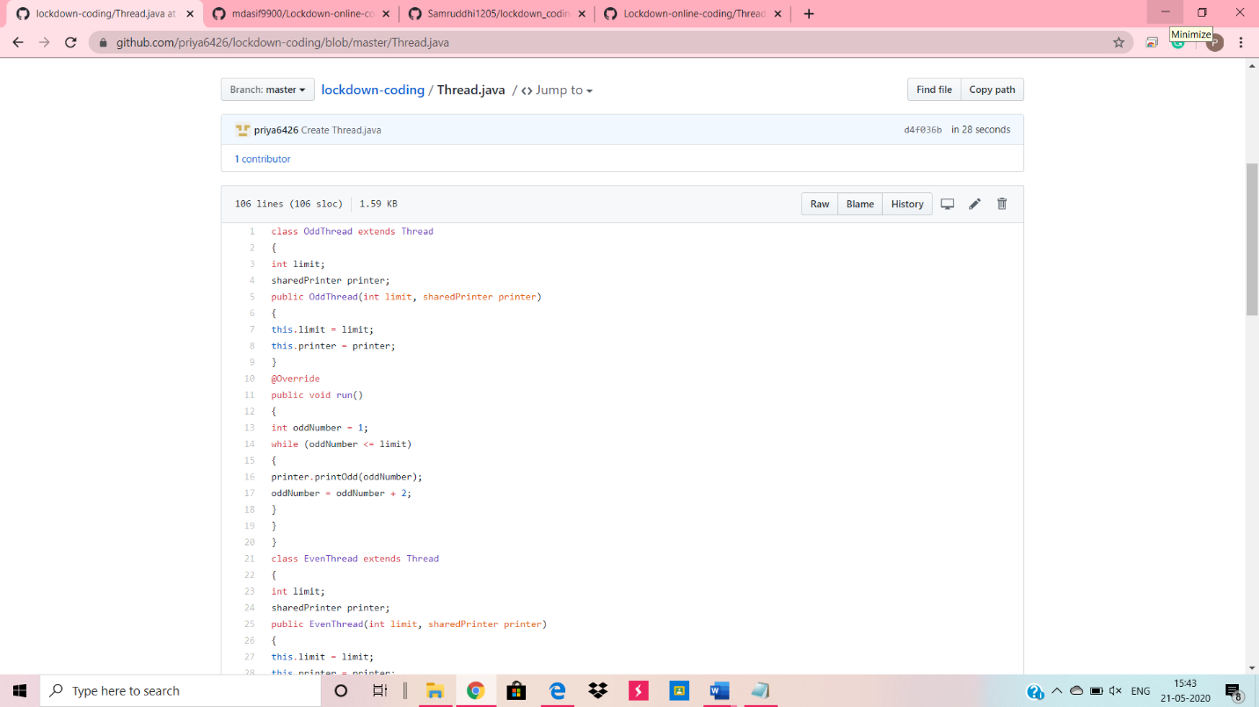

Problem :2. C program to reverse a linked list.

Solution: uploaded in github

