Calculator Project

# 1.0 Description of the Project

1. Create a Calculator library in C++
2. Integrate unit testing using googletest
3. Integrate cmake to
   1. build the Calculator library
   2. create a test executable(using googletest) that runs on the Calculator library
4. Add a Python script to build the library, build test framework, run tests and add results in a csv file.

# 2.0 Environment

IDE : VS code

Platform : Windows

# 3.0 Softwares/Tools to be installed

1. Download and Install cmake : https://cmake.org/download/

2. Install Visual Studio community : https://visualstudio.microsoft.com/fr/vs/community/

3. Clone googletest into the root directory : git clone https://github.com/google/googletest.git

**4.0 VS code settings**

Install below plugins:

1. C/C++ for Visual Studio Code

2. CMake Tools

**5.0 How to configure, build and run**

## Configure:

- After cloning the Calculator project and cloning googletest, VS code gives a choice to pick a kit for the compiler

- Choose Visual Studio Community

- The above step will configure the generator, detect the tools and builds the build system

## Build the libraries and test executable:

- Click on Build icon ( F7 windows)

- This will execute cmake --build

- Calculator.lib and the test_CalculatorTests.exe are generated

**Running the tests:**

- Click on the icon Run CTests in VS code

**Running the tests in Terminal:**

- Execute cd "$(pwd)/build/test/Debug"

- Run the exe: test_CalculatorTests.exe

**6.0 PYTHON SCRIPT**

1. Install Python

2. Install pip

3. Open a command prompt and execute the following:

pip install pytest-cpp

pip install pandas

4. Clone googletest into the roort directory

git clone https://github.com/google/googletest.git

5. Run the script:

python script.py

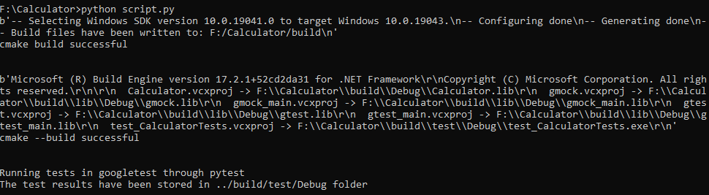

6. The python script should be able to build the build system, Calculator.lib and

test_CalculatorTests.exe and run the exe through pytest and add the test results in a csv

at "$(pwd)/build/test/Debug".

An example output file is added in the repository as ‘Example_output.csv’.