TITLE: Diabetes Risk Analysis using Data Visualization

Submitted By:
Vidya Nayak
Introduction
The diabetes prediction dataset contains health-related information used to analyse factors associated with diabetes. It includes variables such as age, gender, BMI, blood glucose level, hypertension, heart disease, and smoking history. By analysing and visualizing this data, meaningful patterns and relationships can be identified to better understand the factors influencing diabetes.
Objective of the Analysis
The primary objectives of this analysis are:
- To identify key factors influencing diabetes
- To explore relationships between health indicators and diabetes
- To visualize patterns and trends in the dataset
- To provide insights for early detection and preventive healthcare
Dataset Description
Source of Dataset:
The dataset used in this analysis is the Diabetes Prediction Dataset obtained from the data science platform Kaggle.
Number of Records:
The dataset contains 100,000 records with 9 variables representing different health indicators of individuals.
Important Variables Used in the Analysis:
Some of the key variables used for visualization and analysis include:
- Age – Age of the individual
- BMI – Body Mass Index indicating body weight relative to height
- Blood Glucose Level – Blood sugar concentration
- HbA1c Level – Average blood sugar level over time
- Hypertension – Indicates presence of high blood pressure
- Heart Disease – Indicates presence of heart disease
- Smoking History – Smoking habits of individuals
- Diabetes – Indicates whether the individual has diabetes or not
These variables help in understanding patterns and potential risk factors associated with diabetes.
Dataset Source: Kaggle – Diabetes Prediction Dataset.
Exploratory Data Analysis
Initial exploration of the dataset was performed to understand:
- Structure and shape of the dataset
- Data types of variables
- Distribution of values
- Presence of missing or inconsistent data
This step helped in preparing the dataset for further analysis.
Starting Entries
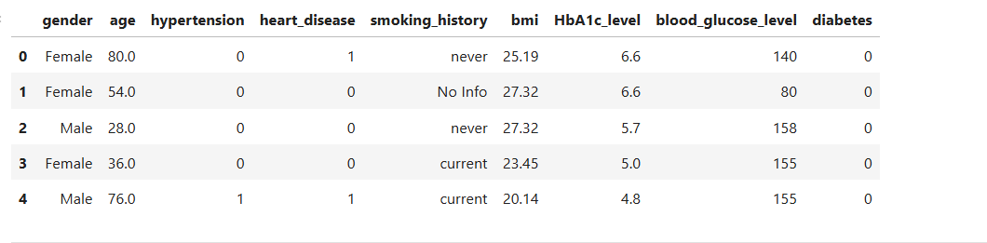
Fig 1:Starting entries
Final Entries
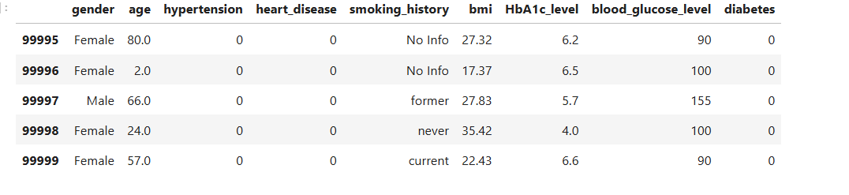
Fig 2: Final entries
Data Types and shape
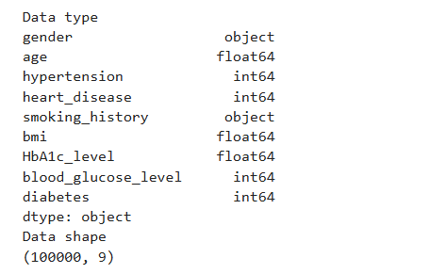
Fig 3: Data types and shapes
Data Preprocessing and Clearing
Data preprocessing is an important step to ensure the accuracy and reliability of the analysis. The dataset was examined and prepared for visualization as follows:
• Missing Values Check: The dataset was checked for missing values in both numerical and categorical variables to ensure data completeness.
• Duplicate Records: The dataset was reviewed for duplicate entries, and any unnecessary duplicates were removed to maintain data integrity.
• Data Consistency: Variables were examined for formatting issues and inconsistencies, and corrections were made where necessary.
• Data Verification: After preprocessing, the dataset was rechecked to confirm that the data was clean and ready for accurate visualization and analysis.
Categorical data cleaning was performed on the smoking_history variable by replacing multiple categories with two standardized groups (current and never) to simplify the analysis and visualization.
dropna() is a data cleaning technique used to remove rows or columns from a dataset that contain missing or null values, ensuring the dataset remains accurate and consistent for analysis.
Before cleaning
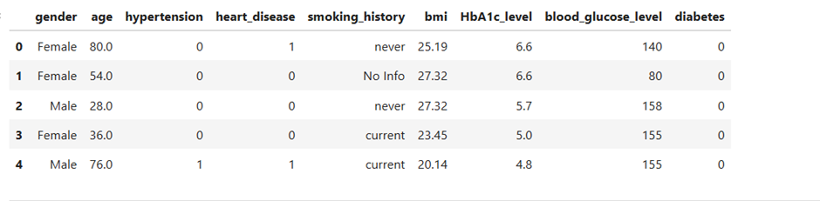
Fig 4:Data set before cleaning
After cleaning
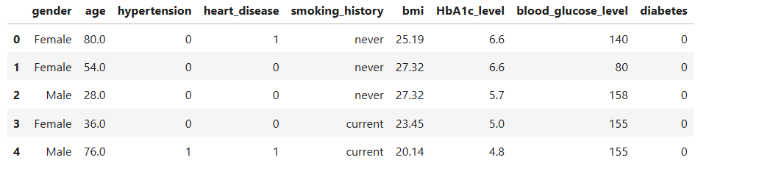
Fig 5: Data set after cleaning
Data Visualization
1.Gender Distribution in the Diabetes Dataset
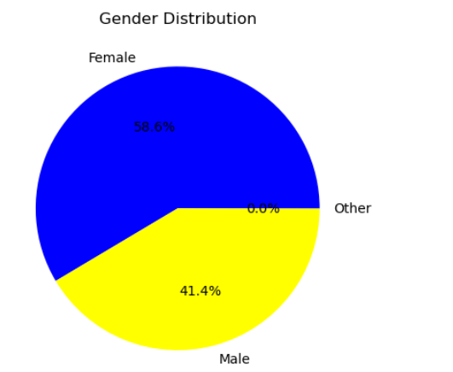
Fig 6: Gender distribution in dataset
This graph shows the proportion of male and female individuals present in the diabetes dataset. It helps understand the gender composition of the population used for analysis. Examining gender distribution can help identify whether diabetes patterns vary between males and females.
2. Age Distribution in the Diabetes Dataset
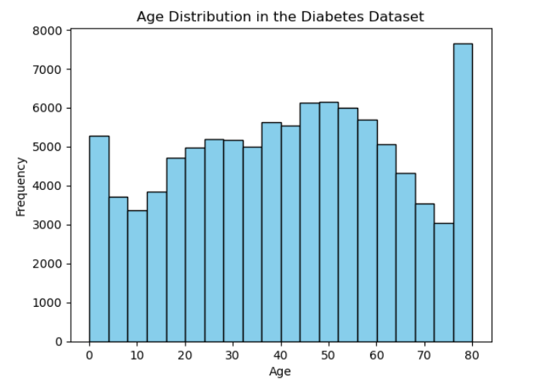
Fig 7:Age distribution in dataset
This graph shows how individuals are distributed across different age groups in the dataset. It helps visualize the frequency of people within various age ranges included in the study. Understanding age distribution is useful for analysing how diabetes risk may vary with age.
3. BMI vs Diabetes
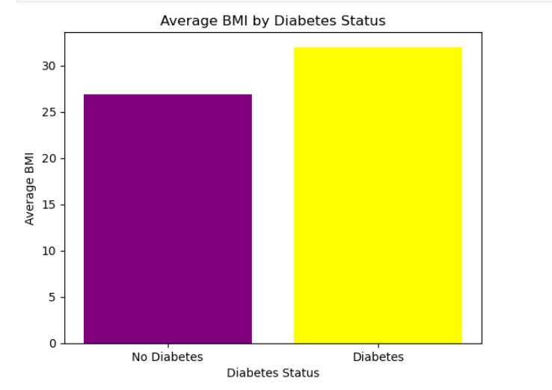
Fig 8:BMI vs Diabetes
This graph compares the Body Mass Index (BMI) of individuals with and without diabetes. It helps observe differences in BMI levels between the two groups. Higher BMI values may indicate a greater risk of developing diabetes.
4. Age Distribution by Diabetes Status
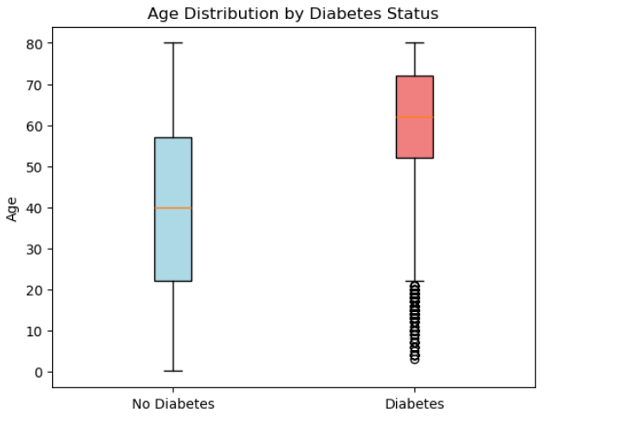
Fig 9:Age distribution by Diabetes Status

This graph compares the age distribution of individuals with diabetes and those without diabetes. It helps identify whether diabetes is more common in certain age groups. Understanding this relationship can provide insights into how age influences diabetes risk.
5. Hypertension vs Diabetes
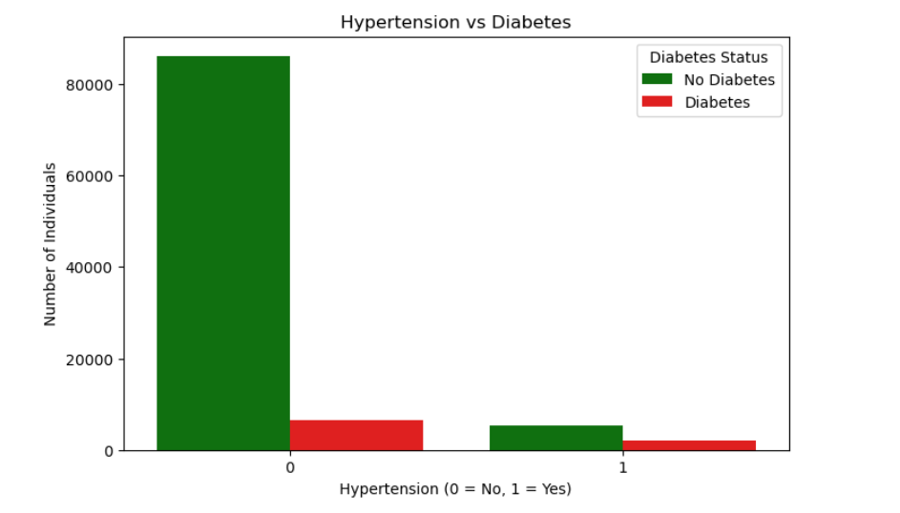
Fig 10: Hypertension vs Diabetes status
This graph compares the number of individuals with and without hypertension in relation to their diabetes status. It helps identify whether hypertension is associated with a higher occurrence of diabetes. Such analysis provides insight into possible health conditions linked with diabetes.
6. Blood Glucose Level vs Diabetes
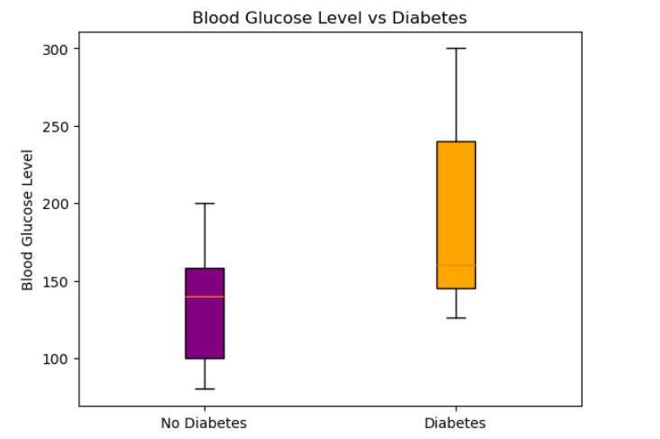
Fig 11: Blood Glucose Level vs Diabetes
This graph compares blood glucose levels between individuals with diabetes and those without diabetes. It helps visualize differences in glucose levels between the two groups. Higher blood glucose levels are commonly associated with diabetes.
7. Heart Disease vs Diabetes
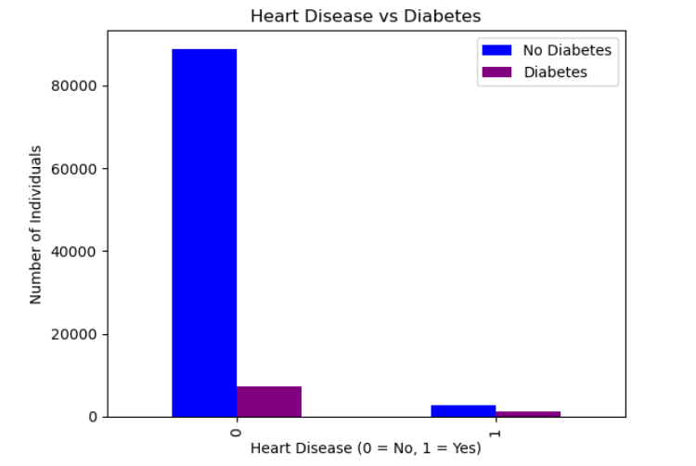
Fig 12: Heart Disease vs Diabetes
This graph compares the number of individuals with and without heart disease in relation to their diabetes status. It helps identify whether people with heart disease have a higher occurrence of diabetes. Understanding this relationship can provide insights into health conditions associated with diabetes.
8. Average HbA1c Level by Diabetes Status
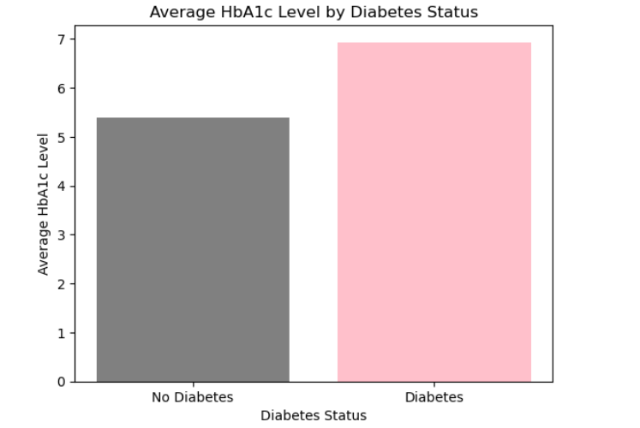
Fig 13: HbA1c Level vs Diabetes
This graph compares the average HbA1c levels of individuals with diabetes and those without diabetes. HbA1c reflects the average blood sugar levels over a period of time. Higher HbA1c levels are generally associated with diabetes and poor glucose control.
9. Blood Glucose Level Distribution
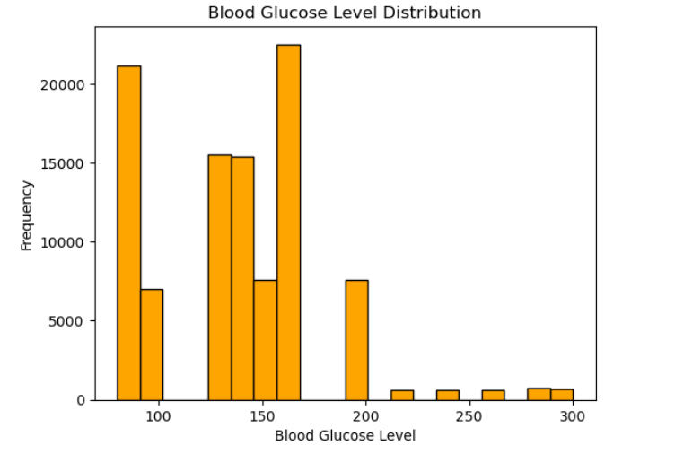
Fig 14: Blood Glucose level Distribution
This graph shows the distribution of blood glucose levels among individuals in the dataset. It helps visualize how glucose levels vary across the population. Blood glucose level is an important indicator used in identifying and monitoring diabetes.
10. Correlation Heatmap of Health Variables
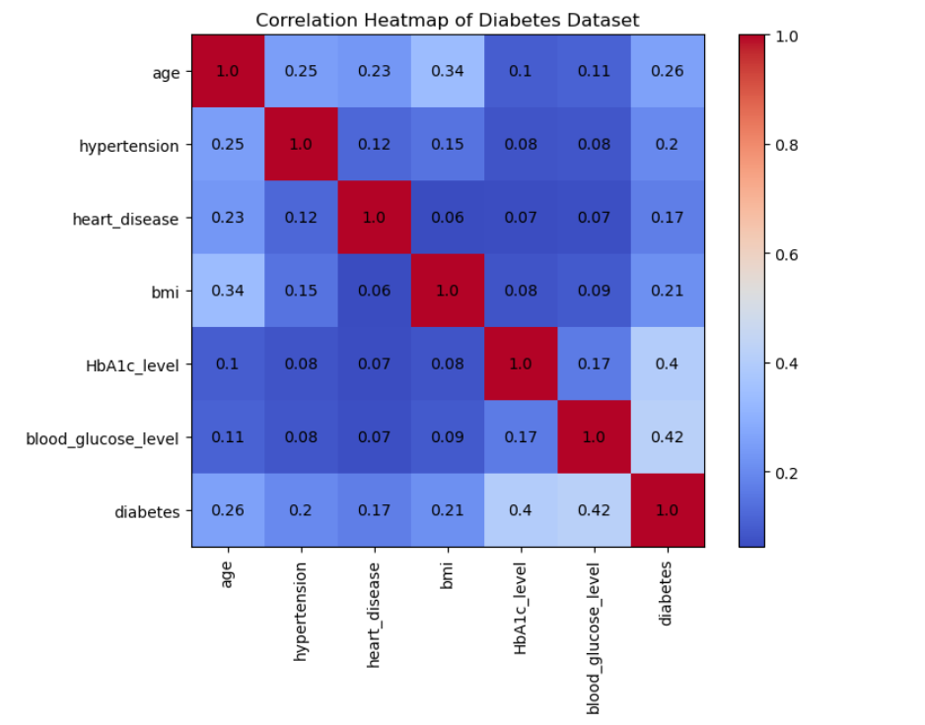
Fig 15: Correlation heatmap of health variables
This heatmap shows the correlation between different health-related variables in the dataset. It helps identify how strongly each variable is related to diabetes and other health indicators. Higher correlation values indicate stronger relationships between the variables.
11. BMI vs Blood Glucose Level
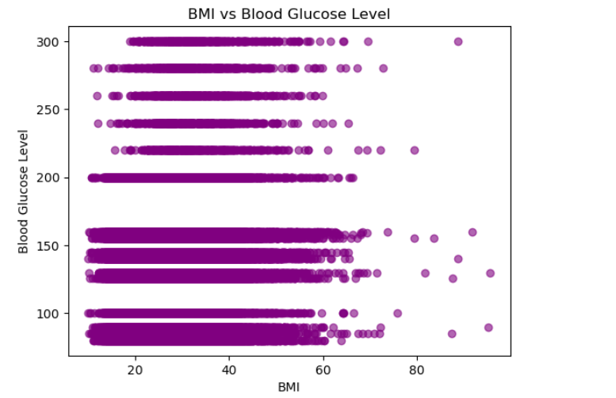
Fig 16: BMI vs Blood Glucose level
This graph shows the relationship between Body Mass Index (BMI) and blood glucose levels among individuals in the dataset. It helps observe whether higher BMI values are associated with higher glucose levels. Such patterns can provide insights into possible risk factors related to diabetes.
12. Box Plot of Selected Health Attributes
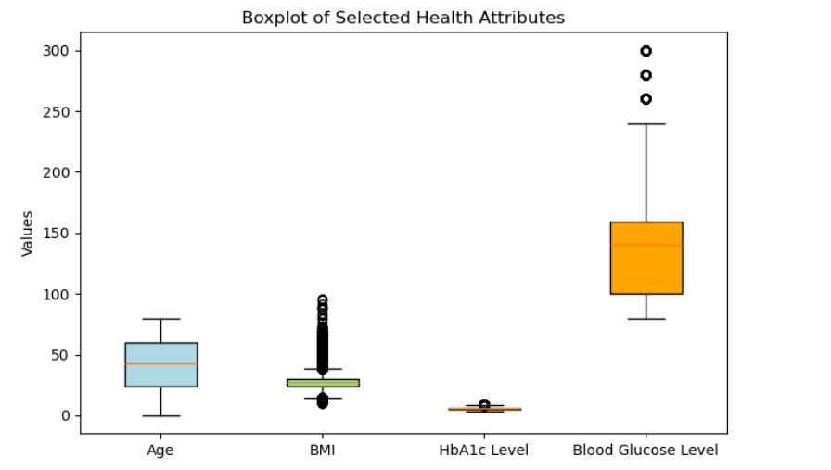
Fig 17: Boxplot of selected health attributes
This box plot compares the distribution of key health attributes such as age, BMI, HbA1c level, and blood glucose level. It helps visualize the spread, median values, and potential outliers within the dataset. Analysing these attributes is useful for understanding factors that may be associated with diabetes.
Key Insights
Key Insights from Diabetes Dataset
1.Trends Observed
- Age & Diabetes: Higher prevalence of diabetes in older age groups. The age distribution line plots show a clear increase in diabetes cases with age.
- BMI & Diabetes: Overweight and obese individuals tend to have a higher incidence of diabetes, seen in the BMI vs diabetes bar and scatter plots.
- Blood Glucose & HbA1c: Individuals with diabetes generally show higher blood glucose and HbA1c levels, confirming these are strong indicators of diabetes.
2.Relationships Between Variables
- Hypertension & Diabetes: People with hypertension have a higher likelihood of having diabetes, suggesting a comorbidity trend.
- Heart Disease & Diabetes: There is a positive association; diabetes patients are more likely to have heart disease.
- Gender & Diabetes: The distribution shows minor differences between males and females, but no strong gender bias.
- Smoking History & Diabetes: Smokers show slightly higher diabetes prevalence, indicating lifestyle factors may play a role.
3.Interesting Patterns Discovered
- BMI vs Blood Glucose: Scatter plot shows that even moderately high BMI individuals can have elevated blood glucose, highlighting early risk.
- HbA1c Levels: Box plots show wide variability, suggesting that while diabetes is associated with higher HbA1c, individual responses vary.
- Correlation Heatmap: Strong positive correlations between HbA1c, blood glucose, and BMI with diabetes status, confirming key risk indicators.
- Age vs Comorbidities: Older diabetes patients tend to have multiple comorbidities like hypertension and heart disease, indicating age-related risk accumulation.
Tools Used
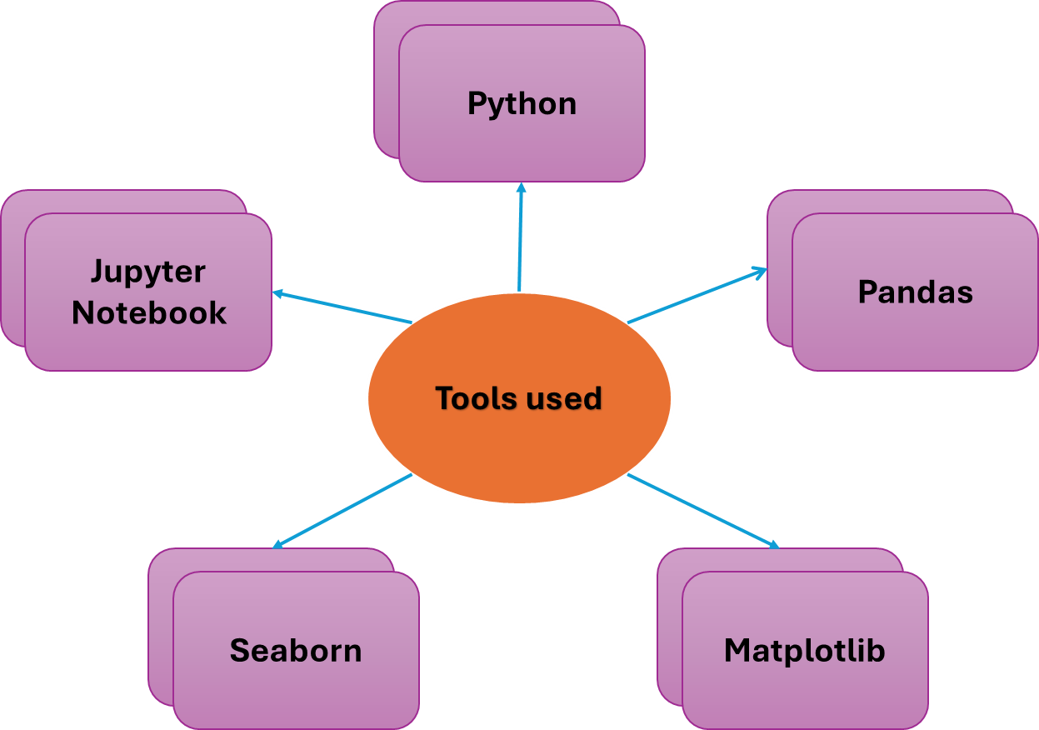
Conclusion
- In conclusion, the analysis of the diabetes dataset reveals clear trends and relationships among key health indicators.
- Higher age, elevated BMI, and increased blood glucose and HbA1c levels are strongly associated with diabetes, while comorbidities like hypertension and heart disease are more prevalent in diabetic patients.
- Lifestyle factors such as smoking show a moderate influence, whereas gender differences are minimal. Overall, these findings highlight the importance of monitoring weight, blood sugar, and cardiovascular health as preventive measures and provide actionable insights for early detection and management of diabetes.
Reference
[1] Data Visualization Lab Manual.
[2] NumPy, "NumPy Documentation," numpy.org, 2022. [Online]. Available: https://numpy.org/doc/
[3] Pandas, "pandas’ documentation — pandas 1.0.1 documentation," pandas.pydata.org, 2024. [Online]. Available: https://pandas.pydata.org/docs/
[4] Matplotlib, "Matplotlib: Python plotting — Matplotlib 3.3.4 documentation," matplotlib.org, 2024. [Online]. Available: https://matplotlib.org/stable/index.html
[5] Towards Data Science, "Towards Data Science - Medium," medium.com, 2024. [Online]. Available: https://towardsdatascience.com/
[6] Kaggle, "Kaggle: Your Machine Learning and Data Science Community," kaggle.com, 2024. [Online]. Available: https://www.kaggle.com/
[7] Scikit-learn, "Scikit-learn: Machine Learning in Python," scikit-learn.org, 2024. [Online]. Available: https://scikit-learn.org/stable/

