AI-POWERED FINANCIAL DASHBOARD WITH CHATBOT INTEGRATION

Project Overview
Introduction
Financial data analysis is one of the most critical operations for businesses and organizations. Every day, companies manage financial records in spreadsheets containing revenue, expense, and transaction details. Analyzing this data manually is time-consuming, prone to human error, and difficult for non-technical users.
This project aims to simplify financial data analysis by building an AI-powered financial dashboard integrated with a Multinomial Naive Bayes machine learning model, interactive Plotly visualizations, and a natural language chatbot.

Problem Statement
Most organizations maintain large sets of financial records in Excel files. Interpreting profit/loss trends, identifying confidential records, and searching for specific transactions (e.g., refund amounts on specific dates) requires manual effort. Without automated visualization and interactive tools, decision-makers struggle to gain fast, actionable insights from raw data. There is a need for an intelligent web platform that automatically processes financial files, predicts outcomes using machine learning, visualizes key metrics, and allows natural language queries through a chatbot.

Objectives
- Enable users to upload Excel/CSV financial datasets directly to the dashboard.
- Automatically predict profit/loss status and classify confidential records using Machine Learning (Multinomial Naive Bayes).
- Generate dynamic, real-time visualizations (horizontal bar graphs, daily breakdown, line trends) using Plotly.
- Provide an AI-powered chatbot assistant for natural language queries (e.g., loss entry count, refund details).
- Host the end-to-end system on AWS EC2 for seamless, cloud-based access.
- Display real-time key metrics like total revenue, expenses, and net profit and provide a date filter dropdown to easily explore daily financial breakdown.
Features of the Project
- Excel & CSV File Handling: Instant spreadsheet parsing using pandas.
- Machine Learning Classification: Predicts Profit/Loss and Confidential status via scikit-learn.
- Interactive Dashboard: Dynamic metric cards (Total Revenue, Total Expenses, Net Result, Analysed Records).
- Dynamic Date Filter: Dropdown menu to view date-wise daily financial breakdown.
- Visual Analytics: Interactive bar charts and timeline trend graphs powered by Plotly.js.
- Structured Financial Table: Organized table display to easily view uploaded spreadsheet records and predictions.
- AI Chatbot Assistant: Answers user natural language queries instantly.
- Backend Integration: RESTful APIs built with Flask (/upload, /predict, /chat).
- Cloud Hosting: Deployed on AWS EC2 (Ubuntu Server) for remote browser accessibility.
- Responsive User Interface: Clean and easy-to-use web layout designed with HTML, CSS, and JavaScript.

System Architecture
CSV / Excel Dataset (.xlsx, .csv)
│
▼
Python Flask Backend
│
▼
Pandas Data Processing & Analysis
│
▼
Scikit-Learn ML Model (MultinomialNB)
│
▼
Plotly.js Visualizations & Interactive Tables
│
▼
AI Chatbot Assistant Engine
│
▼
AWS EC2 Cloud Deployment
│
▼
User Interface

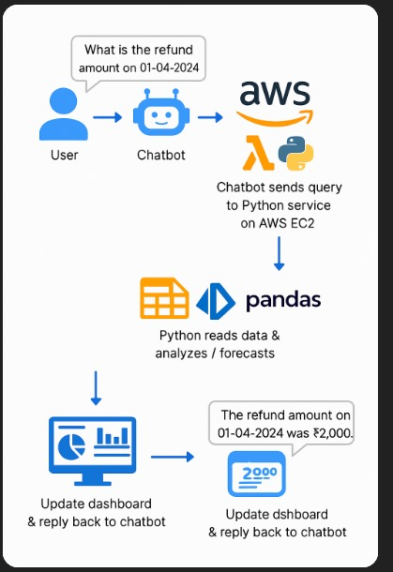

Technologies used
Technology | Purpose
Python | Primary backend programming language
Flask | Web framework handling routing and API endpoints
Pandas | Parsing, cleaning, and calculating spreadsheet metrics
Scikit-Learn | Training and executing Multinomial Naive Bayes ML model
Plotly.js | Creating interactive charts, bar graphs, and line trends
HTML & CSS | Designing the dashboard user interface
JavaScript (ES6) | Managing dynamic UI updates and asynchronous API requests
AWS EC2 | Cloud hosting on Ubuntu OS for real-time web access

Working of the Project
Step 1 – Data Collection & Upload
Financial data is stored in Excel/CSV spreadsheets containing fields like Date, Category, Revenue, Expenses, Status, and Confidentiality. The user uploads the file using the UI upload button.
Step 2 – Backend Processing (Pandas)
The Flask backend receives the file at the /upload endpoint. pandas reads the spreadsheet, cleans column structure, and computes metrics like Total Revenue, Expenses, and Net Result.
Step 3 – Machine Learning Predictions
The data is passed to the trained Multinomial Naive Bayes model (model.pkl). The model classifies records into Profit/Loss categories and flags sensitive data as Confidential.
Step 4 – Visualization (Plotly)
Processed data is returned as structured JSON. Frontend JavaScript renders dynamic Plotly horizontal bar graphs for daily breakdowns and spline line graphs for Profit/Loss trends across dates.
Step 5 – Chatbot Interaction
Users type natural language questions into the AI Assistant chat box. The /chat API processes the query and returns instant statistics (e.g., number of loss entries, refund details).
Step 6 – AWS Cloud Deployment
The entire Flask application is hosted on an AWS EC2 t2.micro instance. Security Groups allow inbound traffic on Port 5000, making the app accessible over the internet via browser.
Results
The AI-Powered Financial Dashboard was successfully developed and deployed.
- Users can upload financial spreadsheets and instantly view computed metrics and predictive outcomes.
- Interactive charts accurately reflect daily expense breakdowns based on date dropdown selections.
- The AI Chatbot assistant responds accurately to natural language queries regarding dataset records.
- The entire platform is hosted on AWS EC2(http://<EC2_PUBLIC_IP>:5000) and operates smoothly across standard web browsers.
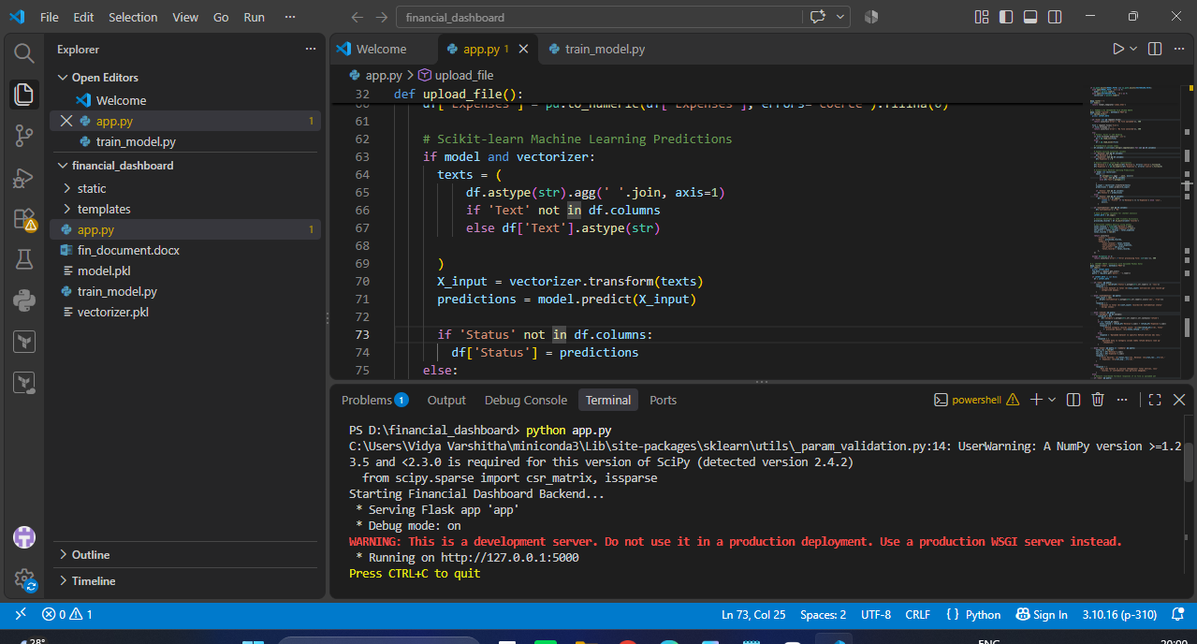
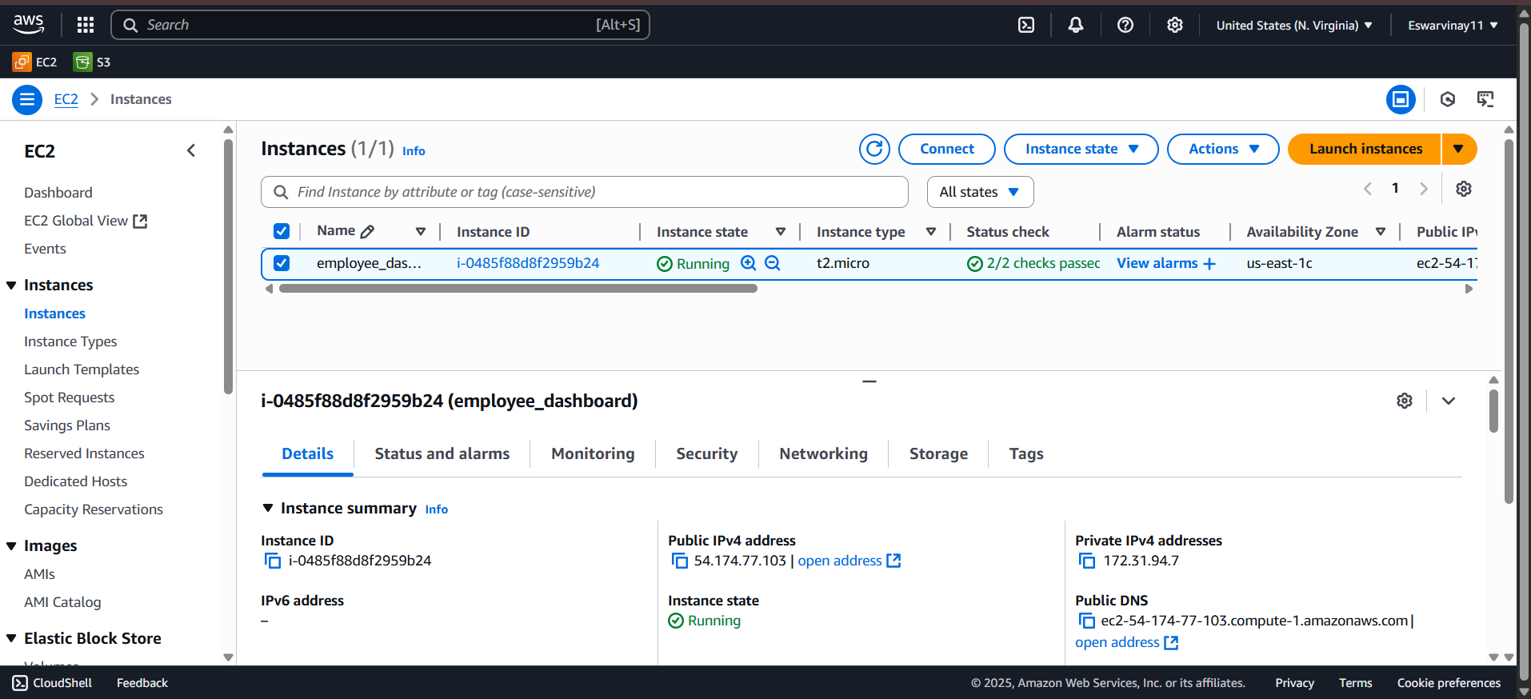

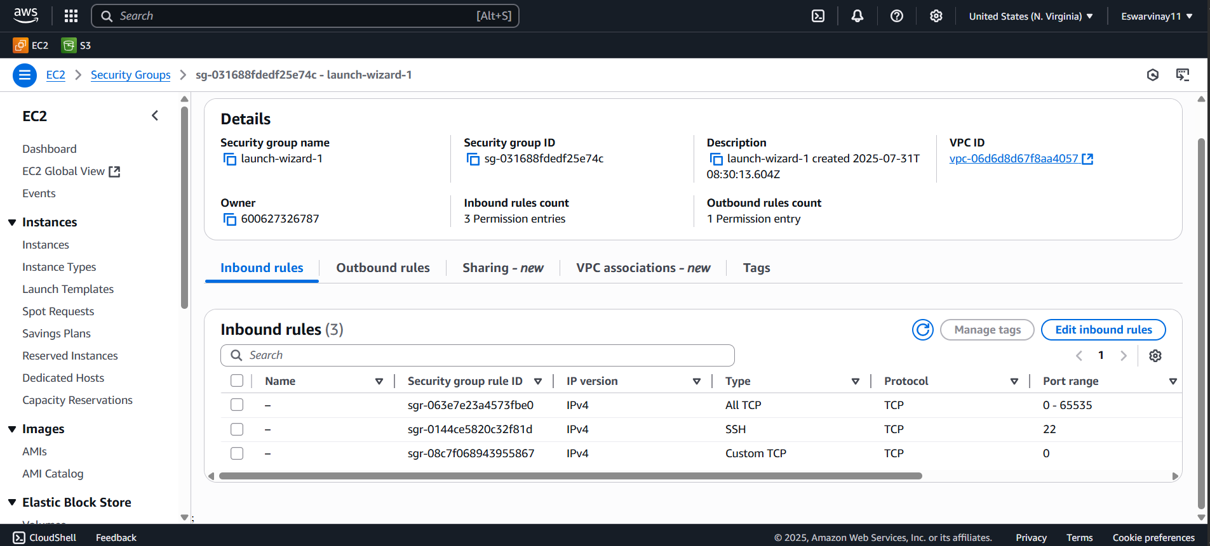

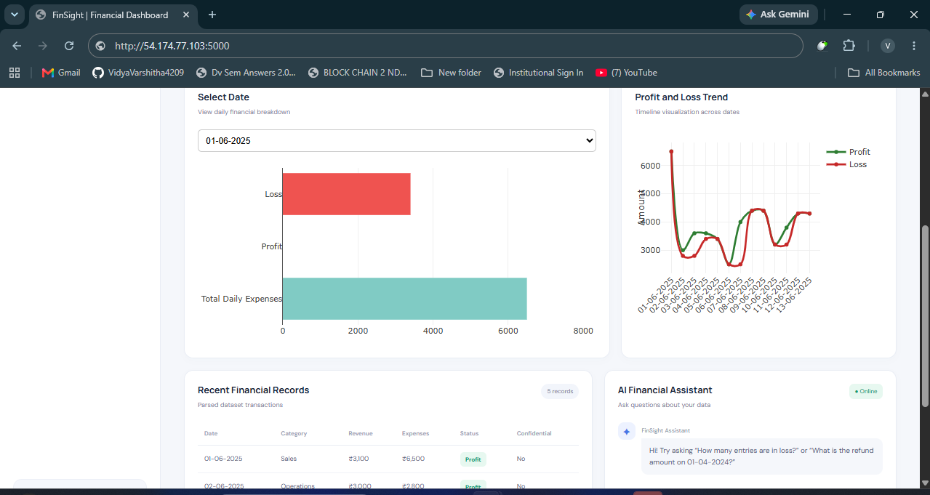

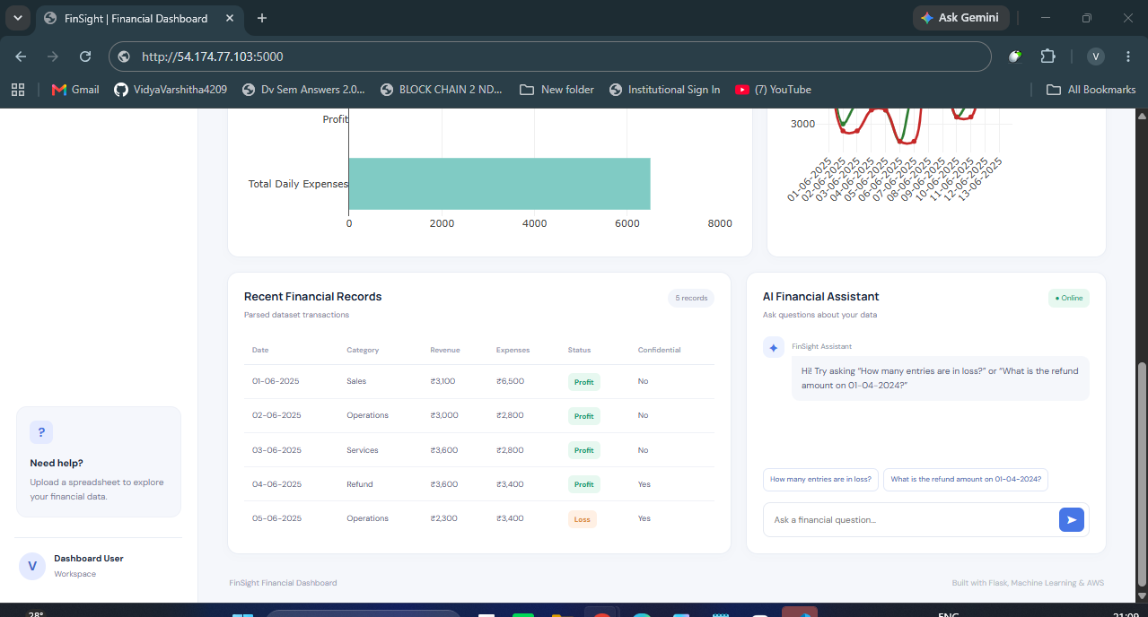

Conclusion
This project successfully demonstrates the development and deployment of an AI-powered financial dashboard integrated with machine learning and natural language chatbot capabilities. By combining Python Flask, Pandas, and Plotly, the application effectively transforms raw financial spreadsheets into dynamic, real-time visual insights. The implementation of a Multinomial Naive Bayes model enables automated classification of profit/loss trends and confidential records, eliminating the need for manual data inspection and reducing the potential for human error.
Furthermore, the integration of a built-in AI assistant provides users with an intuitive natural language interface to query dataset metrics instantly, making financial analysis accessible to both technical and non-technical stakeholders. Hosted on an AWS EC2 cloud instance, the end-to-end system ensures scalability, real-time availability, and remote browser access. Overall, this project serves as a robust solution that streamlines business financial workflows, accelerates decision-making, and highlights the practical applications of AI in financial data analysis.

