1. Payment of 50USD using PayPal (Customer Front-End)

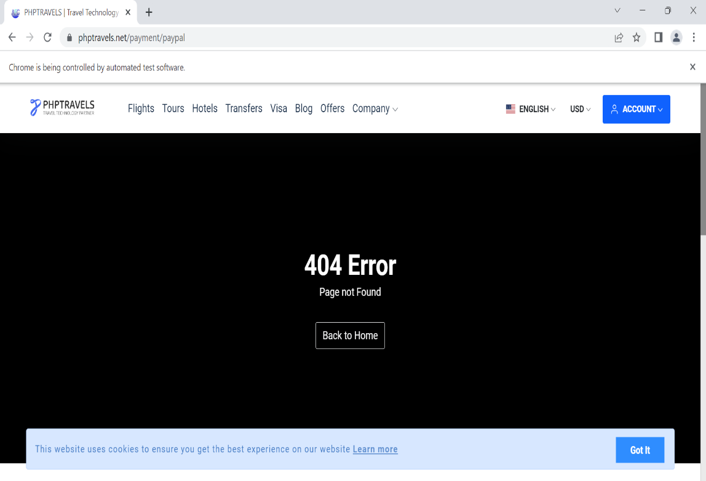

1. Login error (Agent Front-End)

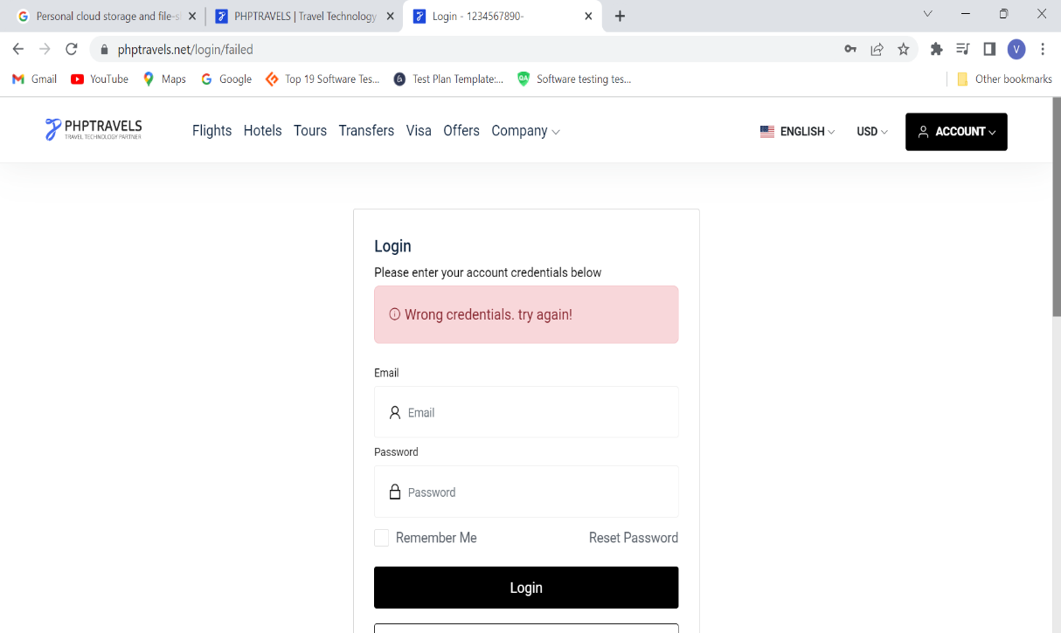

1. Bookings link error (Supplier Back-End)

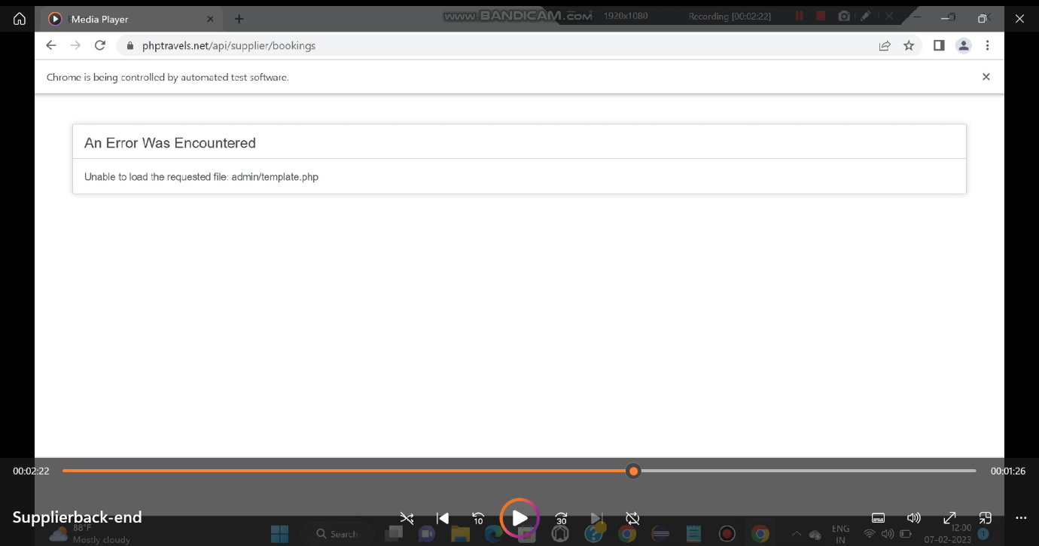

1. Admin Back-End (Showing message “invalid credentials” even after entering correct login details.

