1. **Develop a program to display gray scale image using read and write operation.**

import cv2

image=cv2.imread("dog.jpg")

cv2.imshow('Original Image',image)

cv2.waitKey(0)

gray_img = cv2.cvtColor(image, cv2.COLOR_BGR2GRAY)

cv2.imwrite('gray scale',gray_img)

cv2.waitKey(0)

cv2.destroyAllWindows()

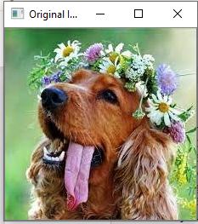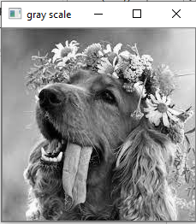

**2.Develop a program to perform Linear Transformation on image(Scaling and Rotation).**

**Scaling:**

import cv2

import numpy as np

img=cv2.imread('dog.jpg')

(height,width)=img.shape[:2]

res=cv2.resize(img, (int(width/2), int(height/2)), interpolation=cv2.INTER_CUBIC)

cv2.imwrite('result.jpg',res)

cv2.imshow('Result',res)

cv2.imshow('image',img)

cv2.waitKey(0)

cv2.destroyAllWindows()

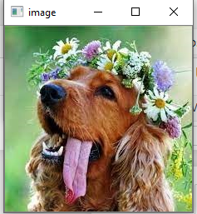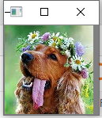

**Rotation:**

import cv2

import numpy as np

img=cv2.imread('dog.jpg')

(rows,cols)=img.shape[:2]

M=cv2.getRotationMatrix2D((cols/2, rows/2),45,1)

res=cv2.warpAffine(img,M,(cols,rows))

cv2.imwrite('result.jpg',res)

cv2.imshow('Result',res)

cv2.imshow('image',img)

cv2.waitKey(0)

cv2.destroyAllWindows()

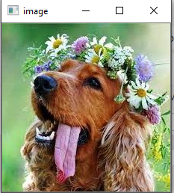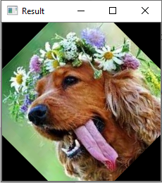

**3. Develop a program to find sum and mean of a set of images.**

**(i)Create ‘n’ number of images and read the directory and perform**

**Operation.**

import cv2

import os

path ="D:\images"

imgs=[]

dirs=os.listdir(path)

for file in dirs:

fpath=path+"\\"+file

imgs.append(cv2.imread(fpath))

i=0

for im in imgs:

cv2.imshow(dirs[i],imgs[i])

i=i+1

print(i)

cv2.imshow('Sum',im)

mean=im/len(dirs.)

cv2.imshow('Mean',mean)

cv2.waitKey()

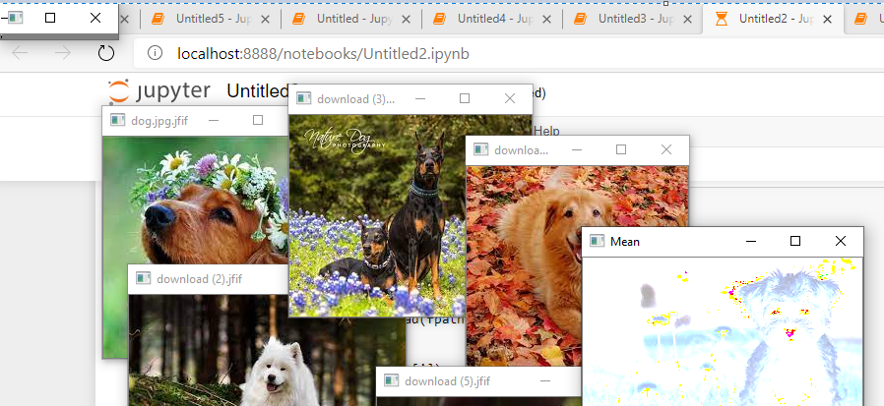

**4.Convert color image to Gray scale and binary image**

import cv2

image=cv2.imread("dog.jpg")

gray_img = cv2.cvtColor(image, cv2.COLOR_BGR2GRAY)

cv2.imshow('gray scale',gray_img)

cv2.waitKey(0)

cv2.destroyAllWindows()

ret,bw_image=cv2.threshold(image,127,255,cv2.THRESH_BINARY)

cv2.imshow('Binary Image',bw_image)

cv2.waitKey(0)

cv2.destroyAllWindows()

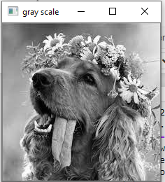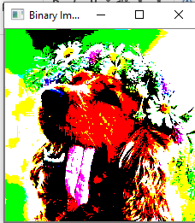

**5.Develop a program to convert color image into different color space.**

import cv2

image=cv2.imread("dog.jpg")

gray = cv2.cvtColor(image, cv2.COLOR_BGR2GRAY)

hsv=cv2.cvtColor(image,cv2.COLOR_BGR2HSV)

lab=cv2.cvtColor(image,cv2.COLOR_BGR2LAB)

cv2.imshow('GRAY IMAGE',gray)

cv2.waitKey(0)

cv2.imshow('HSV iamge',hsv)

cv2.waitKey(0)

cv2.imshow('LAB image',lab)

cv2.waitKey(0)

cv2.destroyAllWindows()

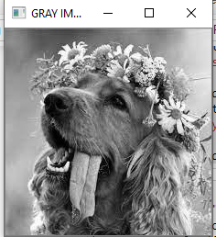

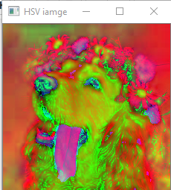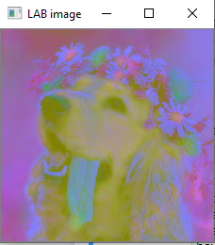

**6. Develop a program to create an image from 2D array generate an array of**

**random size.**

import numpy as np

from PIL import Image

array=np.linspace(0,1,256*256)

mat=np.reshape(array,(256,256))

img=Image.fromarray(mat,'HSV')

img.show()

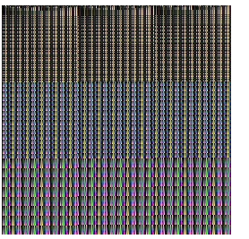

**7.program to find the neighbor of matrix.**

X = [[1,2,3], [4 ,5,6], [7 ,8,9]]

Y = [[9,8,7], [6,5,4], [3,2,1]]

result = [[0,0,0], [0,0,0], [0,0,0]]

for i in range(len(X)):

for j in range(len(Y)):

result[i][j] = X[i][j] + Y[i][j]

print("Resultant array:")

for r in result:

print(r)

def neighbors(radius, rowNumber, columnNumber):

return [[result[i][j]

if i >= 0 and i < len(result) and j >= 0 and j < len(result[0]) else 0

for j in range(columnNumber-1-radius, columnNumber+radius)]

for i in range(rowNumber-1-radius, rowNumber+radius)]

neighbors(4,2,2)

**OUTPUT:**

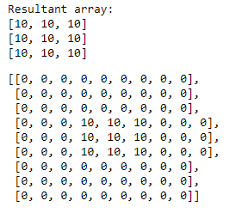

**8. Program to find the Sum of neighbour value of Matrix.**

import numpy as np

M = [[1, 2, 3],

[4, 5, 6],

[7, 8, 9]]

M = np.asarray(M)

N = np.zeros(M.shape)

def sumNeighbors(M,x,y):

l = []

for i in range(max(0,x-1),x+2):

for j in range(max(0,y-1),y+2):

try:

t = M[i][j]

l.append(t)

except IndexError:

pass

return sum(l)-M[x][y]

for i in range(M.shape[0]):

for j in range(M.shape[1]):

N[i][j] = sumNeighbors(M, i, j)

print ("Original matrix:\n", M)

print ("Summed neighbors matrix:\n", N)

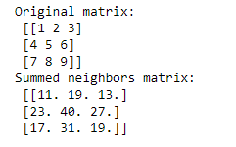

**9. Operator Overloading in C++:Assignment operator of 2 Matrix.**

#include <iostream>

int findSum(int n)

{

// Generate matrix

int a[100][100],b[100][100];

for (int i = 0; i < n; i++)

for (int j = 0; j < n; j++)

std::cin>>a[i][j] ;

for (int i = 0; i < n; i++)

for (int j = 0; j < n; j++)

b[i][j]=a[i][j];

// Compute sum

int sum = 0;

for (int i = 0; i < n; i++)

for (int j = 0; j < n; j++)

sum += b[i][j];

std::cout <<"sum of elements: ";

return sum;

}

int main() {

int n = 3;

std::cout << findSum(n) ;

return 0;

}

**Ouput:**

1 2 3

4 5 6

7 8 9

sum of elements: 45