**Q: Represent the architecture for an automated process to perform testing and deployment of data assets**

**(tables, views, etc) using a database of your choice and using dbt.**

A: Please see below steps to achieve above mentioned architecture. You should have an account with ‘dbt’,

‘Snowflake’ and ‘Git-hub’.

1. Visit <https://www.snowflake.com/> and create an account

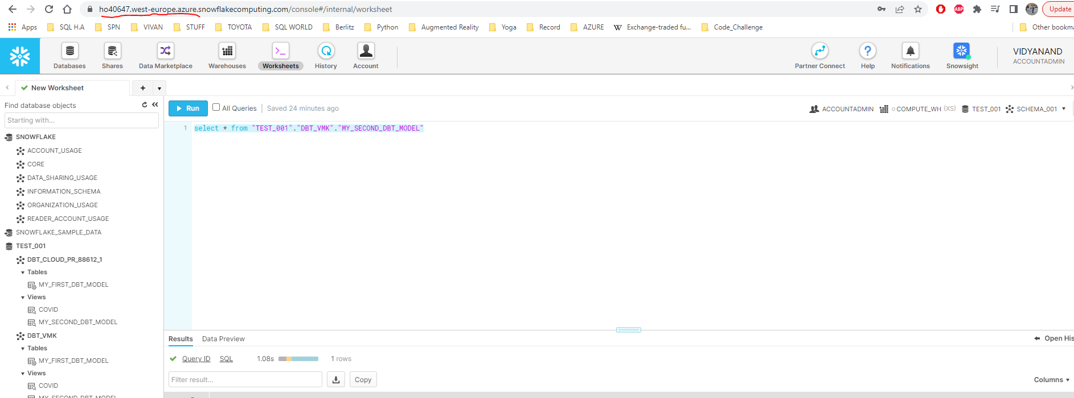

1. Load database / table / views (your choice).
2. Create an account with <https://github.com/> or login with existing account.
3. Create repository as shown in below screen

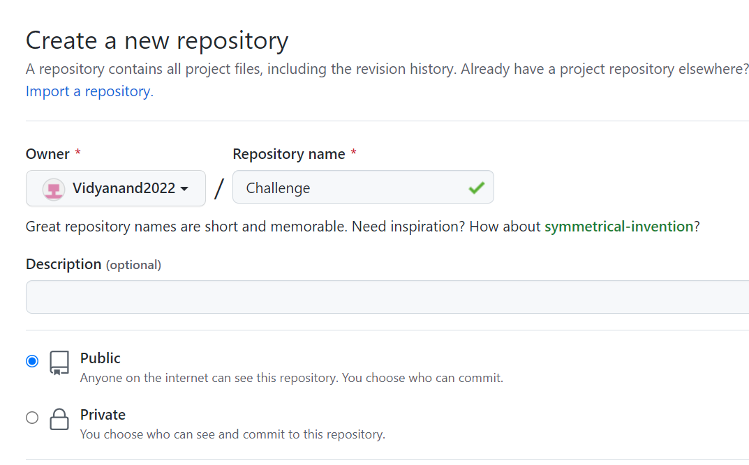

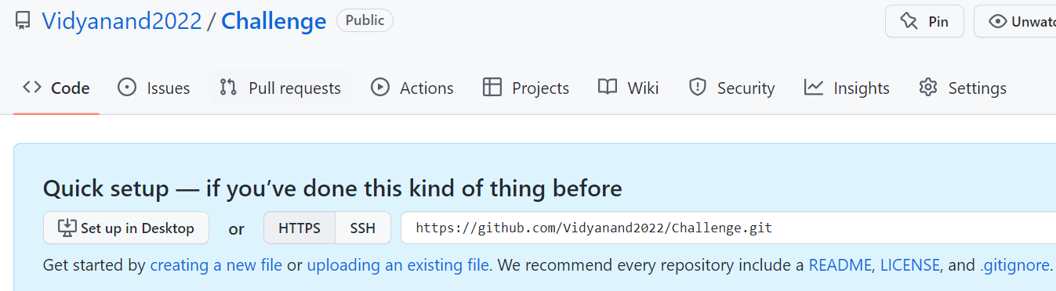

1. Visit <https://cloud.getdbt.com/login/> and create an account.

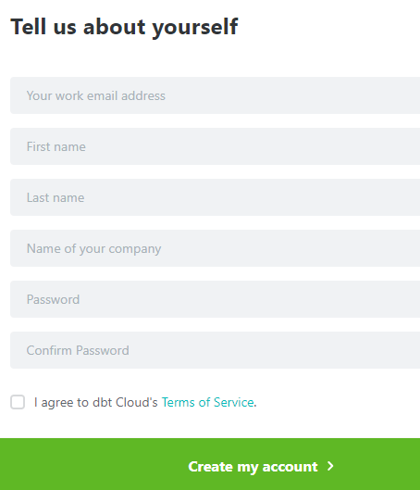

1. After an account creation, you will land on below mentioned page. Click on ‘Continue’ button.

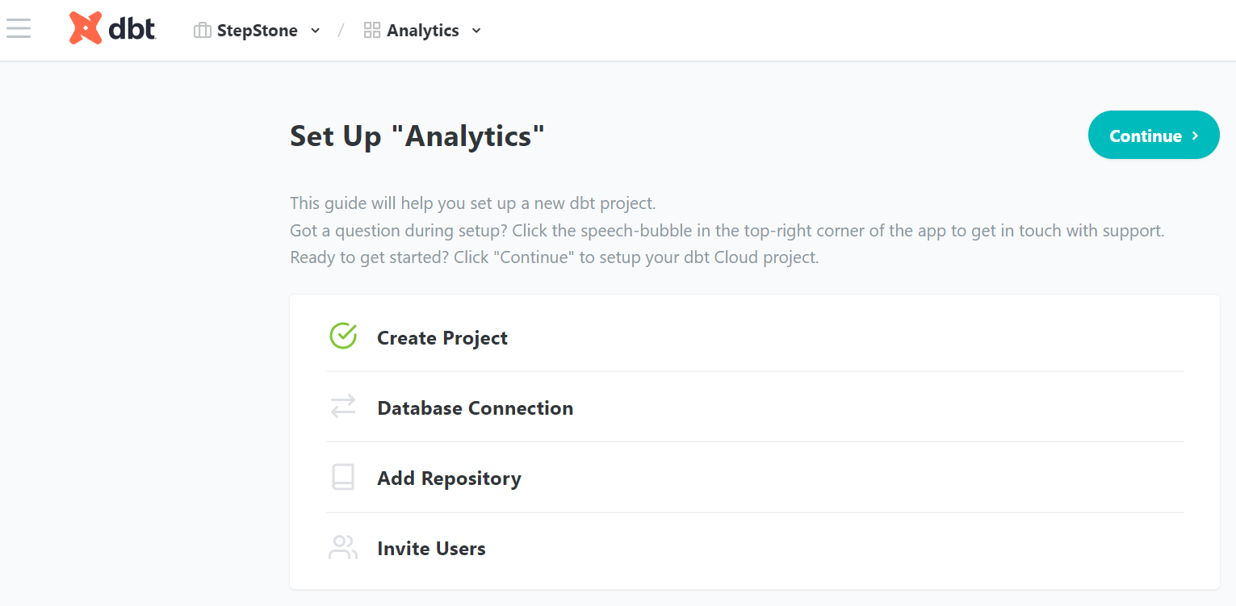

1. Select ‘Snowflake’ option

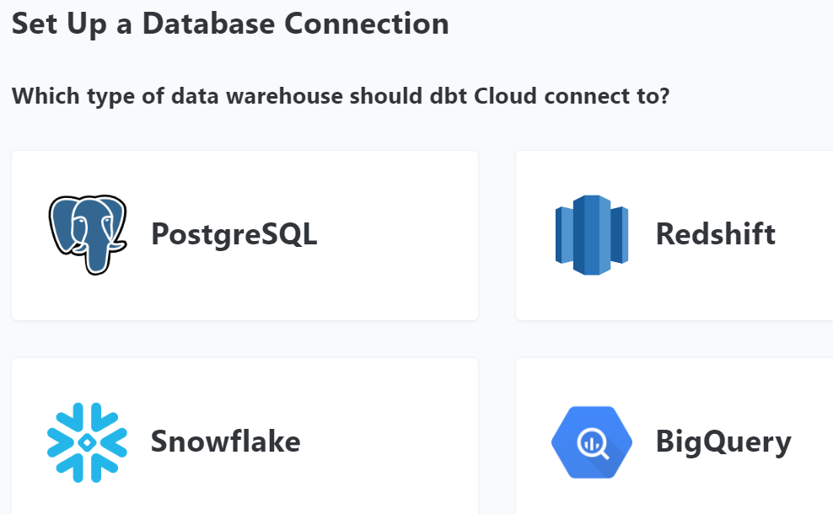

1. Setup database connection by providing details (as shown in below screen).

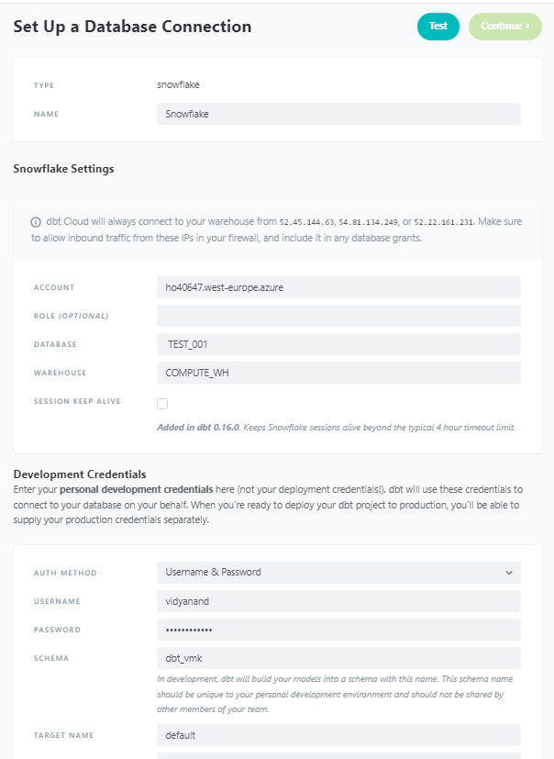

1. After providing all relevant details, click on ‘Test’ button and you will see below message.

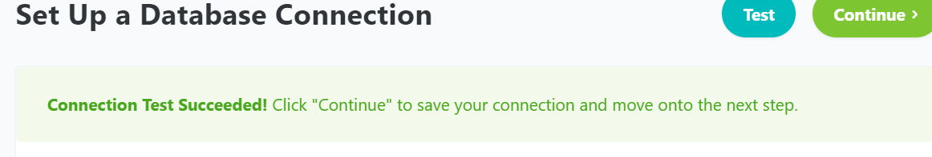

1. Click on ‘Continue’ button to setup Repository. In our case, we will setup ‘Github’ (refer point 3).

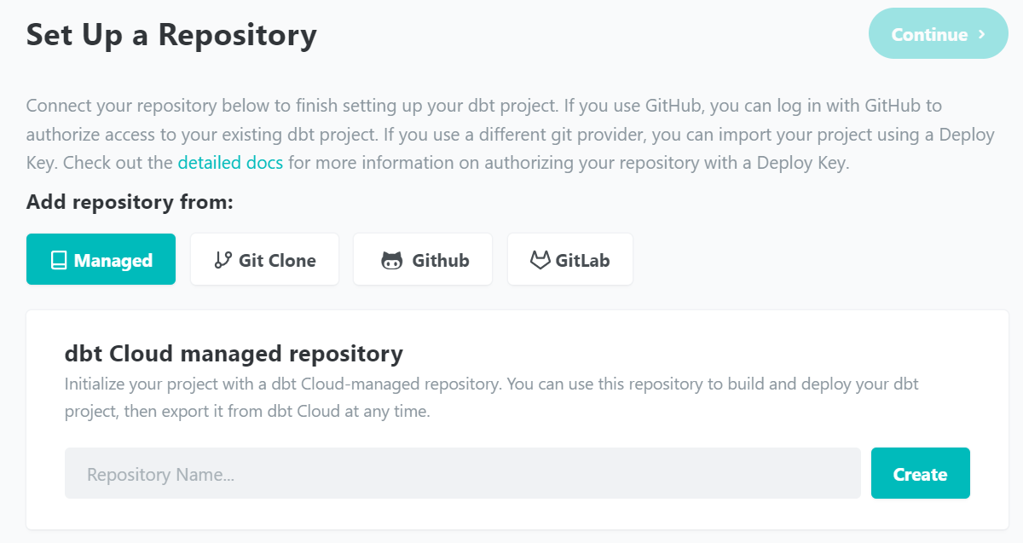

1. Select ‘Github’ and it will prompt you to enter credentials.

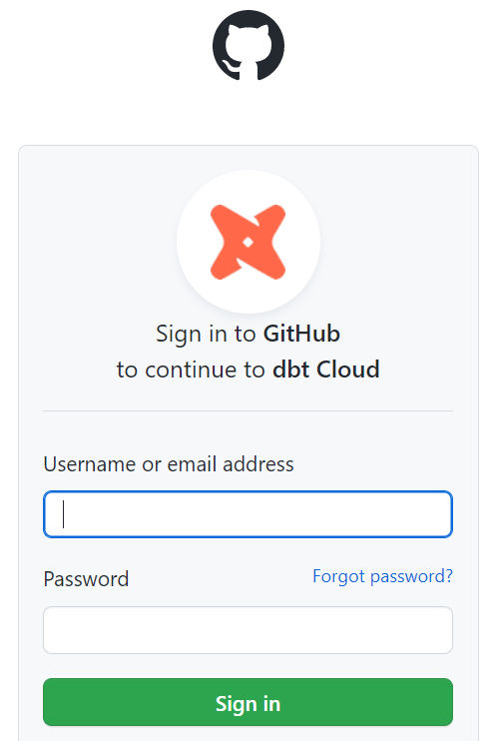

1. Click on ‘Link your Github profile’ option.

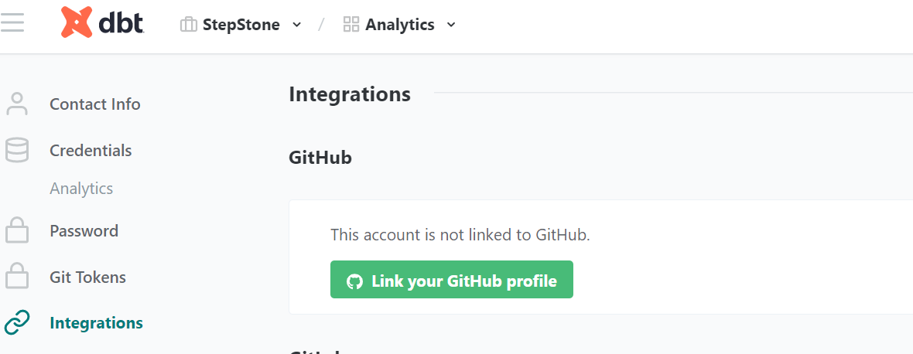

1. Click on ‘profile’ to select repository created (refer point 4).

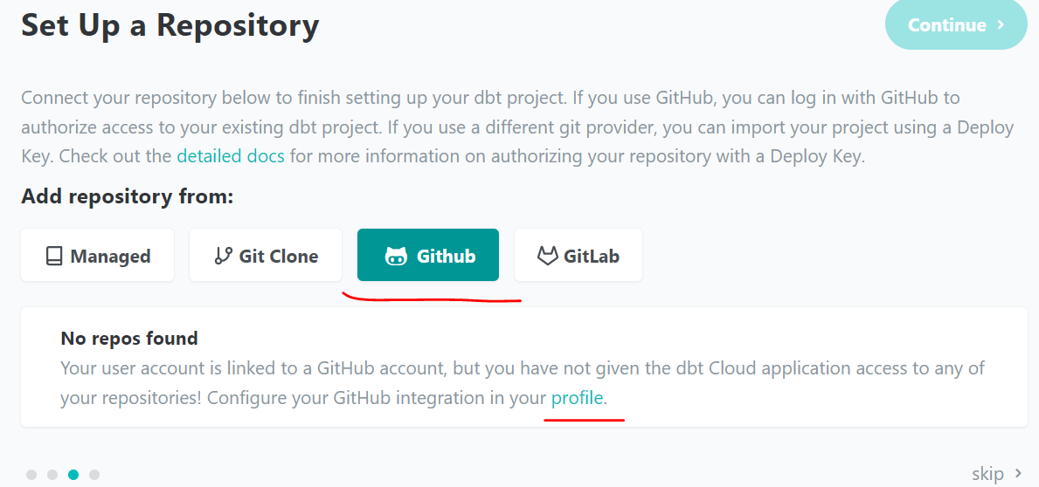

1. Click on ‘Configure integration in Github.

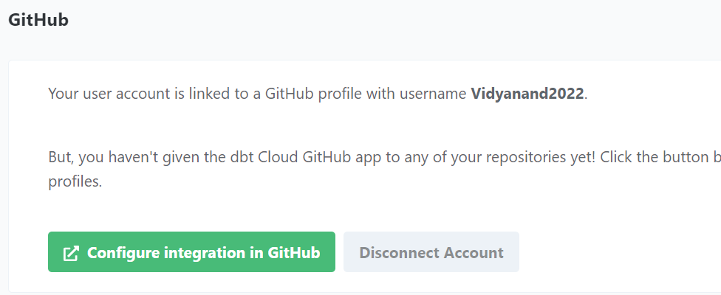

1. Click radio button ‘Only select repositories’ and select repository created (refer point 4). Click on ‘Install’ button.

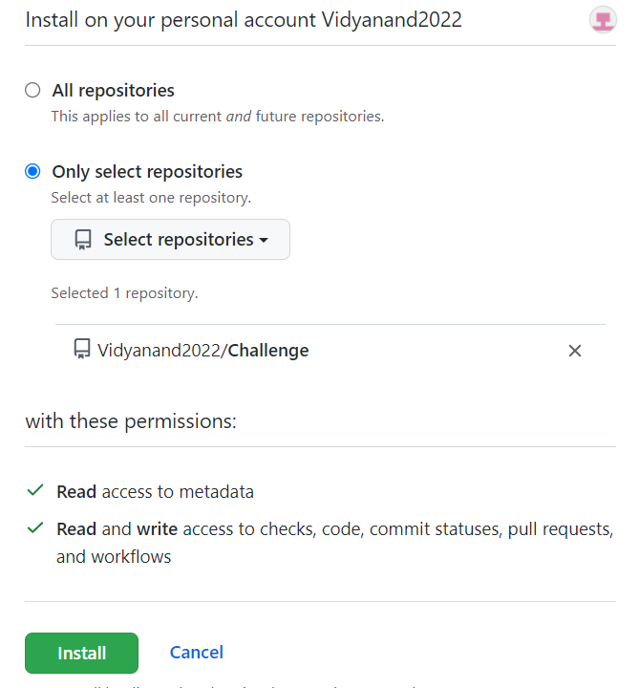

1. Now repository is configured and you will see below message.

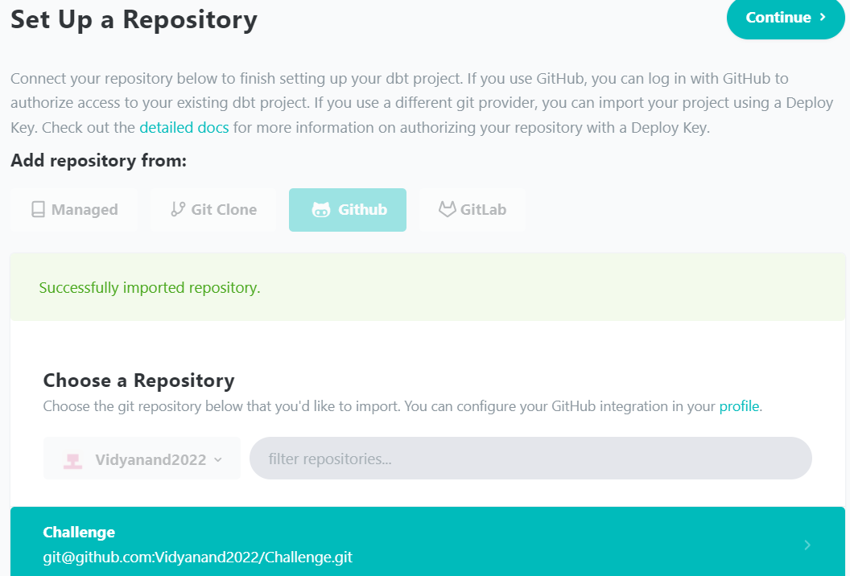

1. You will see below message in next page to start Developing.

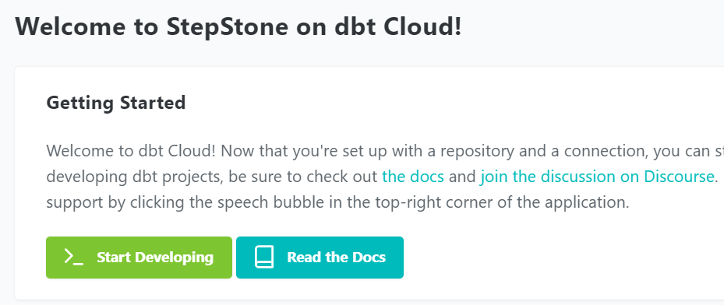

1. Click on ‘initialize your project’

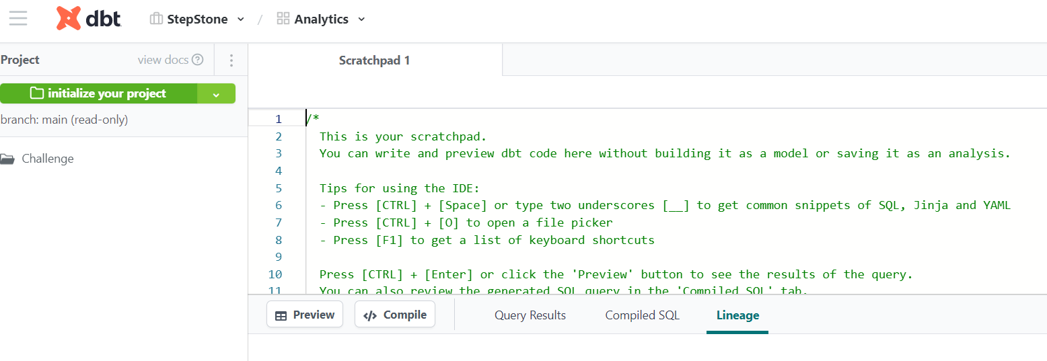

1. Click on ‘Create new branch’, enter branch name and submit.

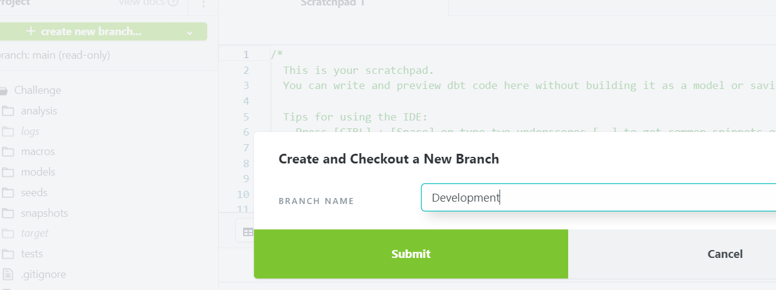

1. Let us do a check-in.

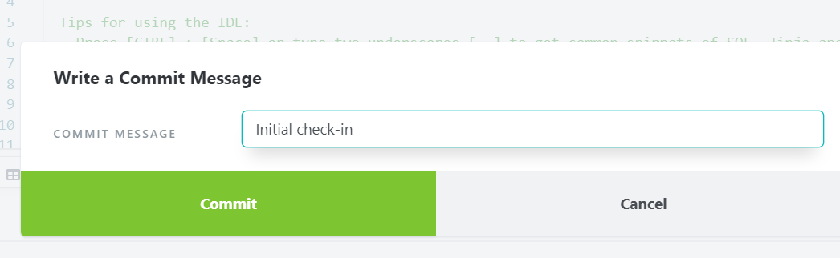

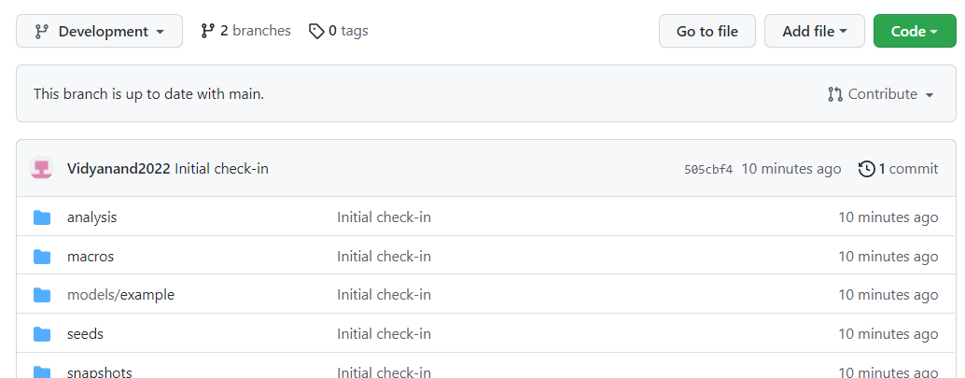

1. Go to ‘Github’ and you will see below details.

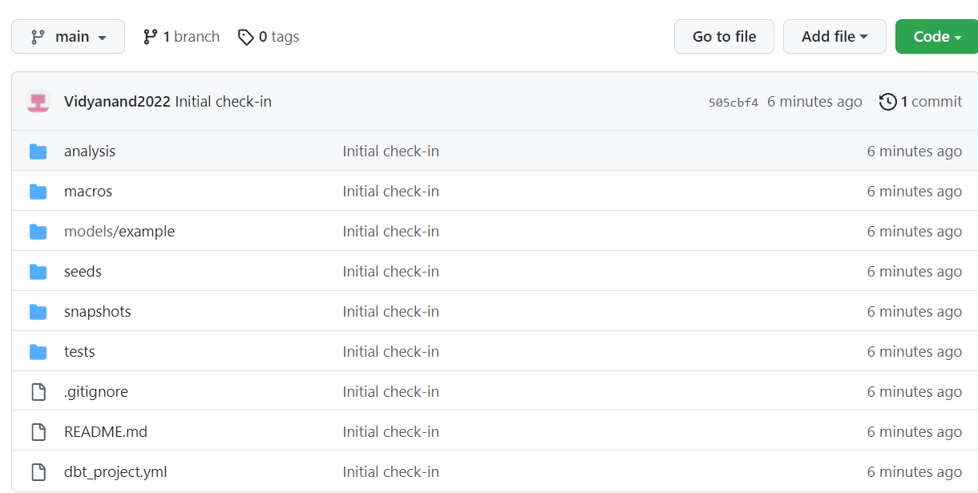

1. Go to ‘dbt’ and you will see below folder structure. You can click on ‘open pull request’.

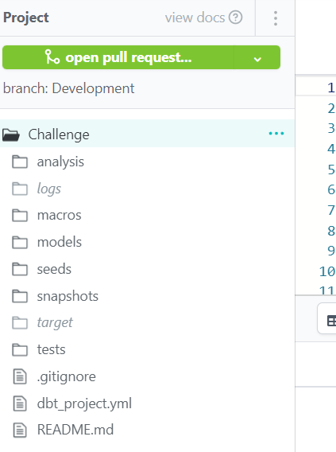

1. Add new sql file under models folder by clicking on 3 dots (right side).

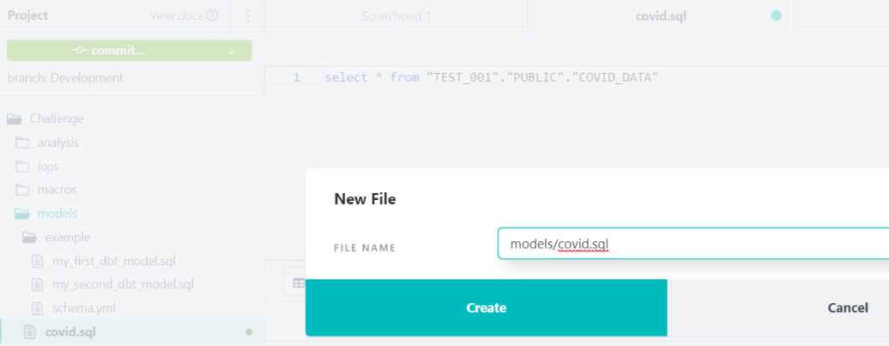

1. Now ‘open pull request’ changes to ‘commit’ option. Write sample CTE script in covid.sql file and save.

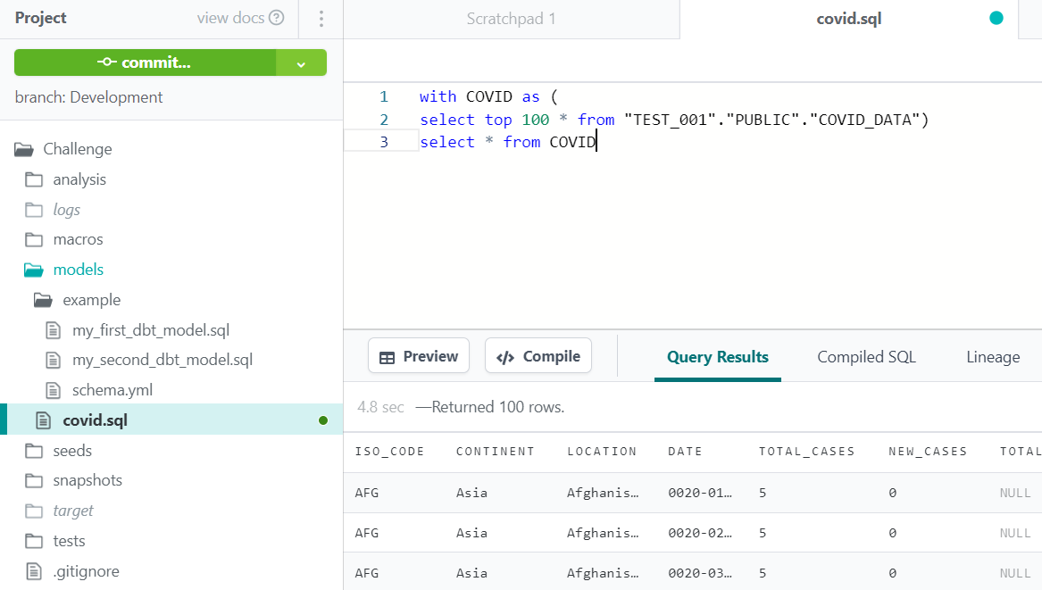

1. In Run tab write ‘dbt run’ command and execute. You should see results shown in below screen.

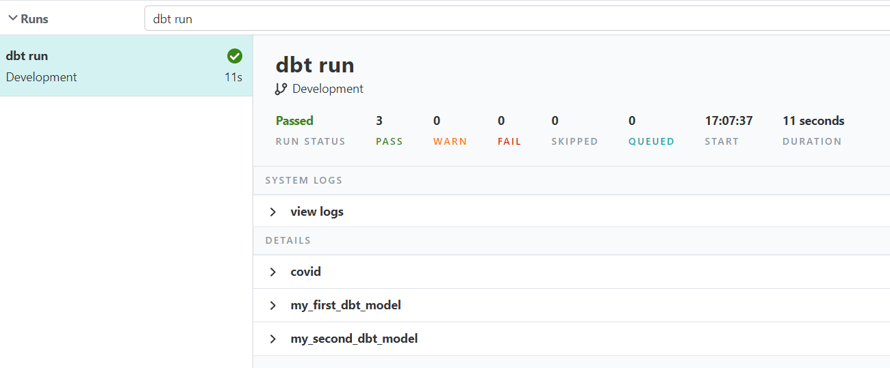

1. Now let’s commit our changes.

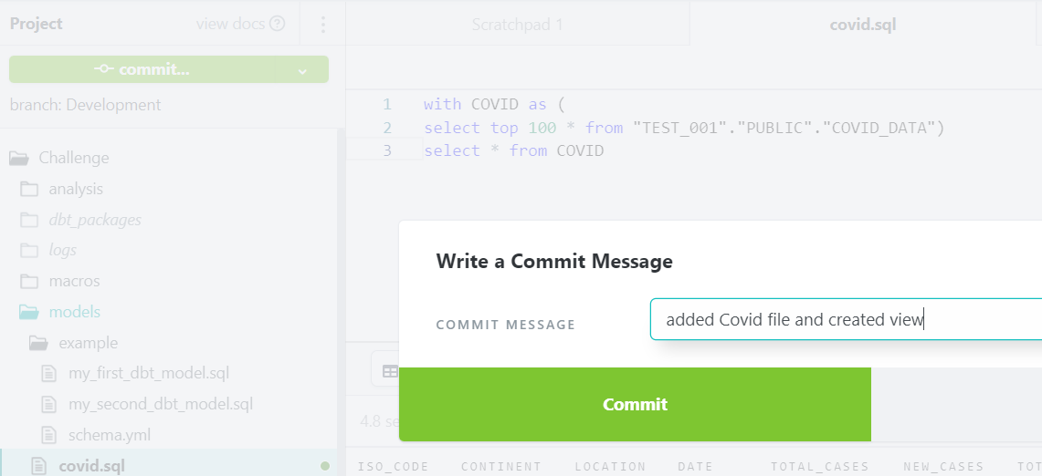

1. Go to Snowflake account and expand database (which is configured with dbt) and you will see ‘COVID’ view created as shown in below screen.

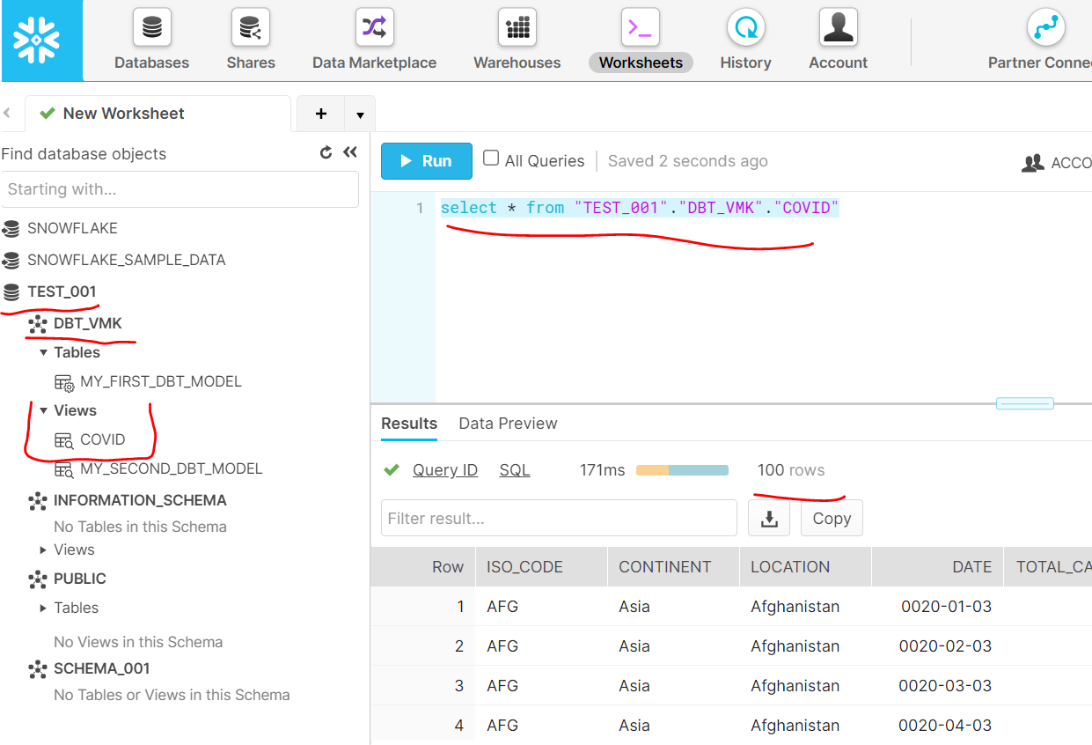

1. Now we will add new environment (Production) for deployment. Add all relevant details as shown in below screen.

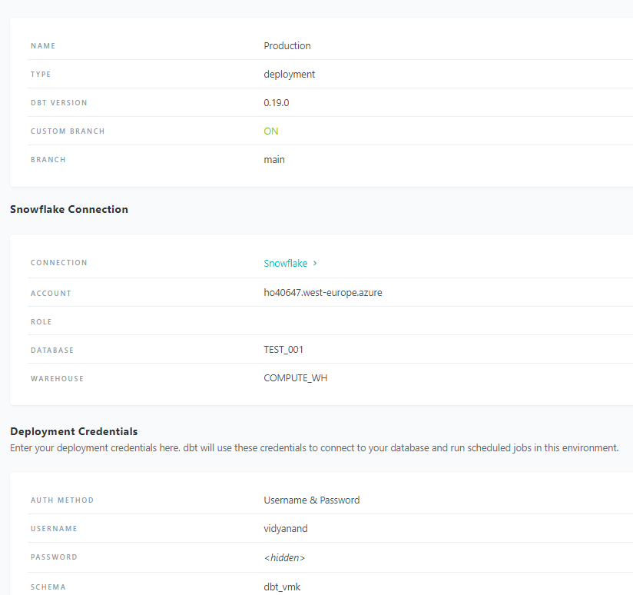

1. You will below message after successfully adding new environment.

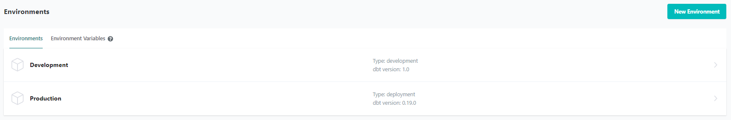

1. We will create a new job to test our deployment from development to production. Enter all details, we will not schedule but let it run based on ‘pull request’ from Github.

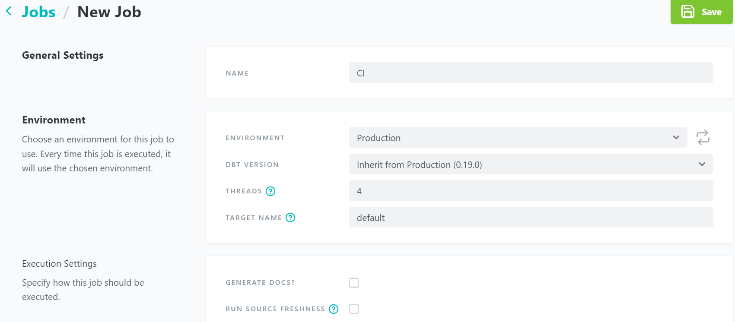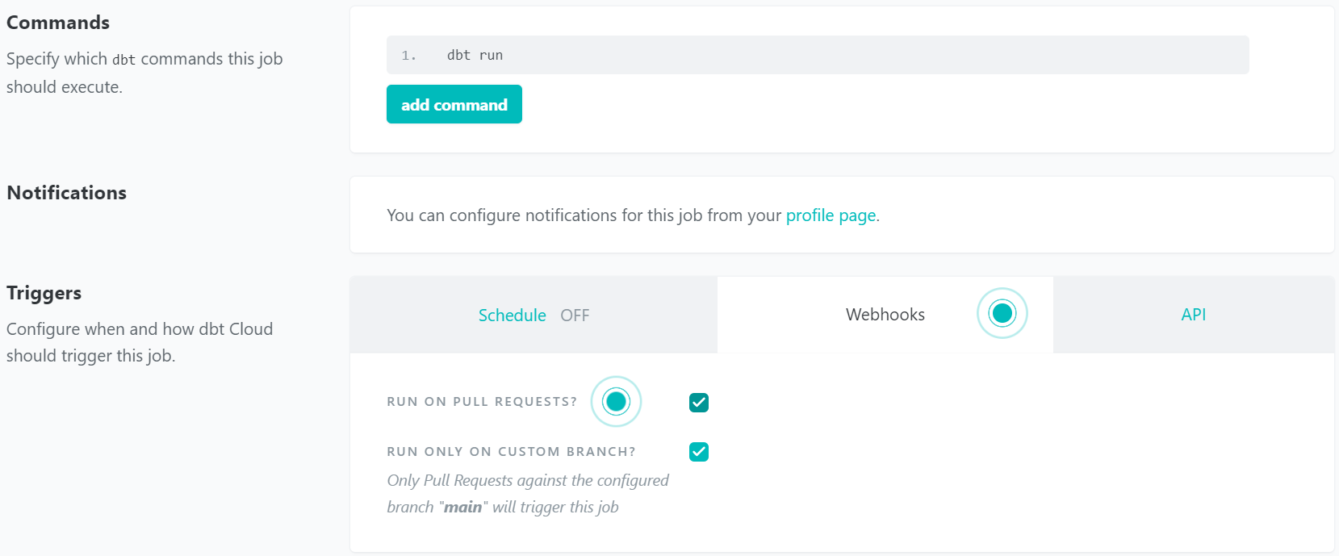

1. Go to ‘Github’ and you will see ‘1 commit ahead’.

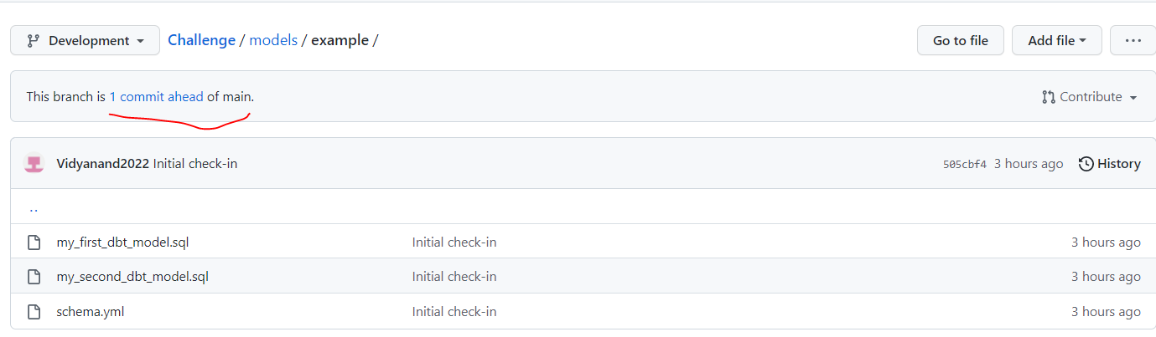

1. Click on ‘Create pull request’ and enter meaningful comments.

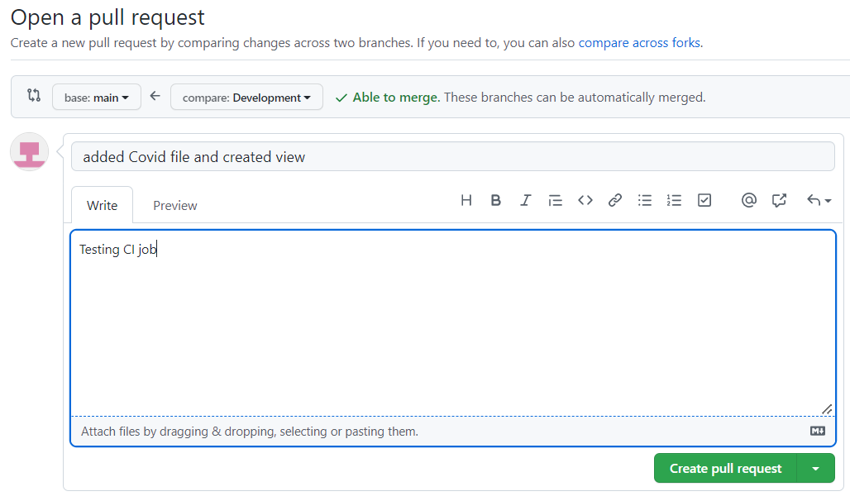

1. In dbt under job run history, you can see job is running because of pull request.

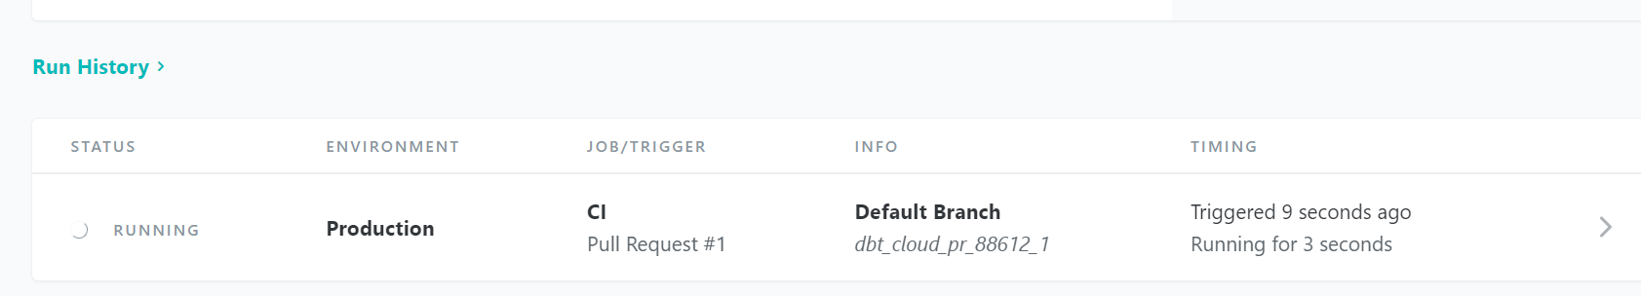

1. It will take some time to execute. After successful execution, you will below message.

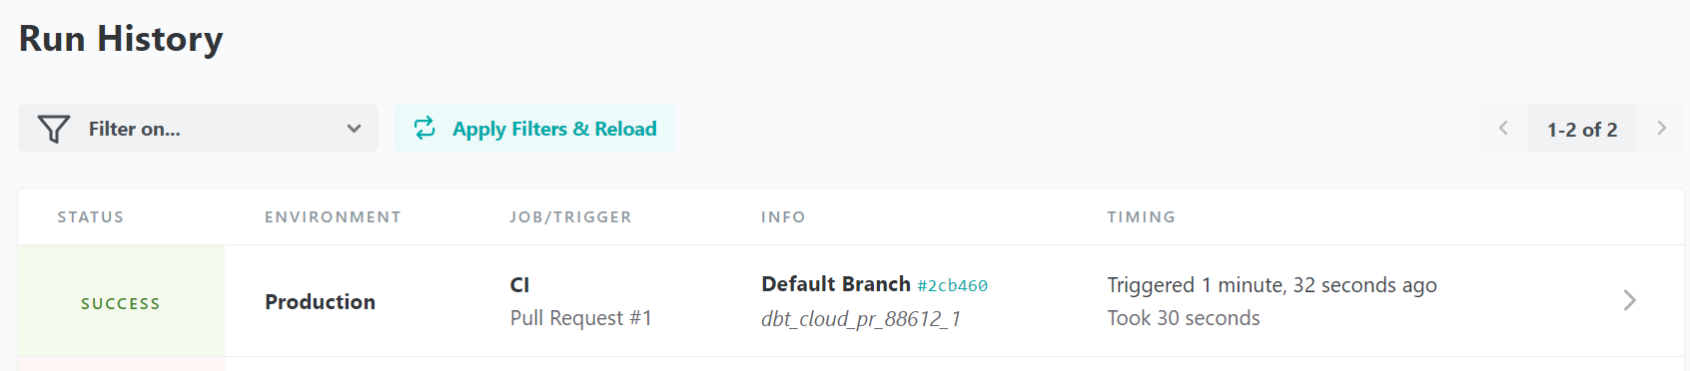

1. Now login to your Snowflake account and you will see ‘DBT_CLOUD_PR_88612_1’ folder is created.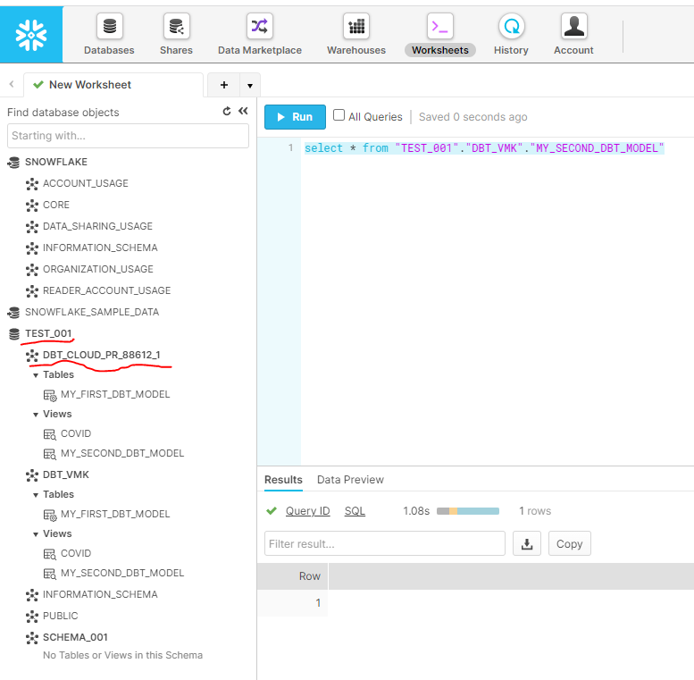
2. You can also schedule job with specific time / interval under CI job.