**FINAL PROJECT:**

**Redefined business rules, conceptual diagram and logical diagram:**

**Business Rules:**

* A facility has many buildings but all the buildings belong to one facility.
* A facility can have many physicians but each physician is affiliated to one full time firm and one personal clinic.
* A patient can have many appointments but one appointment can be affiliated to only one patient.
* In one building, many appointments can be accommodated
* Many patients can be in the waiting list but only one waiting list pertains to a patient.
* A nurse can be affiliated to only one department.
* One building can have many nurses but one nurse can be associated to one building only.
* Patients can consult more than one physician and physicians can treat more than one patient.
* Each patient visit is to one doctor but a doctor gets many patient visits.
* Each facility offers many insurance programs and many insurance programs are affiliated to many hospitals.
* The maximum limit for the number of patients a physician can view in a day is 20.(alterable with advancement in technology)
* Each physician works in one building, but one building will have many physicians working in it.
* Each patient can take up one insurance plan only, but one insurance plan can be taken up by many patients.
* A physician can be associated to one facility only but one facility can have many doctors.
* A physician may work at many buildings and many buildings can have different doctors.
* One department will have only one supplier and one supplier can supply medicines and equipment to different departments.
* A physician r can have only one administrative assistant and one administrative assistant can be affiliated to only one doctor.
* A physician can have only one schedule and one schedule is unique to one physician only.
* One building can have many departments but one department can pertain to only one building.
* A building can undertake many appointments but an appointment can be affiliated to only one building.

**Conceptual ERD:  
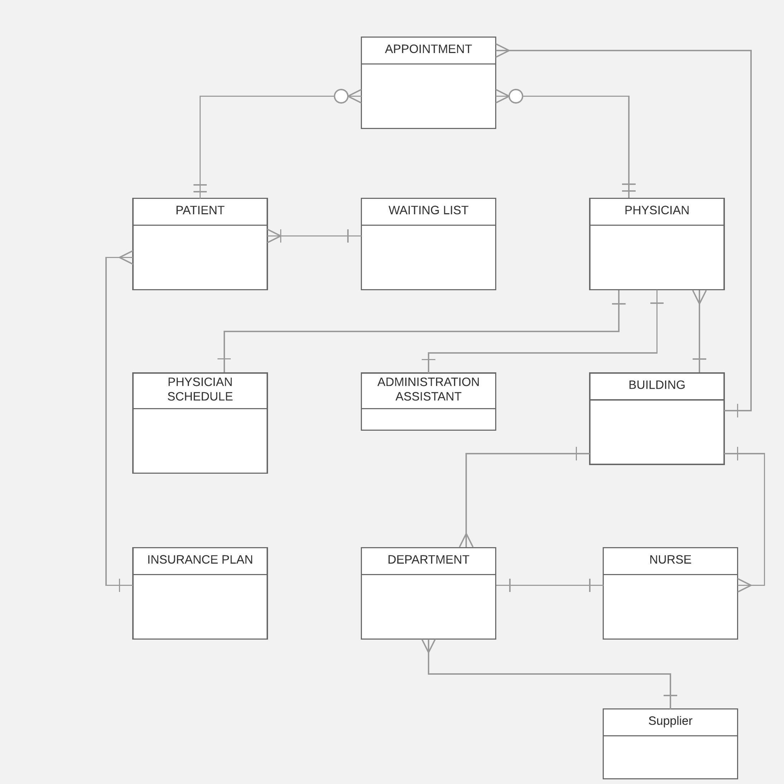**

**Logical ERD:**

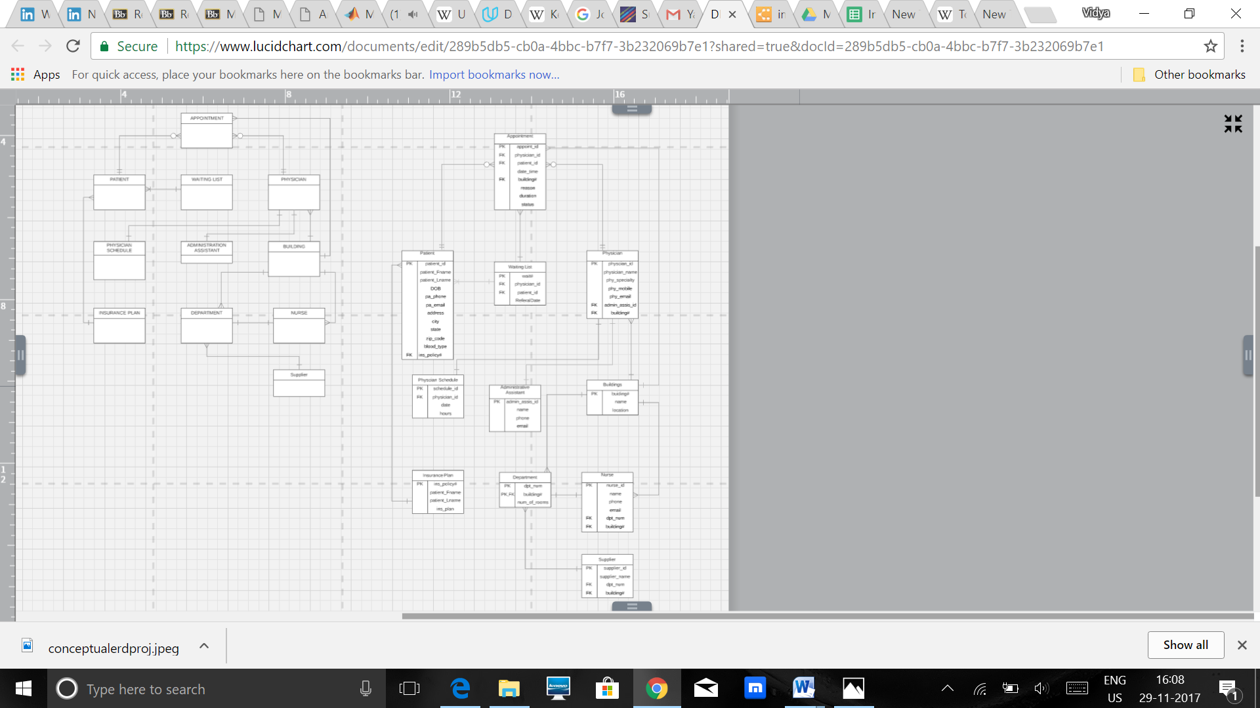

1. **a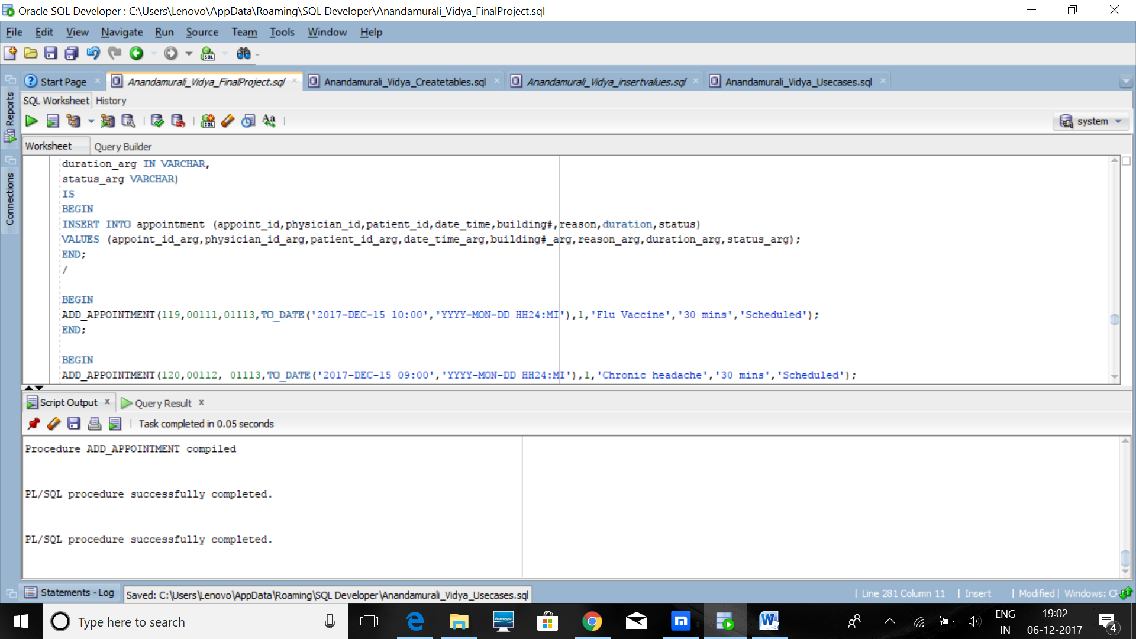 1b.**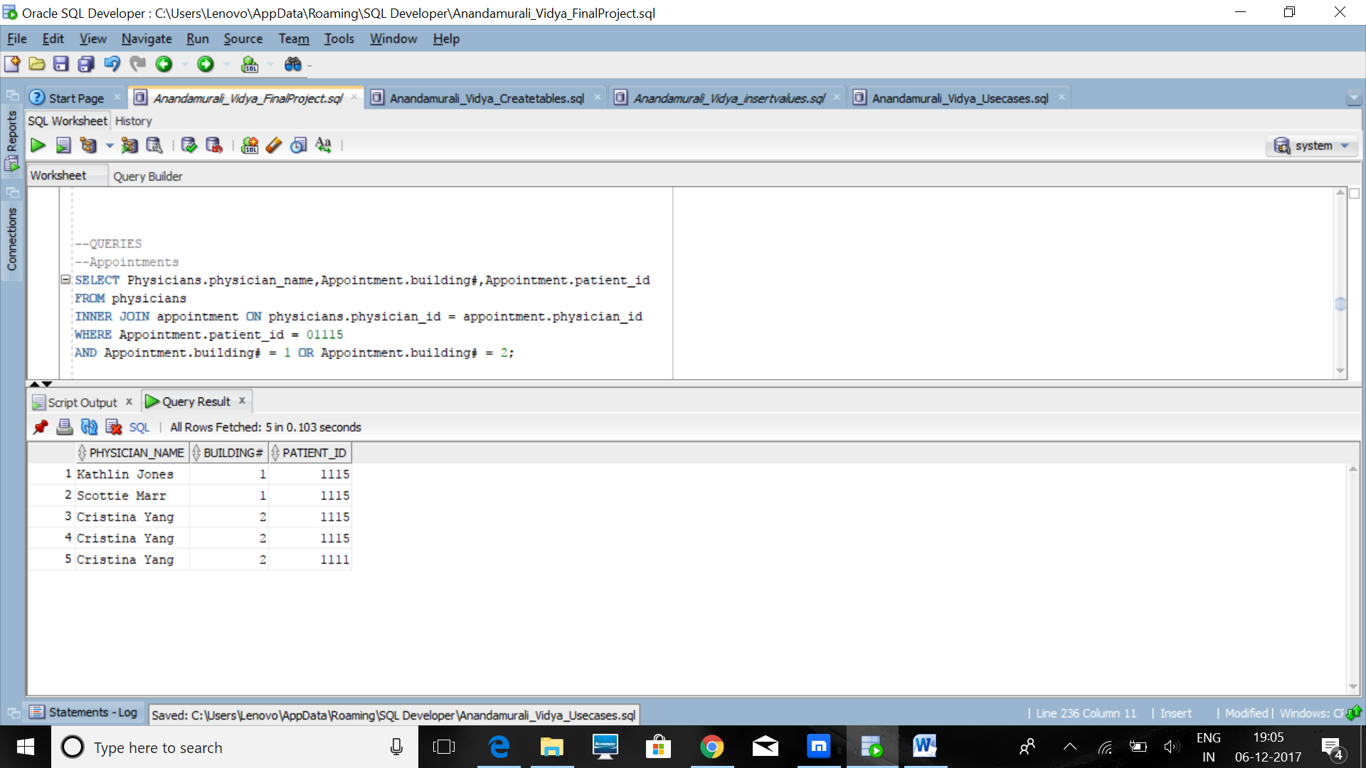
2. **List of tables created for the use cases 2 and 3:**
3. This part will require a waiting list table that adds the patients details into the waiting list table. The administrative assistant adds accordingly pertaining to the availability of the physician that the patient seeks. Then a stored procedure can be evoked for the physician and the patient table to retrieve and connect both their information pertaining to the use cases.
4. This part of the query requires three tables, the patient table, physician and the waiting list table. The waiting list and the patient table must be joined to find the common points and then data specific to a particular physician can be queried out of the data.
5. 3a requires the insurance table and the patient table to query results that pertain to adding a new patient into the insurance plan. This update has to take place in both the tables and hence and procedure can be used.
6. 3b requires us to query out results that require the patient table, the insurance table and query the results pertaining to a time frame of two years.

2a.

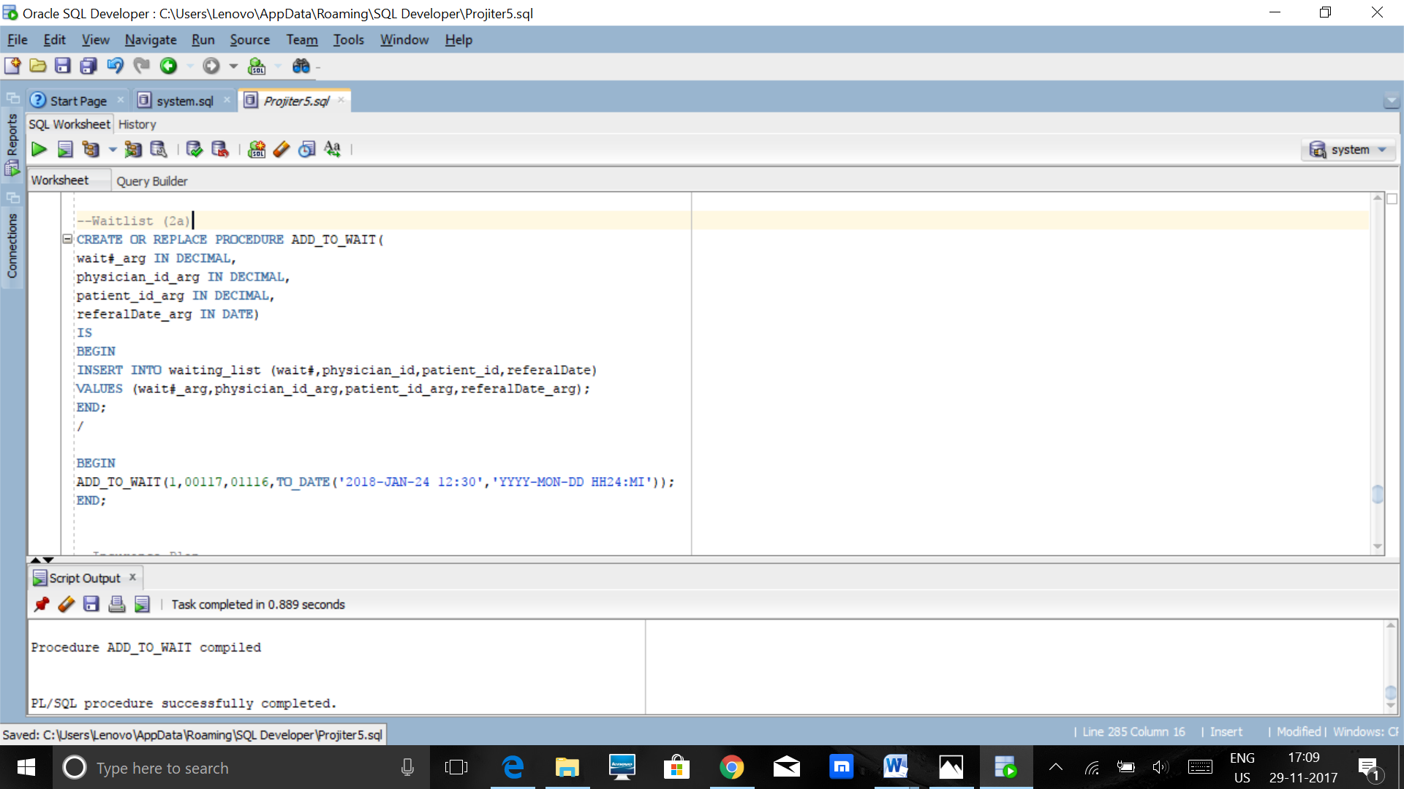

2b.

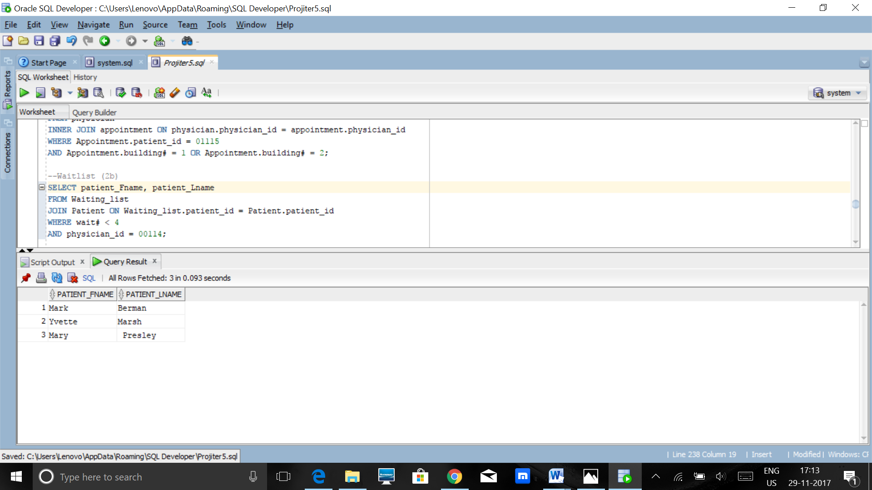

3a.

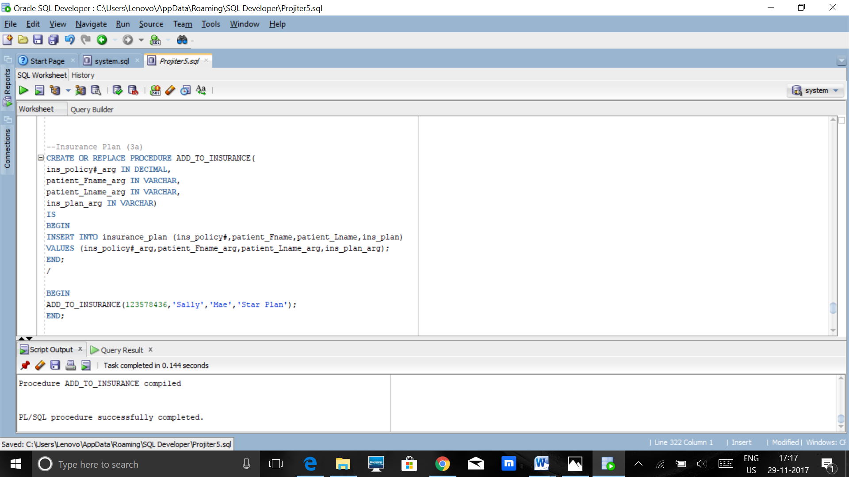

3b.  
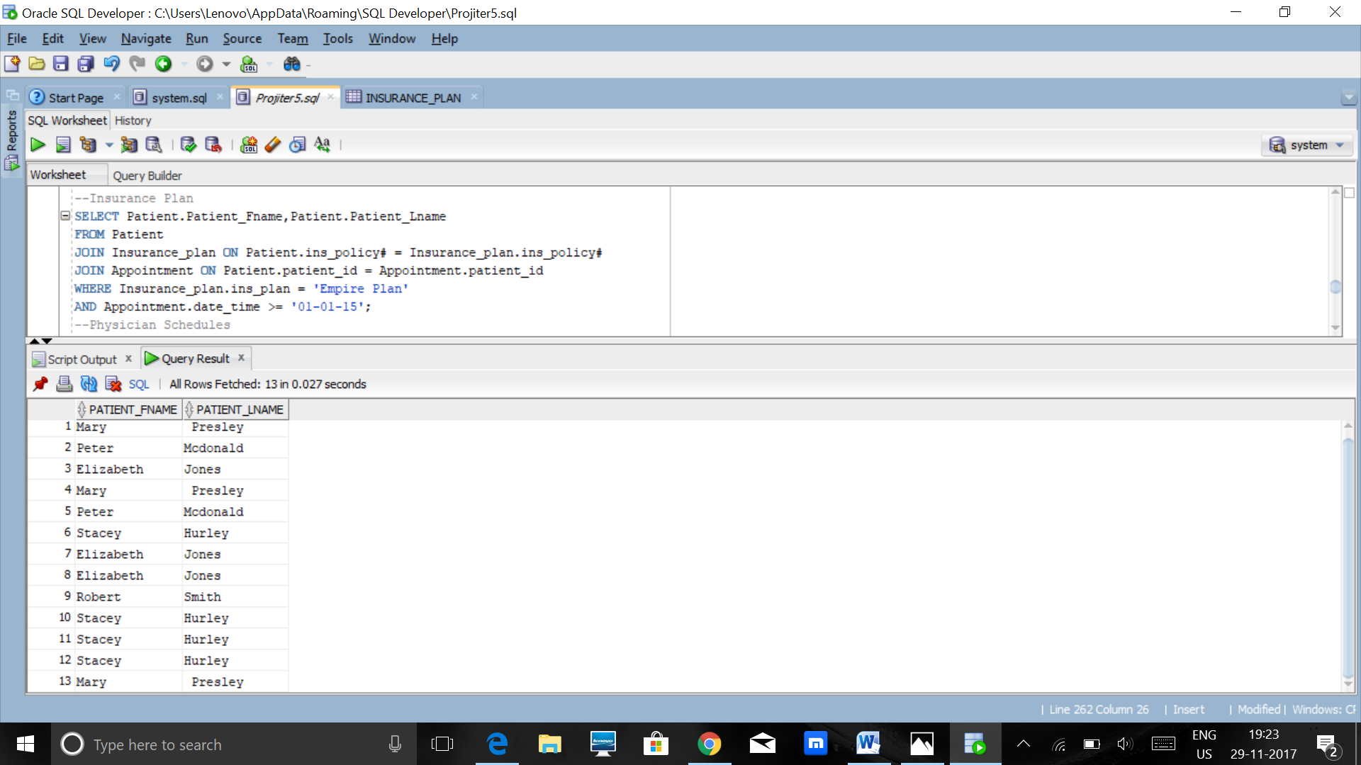

1. a.  
   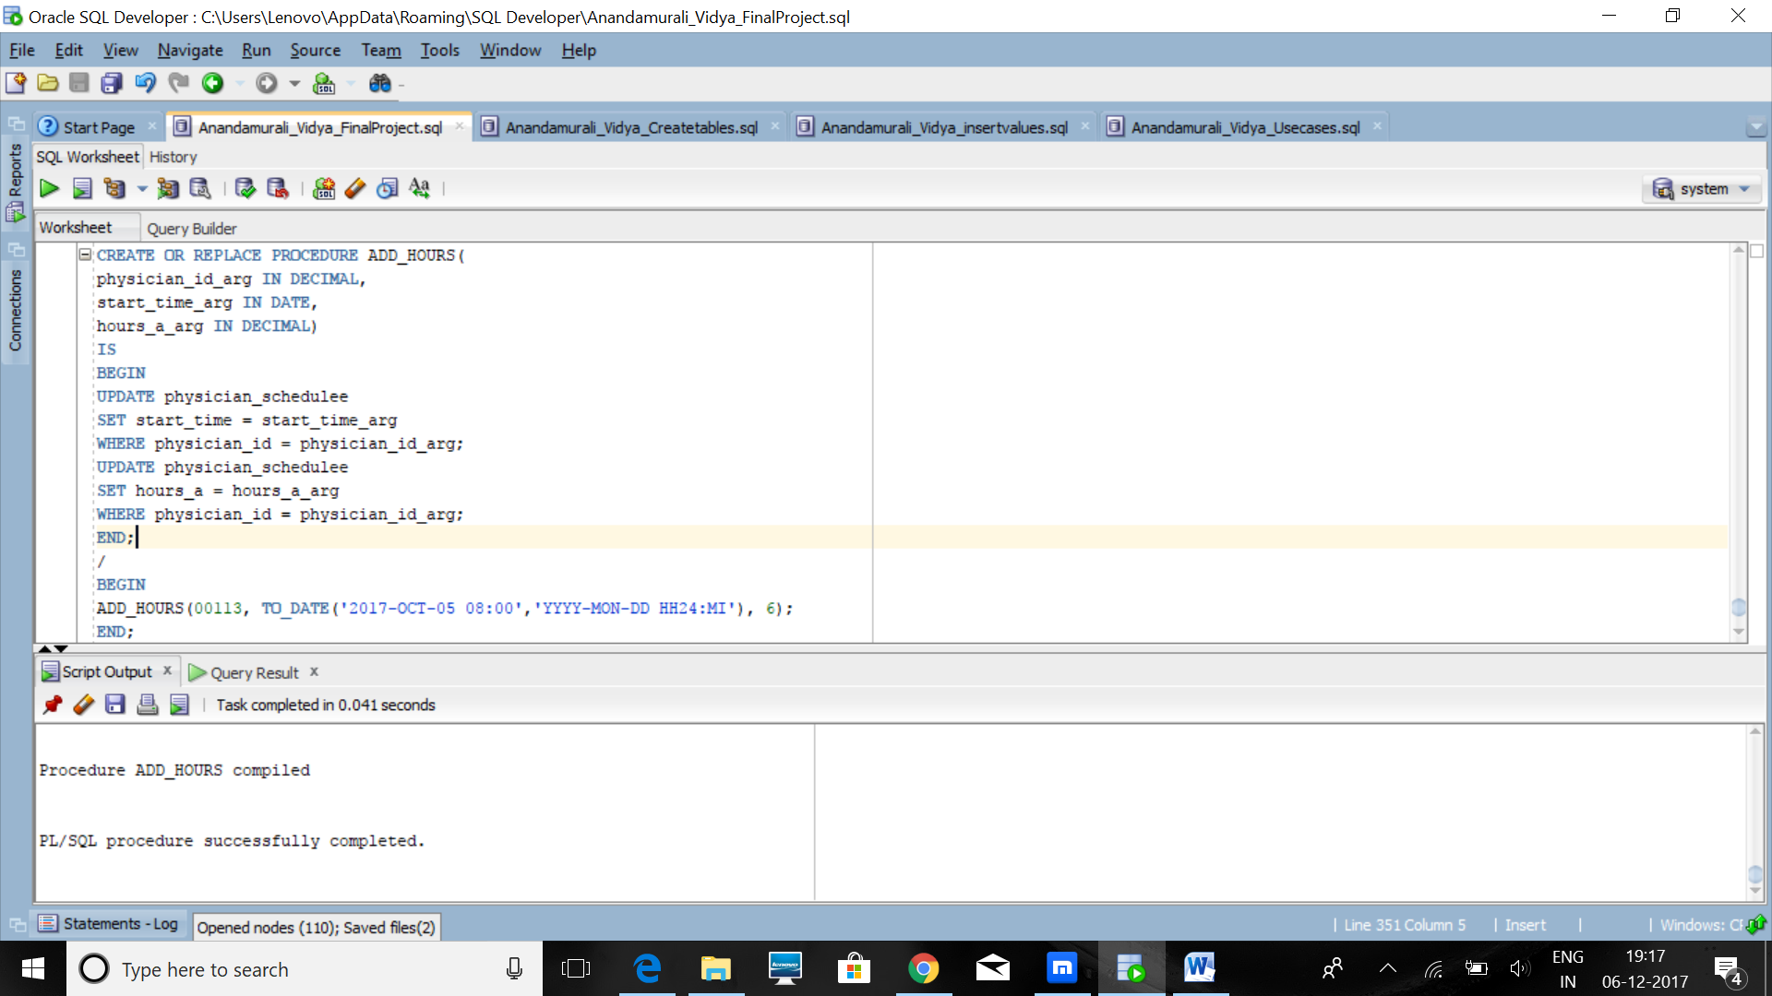  
   b.   
     
   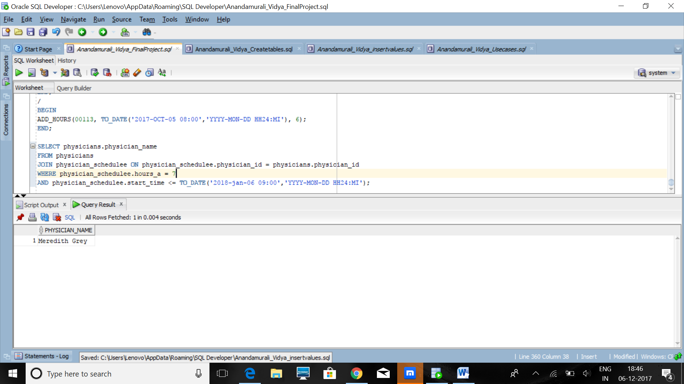
2. 5a – A particular assistant works with many doctors on a timely basis and their records have to be updated and modified with respect to the physician they are working for and hence a stored parameterized procedure can be used to update the data.  
     
   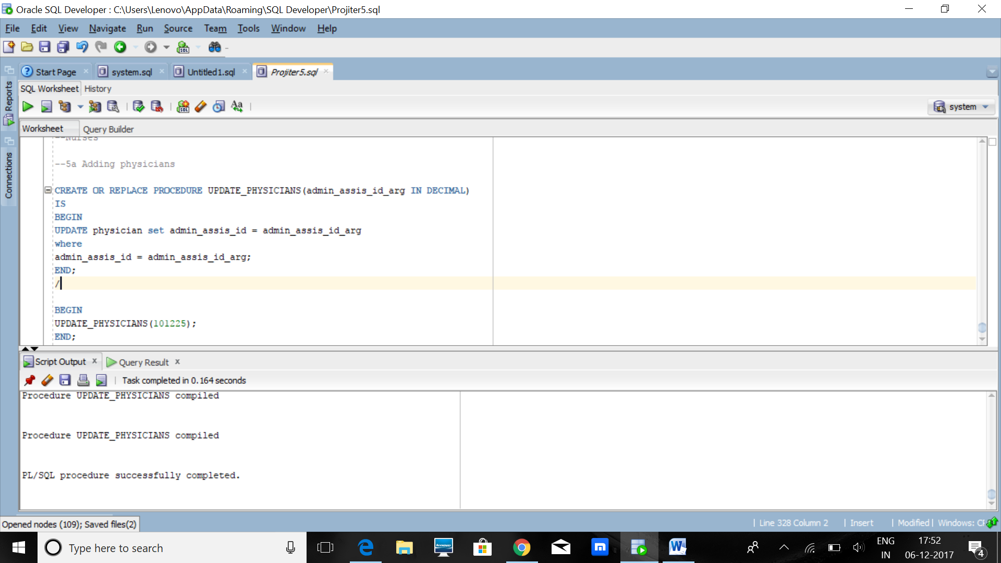

5b – Query the results of the number of doctors who are associated to a a particular appointment in the records.

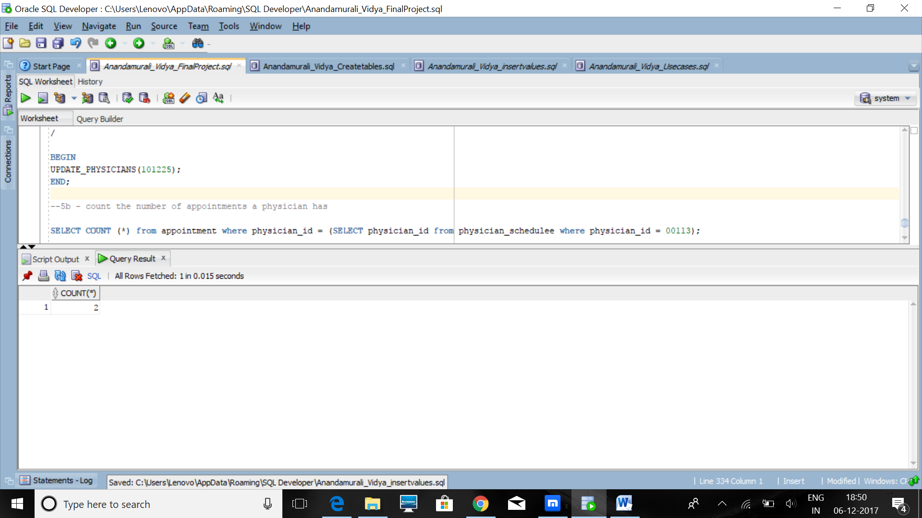

Indexing:  
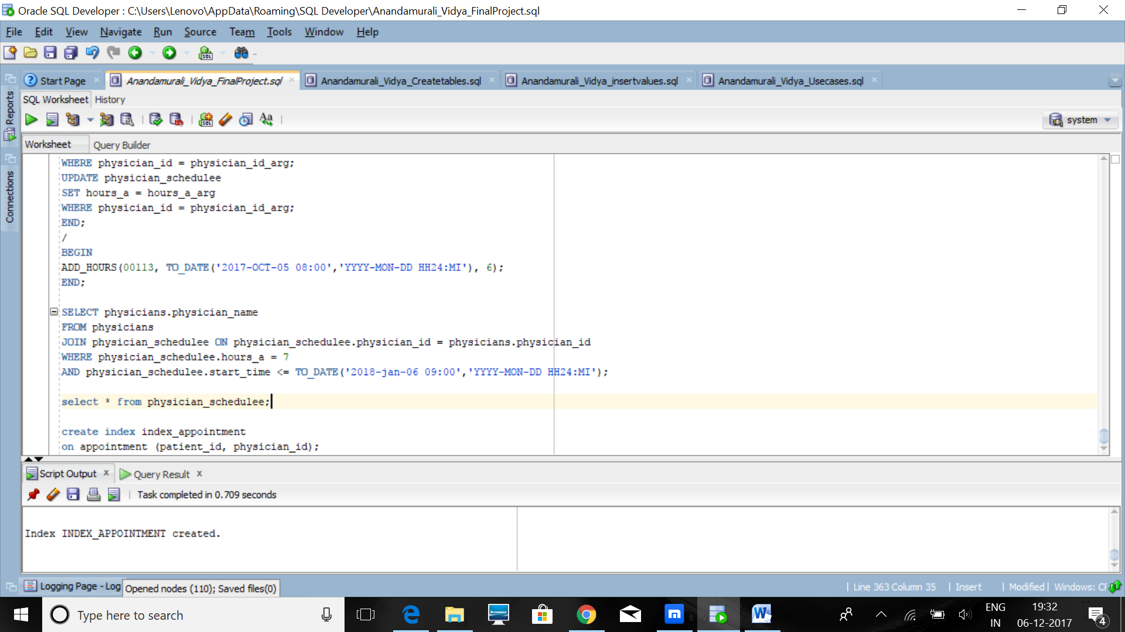

Appointment.patient_id : This is the foreign key for the appointment table referenced from the patient table. The index is non-unique because a patient can have many appointments.

Appointment.physician_id: This is the foreign key to the appointment table referenced from the physician table and the index is non- unique as a physician can have many appointments.

The above parameters are of immense importance to the appointment making in the hospital environment and hence these were chose for indexing here.