Input Audio Signal

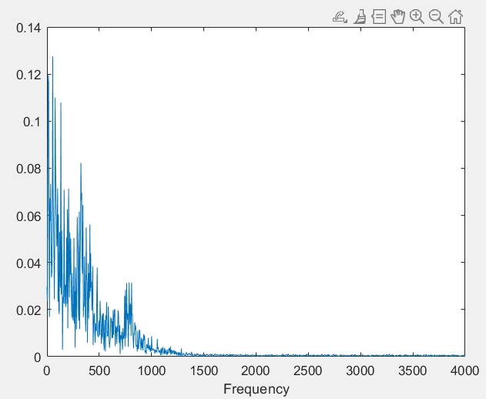

IIR Band rejected audio signal

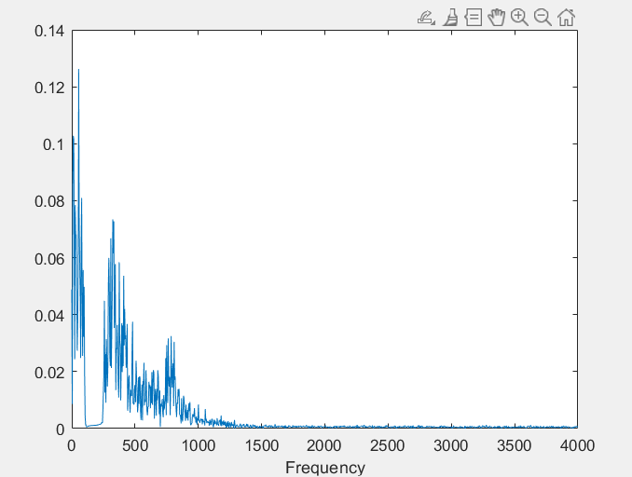

FIR Band rejected audio signal

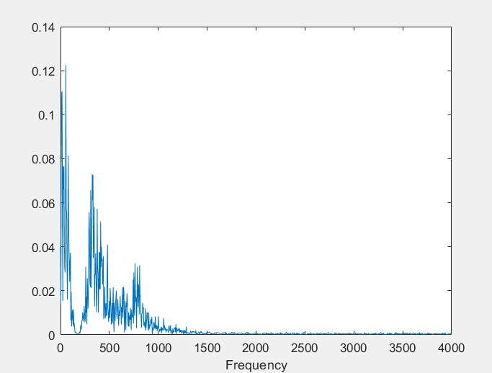

Amplitude Spectrum of IIR filtered signal

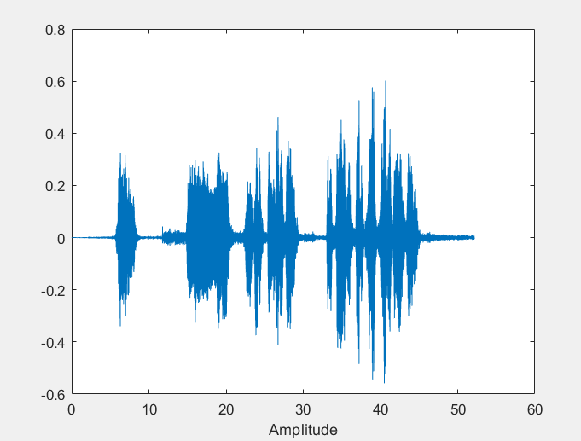

Amplitude Spectrum of FIR filtered signal

