**Analysis of Accident Locations on Indian Roads:**

**A Case Study of Delhi City**

*Team Name: Aditya Shankar Team: Aditya Vardhan, VidyaShankar K P*

*Institute Mentor: Dr Rajesh N, Professor, Dept of ECE, NMIT*

*Industry Mentor: Abhisheknandy*

**Introduction:**

Road accidents are a major concern in India, leading to loss of life, property damage, and economic repercussions. Delhi, the capital city of India, is one of the busiest urban centers in India, characterized by heavy traffic and diverse transportation modes. This report aims to analyze accident locations on Indian roads, with a specific focus on Delhi city. By understanding the spatial distribution of accidents, identifying high-risk areas, and exploring potential contributing factors, this analysis can help in devising targeted strategies for accident prevention and enhancing road safety.

**a) Spatial Analysis**: Accident locations were mapped on a reference map of Delhi city using a Geographic Information System (GIS). The distribution of accidents across different areas of the city was analyzed, identifying high-density zones and potential hotspots.

**b)Statistical Analysis:** Statistical techniques such as clustering analysis and hotspot analysis were applied to identify patterns and clusters of accidents. Factors such as road type, time of day, weather conditions, and vehicle types were considered for deeper analysis.

**c) Hotspot Identification:** Using hotspot analysis, several accident clusters were identified in specific regions of Delhi. These hotspots were characterized by a significantly higher frequency of accidents compared to surrounding areas. Such hotspots provide crucial information for targeted intervention and resource allocation for accident prevention measures.

**Spatial analysis results from QGIS:**

Mapping of fatal accident locations in Delhi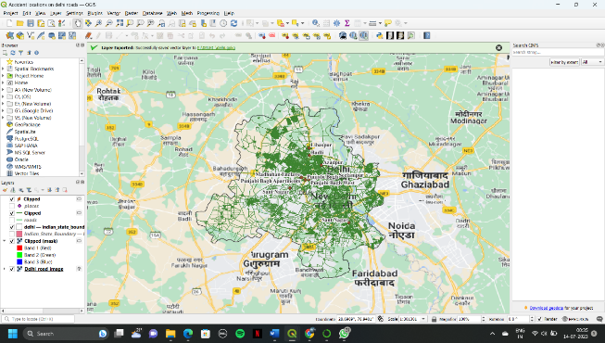 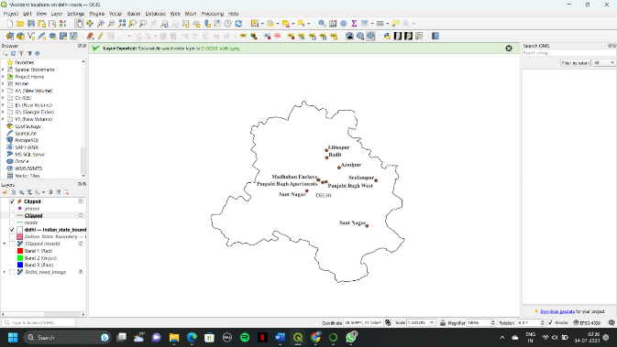

**Fig[1**] **Fig[2]**

The above two pictures shows the fatality rate in most accident prone areas in Delhi city.these are the major places that took more road accidents.

**Python Code For Statistical Ananlysis:**

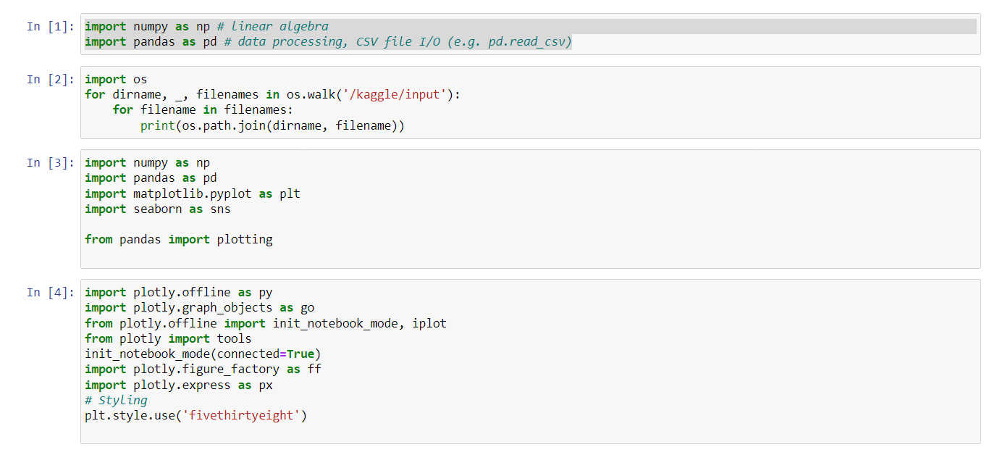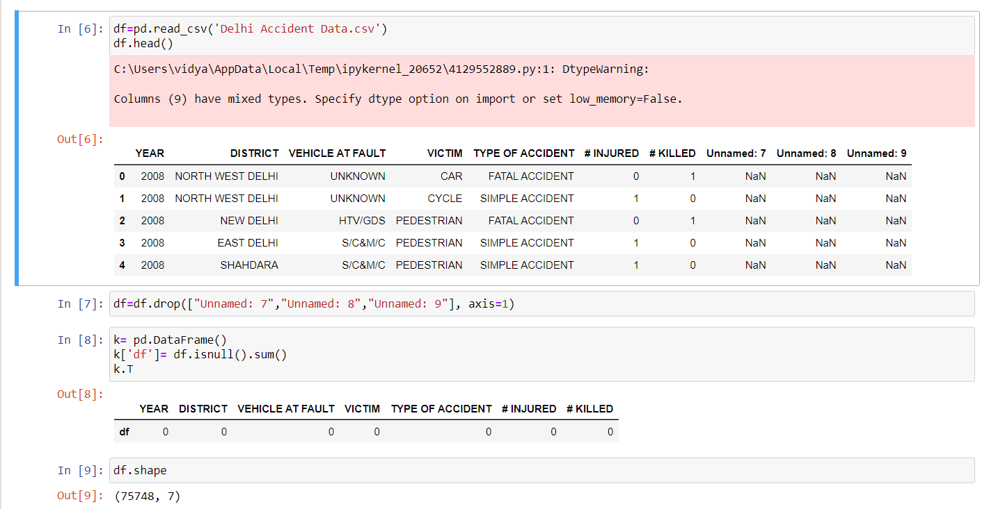

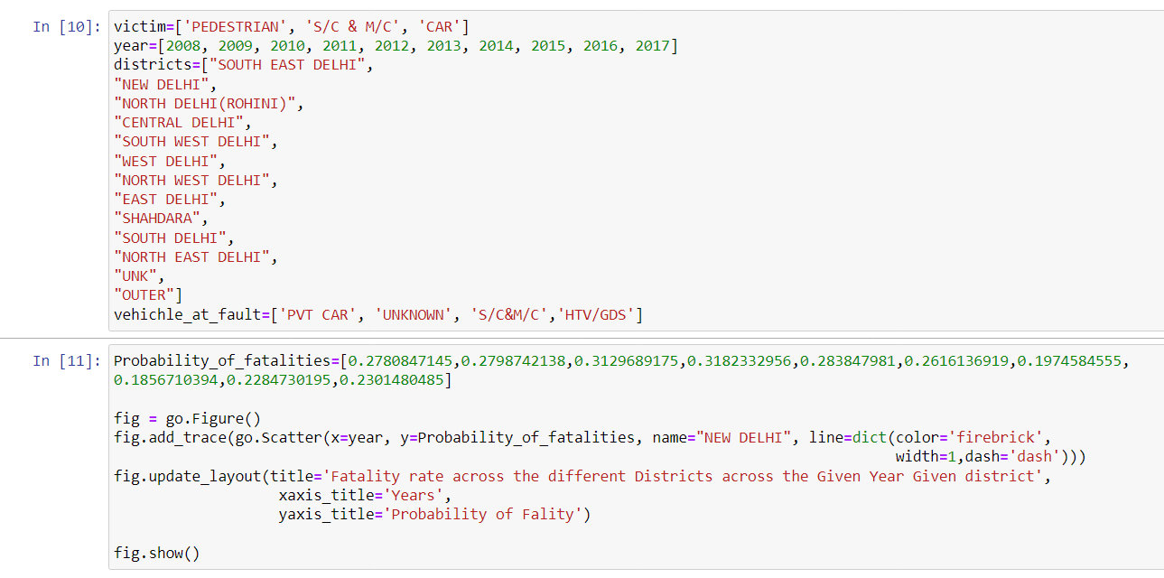

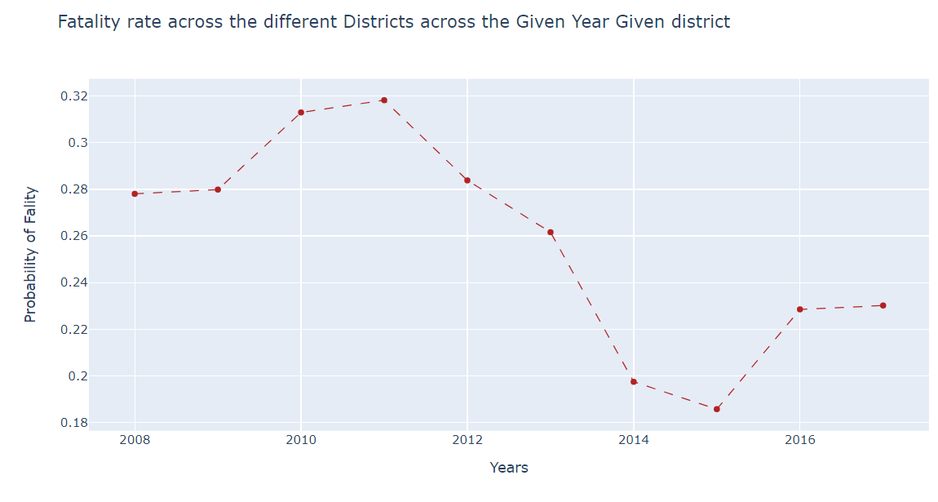

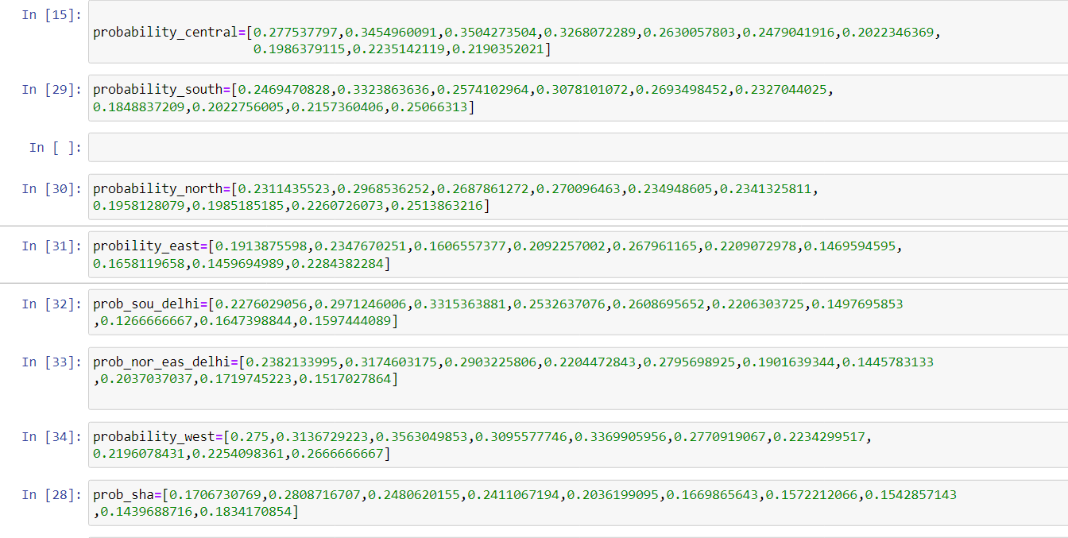

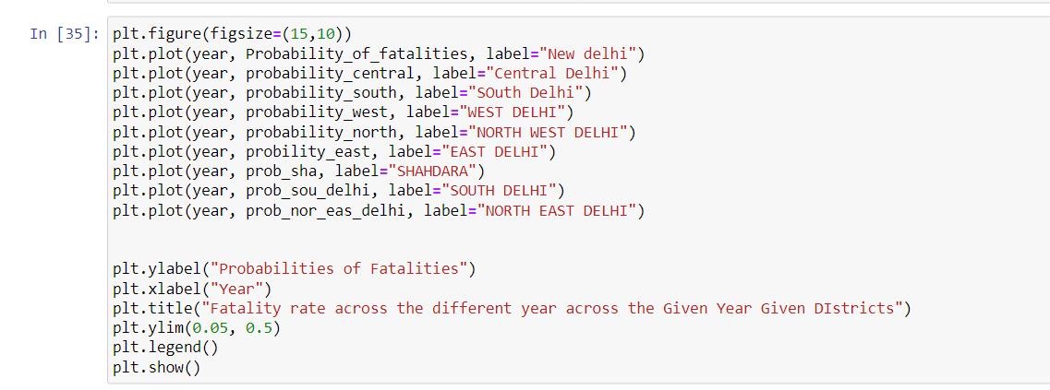

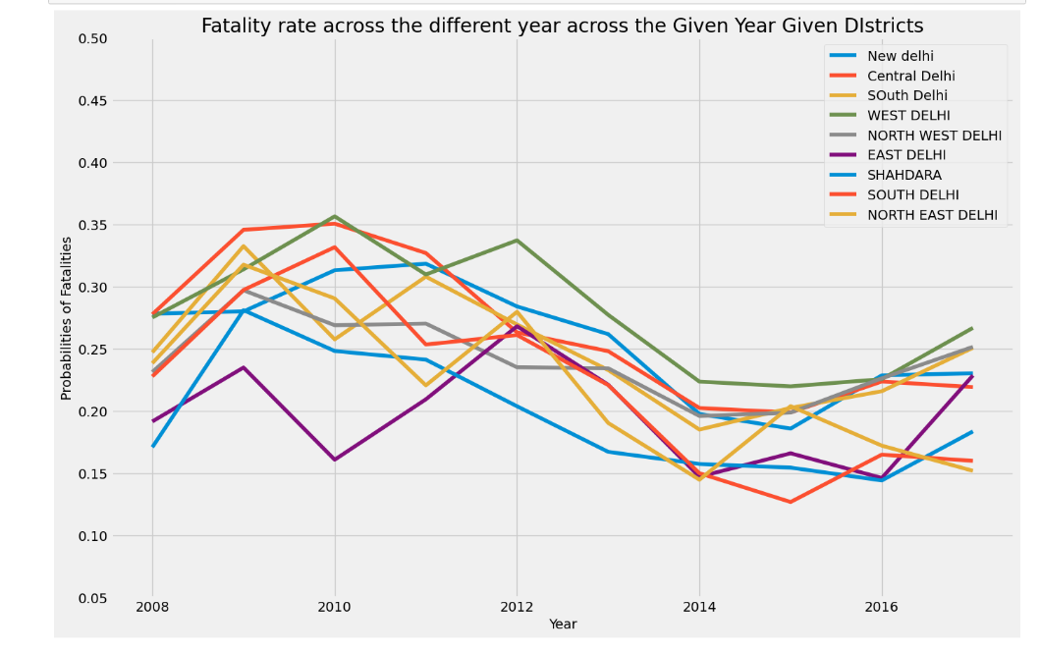

**Recommendations and Conclusion:**

**a) Enhanced Traffic Management:** The findings suggest the need for improved traffic management in high-density zones and accident hotspots. Measures such as traffic signal optimization, road signage improvements, and enhanced enforcement can help mitigate accident risks.

**b) Infrastructure Upgrades:** Investment in infrastructure upgrades, including wider roads, dedicated bicycle lanes, improved pedestrian infrastructure, and better street lighting, can enhance road safety and reduce accident rates.

**c) Public Awareness and Education:** Initiating public awareness campaigns and educational programs on road safety can help inculcate responsible driving habits and improve awareness among road users.

**d) Collaborative Efforts:** Collaboration between the traffic police department, city planners, and transportation authorities is crucial for effective accident prevention strategies. Regular data sharing, analysis, and joint decision-making can lead to more targeted and impactful interventions.

In conclusion, the analysis of accident locations on Indian roads, with Bengaluru city as a reference, provides valuable insights into spatial patterns and contributing factors. By understanding these patterns, policymakers can devise evidence-based strategies to enhance road safety and reduce the frequency and severity of accidents. Continued monitoring, analysis, and implementation of preventive measures are essential for achieving significant improvements in road safety across India.

**Github links**: <https://github.com/AdityaEC62/aditya.git>

<https://github.com/VidyashankarKP/kprepo.git>