**Vidyashree**

**1NT19IS185**

**Basic CRUD operations:-**

* **Create database**

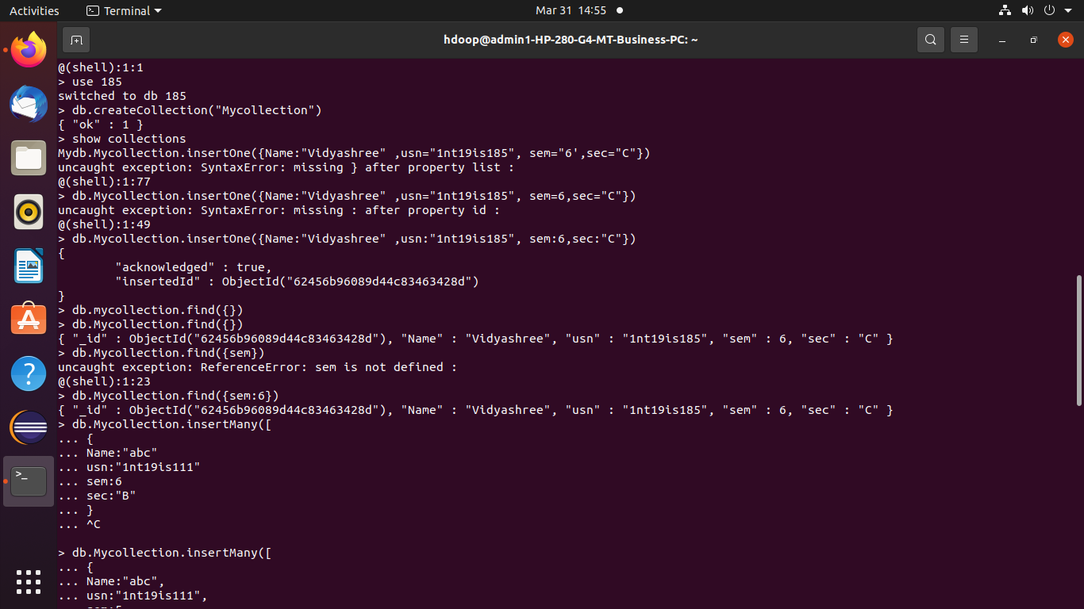use 185

* Show database

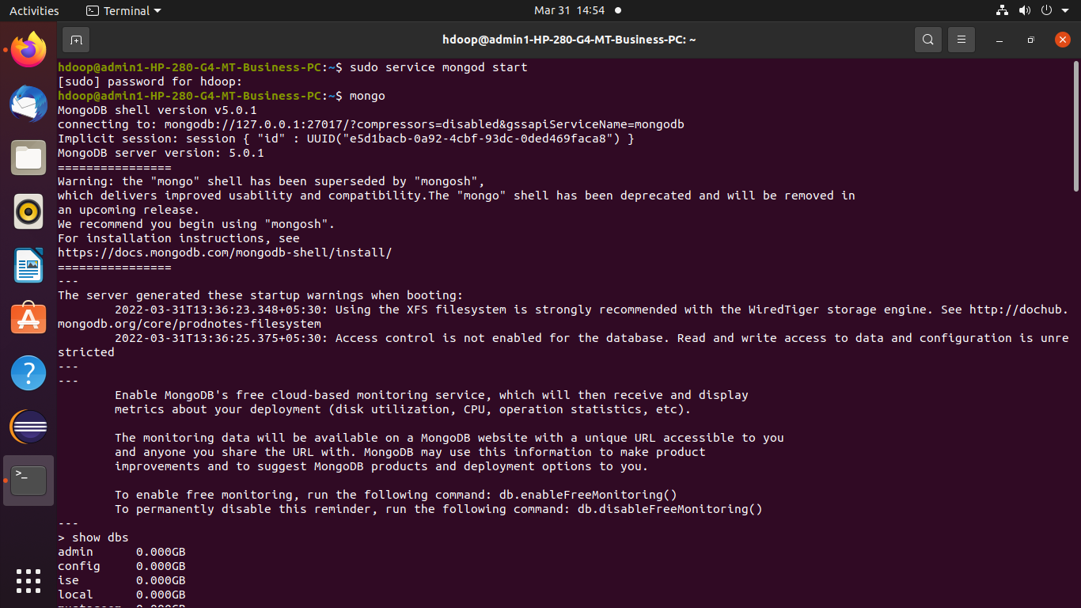show dbs

* **Create Collection:-**

db.createCollection(“MyCollection”)

* **Insertion Operation**

**insertOne():-**

db.Mycollection.insertOne({Name:"Vidyashree" ,usn:"1nt19is185", sem:6,sec:"C"})

{

"acknowledged" : true,

"insertedId" : ObjectId("62456b96089d44c83463428d")

}

db.Mycollection.find({})

{ "_id" : ObjectId("62456b96089d44c83463428d"), "Name" : "Vidyashree", "usn" : "1nt19is185", "sem" : 6, "sec" : "C" }

**insertMany():-**

db.Mycollection.insertMany([ { Name:"abc", usn:"1nt19is111", sem:5,sec:"B" } , { Name:"def", usn:"1nt19is222", sem:6,sec:"C" } ])

{

"acknowledged" : true,

"insertedIds" : [

ObjectId("62456ddc089d44c83463428e"),

ObjectId("62456ddc089d44c83463428f")

]

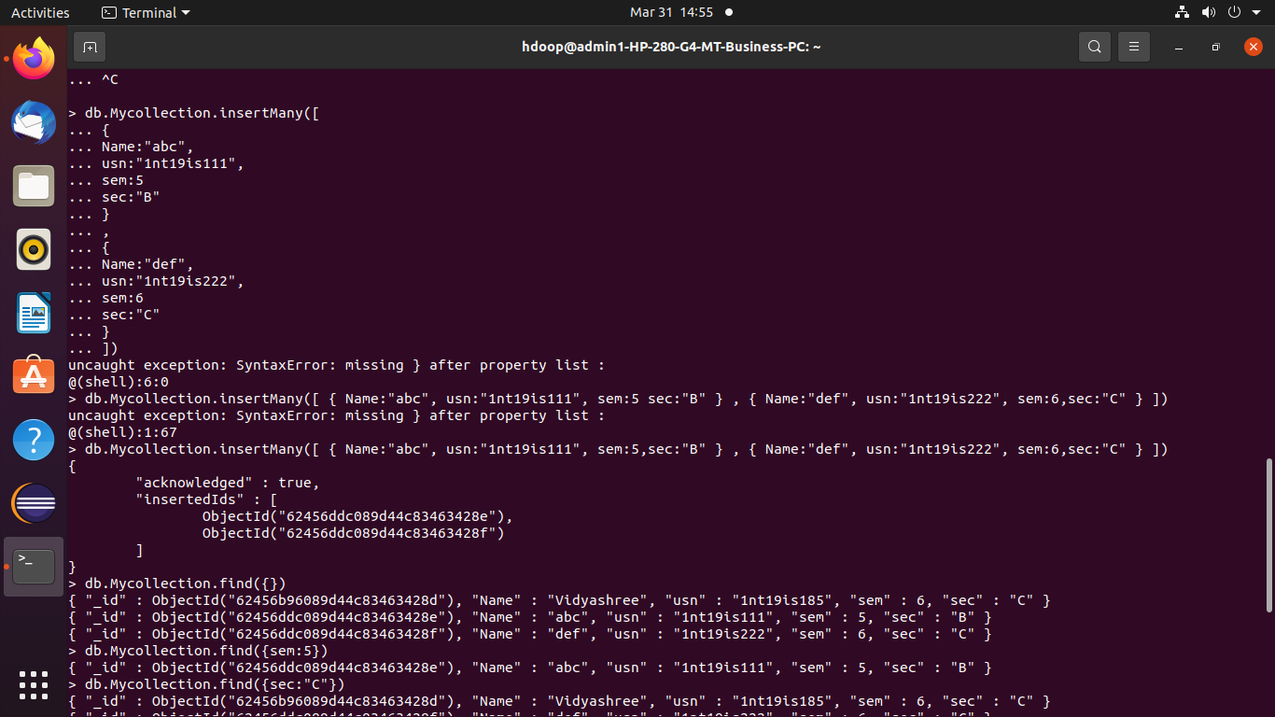}

db.Mycollection.find({})

{ "_id" : ObjectId("62456b96089d44c83463428d"), "Name" : "Vidyashree", "usn" : "1nt19is185", "sem" : 6, "sec" : "C" }

{ "_id" : ObjectId("62456ddc089d44c83463428e"), "Name" : "abc", "usn" : "1nt19is111", "sem" : 5, "sec" : "B" }

{ "_id" : ObjectId("62456ddc089d44c83463428f"), "Name" : "def", "usn" : "1nt19is222", "sem" : 6, "sec" : "C" }

> db.Mycollection.find({sem:5})

{ "_id" : ObjectId("62456ddc089d44c83463428e"), "Name" : "abc", "usn" : "1nt19is111", "sem" : 5, "sec" : "B" }

> db.Mycollection.find({sec:"C"})

{ "_id" : ObjectId("62456b96089d44c83463428d"), "Name" : "Vidyashree", "usn" : "1nt19is185", "sem" : 6, "sec" : "C" }

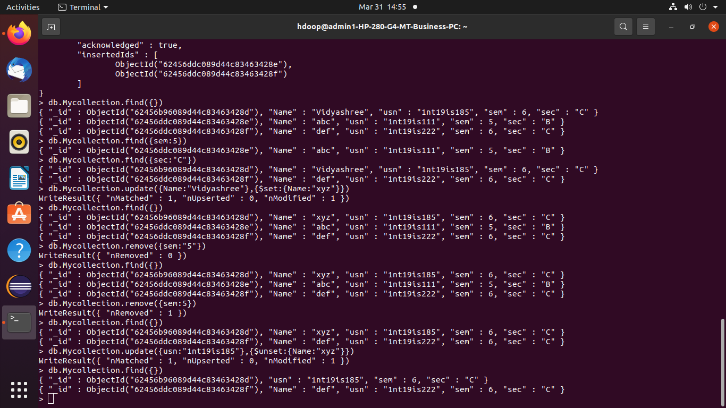{ "_id" : ObjectId("62456ddc089d44c83463428f"), "Name" : "def", "usn" : "1nt19is222", "sem" : 6, "sec" : "C" }



* **Update Operation**

db.Mycollection.update({Name:"Vidyashree"},{$set:{Name:"xyz"}})

WriteResult({ "nMatched" : 1, "nUpserted" : 0, "nModified" : 1 })

> db.Mycollection.find({})

{ "_id" : ObjectId("62456b96089d44c83463428d"), "Name" : "xyz", "usn" : "1nt19is185", "sem" : 6, "sec" : "C" }

{ "_id" : ObjectId("62456ddc089d44c83463428e"), "Name" : "abc", "usn" : "1nt19is111", "sem" : 5, "sec" : "B" }

{ "_id" : ObjectId("62456ddc089d44c83463428f"), "Name" : "def", "usn" : "1nt19is222", "sem" : 6, "sec" : "C" }

db.Mycollection.update({usn:"1nt19is185"},{$unset:{Name:"xyz"}})

WriteResult({ "nMatched" : 1, "nUpserted" : 0, "nModified" : 1 })

> db.Mycollection.find({})

{ "_id" : ObjectId("62456b96089d44c83463428d"), "usn" : "1nt19is185", "sem" : 6, "sec" : "C" }

{ "_id" : ObjectId("62456ddc089d44c83463428f"), "Name" : "def", "usn" : "1nt19is222", "sem" : 6, "sec" : "C" }

* **Remove Operation:-**

db.Mycollection.remove({sem:5})

WriteResult({ "nRemoved" : 1 })

> db.Mycollection.find({})

{ "_id" : ObjectId("62456b96089d44c83463428d"), "Name" : "xyz", "usn" : "1nt19is185", "sem" : 6, "sec" : "C" }

{ "_id" : ObjectId("62456ddc089d44c83463428f"), "Name" : "def", "usn" : "1nt19is222", "sem" : 6, "sec" : "C" }

