Vidyashree
1NT19IS185

1.Create a directory named by your name

hadoop fs -mkdir /Vidyashree-1nt19is185
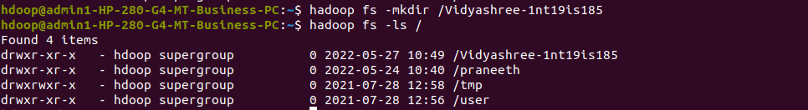
2.Add two empty file to it.

hdoop@admin1-HP-280-G4-MT-Business-PC:~$ hadoop fs -touchz /Vidyashree- 1nt19is185/e1.txt
hdoop@admin1-HP-280-G4-MT-Business-PC:~$ hadoop fs -touchz /Vidyashree-1nt19is185/e2.txt

3.List all files in the directory that you have created.

hdoop@admin1-HP-280-G4-MT-Business-PC:~$ hadoop fs -ls /Vidyashree-1nt19is185
Found 2 items
-rw-r--r-- 1 hdoop supergroup 0 2022-05-27 10:52 /Vidyashree-1nt19is185/e1.txt
-rw-r--r-- 1 hdoop supergroup 0 2022-05-27 10:52 /Vidyashree-1nt19is185/e2.txt

4.Create one more directory by your usn and put that inside the directory of your name

hadoop fs -mkdir /Vidyashree-1nt19is185/1nt19is185
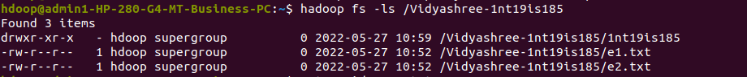

5.Create a file in your directory by your local system by the name_usn.txt and the add the contents as “Syntax to list ls command is hadoop fs -ls”

cat > Vidya185.txt

- Put the file usn_name.txt in your hdfs directory called usn
hadoop fs -touchz /Vidyashree-1nt19is185/1nt19is185/vidya_185.txt
- Put empty file of hdfs into the local file system
hadoop fs -copyToLocal /Vidyashree-1nt19is185/1nt19is185/vidya_185.txt
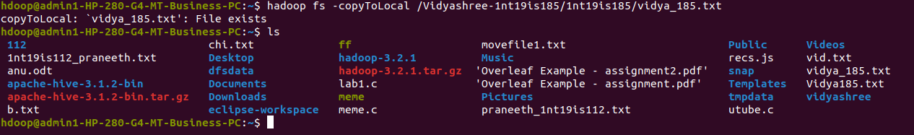
- Experiment with cp command:
hadoop fs -cp /Vidyashree-1nt19is185/e1.txt /Vidyashree-1nt19is185/1nt19is185
- Use my command to move files from local file system and hdfs file system
hadoop fs -ls /Vidyashree-1nt19is185/1nt19is185
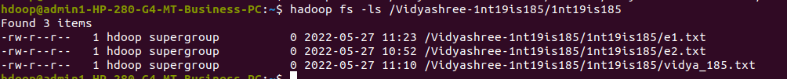
- Display the total size of all the files in name directory
hadoop fs -du /Vidyashree-1nt19is185/1nt19is185

