Aggregate Function:-

- Create Collection:-
db.createCollection("Collection185")

- Insert into Collection:-
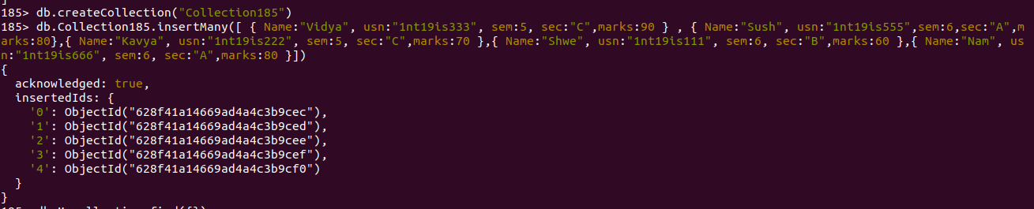
db.Collection185.insertMany([ { Name:"Vidya", usn:"1nt19is333", sem:5, sec:"C",marks:90 } , { Name:"Sush", usn:"1nt19is555",sem:6,sec:"A",marks:80},{ Name:"Kavya", usn:"1nt19is222", sem:5, sec:"C",marks:70 },{ Name:"Shwe", usn:"1nt19is111", sem:6, sec:"B",marks:60 },{ Name:"Nam", usn:"1nt19is666", sem:6, sec:"A",marks:80 }])

- Display:-

db.Collection185.find({})
[
{
_id: ObjectId("628f41a14669ad4a4c3b9cec"),
Name: 'Vidya',
usn: '1nt19is333',
sem: 5,
sec: 'C',
marks: 90
},
{
_id: ObjectId("628f41a14669ad4a4c3b9ced"),
Name: 'Sush',
usn: '1nt19is555',
sem: 6,
sec: 'A',
marks: 80
},
{
_id: ObjectId("628f41a14669ad4a4c3b9cee"),
Name: 'Kavya',
usn: '1nt19is222',
sem: 5,
sec: 'C',
marks: 70
},
{
_id: ObjectId("628f41a14669ad4a4c3b9cef"),
Name: 'Shwe',
usn: '1nt19is111',
sem: 6,
sec: 'B',
marks: 60
},
{
_id: ObjectId("628f41a14669ad4a4c3b9cf0"),
Name: 'Nam',
usn: '1nt19is666',
sem: 6,
sec: 'A',
marks: 80
}

]
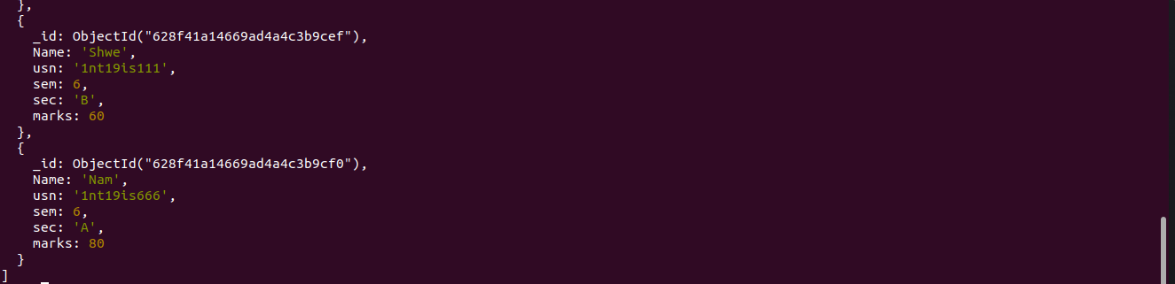

- $match
db.Collection185.aggregate([{$match:{marks:80}},{$count:"Total number of students who scored 80"}])
[ { 'Total number of students who scored 80': 2 } ]

- $sort

db.Collection185.aggregate([{$sort:{‘marks’:1}}])
[
{
_id: ObjectId("628f41a14669ad4a4c3b9cef"),
Name: 'Shwe',
usn: '1nt19is111',
sem: 6,
sec: 'B',
marks: 60
},
{
_id: ObjectId("628f41a14669ad4a4c3b9cee"),
Name: 'Kavya',
usn: '1nt19is222',
sem: 5,
sec: 'C',
marks: 70
},
{
_id: ObjectId("628f41a14669ad4a4c3b9ced"),
Name: 'Sush',
usn: '1nt19is555',
sem: 6,
sec: 'A',
marks: 80
},
{
_id: ObjectId("628f41a14669ad4a4c3b9cf0"),
Name: 'Nam',
usn: '1nt19is666',
sem: 6,
sec: 'A',
marks: 80
},
{
_id: ObjectId("628f41a14669ad4a4c3b9cec"),
Name: 'Vidya',
usn: '1nt19is333',
sem: 5,
sec: 'C',
marks: 90
}
]

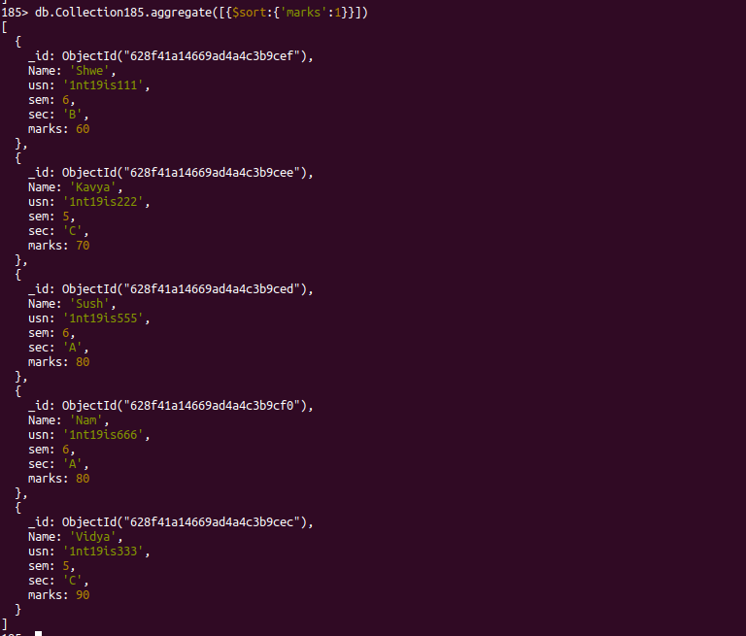

- $group

db.Collection185.aggregate([{$group:{_id:"$marks",total_student:{$sum:1}}}])
[
{ _id: 90, total_student: 1 },
{ _id: 80, total_student: 2 },
{ _id: 70, total_student: 1 },
{ _id: 60, total_student: 1 }
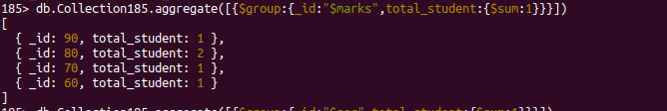
]

185> db.Collection185.aggregate([{$group:{_id:"$sec",total_student:{$sum:1},avg_marks:{$avg:"$marks"}}}])
[
{ _id: 'C', total_student: 2, avg_marks: 80 },
{ _id: 'A', total_student: 2, avg_marks: 80 },
{ _id: 'B', total_student: 1, avg_marks: 60 }
]



- $limit

db.Collection185.aggregate([{$match:{sec:"A"}},{'$sort':{'marks':-1}},{$limit:1}])
{ "_id" : ObjectId("628f70ffa2c7aa5af361d192"), "Name" : "Sush", "usn" : "1nt19is555", "sem" : 6, "sec" : "A", "marks" : 80 }

Aggregation Pipeline:-

db.Collection185.aggregate([{$match:{marks:90}},{$group:{_id:"$sec",total:{$sum:"$sec"}}}])
{ "_id" : "C", "total" : 0 }

Map Reduce:-

var map=function(){emit(this.sec,this.marks)};
> var reduce=function(sec,marks){return Array.sum(marks);}
> db.Collection185.mapReduce(map,reduce,{out:"resultCollection"});
{ "result" : "resultCollection", "ok" : 1 }
> db.resultCollection.find()
{ "_id" : "B", "value" : 60 }
{ "_id" : "A", "value" : 160 }
{ "_id" : "C", "value" : 160 }

