## CHAPTER 1

## INTRODUCTION

The domain "Banking Management System" keeps the day by day tally record as a complete banking. It can keep the information of Account type, Account opening form, Deposit withdrawal and Searching the transaction, Transaction report, Individual account opening form, Group Account. The exiting part of this project is; it displays Transaction reports, Statistical summary of Account type and Interest Information.

A bank is a commercial or state institution that provides financial services, including issuing money in form of coins, bank notes or debit cards, receiving deposits of money, lending money and processing transactions. A commercial bank accepts deposits from customers in turn makes loans based on those deposits. Some banks (called banks of issue) issue bank notes as legal tender. Many banks offer ancillary financial services to make additional profit; for example: selling insurance products, investment products or stock broking. Currently in most jurisdictions commercial banks or regulated and required permission to operate. operational authority is granted by bank regulatory authorities and provides right to conduct the most fundamental banking services such as accepting deposits and making loans. A commercial bank is usually defined as an institution that provides selected banking services without meeting the legal definitions of bank. Banks have a long history, and have influenced economy and politics for centuries. In history, the primary purpose of a bank was to provide liquidity to trading companies. Banks advanced funds to allow business to purchase inventory, and collected those funds back with interest when the goods are sold. For centuries, the banking industry only dealt with business not customers. Commercial lending today is a very intensive activity, with banks carefully analyzing the financial condition of its business clients to determine the level of risk in each loan transaction

In today’s world, the way of functioning and managing the system has been totally changed. There is a sudden and abrupt changes in the structure, maintaining and modification, handling, leveling inside every system. Without managing system through computer application and programming, the developments of infrastructure are unfinished. There are many errors and drawbacks without use of computer programing and applications. we know that, “necessity in the mother of invention”, so in today’s challenging world every system is developed and launched by the use of computer software and programming

**CHAPTER 2**

# SYSTEM ANALYSIS

System analysis is a process of gathering and interpreting facts, diagnosing problems and the information to recommend improvements on the system. It is a problem solving activity that are quires intensive communication between the system users and system developers. System analysis or study is an important phase of any system development process. The system is studied to the minu test detail and analyzed. The system analyst plays the role of the interrogator and dwell deep into the working of the present system. The system is viewed as a whole and the input to the system are identified. The outputs from the organizations are traced to the various processes. System analysis is concerned with becoming aware of the problem, identifying the relevant and decisional variables, analyzing and synthesizing the various factors and determining an optimal or at least a satisfactory solution or program of action. A detailed study of the process must be made by various techniques like interviews, questionnaires etc. The data collected by these sources must be scrutinized to arrive.

## 2.1 Literature survey

Bank management system development using PHP program has lots of codes, using internet in gathering information partially contributed to the success of this project. Due to the fact that PHP is an open source program development of banking management system was not too difficult. However, thanks to the cyber world (internet) that makes it possible to study and make comparison in needs of some code function.

My initial research on banking management is done with reference to” banking management and bank policy in India: A critical review” by MadhavGadgil, S Narendra Prasad &Rauf Ali.

## 2.2 Proposed System

To allow only authorized user to access various function and processed available in the system. Locate any a/c wanted by the user. Reduced electrical work as most of the work done by the computer.Provide greater speed and reduced time consumption.When the data is entered it will check for its validity.Appropriate message are provided as when needed so that the user will not be in a maize of instant.The existing system is highly efficient to offer best services to the customers.

**2.2.1 Scope of the project**

The software product “Banking management system” will be an application that will be used for maintaining the records in an organized manner and to replace old paper work system. This project aims at automating the banking management for in order to conserve record. Updates and modifications will be easily achievable and all the calculations and accounting work would be accurance.

### 2.2.2 Aim of the project

The aim of the system is to tackle these problems in an effective and optimal manner by:

* Centralizing the database and thus providing consistent data to all the employees in the banking management.
* Make the system more user friendly by providing an intensive user interface.

Easy access through queries and reports.

* Restricted data access to employees thus providing additional security to data.

**CHAPTER 3**

**REQUIREMENT SPECIFICATIONS**

## 3.1 System requirements

### 3.1.1 Software configuration

|  |  |
| --- | --- |
| NAME OF THE COMPONENT | SPECIFICATION |
| Operating system | Windows 98,windows XP,windows7,linux  (anyone) |
| Language | HTML,PHP |
| Database | MySQL server |
| Browser | Any of Mozilla, opera, chrome etc. |
| Server | Tomcat7,Apache |

### 3.1.2 Hardware configuration

|  |  |
| --- | --- |
| NAME OF THE COMPONENT | SPECIFICATION |
| Processor | Pentium III 630MHZ or more |
| RAM | 128Mb or more |
| Hard disc | 20Gb |
| Monitor | 15” color monitor or advance |
| Mouse | Any mouse |
| Keyboard | Any keyboard |

3.2**DEVELOPMENT ENVIRONMENT Design Features Open Source**

PHP is freely available for use. The community of open source PHP developers provides technical support and is constantly improving updating the core PHP functionalities. PHP is available at free of cost under PHP General Public License and most of its associative required software's like MySQL, Text Editors and Apache Server are also freely available, so it proves very cost effective for the developers.

**Cross-Platform**

PHP provides high compatibility with leading operating systems and web servers such as thereby enabling it to be easily deployed across several different platforms. PHP scripts can run across operating systems such as Linux, Windows, Solaris, Open BSD, Mac OSX etc.

and also provide support for all major web servers such as Apache, IIS, iPlanet etc.

**Power**

Several web tasks can now be easily perform using PHP. For example now we can develop from small websites to giant business and organizational websites, informative forums, chatting platforms, CRM solutions, e-commerce shopping carts, community websites, e-business, shopping carts and gigantic database driven sites.

**User Friendly**

Designed in a user friendly manner, PHP gives more flexibility than C, C++ and ASP and overall helps in increasing traffic to the site.

## Quick

PHP is designed to work well with the web, and so things like accessing the GET and POST and working with HTML and URLs are built-ins in the PHP language. This makes it really concise and straightforward to make a website.

**Extensions**

Being an open source language, a large number of libraries and extensions, to extend its core functionalities, are available for download. The source code of PHP can be modified to include custom created extensions and components thereby increasing its extensibility.

**Easy Deployment**

There are many hosting companies that will, for a few dollars a month, give you a server running PHP so you can make a website really easily.

**Automatically Refreshes**

Nowadays developing dynamic websites are in the huge demand due to its specific characteristics like it automatically refreshes and does not need to make much changes manually.

**Community Support**

A huge advantage that PHP offers is its community. If you are looking for a particular script, chances are another user has already created something similar.Check within the PHP community for availability. Likewise, if you have created a function that others might enjoy, be sure to post the code for others.

## Other Tools

If you need to access other web based tools like Google maps (which is always advisable for a business website), or any other, PHP makes it easy to access.

**Talent Availability**

You can hire PHP programmers more easily than any other language programmers since so many people know the language.

**Apache Web server**

Often referred to as simply Apache, a public-domain open source Web server developed by a loosely-knit group of programmers. The first version of Apache, based on the NCSA http Web server, was developed in 1995.

Core development of the Apache Web server is performed by a group of about 20 volunteer programmers, called the Apache Group. However, because the source code is freely available, anyone can adapt the server for specific needs, and there is a large public library of Apache add-ons. In many respects, development of Apache is similar to development of the Linux operating system.

The original version of Apache was written for UNIX, but there are now versions that run under OS/2, Windows and other platforms. The name is a tribute to the Native American Apache Indian tribe, a tribe well known for its endurance and skill in warfare. A common misunderstanding is that it was called Apache because it was developed from existing NCSA code plus various patches, hence the name a patchy server, or Apache server.

Apache consistently rates as the world’s most popular Web server according to analyst surveys. Apache has attracted so much interest because it is full-featured, reliable, and free.

Originally developed for UNIX™ operating systems, Apache has been updated to run on Windows, OS/2, and other platforms. One aspect of Apache that some site administrators find confusing — especially those unfamiliar with UNIX-style software — is its configuration scheme.

Instead of using a point-and-click graphic user interface (GUI) or Windows Registry keys as most other modern software packages, Apache generally relies on simple text files for its configuration settings.

## INTRODUCTION TO MYSQL:

MySQL is a powerful database. It’s very good and free of change. Many developers in the world selected MySQL and php for developing their website.

The MySQL database has become the world’s most popular open source database because of its consistent fast performance, high reliability and easy of use. It’s used in more than 6 million installations ranging from large corporations to specialized embedded applications on every continent in the world.

Not only is MySQL the world’s most popular open source database, it’s also become the database of choice for a new generation of applications built on the LAMP stack(Linux, Apache, MySQL, php / Perl / python.) MySQL runs on more than 20 platforms including Linux, Window, OS/X, HP-UX, AIX, Netware, giving you the kind of flexibility that puts you in control.

Whether you’re new to database technology or an experienced developer or DBA, MySQL offers a comprehensive range of certified software, support, training and consulting to make you successful .MYSQL is a free, widely used SQL engine. It can be used as a fast database as well as a rock-solid DBMS using modular engine architecture.

### MYSQL Language :

DDL (Data Definition Language) refers to the CREATE, ALTER and DROP statements.DDL allows adding / modifying / deleting the logical structures which contain the data or which **a**llow users to access / maintains the data (databases, tables, keys, views...). DDL is about "metadata".

DCL is used to grant / revoke permissions on databases and their contents. DCL is simple, but MYSQL's permissions are rather complex. DCL is about security.

**MySQL Homepage:**

### 1. Scalability and Flexibility

The MySQL database server provides the ultimate in scalability, sporting the capacity to handle deeply embedded applications with a footprint of only 1MB to running massive data warehouses holding terabytes of information.

### 2. High Performance

A unique storage-engine architecture allows database professional to configure the MySQL database server specifically for particular applications, with the end result being amazing performance results.

### 3. High Availability

Rock-solid reliability and constant availability are hallmarks of MySQL, with customers relying on MySQL to guarantee around-the-clock uptime.

### 4. Robust Transactional Support

MySQL offers one of the most powerful transactional database engines on the market. Features include complete ACID (atomic, consistent, isolated, durable) transaction support, unlimited row-level locking, distributed transaction capability, and multi-version transaction support where readers never block writers and vice-versa.

### 5. Web and Data Warehouse Strengths

MySQL is the de-facto standard for high-traffic website because of its high-performance query engine, tremendously fast data inserts capability, and strong support for specialized web functions like fast full text searches.

### 6. Strong Data Protection

Because guarding the data assets of corporations is the number one job of database professionals, MySQL offers exceptional security features that ensure absolute data protection.

### 7. Comprehensive Application Development

One of the reasons MySQL is the world’s most popular open source database is that it provides comprehensive support for every application development need.

### 8. Management Ease

This rule holds true whether the platform is Microsoft Windows, Linux, or UNIX. Once installed, Self-management features like automatic space expansion, auto-restart, and dynamic configuration changes take much of the burden off already overworked database administrators.

**XAMPP**

It is a free and open source cross platform web server solution stack package developed by Apache . It is simple , lightweight Apache distribution that makes it extremely easy for developers to create a local web server for testing and deployment purposes. XAMPP is also cross-platform , which means it works equally well on Linux , Mac and windows . Since most actual web server deployments use the same components as XAMPP , it makes transitioning from a local test server to a live server extremely easy as well.

**XAMPP CONTROL PANEL**

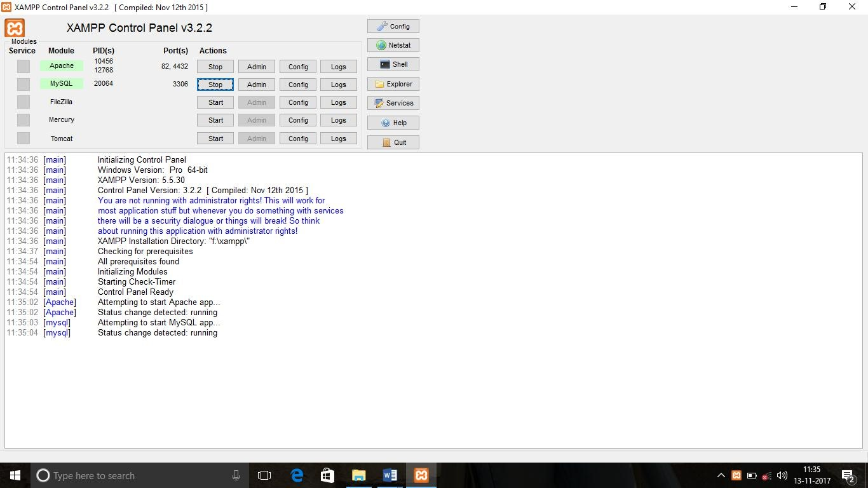

**CHAPTER 4**

## SYSTEM DESIGN

### 4.1 ER DIAGRAM

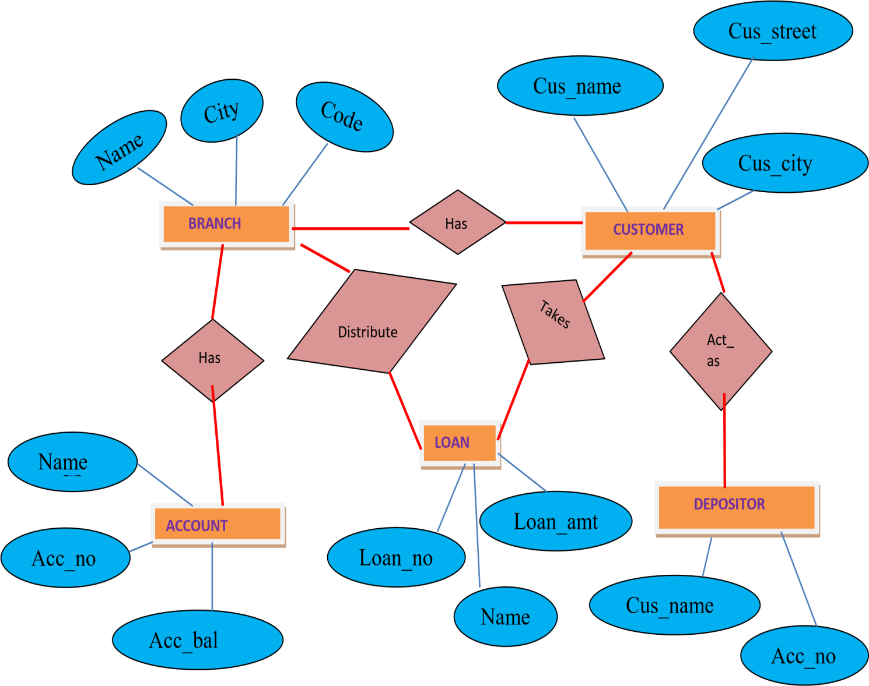

### 4.2 SCHEMA DIAGRAM

#### Branch

|  |  |  |
| --- | --- | --- |
| Name | City | Code |

**Customer**

|  |  |  |  |  |
| --- | --- | --- | --- | --- |
| Cus_id | Cus_Name | Cus_Street | Cus_City | Cus_Occupation |

**Account**

|  |  |  |
| --- | --- | --- |
| Acc_no | Name | Acc_bal |

**Loan**

|  |  |  |  |
| --- | --- | --- | --- |
| Loan_no | Name | Loan_amt | Purpose |

**Depositor**

|  |  |
| --- | --- |
| Cus_id | Acc_no |

|  |
| --- |
|  |

**CHAPTER 5**

## SYSTEM IMPLEMENTATION

**5.1 MODULE DESCRIPTION**

**5.1.1 INPUT DESIGN:**

Input design is the method by which valid data are accepted from the user. The valid data turn is stored as operational data in the database. Incorrect input data are the most common cause of errors in the data processing. The input design is carried out in such a way that the input screens are user friendly. The goals of designing input design are to make input data entry as easy and error free. Input screen takes care to filter the valid data from being becoming an operational data at data entry phase.

Input design is the part of the overall system design that careful attention and is the most expensive phase. It is the point of most contact for the users with the system and so it is prone to errors.

**5.1.2. OUTPUT DESIGN:**

The output design defines the output required and the format in which it is to be produced. Care must be given to present the right information.

The output is the most important and direct source of information to the user. Efficient, output design should improve the systems relationship with the user and helps in decision making. A major form of output is a hard copy from the printer. Printouts should be designed around the output requirement to the user. The standard that is maintained for output design is clear. Output provides a permanent copy of the results for the later consultation.

* **Create**, create table statement is used to create table to store data. Integrity constraints like primary key, foreign key, unique key can be defined while creating the table.
* **Insertion**, insertion is used to insert the table or row to the table. We insert value from front end by making use HTTP the value inserted from to front end will be going to store in back end database in XAMPP Server.
* **Update,** update will help to edit the tables in the database. In this project we have given update option for all table to update the attributes values.
* **Delete,** delete will help us to delete a table or row from the table. In this project we have delete option for table to delete the particular row from that table. We have delete operation for all tables which deletes particular table or row.
* **Trigger,** a trigger is a special kind of stored procedure that automatically executes when an event occurs in the database server. DML triggers execute when a user tries to modify data through a data manipulation language (DML) event. DML events are INSERT, UPDATE, OR DELETE statements on a table or view.
* **Stored procedure,** a stored procedure is a set of Structure Query Language (SQL) statements with an assigned name, which are stored in a relational database management system as a group, so it can be reused and shared by multiple programs. Stored procedure can access or modify data in a database.

Sample code of Showing Create and Insert Command for table Agency:

### 5.2 LIST OF MODULE

#### 5.2.1 Table name: Branch _tbl

Create Command:

Create table Branch(Name varchar(50) Primary key,Cityvarchar(30),Code int);

Insert Command:

Insert into Branch Values(‘&Name’,’&City’,’&Code’);

**Attributes**

**Data Type**

**Description**

Name

Varchar(50)

Primary key

City

Varchar

(30)

Name of the branch

Code

Integer

Code for branch

#### 5.2.2 Table name: Customer_tbl

Create Command:

Create table Customer(Cus_idinteger primary key,Cus_Namevarchar(50),Cus_Streetvarchar(60),Cus_Cityvarchar(55),Cus_Occupationvarchar(100));

Insert Command:

Insert into Customer values(‘&Cus_id’,’&Cus_Name’,’&Cus_Street’,‘&Cus_City ‘&Cus_Occupation);

|  |  |  |
| --- | --- | --- |
| **Attributes** | **Data Type** | **Description** |
| Cus_id | Integer | Primary key |
| Cus_Name | Varchar(50) | Customer street |
| Cus_Street | Varchar(60) | Customer city |
| Cus_City | Varchar(55) | Customer Occupation |
| Cus_Occupation | Varchar(100) | Customer Occupation |

**5.2.3 Table name: Account_tbl**

Create Command:

Create table Account(Acc_no integer primary key Name varchar(50),Acc_bal integer references Branch(Name) on delete cascade);

Insert Command:

Insert into Account values(‘&Acc_no’,’&Name’,’&Acc_bal’);

|  |  |  |
| --- | --- | --- |
| **Attributes** | **Data Type** | **Description** |
| Acc_no | Integer | Account number |
| Name | varchar | Branch name |
| Acc_bal | Integer | Account balance |

#### 5.2.4 Table name: Depositor_tbl

Create Command:

Create table Depositor(Cus_idinteger,Acc_nointeger primary key references Customer(cus_id) on delete cascade,references Account(Acc_no) on delete cascade);

Insert Command:

Insert into Depositor values(‘&Cus_id’,’&Acc_no’);

|  |  |  |
| --- | --- | --- |
| **Attributes** | **Data Type** | **Description** |
| Cus_id | Integer | Primary key |
| Acc_no | Integer | Primary key |

**5.2.5 Table name: Loan_tbl**

Create Command:

Create table Loan(Loan_no integer primary key,Namevarchar(50),Loan_amtinteger,Purposevarchar(100) references Branch(Name) on delete cascade);

Insert Command:

Insert into Loan(‘&Loan-no’,’&Name’,’&Loan_amt’,’&Purpose’);

|  |  |  |
| --- | --- | --- |
| **Attributes** | **Data Type** | **Description** |
| Loan_no | Integer | Primary key |
| Name | Varchar(50) | Branch name |
| Loan_amt | Integer | Loan amount |
| Purpose | Varchar(100) | Purpose of loan |

**TRIGGER:**

Set new.interest=(new.loan_amt*12*0.1)

**STORE PROCEDURE:**

Select Sum(interest)into sum_of_interest from Loan

**CHAPTER 6**

**6. SAMPLE OUTPUTS**

### 6.1 SCREEN SHOTS

**6.1.1 HOME PAGE**

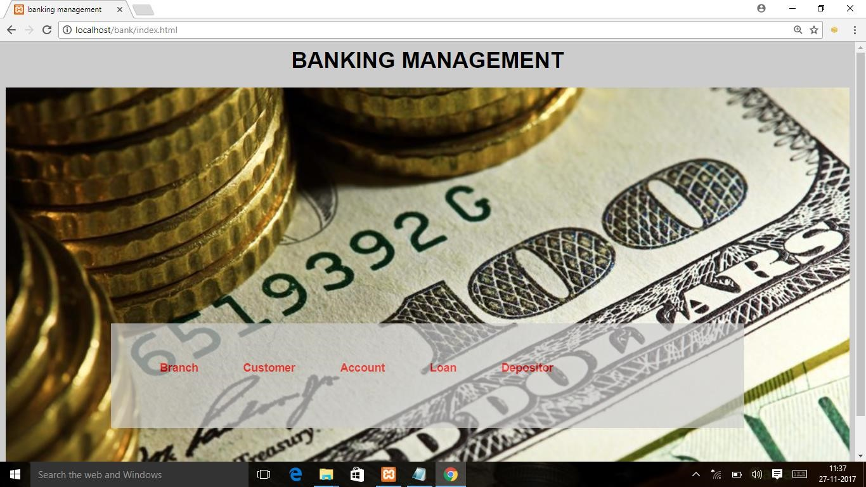

#### Fig 6.1.1 Home Page

**6.1.2 BRANCH INFORMATION**

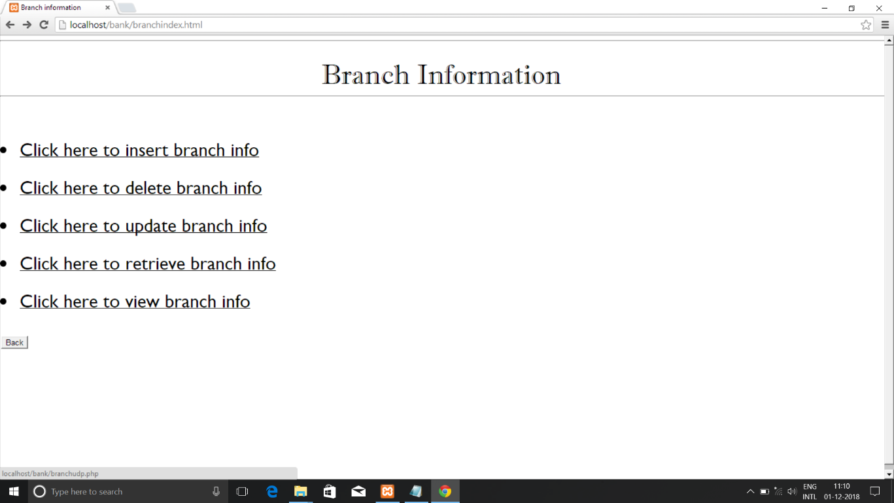

**Fig 6.1.2 Branch information**

#### 6.1.3 INSERTION OF BRANCH RECORD

**Fig 6.1.3 Insertion for Branch**

**6.1.4 VIEW OF BRANCH INSERTED**

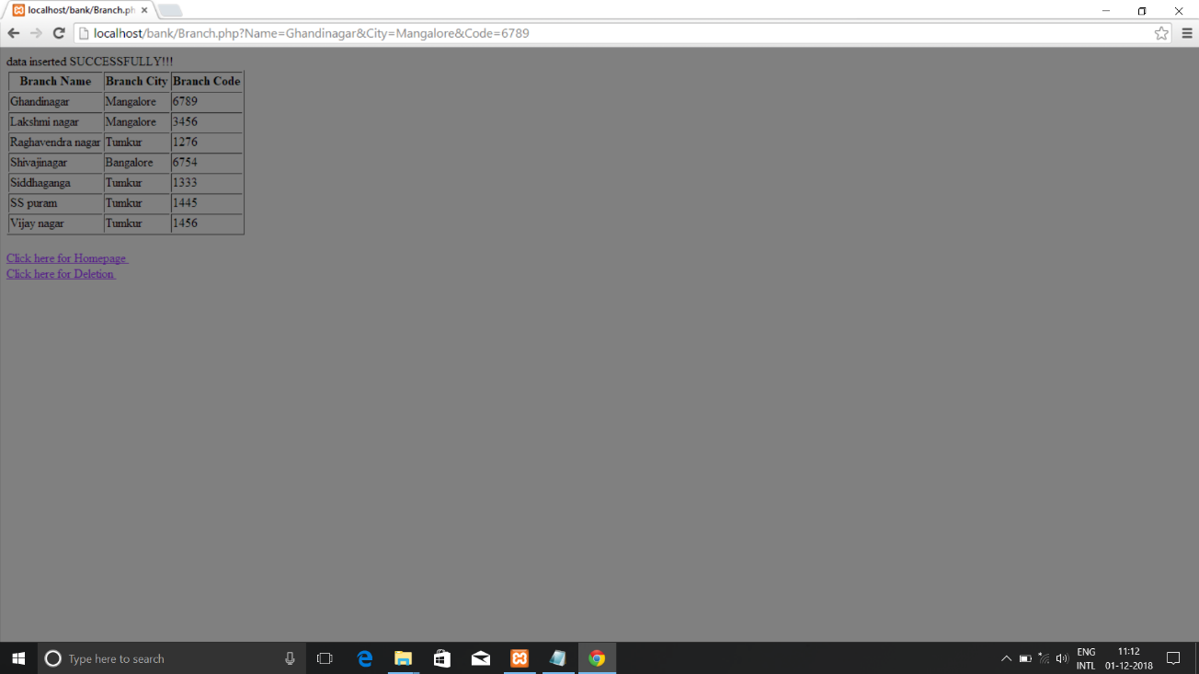

**Fig 6.1.4 View of branch insertion**

**6.1.5 DISPLAY OF BRANCH TABLE IN XAMPP**

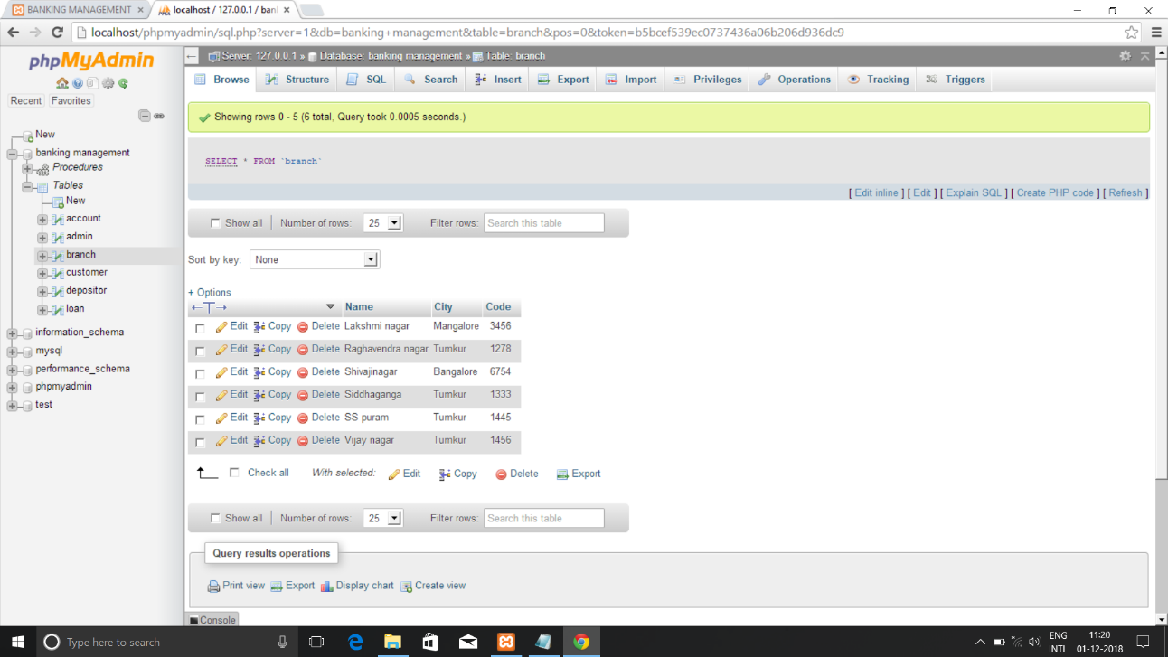

**Fig 6.1.5 Display in XAMPP**

**6.1.6 DELETION OF BRANCH RECORD**

#### 

**Fig 6.1.6 Deletion of branch record**

**6.1.7 VIEW OF DELETED RECORD**

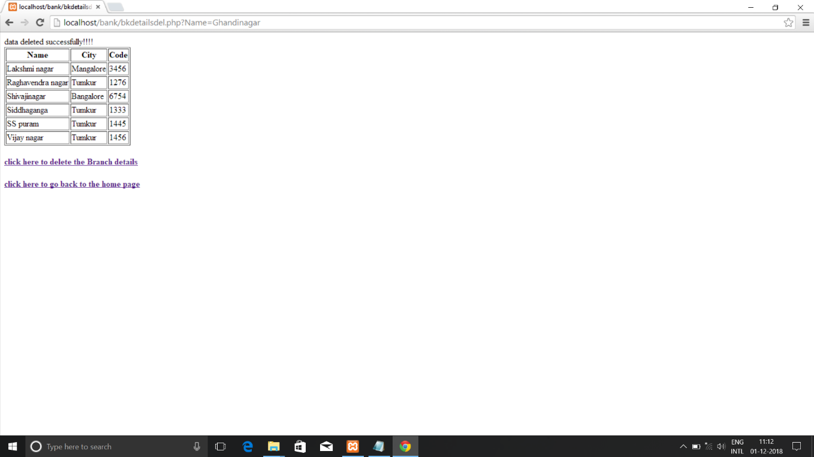

**Fig 6.1.7 Deletion View**

**6.1.8 UPDATION OF BRANCH RECORD**

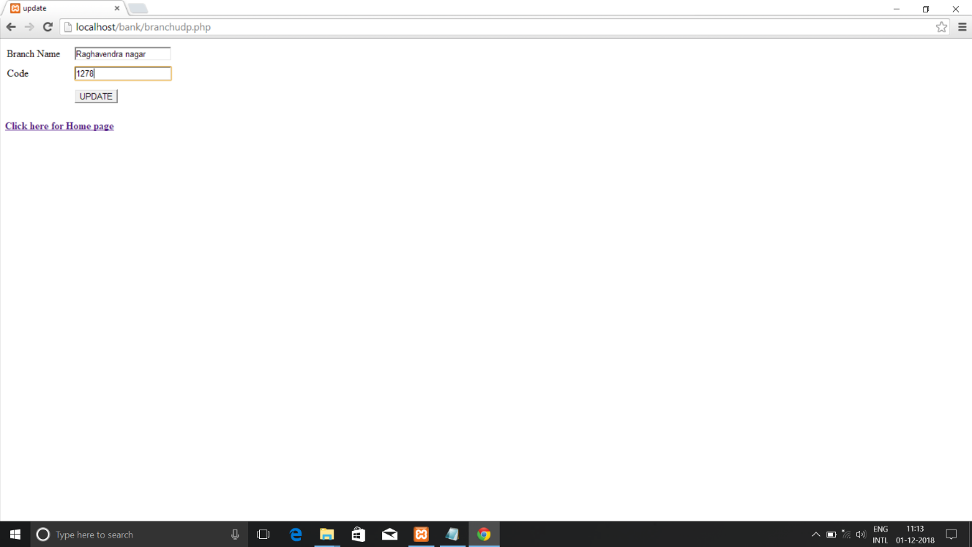

**Fig 6.1.8 Updation of branch record**

**6.1.9 VIEW OF UPDATION RECORD**

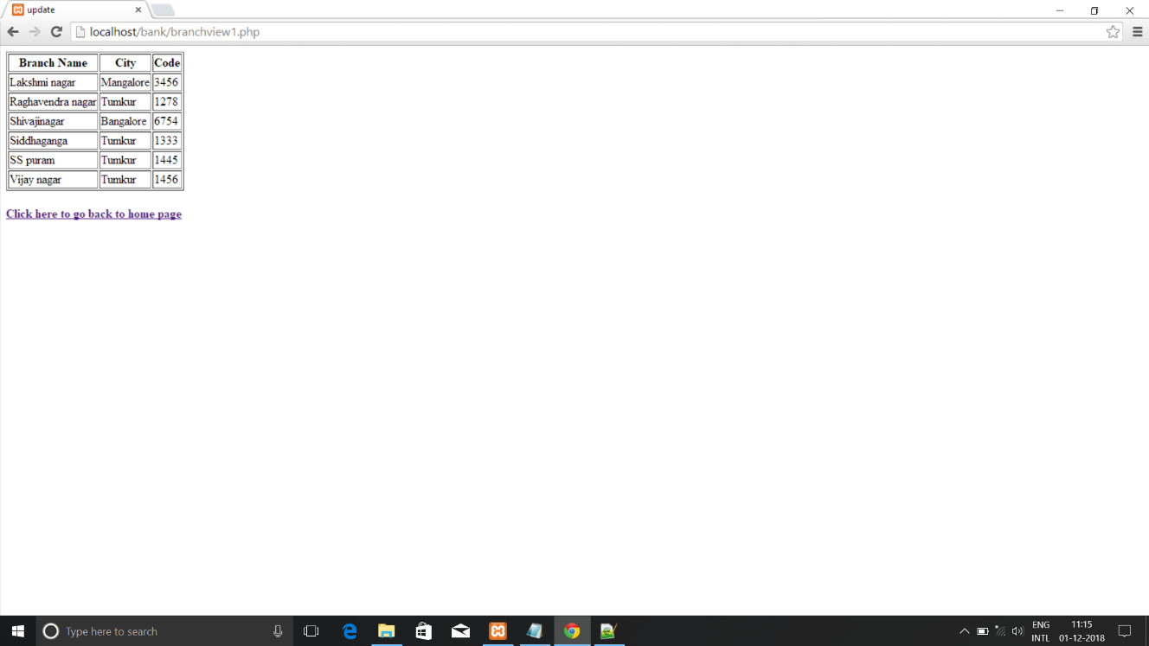

**Fig 6.1.9 Updation View**

**6.2.1 RETRIVAL OF BRANCH RECORD**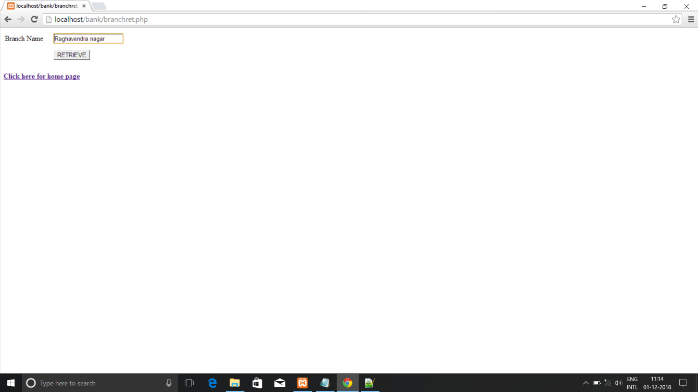

**Fig 6.2.1 Retrival of branch record**

**6.2.2 VIEW OF RETRIVAL RECORD**

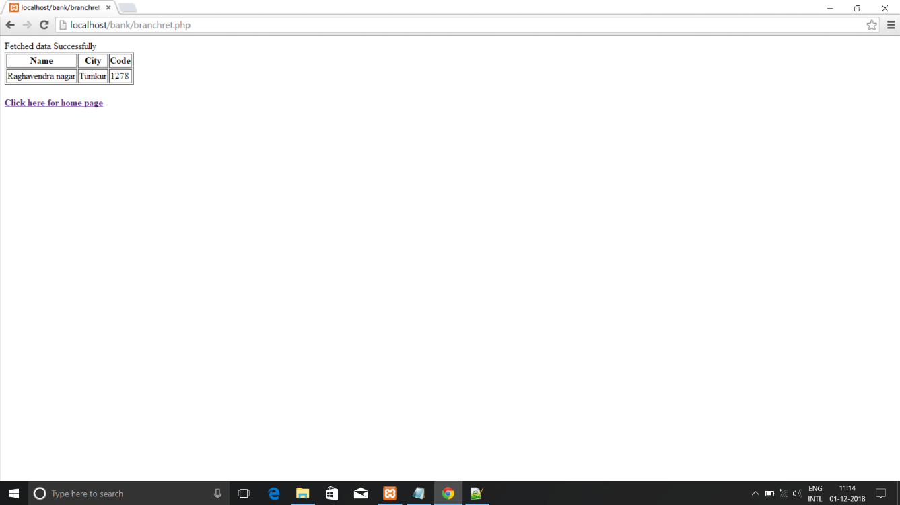

Fig 6.2.2 Retrival view

**6.2.3 TRIGGER IN XAMPP**

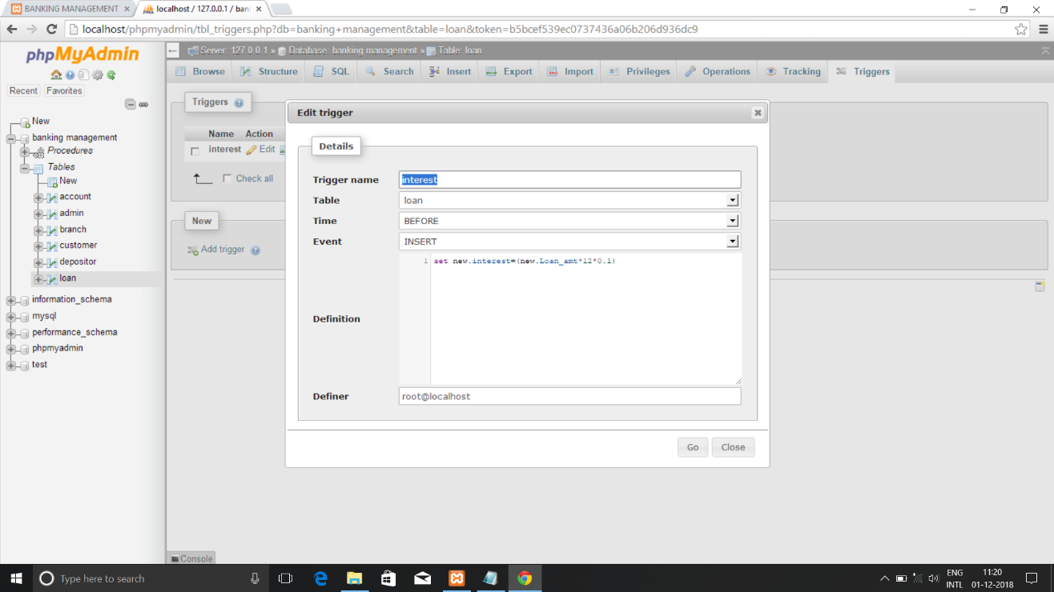

**Fig 6.2.3 Trigger**

**6.2.4 VIEW OF TRIGGER**

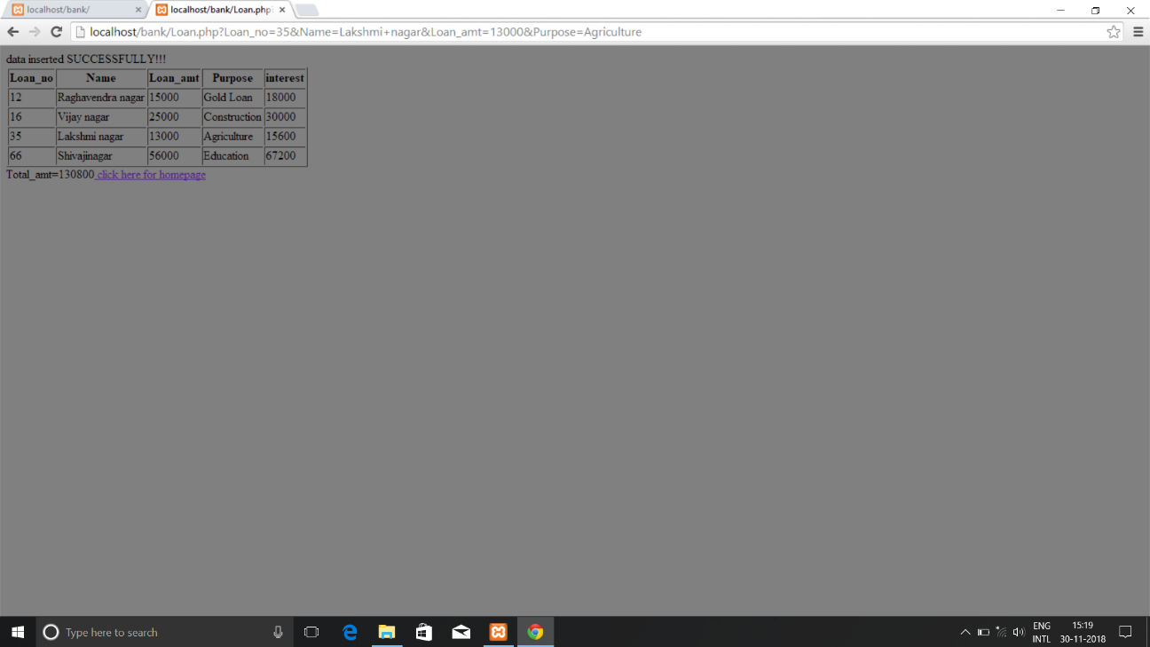

**Fig 6.2.4 Trigger view**

**6.2.5 STORED PROCEDURES**

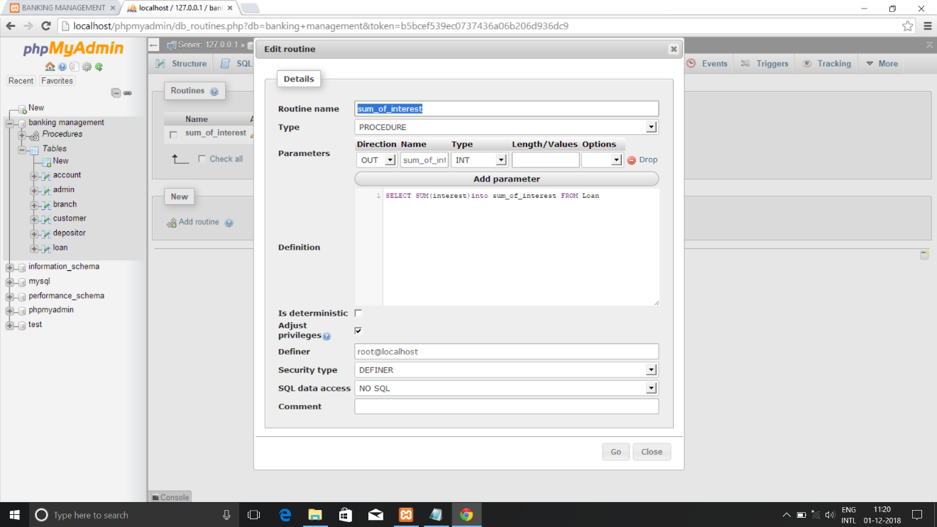

**Fig 6.2.5 Stored procedure**

**6.2.6 VIEW OF STORED PROCEDURE**

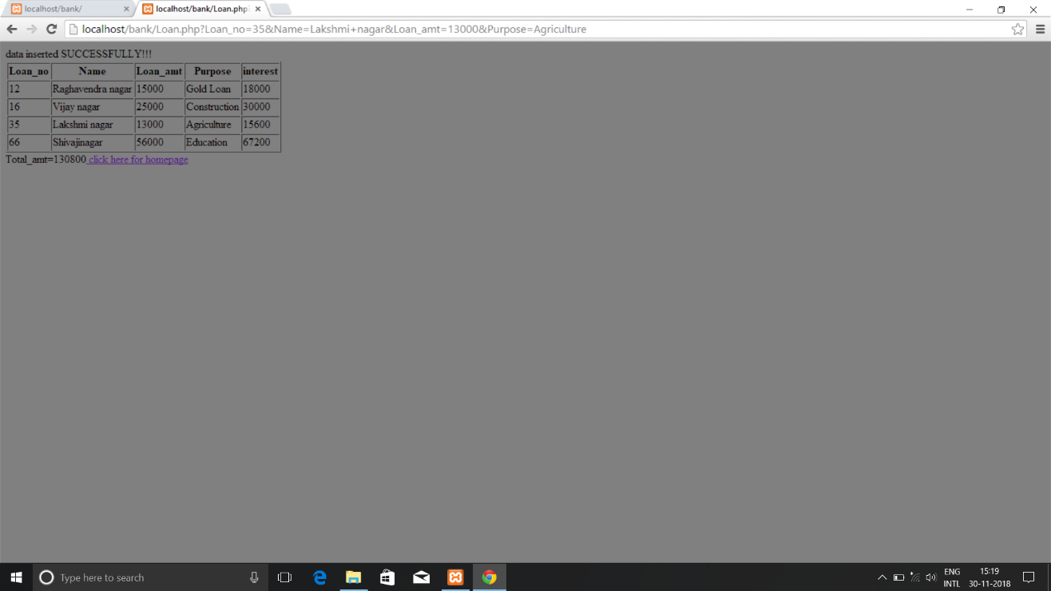

**Fig 6.2.6 Stored procedure view**

**CHAPTER 7**

**CONCLUSION**

To conclude the description about the project: The project developed using PHP and MySQL is based on the requirement specification of the user and the analysis of the existing system, with flexibility for future enhancement.

The expanded functionality of today’s software requires an appropriate approach towards software development. This banking management software is designed for people who want to manage various active in the bank. For the past few years the numbers of educational institutions are increasing rapidly. This particular project deals with the problems on managing a bank and avoids the problems which occur when carried manually.

Identification of the drawbacks of the existing system leads to the designing of computerized system that will be compatible to the existing system with the system which is more user friendly and more GUI oriented.

# 8.BIBLIOGRAPHY

[1]. www.w3schools.com

[2]. in.php.net

[3]. en.wikipedia.org/wiki/PHP

[4]. www.hotscripts.com/category/php/

[5]. www.apache.org/

[6]. www.mysql.com/click.php?e=35050