**Bigdata and hadoop introduction**

Assignment-1

1. To start hadoop single node on VM

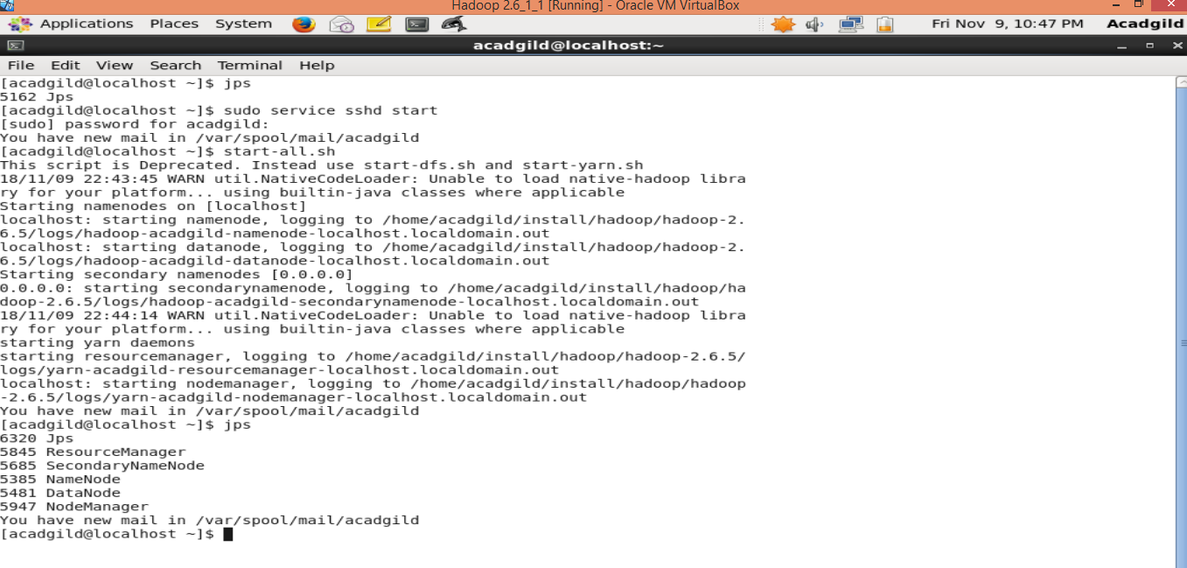

1. To run jps command to see if all hadoop daemons are running

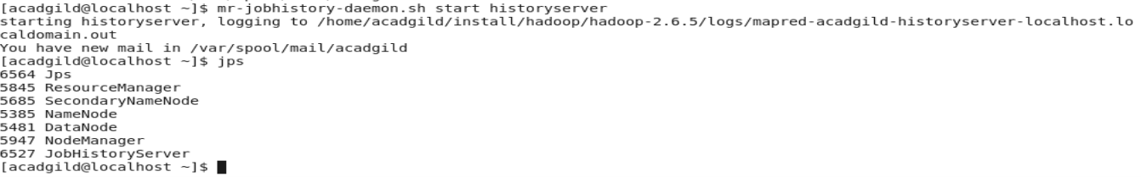

1. Few LINUX commands

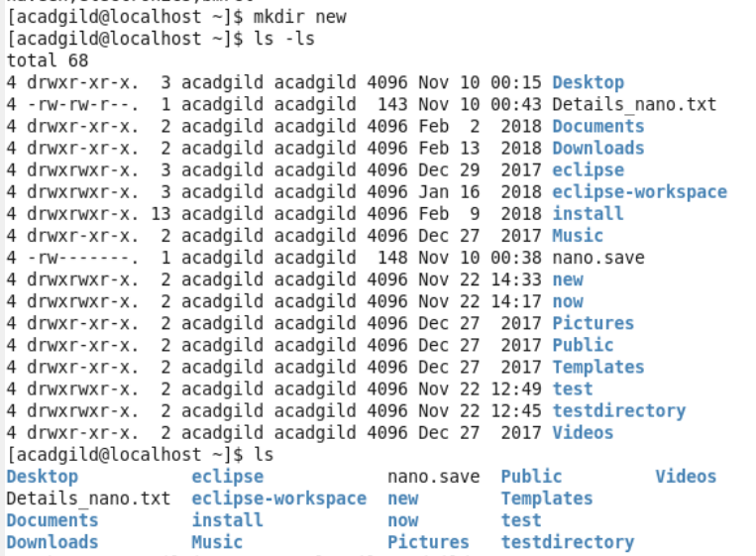

Mkdir – it is used to create a directory

Ls – it is used to view all the files and directories

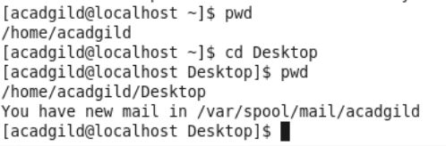

Pwd- it shows the current path we are in

cd- it is the command used to change directory

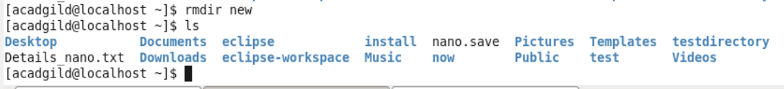

Rmdir – it is used to remove directo

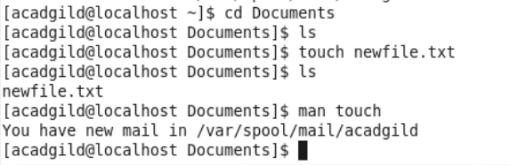

Touch- this command cretes a new emptyfile if file doesn’t exist, if file exists it alters the time

Man- man command shows the manual(explanation and guidance) of the particular commands

1. File created in the terminal using nano editor and verified whether the file is saved

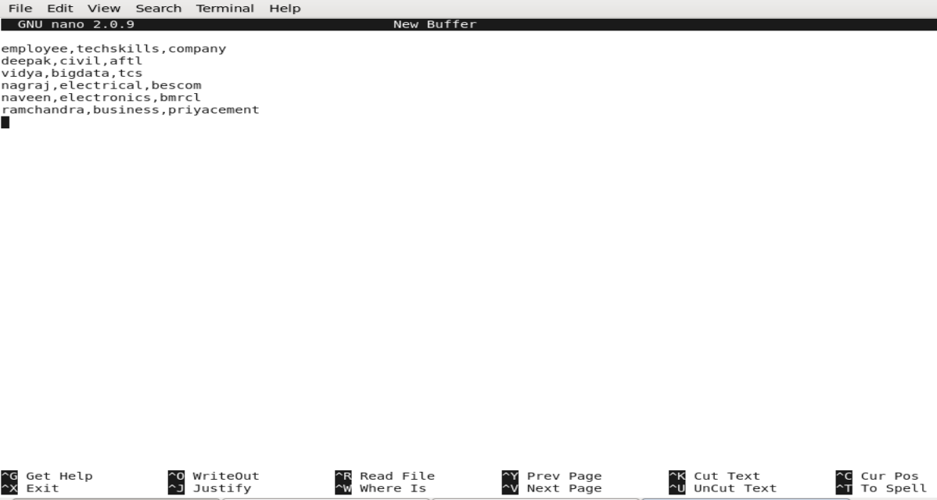

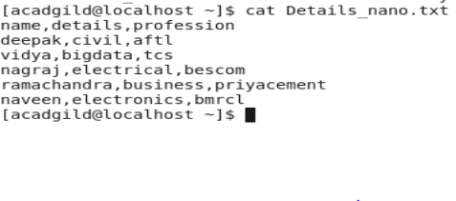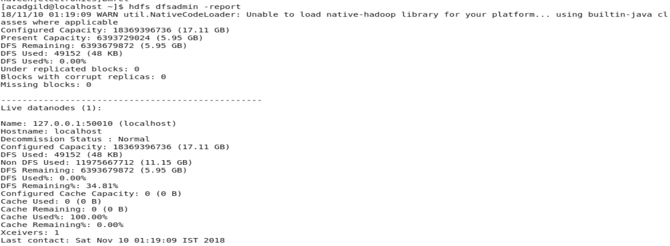

1. Opened the HDFS web page in the browser and checked for all the details of HDFS

