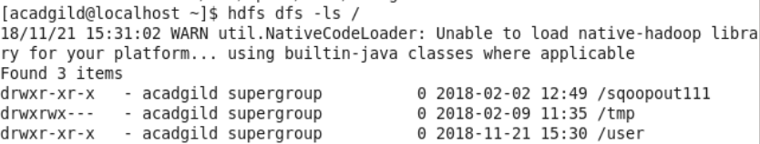

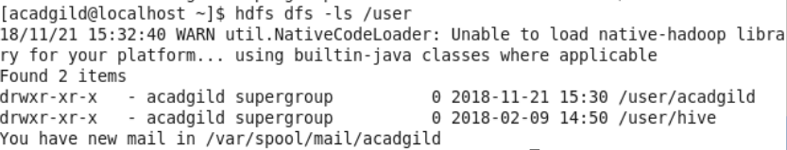

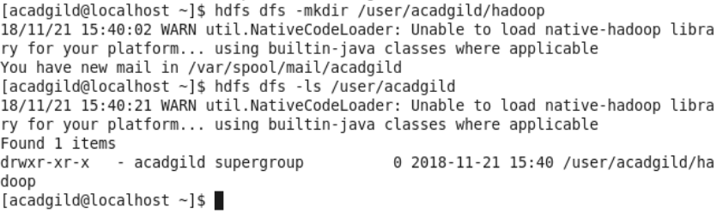

[mageshbacklash7@gmail.com](mailto:mageshbacklash7@gmail.com)

Task 2:

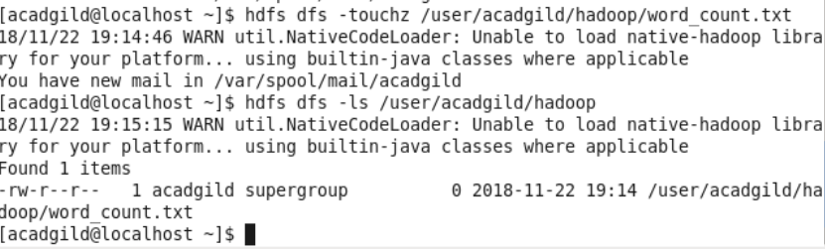

Hi team, my VM was down and system had some problem so couldn’t complete all the tasks of assignment 2

I will attach my assignment 2 and 3 in the assignment 3,

Please ignore this time