Executing programs using hadoop-mapreduce-examples-2.9.0.jar

Command

Hadoop jar hadoop-mapreduce-examples-2.9.0.jar wordmedian /input.txt /output.txt

* hadoop-mapreduce-examples-2.9.0.jar is the jar file
* wordmedian is the class name written in jar file
* input.txt is the input file in hdfs directory
* output.txt is the output directory that creates in hdfs after execution

copying inputfile from local to hdfs

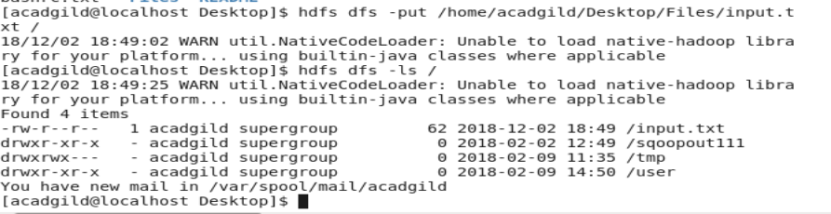

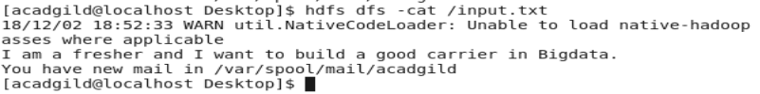

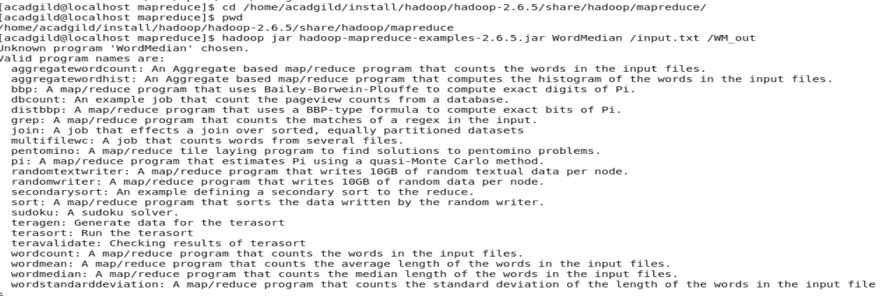

After executing wordmedian

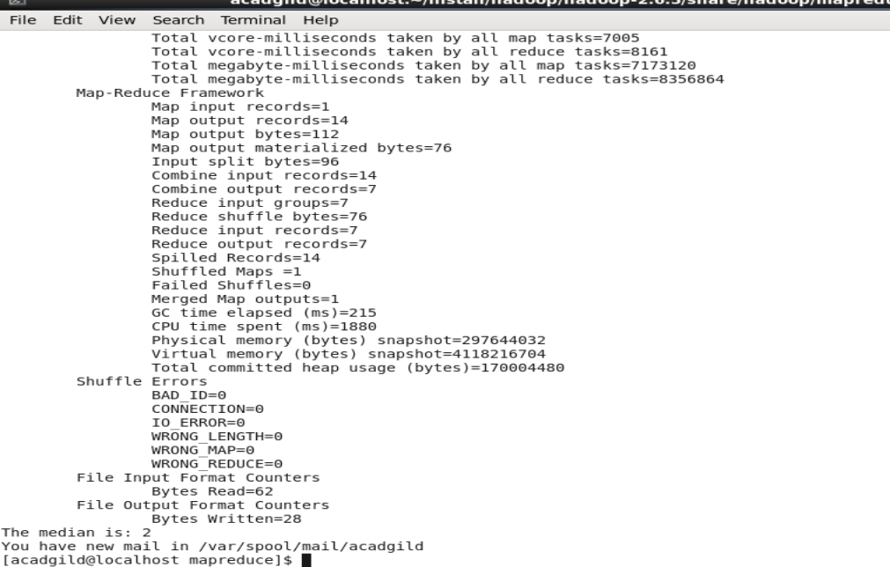

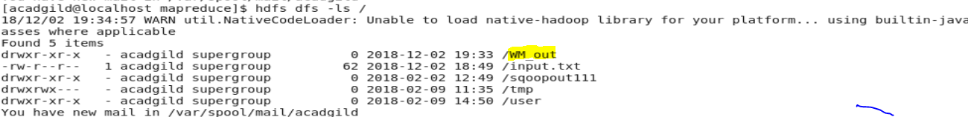

Word mean



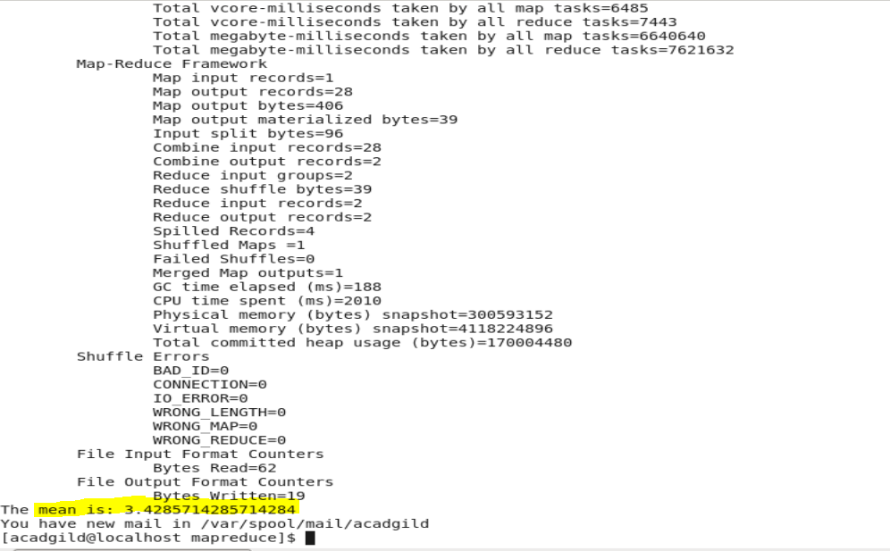

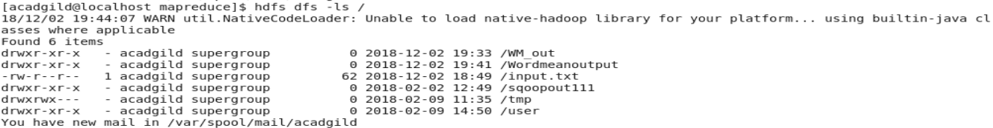

Word standard deviation

