Title : CD devices Memory and Image format

Boot.Hex:

Code 0 to 2A0

Eeprom: Bootloader version

Config bits: are loaded only while flashing file using debugger

App. Hex

Code : 2A0 to 7FF

EEPROM: App version (1byte )

Config bits: are loaded only while flashing file using debugger

App.hex only contain application version

App.OTA

This file is direct copy of APP.hex for OTA purpose. It is ascii readable OTA file

(Command:1)(Address:2)(Data:n)

* All 8 bitdata in decimal seperated by space
* Command supported 2: write to eep ,1: write to flash,255:ignore (used for delying or NOP)
* Eg 2 242 240 3 0 meanse write to EEPROM with address F0F2 value 03 ,0 ignored
* One byte can be written to eeprom with command 2
* 32 bytes can be written to Flash with command 1

App.TLV8

This file is direct copy of APP.hex for OTA purpose. It is binary OTA file

Size of this file 3 times lesser then App.OTA file , it is to be opend in hex editor for analyzing

// TLV8 Format

//TLV8Header,Tag,Length,Value,Tag,Length,Value...Checksum

//- TLV8Header :2 byte (TLV Type,TagCount) ...type TLV8:0 ,TagCount: 1- 250

//- [TAG] 1 byte (0-250 valid values) 255:deleted/unused tag , 254:

//- [LEN] 1 byte , Indicate length of data bytes

//- [VALUE] 1 byte

//- example TLV8(2): 0x00[TLV8],0x02[TagCount],0xFF[TAG],0x01[LEN],0x33[VAL],0x06[TAG],0x02[LEN],0x00[VAL],0x01[VAL],0xCC[CHK]

//- There are 2 tags [TagCount]

//- 1st tag is deleted one and other new tag with same length can be written

//- CHK is Checksum [CHK]

TAG 00 : OTA command

Length = legnt of bytes in each line of App.OTA file

Data = each data in binary

AppBootCombine.Hex:

This File is input for fectory tool and contain Boot, app CRC ,device type and App valid flag set in eeprom.Device type is read from config file and injected. This is done in this because OTA file shuld not contain this value, as Device type to be written one time in fectory. OTA conatains only app valid value which is compared with Device type by controller to validate image is for same device.

AppBootCombineFactory.hex

This file is generated from AppBootCombine.Hex after fectory tool inject Serial number and fectory programing flag is set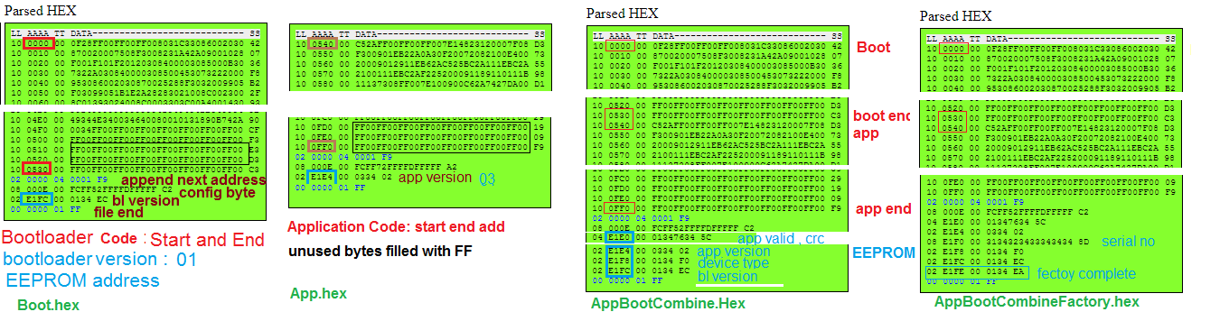

Note: in this hex file address is twise as actual , ie

Every data byte is appended with 0x34 , so word is of two bytes.ie app version value is 01 but it is represented as 01 34

Checksum as last byte = (1 + ~(add all bytes in line except checksum byte)) %256

Tools for Analyzing hex file:

<http://www.dlwrr.com/electronics/tools/hexview/hexview.html>