UNIVERSITY OF TRANSPORT HO CHI MINH CITY
INSTITUTE OF IT AND ELECTRICAL & ELECTRONICS ENGINEERING


PROJECT REPORT
LIBRARY MANAGEMENT SYSTEM
SUBJECT: SOFTWARE ENGINEERING
Lecture: Tran Thi My Tien
Members:
- Nguyen Van Duong ID: 22H1120036
- Duong Tan Dat ID: 064206009536
- Nguyen Thanh Ngan ID: 074306006554
- Tra Ngoc Kim Ngan ID: 080306011562
- Tran Minh Tuyen ID: 056206005060
- Phan Nhat Vien ID: 049206000576

Ho Chi Minh City, June 17, 2026

ACKNOWLEDGEMENTS

PROJECT ABSTRACT
List of Figures
- Functional Requirements
FR1: Login
The Login function allows people to access the system using an account that has been created previously. For guests, if they do not have an account, they must register for a library card. For readers, the account is only permitted to log in after the registration process has been completed and approved by a librarian. After a successful login, the system shall assign permissions and direct users to the functional interface appropriate to their roles. Invalid accounts, accounts that have not been approved, accounts that have been rejected, or accounts that have been locked shall not be permitted to access the system
FR2: Library Card Registration
Guests may register for a library card by providing complete personal information, including full name, email address, phone number, citizen identification number, date of birth, gender, and password
After the registration application has been approved by a librarian, readers may use the library card to borrow books directly from the library. In addition, they may log in to the system using the registered account through their email address and password. The system shall grant readers access permissions to use the available functions, such as viewing book information and viewing borrowing history
If the library card registration application is rejected by the librarian, the applicant may view the reason for rejection through the system

FR3: Library Card Registration Management
The librarian performs the Library Card Registration Management function to process library card registration requests from readers
First, the librarian reviews the registration application to verify personal information and the required conditions (full name, email address, citizen identification number, phone number, password, etc.). If the application is valid, the librarian approves the registration, and the system issues a library card to the reader
Otherwise, if the application does not meet the requirements, the librarian rejects the registration and enters the reason for rejection. The system shall store the rejection reason and notify the user of the processing result
FR4: Book Borrowing Management
The librarian performs the Book Borrowing Management function to record a reader’s book borrowing transaction
First, the librarian checks the library card by entering the card ID, allowing the system to display the card status and borrowing conditions. Next, the librarian checks the book information by searching for the book, and the system displays the current status of the book.
If the reader satisfies the borrowing conditions and the book is available, the librarian creates a borrowing record, including the library card ID, book title, borrowing date, and return date
After the borrowing record has been created successfully, the system updates the remaining quantity of the corresponding book, updates the book status, and sets the borrowing record status to “Borrowing”
FR5: Book Returning Management
The librarian performs the Book Returning Management function to record the return of books by readers
First, the librarian checks the library card by entering the card ID, allowing the system to display the reader’s information. Next, the librarian reviews the borrowing record to view information about the books currently being borrowed and handle overdue cases, if any.
Then, the librarian checks the condition of the book when receiving the returned book from the reader
If the book return complies with the regulations, the system updates the book status, the book quantity, and the borrowing record status to “Returned”
FR6: Viewing Borrowing History
Readers who have a library card may view their borrowing history through the system to access information such as book title, borrowing date, return date, due date, and fine amount (if any). This function helps users retrieve information about books they have previously borrowed
FR7: Viewing Book Information
When a reader selects a book, the system shall display the book title, author, publisher, publication year, category, and book description. In addition, the system shall display the book status, allowing users to know whether the book is available or has been borrowed by another reader
FR8: Search Book
Readers may search for books by book title or author name. The system shall display a list of books that match the search keyword on the reader interface. In addition, when a librarian accesses the Book Management function to search for books by book title or category, the system shall display the search results on the librarian interface
FR9: Reporting and Statistics
The librarian may generate statistical reports of the system for a selected period of time
The reports include:
Book statistics, including the total number of book titles and the number of books currently being borrowed
Borrowing and returning statistics, including the total number of borrowings, returns, and overdue returns
Fine statistics, including the total amount of fines collected for overdue book returns
Reader statistics, including the total number of library cards issued and the number of active readers
The librarian may view each type of report individually, view a consolidated report on the screen, or export reports from the system
FR10: Reader Management
After a library card registration has been approved successfully, the system shall automatically create a library member account based on the reader's information
From the librarian dashboard, the librarian may manage the list of readers and view reader information
In addition, the librarian may lock or unlock a reader's library card
- Non-Functional Requirements
Usability
The system shall provide a user-friendly interface for both readers and librarians.
The user interface shall support responsive design and display properly on desktop computers, tablets, and mobile devices.
Common operations such as searching for books, borrowing books, and returning books shall be easy to perform with a minimal number of steps
Reliability
The system shall operate reliably during the library's working hours.
The system availability shall be greater than 99%.
Borrowing and returning records shall be stored accurately and shall not be lost in the event of system failures.
The system shall support periodic data backup to prevent data loss
Performance
The response time for book search operations shall not exceed 3 seconds under normal operating conditions
The login process shall be completed within 2 seconds under normal operating conditions
The system shall support at least 500 concurrent users
The system shall be capable of storing:
More than 100,000 book records
More than 50,000 reader accounts
More than 1,000,000 borrowing and returning records
Supportability
The system shall be designed to facilitate maintenance and future upgrades
The application shall follow a layered architecture to improve maintainabiliy and separation of concern
The source code shall be organized into modules to support future enhancements and scalability
Security
Readers shall only be able to view their own borrowing history.
Librarians shall only have access to functions authorized by their assigned roles and permissions
User passwords shall be encrypted before being stored in the database.
The system shall protect against common security vulnerabilities, including:
SQL Injection
Cross-Site Scripting (XSS)
Cross-Site Request Forgery (CSRF)
The system shall limit consecutive failed login attempts to reduce the risk of brute-force attack
CAPTCHA or an equivalent mechanism shall be used to prevent automated registration requests and malicious bot activities
Development Requirements
Frontend technologies: HTML5, CSS3, JavaScript
Backend technology: Node.js Framework
Database Management System: MySQL
Deployment Environment: Linux Server
Web Server: Apache or Nginx
Source Code Management: Git
The system shall be developed using a client-server architecture

Data Flow Diagram
DFD-Level 0
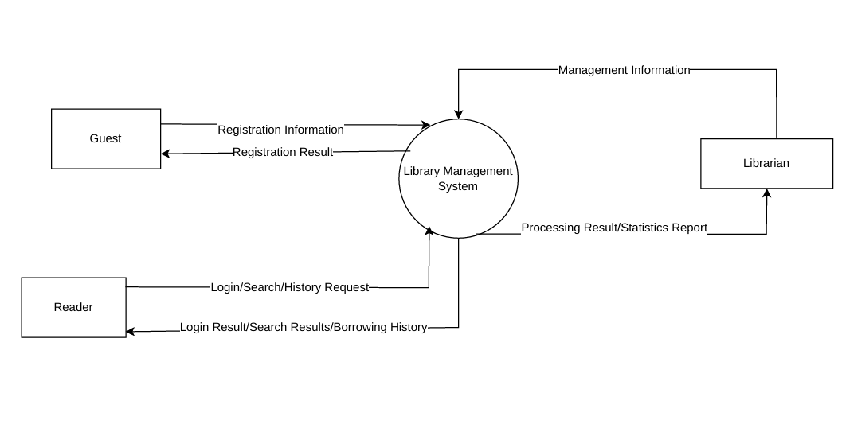
DFD-Level 1
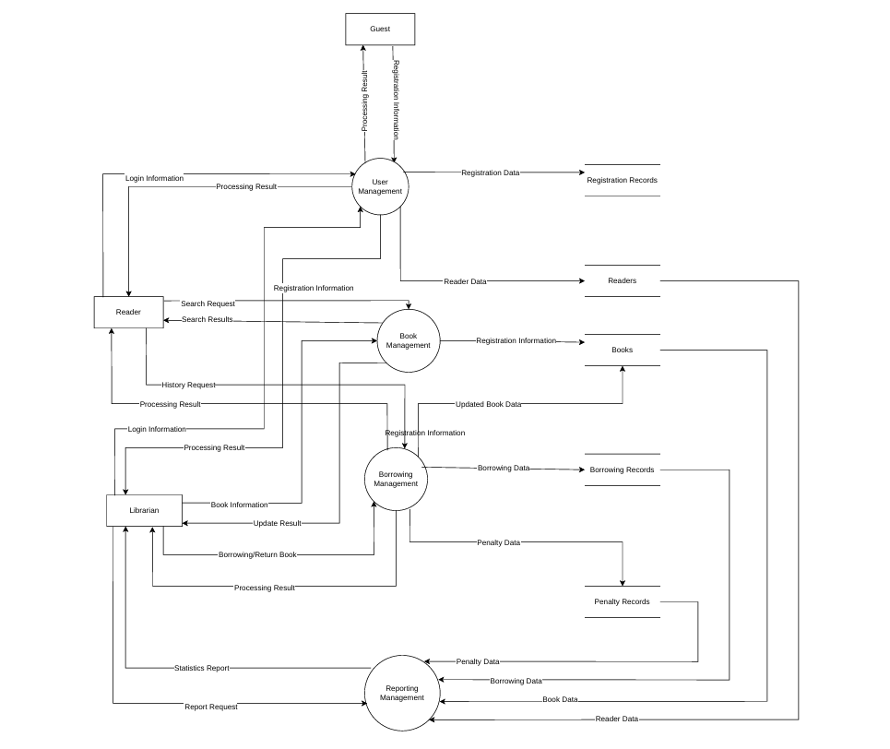

Use case Diagram

  - Overview Use Case Diagram
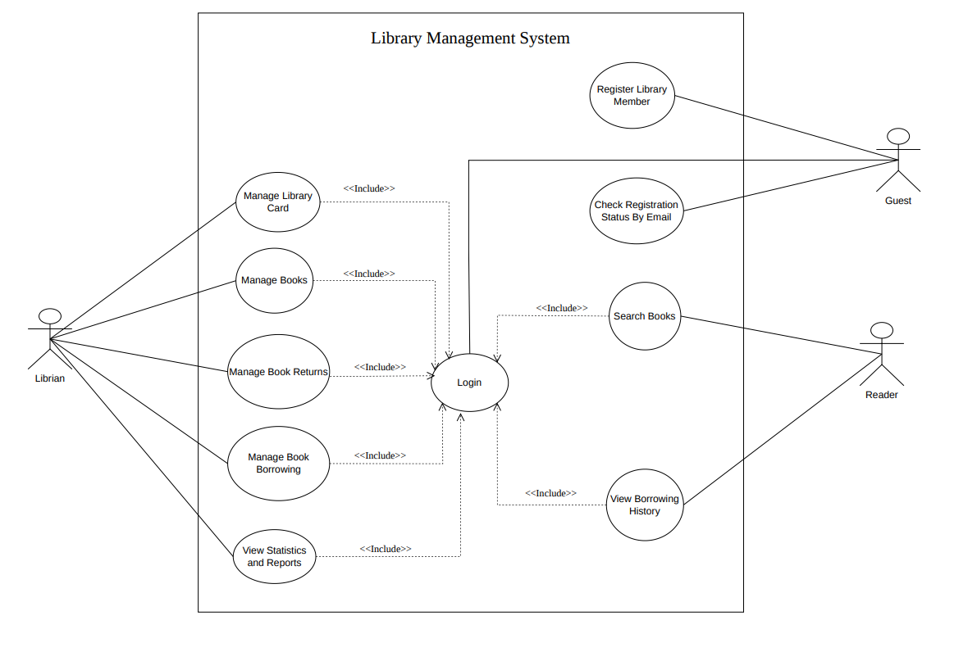

4.2 Use Case Log in
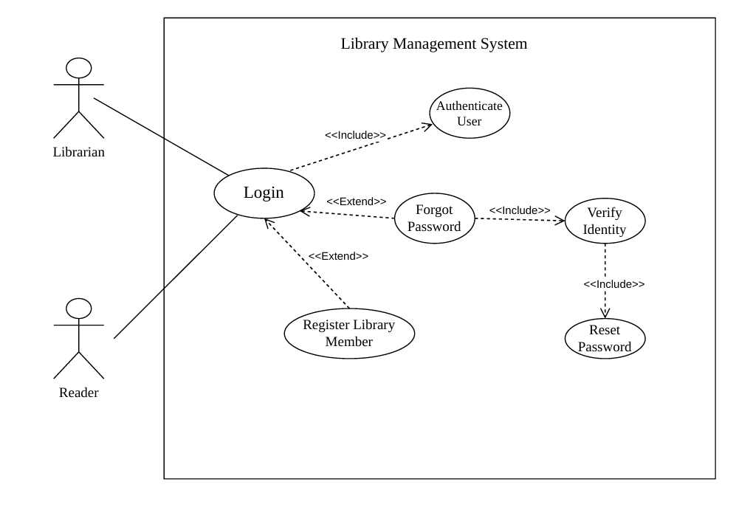

4.3 Use Case Reader Service
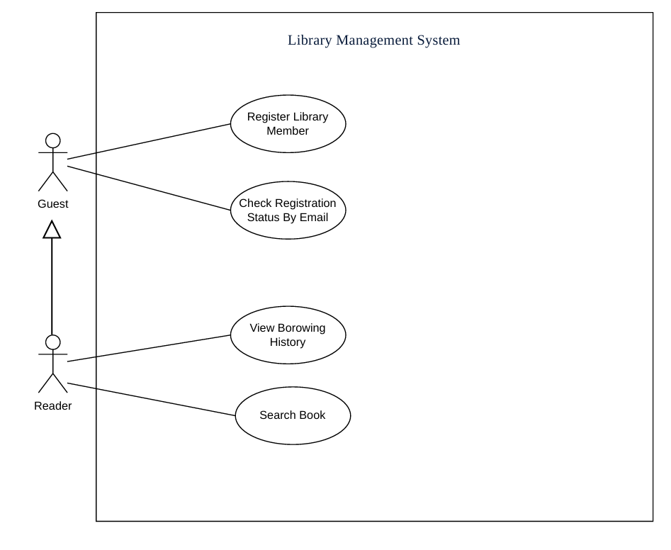

4.4 Use Case Manage Register Library Member
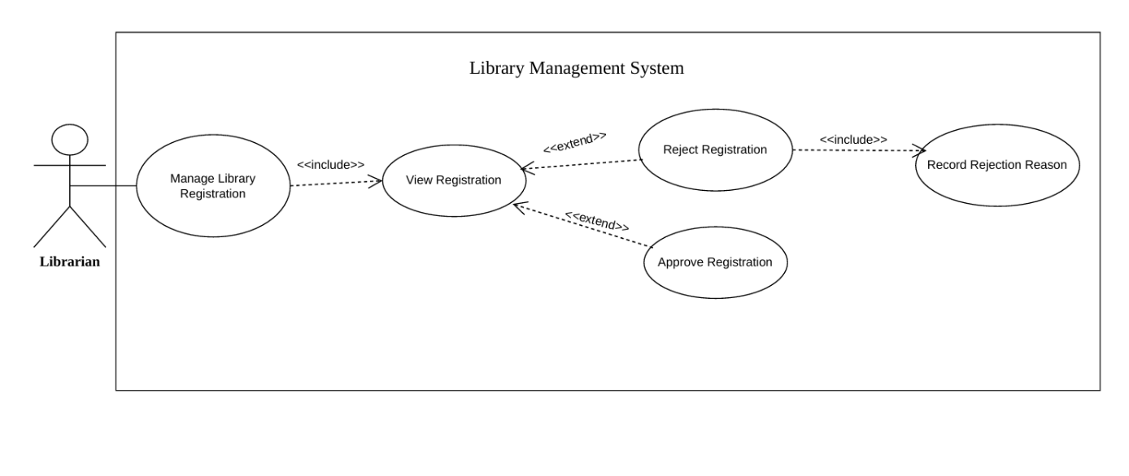

4.5 Use Case View Statistics and Reports
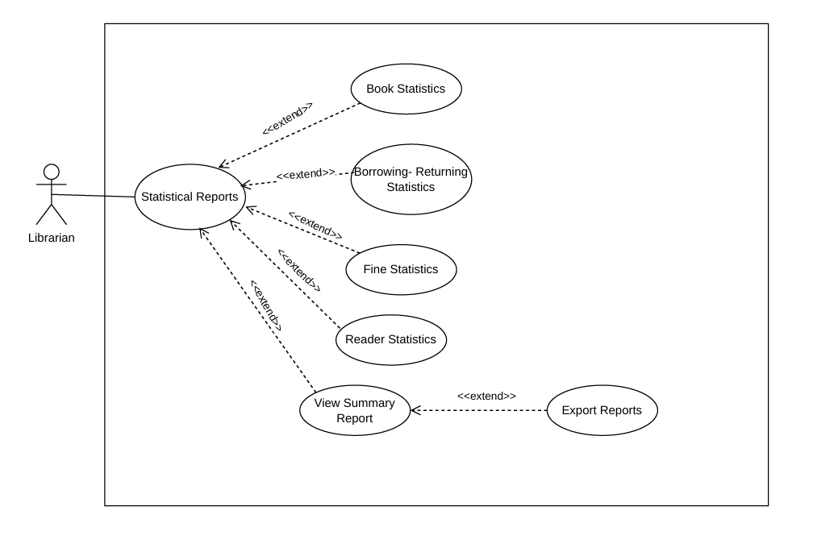

4.6 Use Case Manage Book Returns
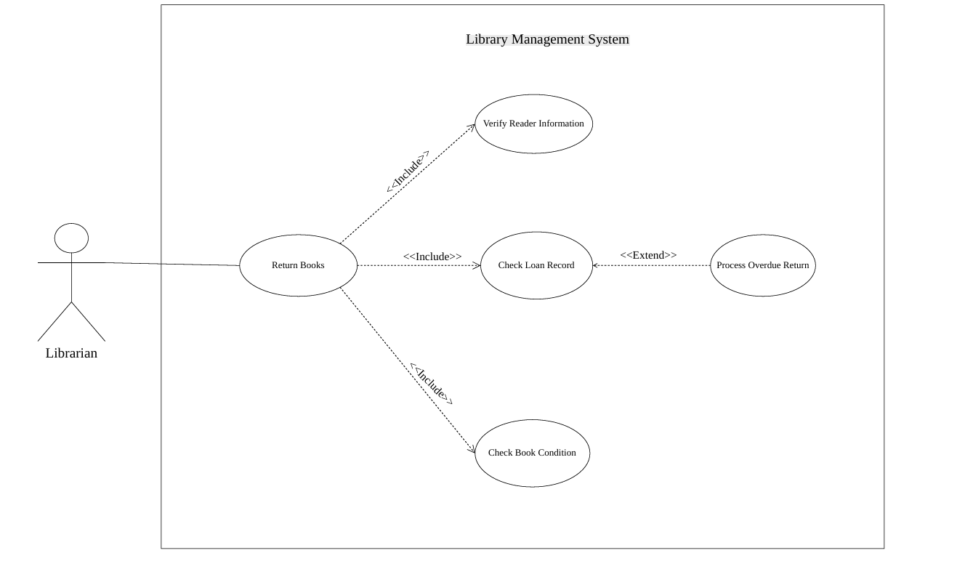

4.7 Use Case Manage Book Borrowing
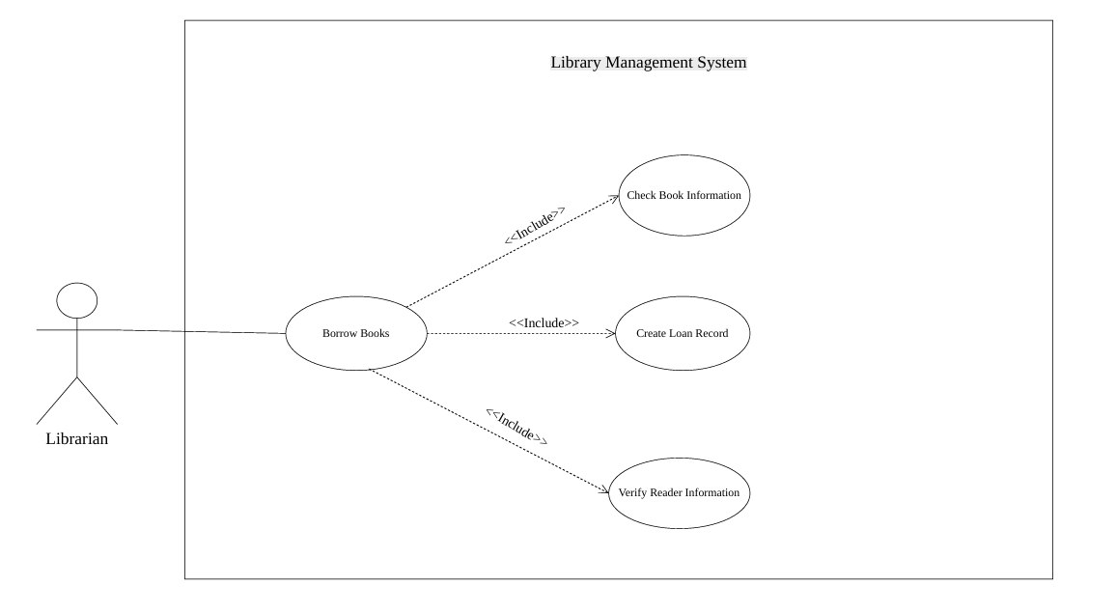

4.7 Use Case Manage Readers
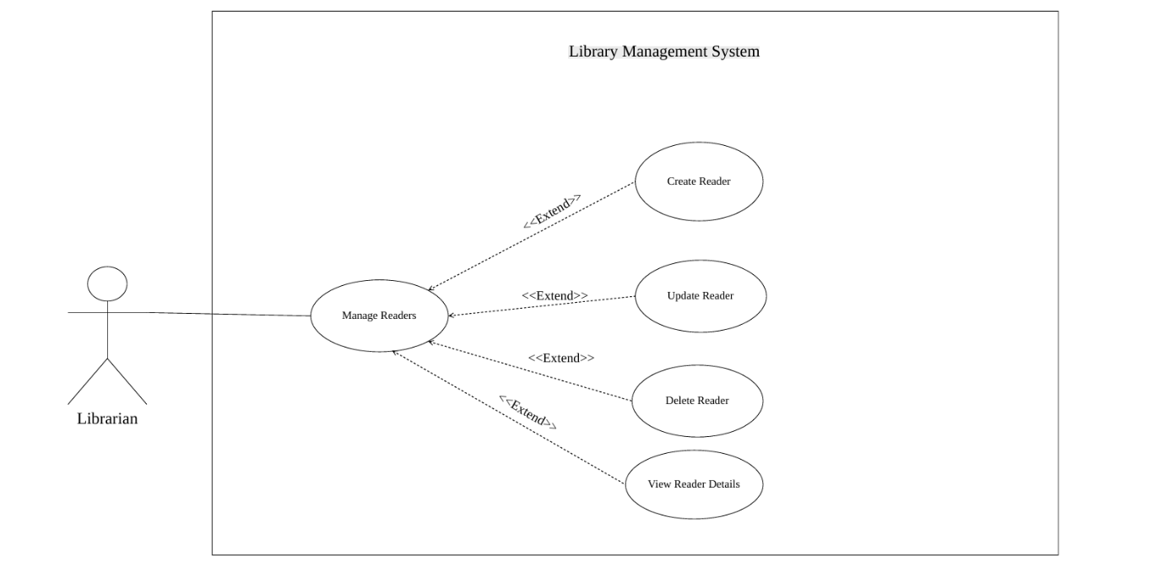

4.8 Use Case Manage Books
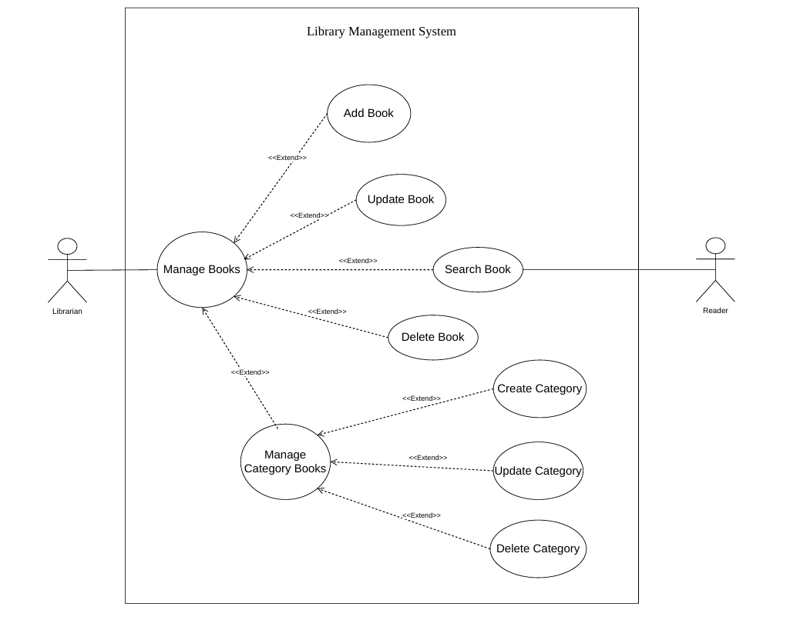

4.9 List of Actors
 | Actor | Description
1 | Guest | A guest who has not logged into the system.
2 | Reader | A reader who has registered for a library card and logged into the system.
3 | Librarian | The librarian who manages the system
  - List of Use Cases
No. | Use-case | Note
1 | Manage Library Cards | Librarian
2 | Login | Guest, Reader, Librarian
3 | Manage Book Borrowing | Librarian
4 | Manage Book Returns | Librarian
5 | Manage Books | Librarian
6 | View Statistics and Reports | Librarian
7 | View Borrowing History | Reader
8 | Register Library Card | Guest, Reader
9 | Search Book | Reader
Use Case Descriptions
1. Use Case: Manage Library Card Registration
1.1 Summary
This use case allows the librarian to review library card registration applications submitted by readers and approve or reject them.
1.2 Flow of Events
1.2.1 Main Flow
The use case begins when the Librarian selects the "Manage Library Cards" function in the system.
- The system displays a list of library card registration requests submitted by readers.
- The Librarian reviews a registration request.
- The Librarian chooses to approve the registration request.
- The system creates and activates the library card for the reader.
- Alternatively, the Librarian chooses to reject the registration request and provides a reason for rejection.
- The system sends a rejection notification, including the reason, to the reader's email address.
1.2.2 Alternative Flows
No registration applications available: The system displays the message "No registration applications available."
1.2.3 Special Requirements
Only librarians are authorized to access this function.
1.4 Preconditions
The Librarian has logged into the system with reader management privileges.
1.5 Postconditions
The reader's registration information and library card records are successfully stored or updated in the database.
1.6 Extension Points
None
2. Use Case: Login
2.1 Summary
This use case describes the user authentication process for Readers and Librarians. It grants authorized access to the management interface and ensures the security of the library system's data.
2.2 Flow of Events
2.2.1 Main Flow
The use case begins when the user accesses the application and selects the "Log In" function.
- The system displays the login screen.
- The user enters their Library Card ID (Email) and Password, then clicks "Log In"
- The system encrypts the password and validates the credentials against the database.
- The system verifies the user's identity, creates a session, and assigns the appropriate access permissions
- The system redirects the user to the main Dashboard page
2.2.2 Alternative Flows
Invalid credentials: If the Library Card ID or Password is incorrect, the system clears the password field and displays the following error message in red "Invalid Library Card ID (email) or Password"
2.3. Special Requirements
None
2.4 Preconditions
The user is using a device with a network connection to the library server.
2.5 Postconditions
The user successfully accesses the system and is granted the features and permissions associated with their role.
2.6 Extension Points
None
3. Use Case: Manage Book Borrowing
3.1 Summary
This use case manages the process of lending library materials to readers by linking physical book copies to a reader's record for a specified borrowing period through the creation of a Borrowing Slip
3.2 Flow of Events
3.2.1 Main Flow
The use case begins when the Librarian selects the "Manage Book Borrowing" function and enters the reader's Library Card ID.
- The system verifies the library card and displays the reader's information, including the number of books the reader is still allowed to borrow.
- The Librarian selects the "Search Book" function to locate the book to be borrowed.
- The system displays the book information and its availability status.
- The Librarian creates a borrowing slip containing the Library Card ID, book title, borrowing date, and due date.
- The system generates and prints the borrowing slip.
- The system updates the available quantity and borrowing status of the corresponding book.
3.2.2 Alternative Flows
No available copies: If no copies of the requested book are available, the system displays the message "All copies of this book are currently borrowed"
3.3 Special Requirements
Only librarians are authorized to access this function.
3.4 Preconditions
The Librarian has successfully logged into the system.
The reader possesses a valid library card.
The requested books are marked as "Available" in the library inventory.
3.5 Postconditions
A borrowing slip is successfully created, and the book quantity and status are updated accordingly.
3.6 Extension Points
Use Case Search Book: The Librarian searches for books to lend to readers.
4. Use Case: Manage Book Returns
4.1 Summary
This use case describes the process of receiving returned books from readers, calculating any penalties incurred due to overdue returns or damaged books, and restoring the books' status in the library inventory
4.2 Flow of Events
4.2.1 Main Flow
The use case begins when the Librarian selects the "Book Return" function and enters the Library Card ID.
- The system displays the reader's information.
- The Librarian verifies the information and confirms the book return.
- The system updates the quantity and status of the returned book.
4.2.2 Alternative Flows
Overdue book return:
If the system detects that the book is overdue, it automatically calculates the number of overdue days, generates a Penalty Receipt, and requires the Librarian to collect the penalty fee.
The Librarian confirms the payment before the system allows the book return to be completed.
4.3 Special Requirements
Only librarians are authorized to access this function.
4.4 Preconditions
The Librarian has logged into the system.
A borrowing slip with the status "Not Returned" exists.
4.5 Postconditions
The quantity and status of the returned book are updated successfully.
4.6 Extension Points
None
5. Use Case: Manage Books
5.1 Summary
This use case allows the Librarian to add new books, edit book information, and delete books. In addition, the system supports the creation of book categories to facilitate effective book classification and management.
5.2 Flow of Events
5.2.1 Main Flow
The use case begins when the Librarian selects the "Manage Books" function and chooses "Add New Book"
- The system displays a book information entry form
- The Librarian enters the book details, including Title, Author, Category, Publisher, and Quantity
- If the book category does not exist, the Librarian selects the "Add Book Category" function and enters the new category information
- The system saves the book category and updates the category list
- The Librarian saves the book information
- The system stores the book information and updates the quantity and status of the book
- The Librarian selects "Delete Book" and confirms the deletion of a book
- The system deletes the book and updates the quantity and status of the book
5.2.2 Alternative Flows
None
5.3 Special Requirements
Only librarians are authorized to access this function.
5.4 Preconditions
None
5.5 Postconditions
The book information, quantity, and status are updated successfully
5.6 Extension Points
None
6.Use Case: View Statistics and Reports
6.1 Summary
This use case allows the Librarian to view statistical reports on library activities, including the number of borrowed books, the number of registered library cards, and other related statistics within a specified period of time
6.2 Flow of Events
6.2.1 Main Flow
The use case begins when the Librarian selects the "Statistics & Reports" function in the system
- The system displays the statistics interface with filtering options by time period (day, month, or year)
- The Librarian selects the desired time period
- The system displays a statistical report including: Total number of books in the library, total number of book borrowings, total number of active library cards, most frequently borrowed books, most active users
- If the Librarian chooses to export the report, the system generates a report file based on the selected statistical data
6.2.2 Alternative Flows
No data available for the selected period: The system displays the message "No statistical data is available for the selected period"
6.3 Special Requirements
Only librarians are authorized to access this function
6.4 Preconditions
The Librarian has logged into the system
6.5 Postconditions
None
6.6 Extension Points
None
7. Use Case: View Borrowing History
7.1 Summary
This use case allows readers to view their borrowing history, including borrowed books, borrowing dates, return dates, due dates, and penalty fees (if any)
7.2 Flow of Events
7.2.1 Main Flow
The use case begins when the Reader selects the "View Borrowing History" function in the system
- The system displays the reader's borrowing history, including: Book title, borrowing date, due date, actual return date, status
- If the reader chooses to view the details of a borrowing record, the system displays detailed information, including: Book information, borrowing date, due date, actual return date, penalty fee (if any)
7.2.2 Alternative Flows
No borrowing history available: The system displays the message "Please borrow a book first"
7.3 Special Requirements
None
7.4 Preconditions
The Reader has a valid library card
The Reader has logged into the system
7.5 Postconditions
None
7.6 Extension Points
None
8. Use Case: Register for a Library Card
8.1 Summary
This use case allows users to register for a library card in order to use the library's services
8.2 Flow of Events
8.2.1 Main Flow
The use case begins when the user accesses the library card registration interface on the system
- The system displays a library card registration form, including: Full name, date of birth, gender, national ID number, email, phone number, password
- The user enters all required information and submits the registration request.
- The system validates the entered data
- The system verifies that the user does not already have an active library card.
- The Librarian reviews and approves the registration request
- The system creates a new library card containing the following information: Library Card ID, full name, issue date, expiration date, email, phone number, password, gender, date of birth
- The system displays a registration success message along with the newly issued library card information
8.2.2 Alternative Flows
Invalid Data: If any entered information is invalid, the system displays the corresponding error message and requests the user to re-enter the information.
Registration Rejected by the Librarian: The rejection may occur because the application is invalid or the user already has a library card, the system displays the reason for rejection to the user.
8.3 Special Requirements
None
8.4 Preconditions
None
8.5 Postconditions
A library card is created and linked to the user's account.
8.6 Extension Points
None

9. Use Case: Search for Books
9.1 Summary
This use case allows readers to search for books in the library system using various criteria such as book title, author name, category, and publisher.
9.2 Flow of Events
9.2.1 Main Flow
The use case begins when the Reader enters a keyword into the search box on the system.
- The system displays the search interface with a keyword input field.
- The Reader enters a search keyword.
- The system searches for matching books and displays a list of results, including: Book ID, book title, author, category, publication year
- The Reader selects a book from the search results
- The system displays detailed information about the selected book.
9.2.2 Alternative Flows
No matching results found: If no books match the search keyword, the system displays the message "No books matching the search criteria were found"
9.3 Special Requirements
The system shall support keyword-based book searches and perform searches in a case-insensitive manner to help users easily find book information.
9.4 Preconditions
None
9.5 Postconditions
None
  - Extension Points
None
10. Use Case: Manage Reader
10.1 Summary
This use case allows the Librarian to manage reader accounts in the system, including viewing reader information and locking or unlocking library cards
10.2 Flow of Events
10.2.1 Main Flow
The use case begins when the Librarian selects the "Manage Readers" function in the system
- The system displays a list of readers, including: Library Card ID, full name, phone number, national ID number, email, date of birth, gender, account status (Active / Locked)
- The Librarian selects "Lock Library Card"
- The system updates the card status to Locked and prevents the reader from logging into the system
- The Librarian selects "Unlock Library Card"
- The system updates the card status to Active and allows the reader to log in and use the system normally
10.2.2 Alternative Flows
None
10.3 Special Requirements
Only librarians are authorized to perform this use case
10.4 Preconditions
The Librarian has logged into the system
10.5 Postconditions
The reader's information and account status are updated in the database
10.6 Extension Points
None

5.Class Diagram
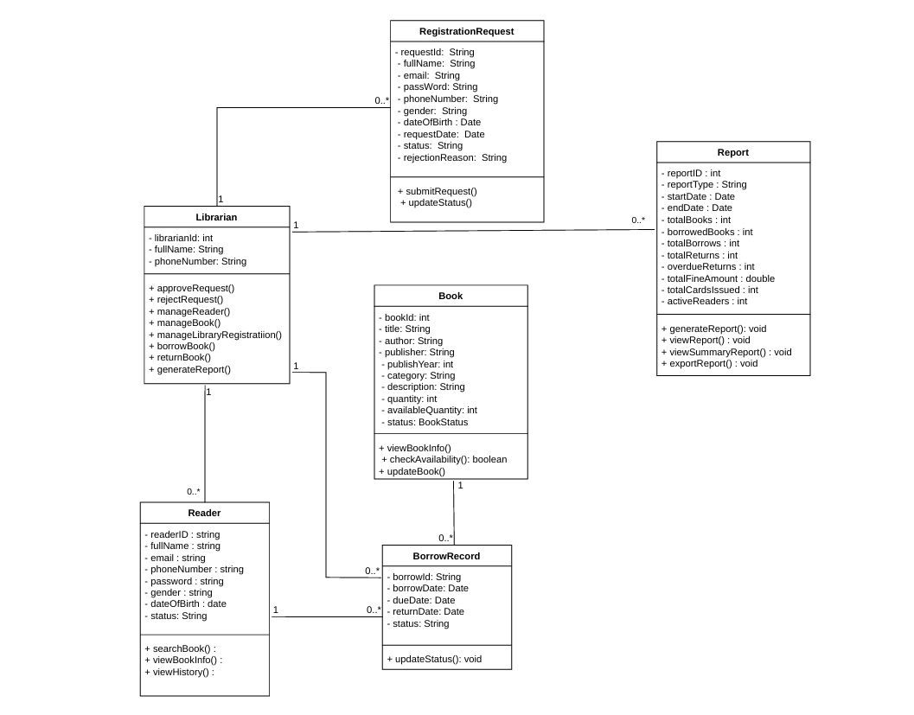

- Data Model
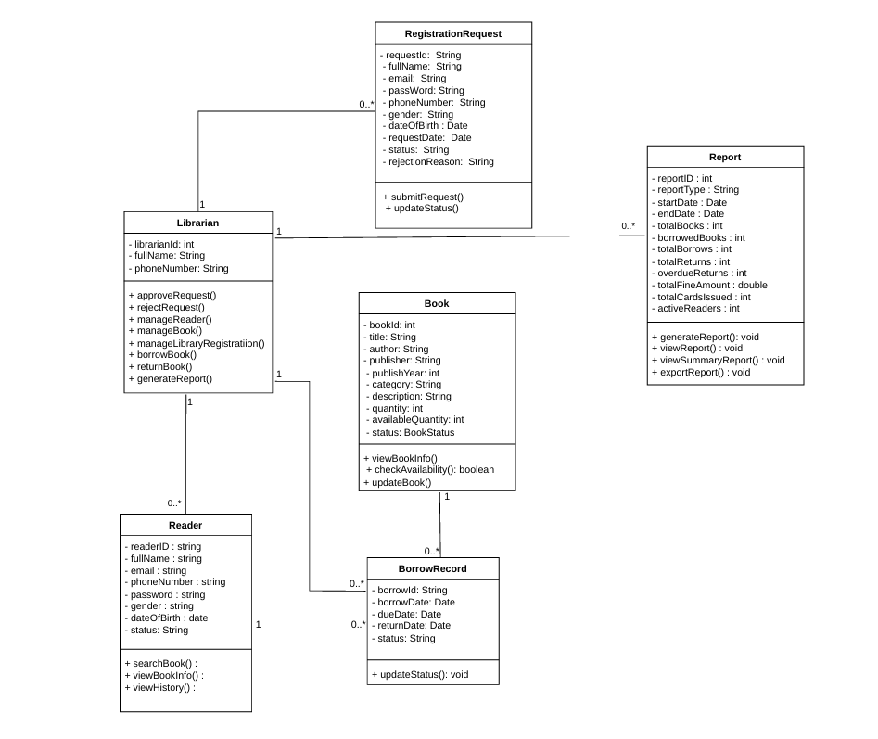
7. Interface Design Description

7.1. Login Screen Interface
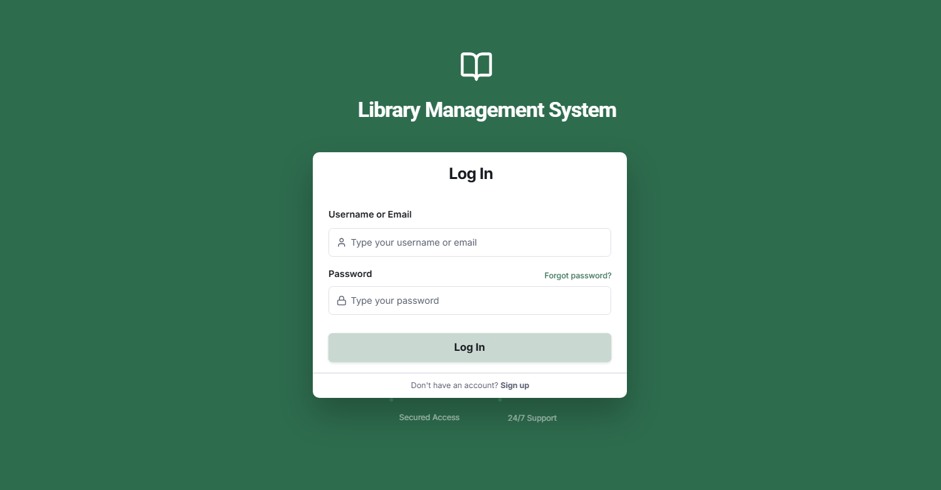

7.2. Library Card Registration Interface

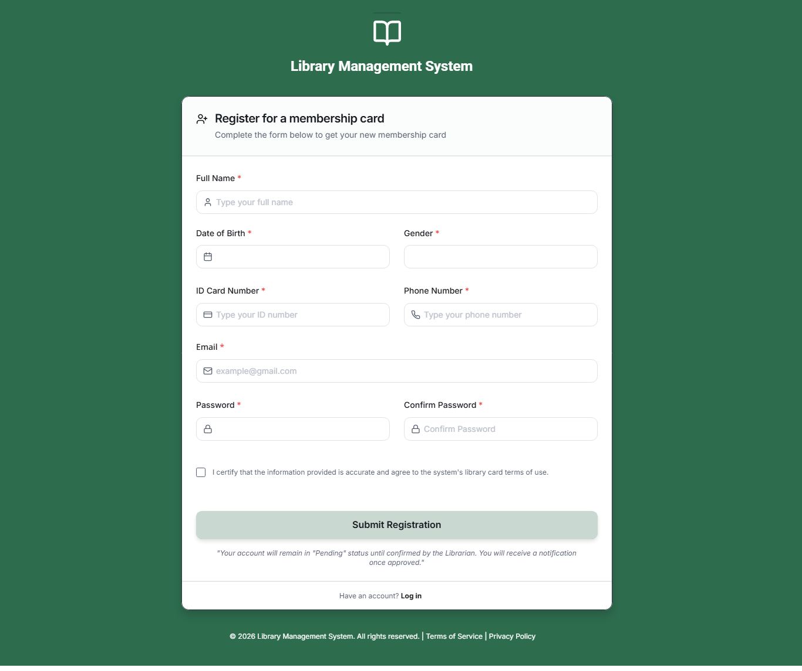

7.3. Library Card Registration Management Interface
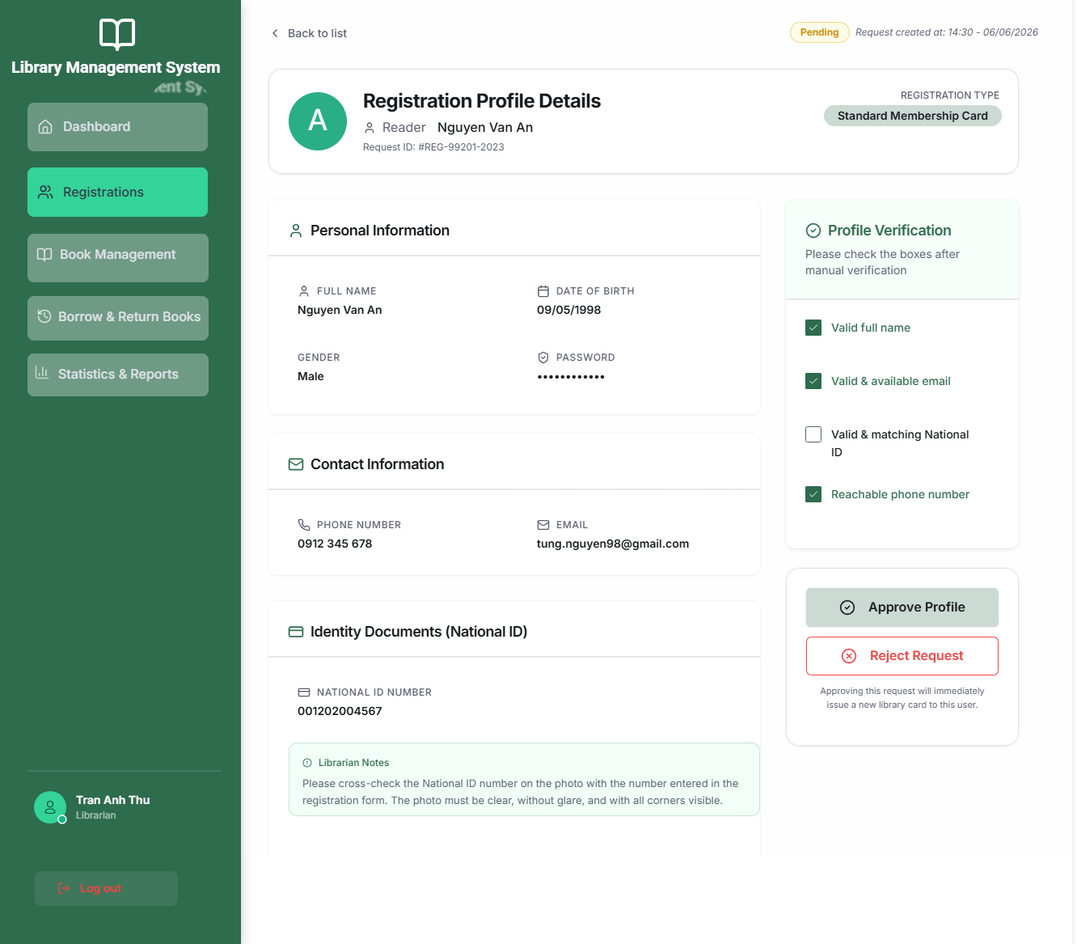

7.4. Library Card Registration Approval Interface
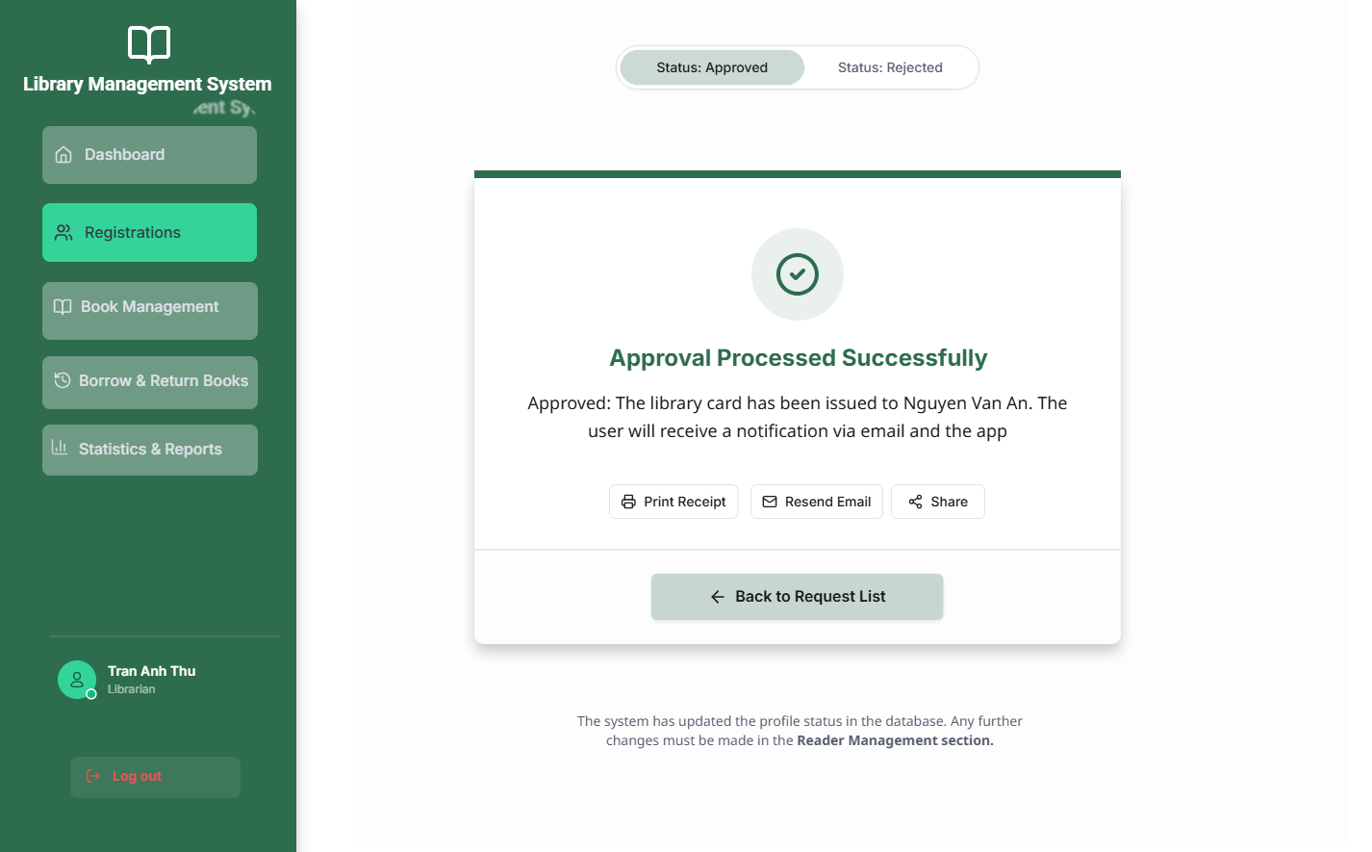

7.5 Reader Borrowing and Returning History Interface
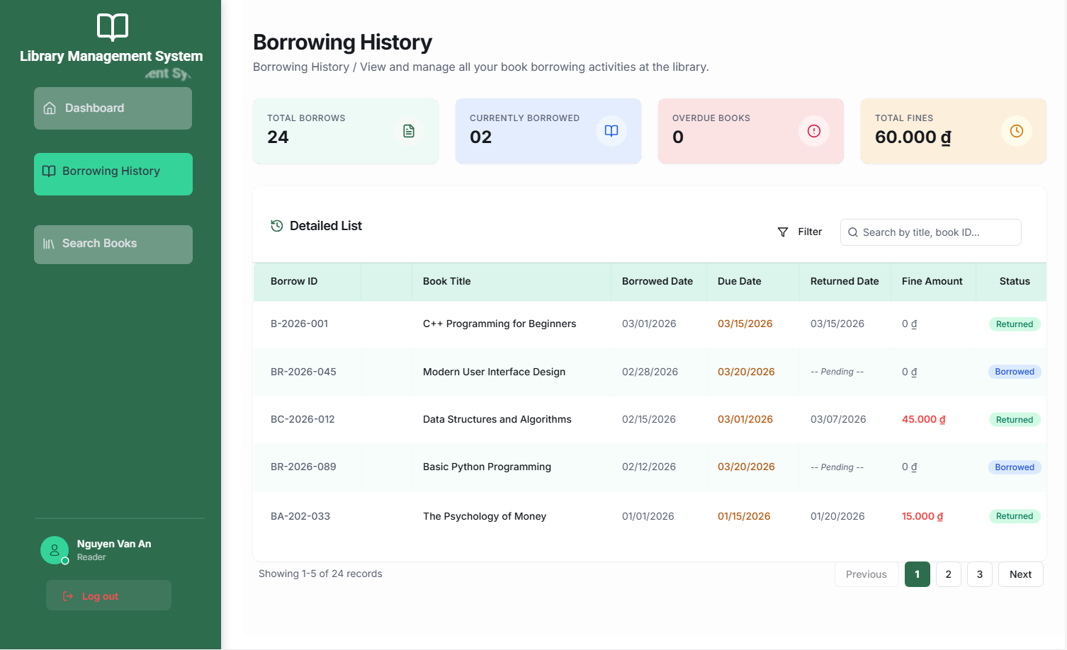

7.6 Reader Book Search Interface
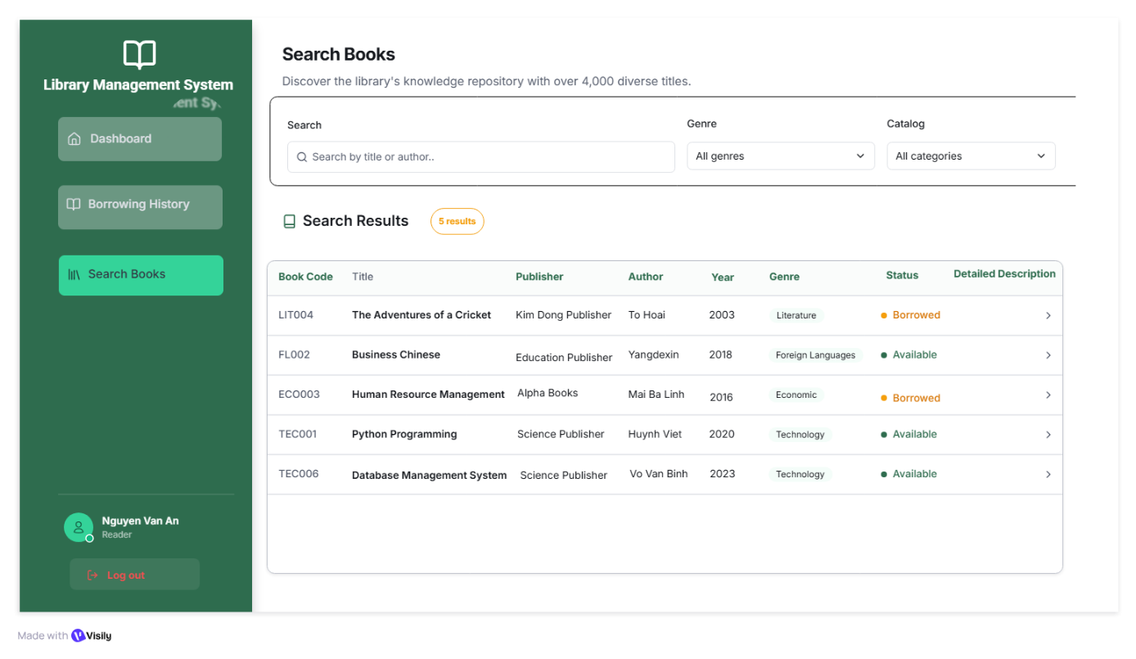
7.7 Librarian Book Management Interface
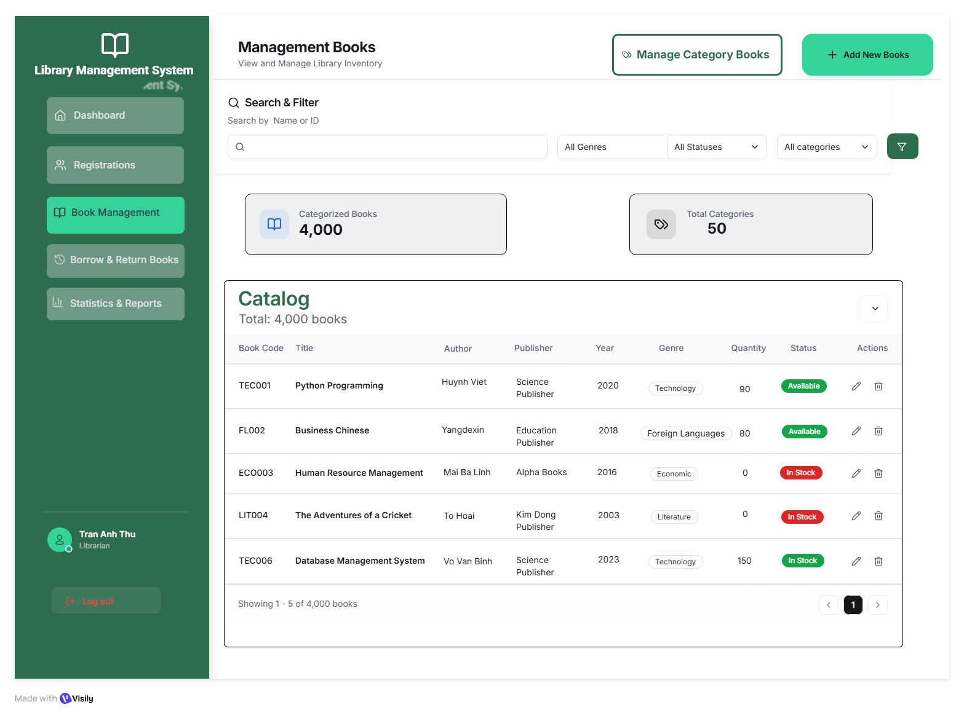
7.7.1 Add Book Interface
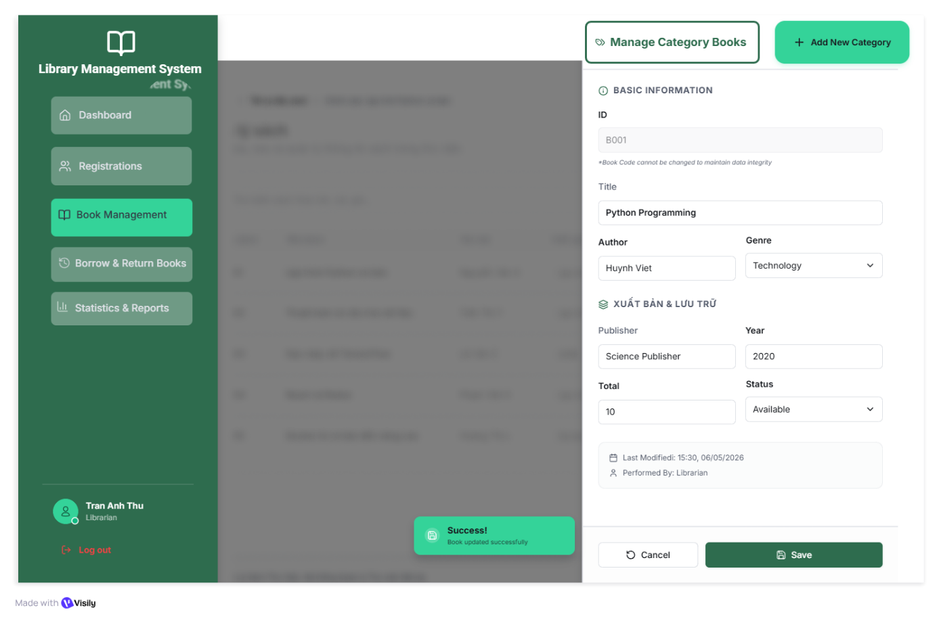
    - Librarian Book Category Creation Interface

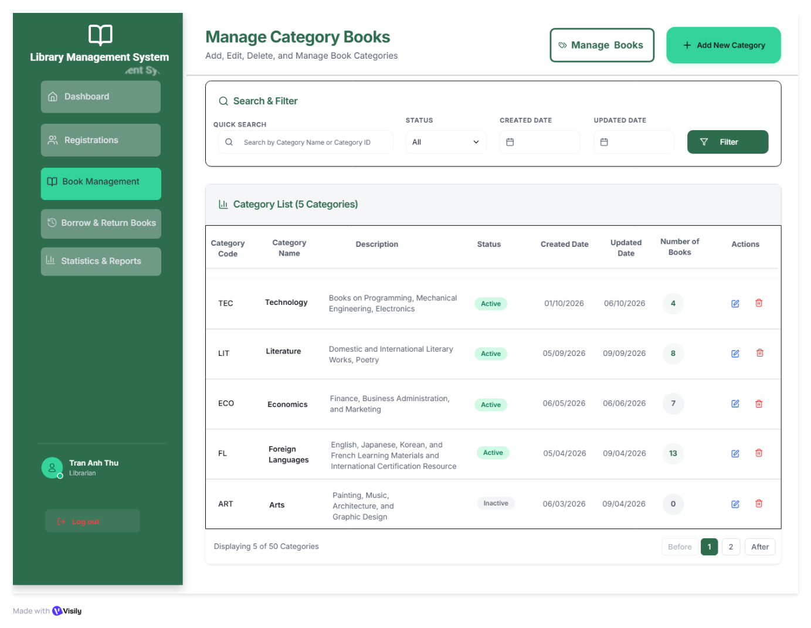
  - Librarian Book Borrowing Management Interface
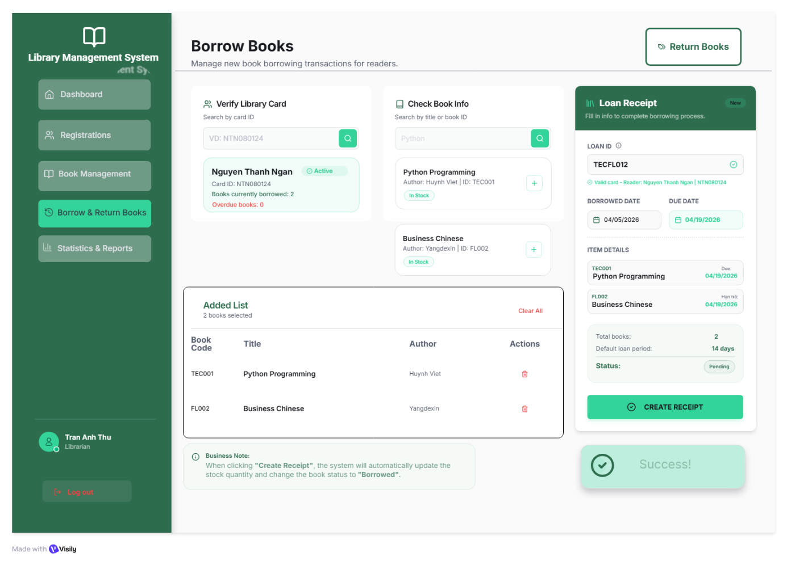
  - Librarian Book Return Management Interface
